COMPUTER ORGANISATION AND ARCHITECTURE
LAB

FAROOQ AHMAD EXPERIMENT # 11
17L4407 LAB REPORT # 11
BEE-6A1
USING BIOS SERVICES AND DOS FUNCTIONS

INTRODUCTION
In this lab session, we were introduced to the BIOS service and DOS functions. BIOS interrupt calls are a facility that operating systems and application programs use to invoke the facilities of the Basic Input/output System on IBM PC compatible computers. Traditionally, BIOS calls are mainly used by DOS programs and some other software such as boot loaders (including, mostly historically, relatively simple application software that boots directly and runs without an operating system—especially game software). BIOS only runs in the real address mode (Real Mode) of the x86 CPU, so programs that call BIOS either must also run in real mode or must switch from protected mode to real mode before calling BIOS and then switch back again. For this reason, modern operating systems that use the CPU in Protected Mode generally do not use the BIOS to support system functions, although some of them use the BIOS to probe and initialize hardware resources during their early stages of booting.

OBJECTIVE
The course learning objective of this lab session was to introduce BIOS and DOS interrupt service routines to be utilized in assembly language programs. In this experiment, you will use BIOS and DOS services to write programs that can do the following: read a character/string from the keyboard, output a character/string to the display monitor, clear the display screen and display cursor at a desired location on the screen.

PROCEDURE
Question 1
ORG 0x100

MOV AH,07H
INT 21H
INC AL
MOV DL,AL
MOV AH,02H
INT 21H

MOV AX,0x4C00
INT 21H
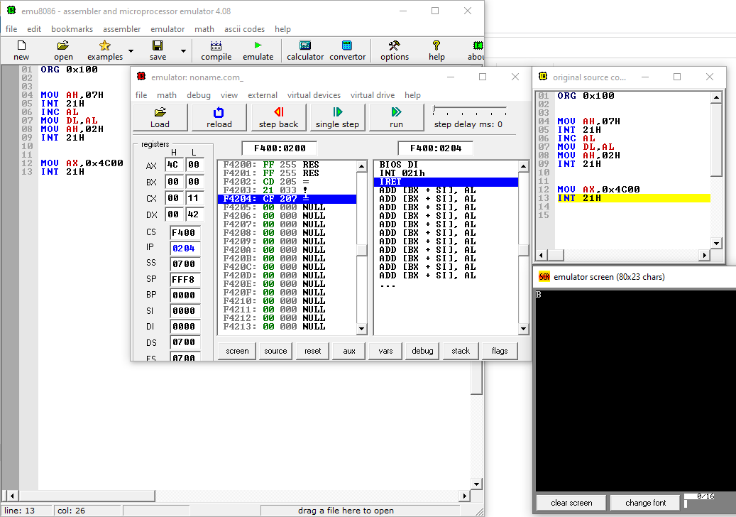

Question 2
ORG 0x100
mov SI,0
mov ah,00
mov al,03h
int 10h

MOV AH, 06h ; Scroll up function
XOR AL, AL ; Clear entire screen
XOR CX, CX ; Upper left corner CH=row, CL=column
MOV DX, 184FH ; lower right corner DH=row, DL=column
MOV BH, 11110000b ;background color = white and foreground color = black
INT 10H
again:
mov dl,[string+SI]
cmp dl,0
je terminate
inc SI
mov ah,02h
int 21h

jmp again
terminate:

MOV AX,0x4C00
INT 21H
string:db "Hello World",0
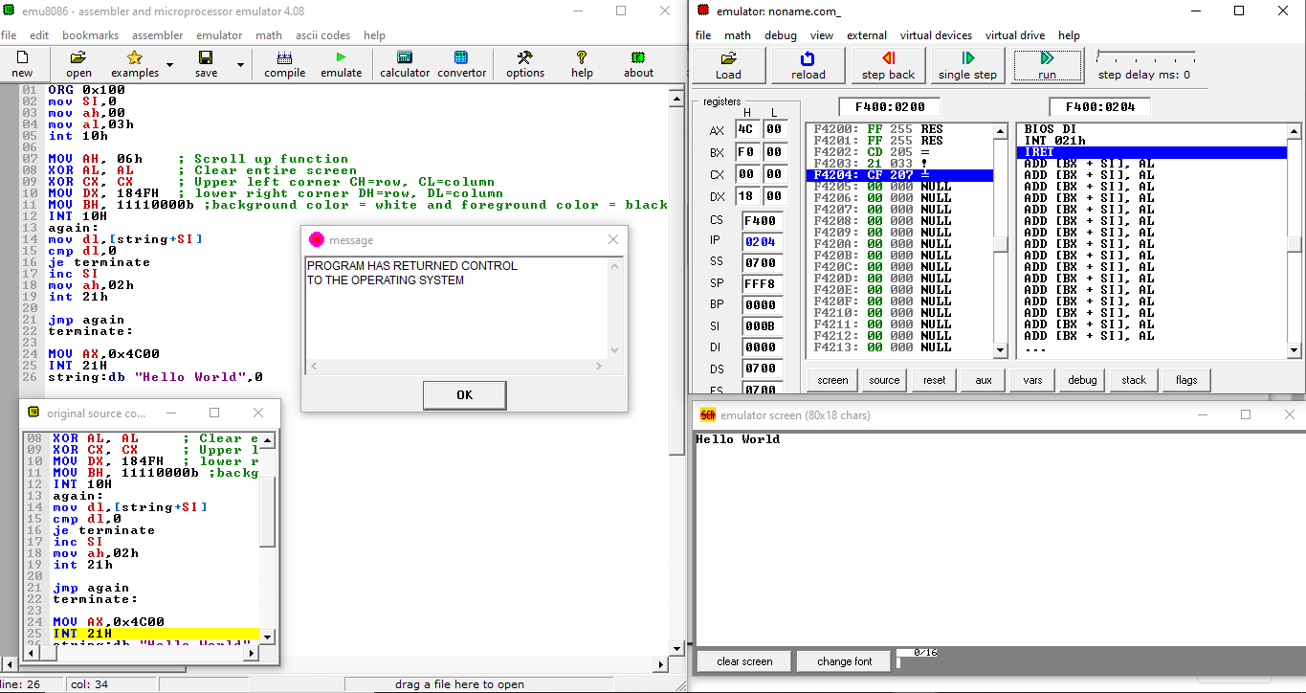

Question 3
ORG 0x100
mov SI,0
mov ah,00
mov al,03h
int 10h

MOV AH, 06h ; Scroll up function
XOR AL, AL ; Clear entire screen
XOR CX, CX ; Upper left corner CH=row, CL=column
MOV DX, 184FH ; lower right corner DH=row, DL=column
MOV BH, 11110000b ;background color = white and foreground color = black
INT 10H

mov ah,02
mov bh,0
mov dh,12
mov dl,40
int 10h
mov dl,'C'
mov ah,02h
int 21h
mov ah,07h
int 21h
cmp al,'L'
je left
again1:
mov dl,[R+SI]
cmp dl,0
je terminate
inc SI
mov ah,02h
int 21h
jmp again1

left:
mov ah,02
mov bh,0
mov dh,12
mov dl,35
int 10h

again2:
mov dl,[L+SI]
cmp dl,0
je terminate
inc SI
mov ah,02h
int 21h
jmp again2
terminate:

MOV AX,0x4C00
INT 21H
L:db "Left",0
R:db "Right",0
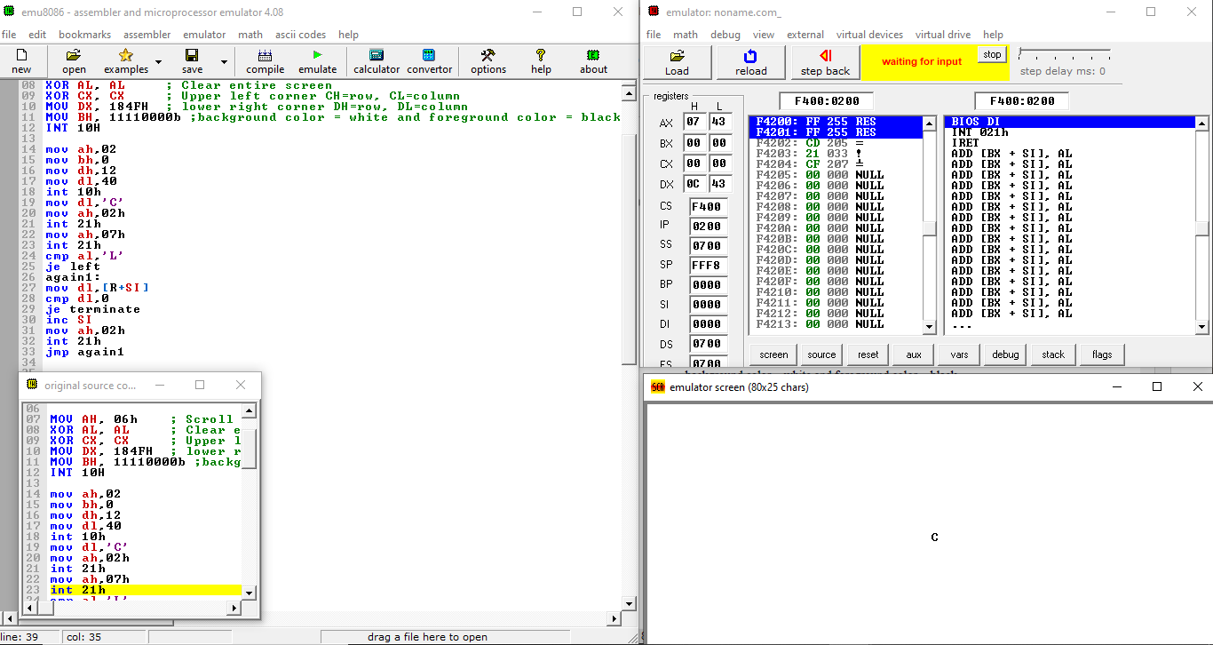
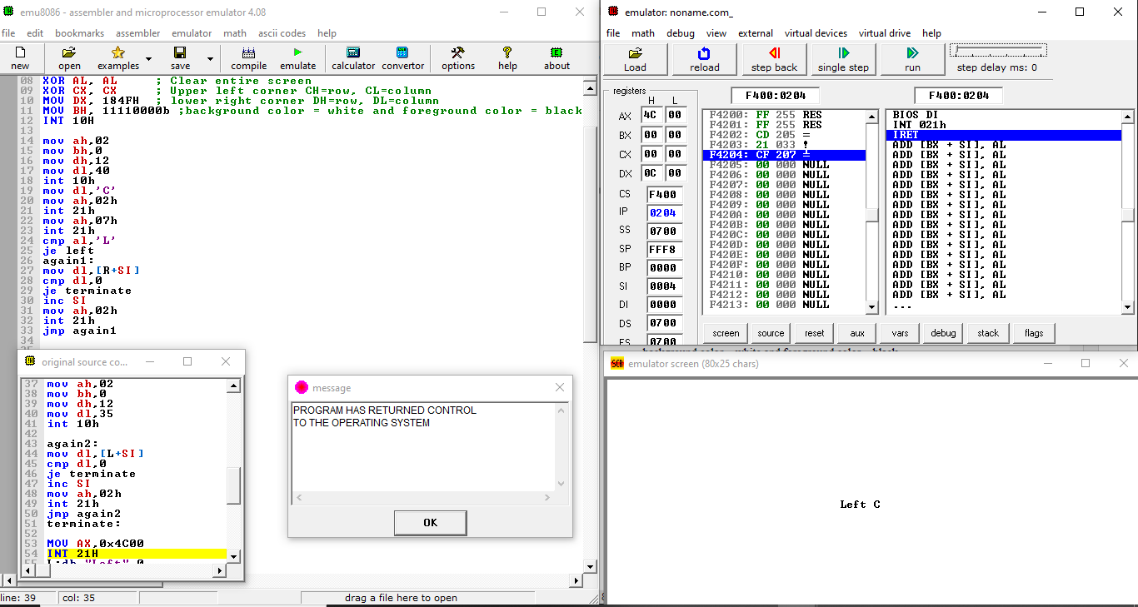
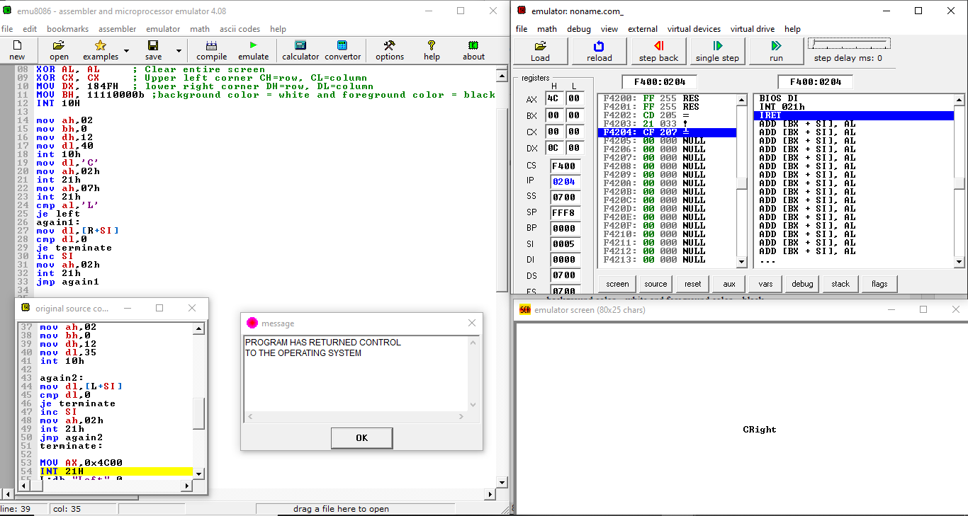

ISSUES
There were no issues.

CONCLUSION
The BIOS and DOS interrupts can be used by any operating system for low-level input/output to various devices. BIOS and DOS interrupt routines provide a number of services that can be used to write programs. These services include formatting disks, creating disk files, reading from or writing to files, reading from keyboard, writing to display monitor, etc. The software interrupt instruction INT is used for calling these services.

APPLICATIONS
The interrupt types 20h-3Fh are serviced by DOS routines that provide high-level service to hardware as well as system resources such as files and directories. The most useful is INT 21H, which provides many functions for doing keyboard, video, and file operations.

