COMPUTER ORGANISATION AND ARCHITECTURE
LAB

FAROOQ AHMAD EXPERIMENT # 12
17L4407 LAB REPORT # 12
BEE-6A1
INSTRUCTION PIPELINE

INTRODUCTION
In this lab session, we were introduced to the instruction pipeline and its hazards. Pipelining is the process of accumulating instruction from the processor through a pipeline. It allows storing and executing instructions in an orderly process. It is also known as pipeline processing. Pipelining is a technique where multiple instructions are overlapped during execution. Pipeline is divided into stages and these stages are connected with one another to form a pipe like structure. Instructions enter from one end and exit from another end. A pipeline hazard occurs when the instruction pipeline deviates at some phases, some operational conditions that do not permit the continued execution. The major pipeline hazards are described below:
- Resource hazard.
- Data hazard.
- Branch hazard.

OBJECTIVE
The course learning objective of this lab session was
- Understanding instruction pipeline using MIPS Simulator
- To understand different pipeline hazards
- Use WINMIPS64 (MIPS program pipe-line simulator)

PROCEDURE
Question 1
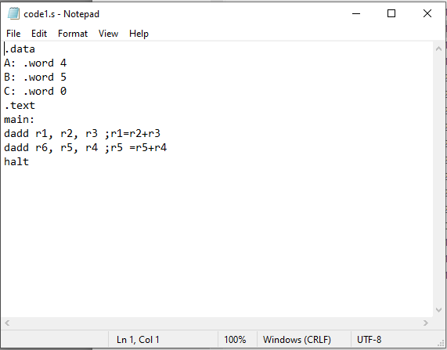
a)
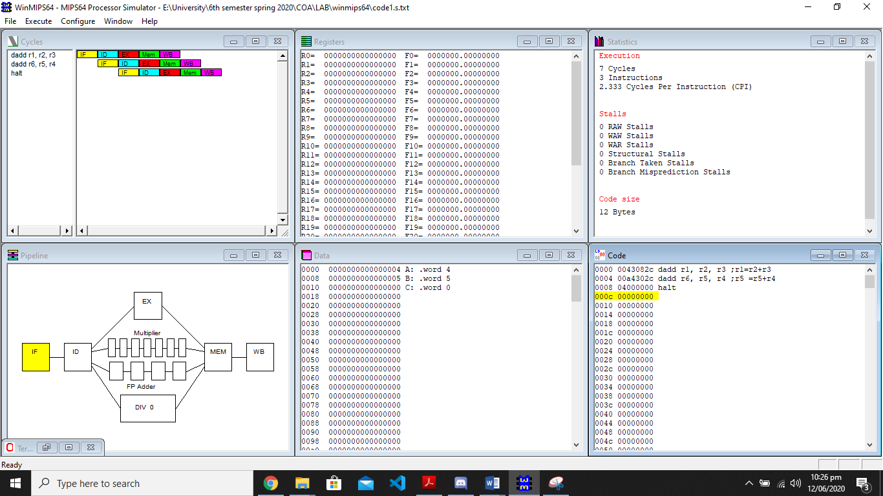
b)
Execution time on non-pipelined computer is given as: tnp = nk
where k=5 and n=3
Tnp=5x3=15s
c)
Instruction Throughput (Non-Pipelined Execution) =
No. of instructions executed per unit time = IPC = n / tnp = 3/15=0.2
d)
Execution time on pipelined computer is given as: tp = (n+k-1)
Tp=(3+5-1)=7s
e)
Speedup = tnp / tp
=15/7 =2.14
f)
Instruction Throughput (Pipelined Execution) =
No. of instructions executed per unit time = IPC = n / tp
=3/7 =0.428
g)
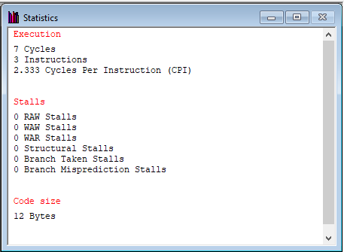

Question 2
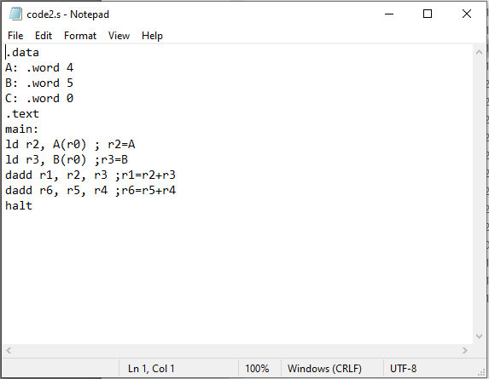

a)
RAW hazard found which is read after write. Hazard occurs when reading is done first and then writing.

b)
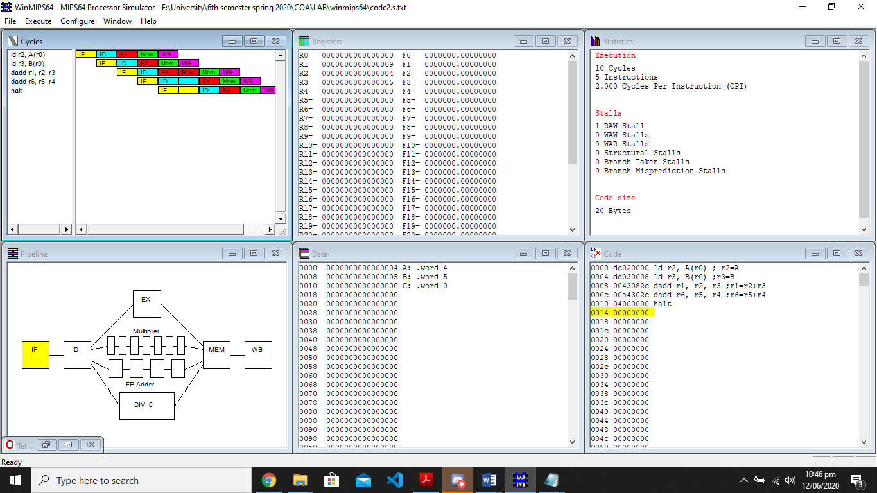

Question 3
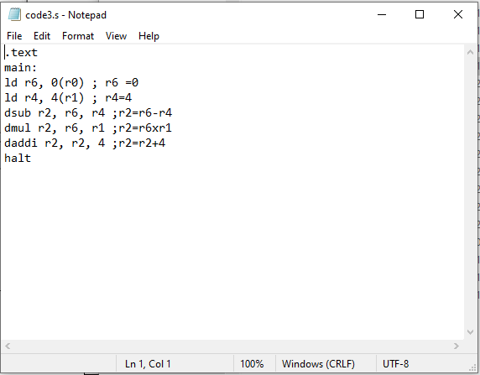
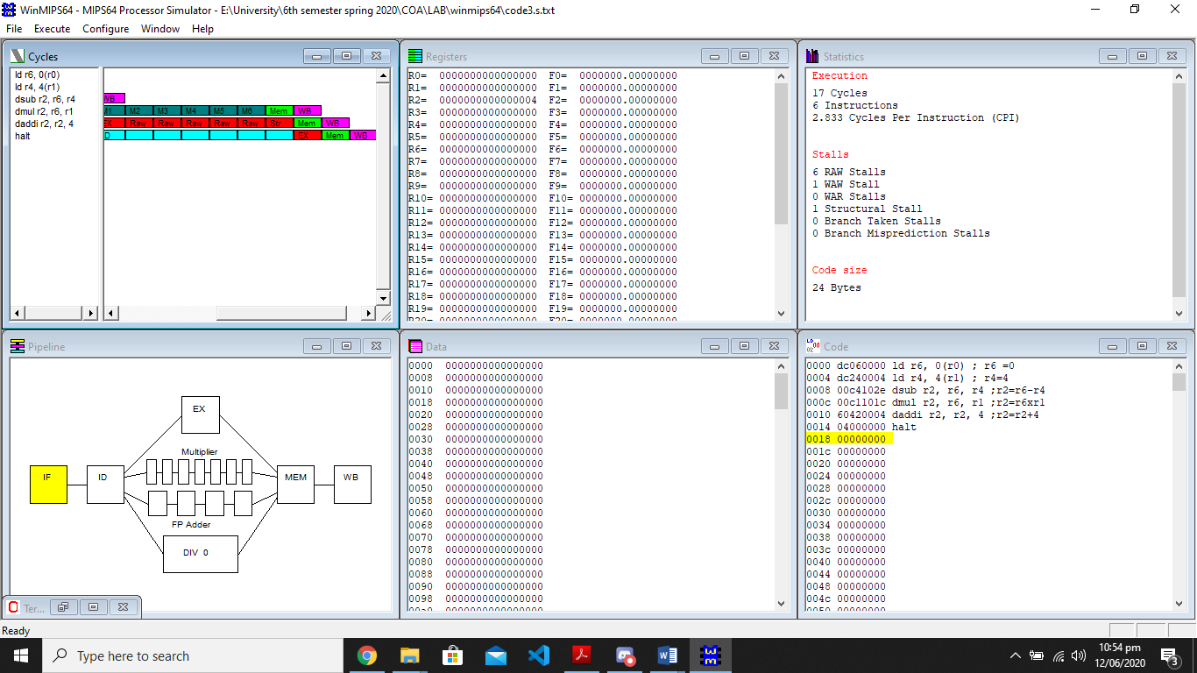
a)
17
b)
2.833
c)
RAW: reading is done first and then writing.
WAW: first instruction writes before the second write.
Structural stall: They arise from resource conflicts when the hardware cannot support all possible combinations of instructions in simultaneous overlapped execution.

ISSUES
There were no issues.

CONCLUSION
From the above experiment, we can conclude that pipeline systems are more efficient compared to non-pipeline systems because pipeline systems divide the tasks into different categories. However, with pipeline systems, if hazards arise then efficiency is reduced. Some of the hazards that arise are read after write where an instruction tries to read a memory before the previous instruction writes it, so current instruction incorrectly gets the old value. Another hazard is write after write where current instruction tries to write an operand before it is written by previous instruction. Other hazards are write after write and structural stall

APPLICATIONS
Instruction pipelining is a technique used in the design of modern microprocessors, microcontrollers and CPUs to increase their instruction throughput.

