COMPUTER ORGANISATION AND ARCHITECTURE
LAB

FAROOQ AHMAD EXPERIMENT # 1
17L4407 LAB REPORT # 1
BEE-6A1
INTRODUCTION TO THE ASSEMBLER

INTRODUCTION
In this lab session, we were introduced to the assembly language and the software to run the assembly language, assembler. Assembly language is a low-level programming language for a computer or other programmable device specific to a particular computer architecture in contrast to most high-level programming languages, which are generally portable across multiple systems. Assembly language is converted into executable machine code by a utility program referred to as an assembler like NASM, MASM, etc.

OBJECTIVE
The course learning objective of this lab session was to learn how to write a simple assembly language program for x86 (x88) real mode, how to use the Assembler for editing, assembling and debugging an assembly language program and how to use the debugger interface for understanding the computer organization.

PROCEDURE
After getting an introduction to NASM and its properties, we tried to check the output of following code.
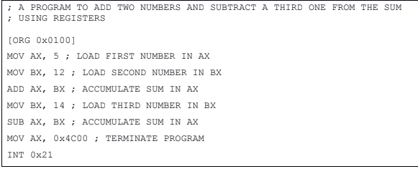
Firstly, a notepad file was created, code was written in it and file saved with ‘.asm’ extension. Then file was assembled using NASM on DOSBox with the following command:
nasm [infile] [-o outfile]
the infile was the name of our .asm file and outfile was the name of output file which is the executable file we wanted to be produced. Lastly, to debug this and check the output, command used was:
afd [filename]
this created a pop-up of the debugger windows which for the above code is as follows:
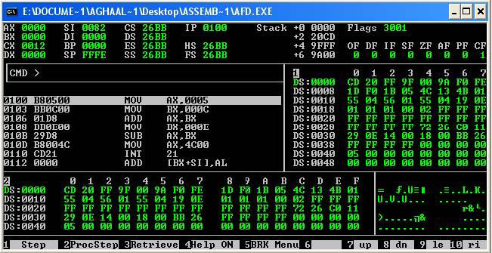
This debugger is easy to use and understand, we can use F1 to step through the code and see the changes that execution of each line in code brings. To return to the previous window we can simply write “quit” in the CMD.
This program was then modified to generate the sum of four numbers, using registers, as an in lab-task and simply by using ‘ADD’ instruction. Next post lab task was performed which was to write a program to add three numbers in Ax register and store the result in Bx register. This was also done successfully using “MOV” and “ADD” instructions. It was observed that the last lines of code following “INT 0X21” were meant to terminate the program.

ISSUES
There were no issues.

CONCLUSION
The segmentation of main memory increases the execution speed of computer system so that the processor is able to fetch and execute the data from memory faster and easily. Another advantage of segments is that it allows placing of code data and stack portions of the same program in different parts of the memory, for data and code protection. The addresses of the stack increase downward in memory so every new value is added to lower memory addresses. In order to push a value into stack PUSH instruction is used and to pop a value out the stack POP instruction is used.

APPLICATIONS
Registers are used to carry out arithmetic operations while also storing data similar to main memory which also stores code data and stack data.

POSTLAB
[org 0x0100]
mov ax,0x1254
add ax,0xEDAB
mov bx,0x0FFF
add ax,bx
mov ax, 0x4c00 ; terminate program
int 0x21

INT 0x21 is basically an interrupt call used to terminate the program

