COMPUTER ORGANISATION AND ARCHITECTURE
LAB

FAROOQ AHMAD EXPERIMENT # 2
17L4407 LAB REPORT # 2
BEE-6A1
REGISTERS AND FLAGS

INTRODUCTION
In this lab session, we were introduced to registers and flags. The 8086 uses different registers to perform specific tasks. There are four general purpose registers, AX, BX, CX and DX, that are 16-bit each. They are used to contain arithmetic and logical operands. The special function registers are the CS, DS, SS and ES. These four registers determine, at any given time, which segments of memory are currently addressable. FLAGS is a 16-bit register which contains single bit flags that are divided into two major groups: the status flags and the control flags. Status FLAGS reflect the result of an operation executed by the processor. The control FLAGS enable or disable certain operations of the processor. The instruction pointer, also called program counter, is a special register in a processor. It holds the address of the next instruction to be executed.

OBJECTIVE
The course learning objective of this lab session was to learn how to interpret the different types of registers available in the IAPX86 architecture and how to manipulate them using assembly language. Also be able to interpret the function of flags and to use them effectively to perform arithmetic operations. Lastly, be able to use the debugger for viewing the available registers and their function.

PROCEDURE
In this lab, our task was to calculate the square of 20 by using a loop that adds 20 to the accumulator 20 times. For this code written was:
[Org 0x0100]

mov ax, 0
mov cx, 20
here add ax,20
Loop here

mov ax, 0x4c00
Int 0x21

Output obtained is as follows:
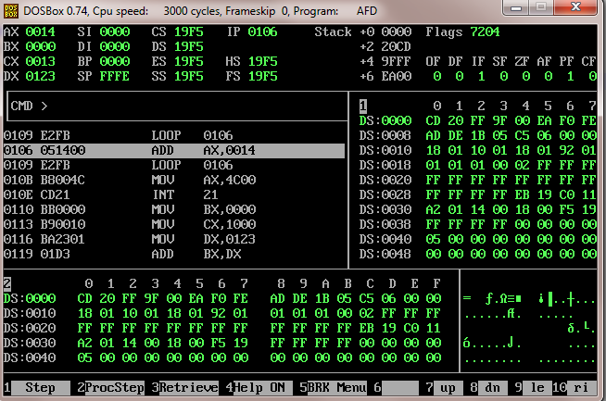

ISSUES
There were no issues.

CONCLUSION
The 8086 has eight more or less general 16-bit registers including the stack pointer but excluding the instruction pointer, flag register and segment registers. Four of them, AX, BX, CX, DX, can also be accessed as twice as many 8-bit registers while the other four, SI, DI, BP, SP, are 16-bit only. There are other types of register too such as the FLAGS, segment registers and special function registers. Each of the registers in the 8086 perform specific tasks and help the user in programming and executing various instructions.

APPLICATIONS
Loop instructions are used widely in 8086 codes to simplify the code operations and perform large number of cycles and iterations of code without having to write the same instruction again and again in the code.

POSTLAB
Question 1
Flags IP ZF CF SF OF
mov ax,0x1254 0103 0 0 0 0
mov bx,0x0FFF 0106 0 0 0 0
add ax,0xEDAB 0109 0 0 1 0
add ax,bx 010B 0 1 0 0
add bx,0xF001 010F 1 1 0 0

Question 2
mov CL,BL
mov AX,DX
mov AL,0x12
mov AX,0x1234
mov AX,0XFFFF

