COMPUTER ORGANISATION AND ARCHITECTURE
LAB

FAROOQ AHMAD EXPERIMENT # 4
17L4407 LAB REPORT # 4
BEE-6A1
SIMULATING CACHE USING MIPS SIMULATOR

INTRODUCTION
In this lab session, we were introduced to simulating cache memory using mips simulator. The Cache Memory is the volatile computer memory which is very nearest to the CPU so also called CPU memory, all the Recent Instructions are Stored into the Cache Memory. It is the fastest memory that provides high-speed data access to a computer microprocessor. Cache meaning is that it is used for storing the input which is given by the user and which is necessary for the computer microprocessor to perform a Task. But the Capacity of the Cache Memory is too low in compare to Memory (random access memory (RAM)) and Hard Disk.
MIPS is a RISC architecture which stands for Reduced Introduction Set Computing. The name was basically an acronym for Microprocessor without Interlocked Pipeline Stages, but they were later reintroduced in order to improve performance. The MIPS architecture is one of the most widely supported of all processor architectures, with a broad infrastructure of standard tools, software and services to help ensure rapid, reliable, cost effective development.

OBJECTIVE
The course learning objective of this lab session was to be able to understand working of cache and to learn the use of MIPS simulator.

PROCEDURE
- Create a new project in MipsIt using the steps mentioned in the given document.
- Compile code1.c and load it to the simulator
- Open the simulator and disable both cache
- Run the simulation and note down the execution time in Table – 1
- Now enable the instruction cache only with default settings. Reload the code and simulate it. Note down the execution time in table – 1.
- Next, enable the data cache only and note down the time
- Now enable both cache (data+ instruction) and note down the time

Table – 1
Scenario | No Cache | Instruction Cache only | Data cache only | Both caches
Time | 60906 | 48556 | 53906 | 41556

- Which scenario took the least time? What is the reason?
Ans. When both cashes are enables, least time is taken because cpu wont have to go and access the memory which takes more time. Answer is found from the cache which is more accessible.

- Enable both cache with default values. Play the simulation. Open the Instruction Cache block by double clicking on it. What type of mapping is used by this cache? Looking at the default values, calculate the word offset bits, cache line bits and tag bits and verify it with simulator block diagram.

Ans. Direct Mapping is used.
word offset bits: 3
cache line bits: 32
tag bits: 26

- Complete the table -2 for the same scenario
Table 2
INSTRUCTION CACHE |  | DATA CACHE
Hit Count | 545 | Hit Count | 408
Miss Count | 296 | Miss Count | 75
Hit Rate | 0.65 | Hit Rate | 0.84
Cycle Count | 44646 | Cycle Count | 44646

- Set the following values in the simulator
Table 3
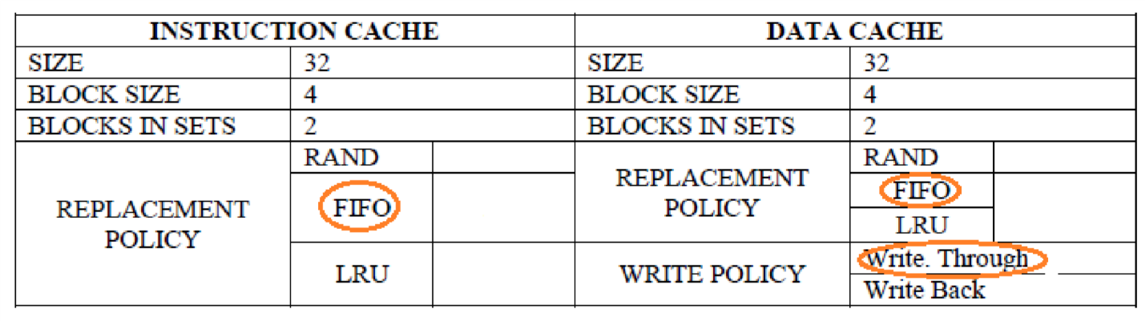

- Set Memory write buffer size = 5

- What is the type of cache Mapping?
Ans. Set-Associative

- Reload the code, open the cache and memory windows, then press play. During simulation, verify by noting down the observations of Data Cache and Memory Locations that with “Write through” method, every time the processor writes to a cached memory location both the cache and the underlying memory locations are updated.
Ans. First instruction cache is used, then data cache is used, and values are updated from memory.

- How much is the Total time taken?
Ans. 11300
- Now change the data cache write policy to “Write back”. What are the changes you see in the cache block?

- After the changes in 16, note the total time again.
Ans. 5396

- Verify by noting down the observations of Data Cache and Memory Locations that with “Write Back” method, when a write is made to system memory at a location that is currently cached, the new data is only written to the cache, not actually written to the system memory. Later, if another memory location needs to use the cache line where this data is stored, it is saved ("written back") to the system memory and then the line can be used by the new address.
Considering the total execution time, comment which write policy is better?
Ans. Write Back is better because it takes lesser time.

ISSUES
There were no issues.

CONCLUSION
In this experiment we got familiar with the MIPs architecture whose fundamental characteristics, such as the large number of registers, the number and the character of the instructions, and the visible pipeline delay slots, enable the MIPS architecture to deliver high performance. We also learned about direct memory mapping where each memory block is assigned to a specific line in the cache, and Associative memory mapping where any block can go into any line of the cache.

APPLICATIONS
MIPS processors are used in embedded systems such as residential gateways and routers. MIPS architecture is used for digital camera processor because the technology enables the team to design products that maximize overall system performance while minimizing any impact to battery life.

POSTLAB
There are three types of cache:
- L1 Cache
- L2 Cache
- L3 Cache
These cache memories are very fast and store the temporary information of the programs which have been opened because of the probability that these programs will be opened again. So, instead of going and accessing the information from the system RAM, which is much slower than the Cache memory, the Cache memory stores it for the future purpose.
L1 cache, or primary cache, is extremely fast but relatively small, and is usually embedded in the processor chip as CPU cache.
L2 cache, or secondary cache, is often more capacious than L1. L2 cache may be embedded on the CPU, or it can be on a separate chip or coprocessor and have a high-speed alternative system bus connecting the cache and CPU. That way it doesn't get slowed by traffic on the main system bus.
Level 3 (L3) cache is specialized memory developed to improve the performance of L1 and L2. L1 or L2 can be significantly faster than L3, though L3 is usually double the speed of RAM. With multicore processors, each core can have dedicated L1 and L2 cache, but they can share an L3 cache. If an L3 cache references an instruction, it is usually elevated to a higher level of cache.

