COMPUTER ORGANISATION AND ARCHITECTURE
LAB

FAROOQ AHMAD EXPERIMENT # 6
17L4407 LAB REPORT # 6
BEE-6A1
MEMORY ADDRESSING

INTRODUCTION
In this lab session, we were introduced to the memory addressing. . The 8086 is a 16-bit microprocessor and, hence, can transfer 16-bit data. Therefore, in addition to byte, a word (16-bit) has to be stored in memory. This is stored by using two consecutive memory locations, one for least significant byte and the other for most significant byte. The way of specifying data to be operated by an instruction is known as addressing modes. This specifies that the given data is an immediate data or an address. It also specifies whether the given operand is register or register pair. The effective address is the offset address and the physical address is the actual address of an instruction. It is an unassigned 16-bit number that expresses the operand’s distance in bytes from the beginning of the segment in which it resides. In 8086 we have base registers and index registers. So, effective address is calculated by summing a displacement, the content of base register and the content of index register. EA = {Base Register} + {Index Register} + {8 0r 16-bit displacement}. The displacement is an 8- or 16-bit number that is contained in the instruction. Part of a register cannot be used to access memory. For example, BX is allowed to hold an address but BL or BH are not. Address is 16-bit and must be contained in a 16-bit register. BX-SI is not possible. The only thing that we can do is addition of a base register with an index register. Any other operation is disallowed. BS+BP and SI+DI are both disallowed as we cannot have two base or two index registers in one memory access.

OBJECTIVE
The course learning objective of this lab session was to learn how to modify the memory contents and to learn how to use segmentation.

PROCEDURE
Question 1(a)
- 0x0112
- 0x1101
- 0x1101
- 0x0200
Question 1(b)
- Not possible
- Not possible
- 0110
- 00F0
- 00FF
- 0101

Question 2
[ORG 0x0100]
mov SI,0
mov DI,0
mov BH,5AH
again:

MOV AL,[InString+DI]
MOV AH,[InString+DI]
inc DI

cmp AH,BH
jle tolower

SUB AL,32
mov [OutString+SI],AL
inc SI

MOV AL,[InString+DI]
JNZ again
jmp here

tolower:
ADD AL,32
mov [OutString+SI],AL
inc SI
jmp again

here:
MOV AX, 0x4C00 ; TERMINATE PROGRAM
INT 0x21

InString: db "Your Name",0
OutString: db ""

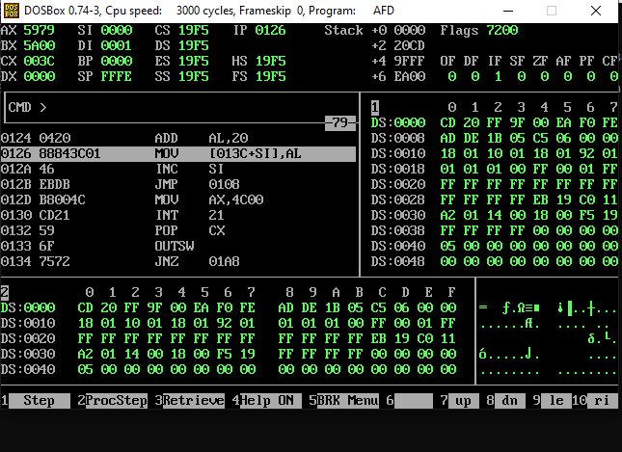
Question 3
[ORG 0x0100]
mov cx,10
mov SI,0
mov ax,0
mov bl,0
here:
mov bl,[Numbers+SI]
add al,bl
inc SI
loop here
MOV AX, 0x4C00 ; TERMINATE PROGRAM
INT 0x21

Numbers: db 59,75,86,92,58,18,8,29,92,32
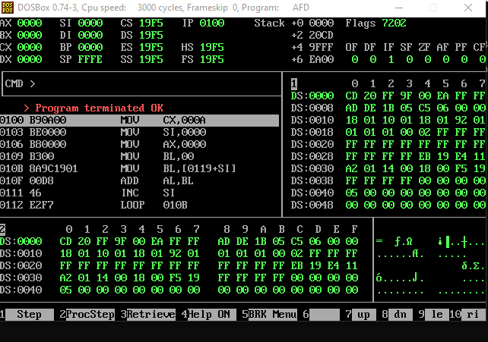

ISSUES
There were no issues.

CONCLUSION
From the above experiment we can conclude that the 8086 processor contains what are called segment registers. They are called cs, ds, es and ss. The important thing is that the physical address is the number of bytes from the bottom of memory where some data item, or machine code instruction resides. Specifically, with the 8086 processor, the physical address is got by multiplying the value stored in a segment register by 16 to give a segment address. Adding on the number of bytes from that address to where some desired item resides gives the physical address.

APPLICATIONS
The registers on the 8086 are used to perform various arithmetic and logical operations such as 32-bit addition and subtraction. Segmentation is used to increase the execution speed of computer system so that processor can fetch and execute the data from memory easily and quickly.

POSTLAB
No postlab.

