COMPUTER ORGANISATION AND ARCHITECTURE
LAB

FAROOQ AHMAD EXPERIMENT # 7
17L4407 LAB REPORT # 7
BEE-6A1
BRANCHING

INTRODUCTION
In this lab session, we were introduced to Branching. There are three types of Jump instructions; short, near and far (long). A short JMP is the relative JMP that you refer to. It is encoded as two bytes; the actual JMP and the number of bytes +/- relative to the current IP. A near jump allows you to jump within the current "segment" (using real mode terms) or within the currently selected memory area in the CS selector. A long or far JMP additionally includes a selector (or segment in real mode).

OBJECTIVE
The course learning objective of this lab session was
- To understand various jump instructions
- To get familiarize with Relative Addressing
- To get an idea of types of jump instructions

PROCEDURE
Question 1
Z=0
S=0F
C=0
- Jg greater will not be taken
- Jl smaller will be taken
- Ja above will be taken
- Jb below will not be taken
Question 2
[ORG 0x0100]
;searching 23 in the binary tree

;counting the total no of elements in the sorted array
mov DI,0
mov al,[Array+DI]
again:
inc DI
mov al,[Array+DI]
cmp al,0
jne again
mov dx,DI
;dx stores the total no of elements in the array
mov ax,DI
mov bl,2
div bl
mov cx,ax
;cx now stores the middle index of the array
;checking the midle index
mov DI,ax
mov al,[Array+DI]
mov bl,23
cmp al,bl
je equal
cmp al,bl
jg upper_class
;lower_class
mov ax,cx
mov bx,2
div bx
mov DI,ax
mov al,[Array+DI]
mov bl,23
cmp al,bl
je equal
cmp al,bl
jg upper
;lower
mov ax,DI
mov bx,2
div bx
mov DI,ax
mov al,[Array+DI]
mov bl,23
cmp al,bl
je equal
cmp al,bl
jg up
dec DI
mov ax,DI
mov bx,2
div bx
mov DI,ax
mov al,[Array+DI]
mov bl,23
cmp al,bl
je equal
mov ax,0
jmp end

up:
inc DI
mov ax,DI
mov bx,2
div bx
mov DI,ax
mov al,[Array+DI]
mov bl,23
cmp al,bl
je equal
mov ax,0
jmp end

upper_class:
sub dx,cx
mov ax,dx
mov bx,2
div bx
add ax,cx
;checking upper_class' middle index
mov DI,ax
mov al,[Array+DI]
mov bl,23
cmp al,bl
je equal
cmp al,bl
jg greater
;lesser
mov ax,DI
mov bx,cx
sub ax,bx
add ax,cx
mov DI,ax
mov al,[Array+DI]
mov bl,23
cmp al,bl
je equal
cmp al,bl
jg up
dec DI
mov ax,DI
mov bx,2
div bx
mov DI,ax
mov al,[Array+DI]
mov bl,23
cmp al,bl
je equal
mov ax,0
jmp end

greater:
mov ax,dx
mov bx,DI
sub ax,bx
add ax,DI
mov DI,ax
mov al,[Array+DI]
mov bl,23
cmp al,bl
je equal
cmp al,bl
jg up
dec DI
mov ax,DI
mov bx,2
div bx
mov DI,ax
mov al,[Array+DI]
mov bl,23
cmp al,bl
je equal
mov ax,0
jmp end

upper:
mov ax,cx
mov bx,DI
sub ax,bx
add ax,cx
mov DI,ax
mov al,[Array+DI]
mov bl,23
cmp al,bl
je equal
cmp al,bl
jg up
dec DI
mov ax,DI
mov bx,2
div bx
mov DI,ax
mov al,[Array+DI]
mov bl,23
cmp al,bl
je equal
mov ax,0
jmp end

equal:
mov ax,1

end:
MOV AX, 0x4C00 ; TERMINATE PROGRAM
INT 0x21

Array: db 2,5,8,12,16,23,38,56,72,91,0
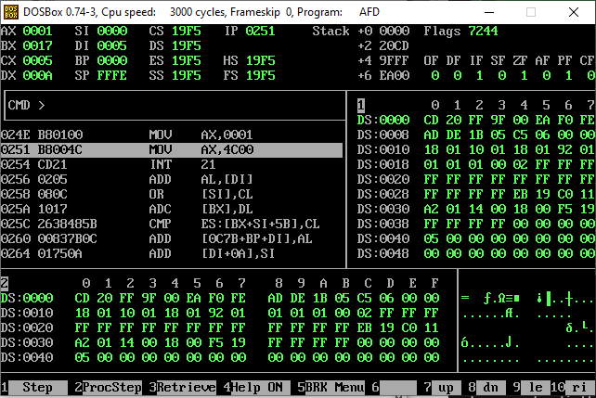
Question 3
[ORG 0x0100]
;dx contains the factorial found of the number
mov dx,0
mov cx,1
;bl contains the no. for factorial
mov bl,5
mov al,bl
cmp al,dl
je zero_ka_factorial_one_hota_hai
dec bl
again:
MUL bl
dec bl
cmp bl,cl
jg again
mov dx,ax
jmp end
zero_ka_factorial_one_hota_hai:
mov al,1
mov dx,ax
end:
MOV AX, 0x4C00 ; TERMINATE PROGRAM
INT 0x21
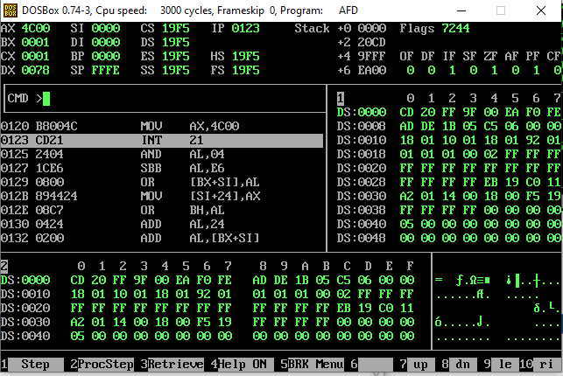

ISSUES
There were no issues.

CONCLUSION
The relative addressing is different from absolute addressing. It does not tell the exact address rather it tells how much forward or backward to go from the current position of IP in the current code segment. We also learnt about the three different types of jumps which are the short jump that can go +127 bytes ahead in code and -128 bytes backwards and no more, the near jump that can jump anywhere within a segment and lastly the long or far jump that can go from one code segment to another.

APPLICATIONS
Jump instructions is used to jump the memory address from one address to another wherever you want or you want to skip some line of code when your condition of statement is full fill.

POSTLAB
No postlab.

