EMBEDDED SYSTEMS LAB
FAROOQ AHMAD EXPERIMENT # 11
17L-4407
EL-7B

SYSTICK TIMER and PLL ON TIVA TM4C123GH6PM MICROCONTROLLER
In this lab session, we were introduced to systick timer and pll on tiva tm4c123gh6pm microcontroller. A phase-locked loop or phase lock loop (PLL) is a control system that generates an output signal whose phase is related to the phase of an input signal. There are several different types; the simplest is an electronic circuit consisting of a variable frequency oscillator and a phase detector in a feedback loop. Most microcontrollers have a phase-lock-loop (PLL) that allows the software to adjust the execution speed of the computer. Typically, the choice of frequency involves the tradeoff between software execution speed and electrical power.
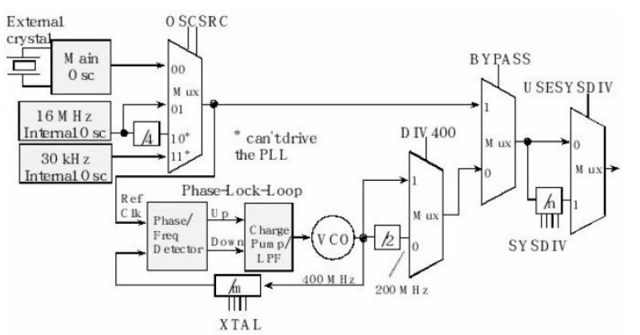
SysTick timer is a simple counter that we can use to create time delays and generate periodic interrupts. The basis of SysTick is a 24-bit down counter that runs on a fixed rate without external signal (either by the system clock or internal oscillator). The System Tick Timer (SysTick) generates interrupt requests on a regular basis. This allows an OS to carry out context switching to support multiple tasking.
1. The first step is set BYPASS2 (bit11). At this point, the PLL is bypassed and there is no
system clock divider.
2. The second step is to specify the crystal frequency in the four XTAL bits using the code in
Figure 10.2.
3. The OSCSRC2 bits are cleared to select the main oscillator as the oscillator clock source.
4. Clear PWRDN2 (bit 13) to activate the PLL.
5. Configure and enable the clock divider using the 7-bit SYSDIV2 field. If the 7-bit SYSDIV2
is n, then the clock will be divided by n+1. E.g., To get the desired 80 MHz from the 400
MHz PLL, we need to divide by 5. So, we place a 4 into the SYSDIV2 field.
6. Wait for the PLL to stabilize by waiting for PLLRIS (bit 6) in the SYSCTL_RIS_R to
become high.
7. Connect the PLL by clearing the BYPASS2 bit.
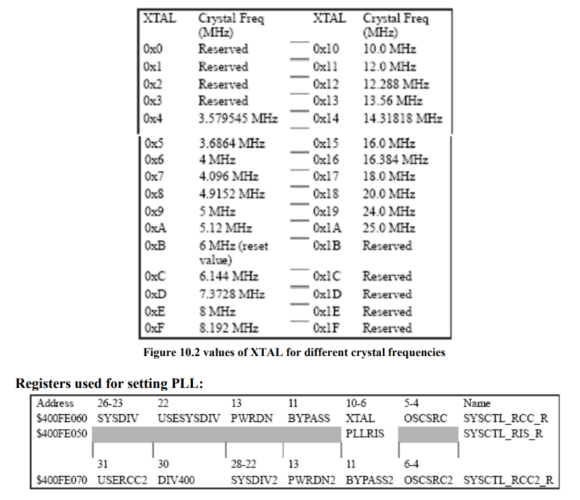
There are four steps to initialize the SysTick timer.
1. First, we clear the ENABLE bit (NVIC_ST_CTRL_R) to turn off SysTick during initialization.
2. Second, we set the RELOAD register with the start value of counter. STRELOAD should contain N-1 for the COUNT to fire every N clock cycles because the counter counts down to 0.
3. Third, we write to the NVIC_ST_CURRENT_R value to clear the counter.
4. Lastly, we write the desired mode to the control register, NVIC_ST_CTRL_R . We set the CLK_SRC bit specifying the core clock will be used. We must set CLK_SRC=1, because CLK_SRC=0 external clock mode is not implemented on the TM4C family.
Formula to load a value for required delay: Required delay = (N+1)/ ClkFrequency
LAB TASKS:
1. Use systick timer to write a routine to add a delay of 10ms using main oscillator. Toggle PF2 every 10ms.
#define SW1 *(volatile uint32_t *) 0x40025040
void delay()
{
int i, j;
for(i=0;i<100;i++)
for(j=0;j<3180;j++)//1ms
{}
}

void PortF_Init(void)
{
SYSCTL_RCGCGPIO_R |= 0x00000020;
GPIO_PORTF_LOCK_R = 0x4C4F434B;
GPIO_PORTF_CR_R = 0x4;
GPIO_PORTF_DIR_R = 0x4;
GPIO_PORTF_DEN_R = 0x4;
}
}
void SysTick_Init(void)
{
NVIC_ST_CTRL_R = 0; / enable SysTick interrupt, use system clock */

NVIC_ST_RELOAD_R = 0x00FFFFFF;
NVIC_ST_CURRENT_R = 0;
NVIC_ST_CTRL_R = 0x00000005;
}

void SysTick_Wait(uint32_t delay)
{
NVIC_ST_RELOAD_R = delay-1; */ reload with number of clocks per second */
NVIC_ST_CURRENT_R = 0;
while((NVIC_ST_CTRL_R&0x00010000)==0){ }}

void SysTick_Wait1ms(uint32_t x){
unsigned long i;
for(i=0; i<x; i++){
SysTick_Wait(16000); }}

int main(void)
{
PortF_Init();
SysTick_Init();
GPIO_PORTF_DATA_R = 4;
while(1)
{
GPIO_PORTF_DATA_R ^= 4;
SysTick_Wait1ms(10); //delay 1 sec
}
}

2. Using PLL, obtain 50MHz from main oscillator. And run the same systick routine you wrote in part 1. How much is the delay generated by systick timer now? Use logic analyzer to view the new waveform and calculate the delay of each half cycle.
#include "tm4c123gh6pm.h"
#define SW1 *(volatile uint32_t *) 0x40025040
void delay()
{
int i, j;
for(i=0;i<100;i++)
for(j=0;j<3180;j++)//1ms
{}
}
#define SYSDIV2 7
//PLL INITIALIZATION CODE
void PLL_Init(void)
{
//set the desired system divider using the following Registers
SYSCTL_RCC2_R;
SYSCTL_RCC_R;
}
void PortF_Init(void)
{
SYSCTL_RCGCGPIO_R |= 0x00000020;
GPIO_PORTF_LOCK_R = 0x4C4F434B;
GPIO_PORTF_CR_R = 0x4;
GPIO_PORTF_DIR_R = 0x4;
GPIO_PORTF_DEN_R = 0x4;
}
}

//INTIALIZATION CODE FROM TASK-1

void SysTick_Init(void)
{
NVIC_ST_CTRL_R = 0;
NVIC_ST_RELOAD_R = 0x00FFFFFF;
NVIC_ST_CURRENT_R = 0;
NVIC_ST_CTRL_R = 0x00000005;
}

void SysTick_Wait(uint32_t delay)
{
NVIC_ST_RELOAD_R = delay-1;
NVIC_ST_CURRENT_R = 0;
while((NVIC_ST_CTRL_R&0x00010000)==0){ }}
void SysTick_Wait1ms(uint32_t x){
unsigned long i;
for(i=0; i<x; i++){
SysTick_Wait(16000);
}
}

int main(void)
{
PLL_Init();
PortF_Init();
SysTick_Init();
GPIO_PORTF_DATA_R = 4;
while(1)
{ GPIO_PORTF_DATA_R ^= 4;
SysTick_Wait1ms(10); //delay 1 sec
}
}

Phase Locked Loop (PLL) is one of the vital blocks in linear systems. It is useful in communication systems such as radars, satellites, FMs, etc. This chapter discusses about the block diagram of PLL and IC 565 in detail. Block Diagram of PLL. A Phase Locked Loop (PLL) mainly consists of the following three blocks − Phase Detector; Active Low Pass Filter
The SysTick timer is a 24-bit countdown timer with auto reload. It is generally used to provide a periodic interrupt for an RTOS scheduler. The default clock source for the SysTick timer is the Cortex-M CPU clock.
PLL (Phase Locked Loop) is the most widely used circuit in modern communication. Phase-locked loops are widely used for synchronization purposes; in space communications for coherent demodulation and threshold extension, bit synchronization, and symbol synchronization. Phase-locked loops can also be used to demodulate frequency-modulated signals. In radio transmitters, a PLL is used to synthesize new frequencies which are a multiple of a reference frequency, with the same stability as the reference frequency. It is used in demodulation of Amplitude Modulated suppressed carrier signal. It is also used for demodulation of Frequency Modulated & Phase Modulated signals.
Following are the some of the applications of systick timer.
Generate delays;
Introducing time delays between two events;
Calling periodic tasks after a specified time e.g. RTOS tick timer;
Used to implements time-share scheduling in RTOS;
TM4C123GH6PM provides a 24 bit timer.

