EMBEDDED SYSTEMS LAB
FAROOQ AHMAD EXPERIMENT # 12
17L-4407
EL-7B

INTRODUCTION TO REAL TIME OPERATING SYSTEM

In this lab session, we were introduced to the real time operating system (RTOS). A real-time operating system (RTOS) is an operating system (OS) intended to serve real-time applications that process data as it comes in, typically without buffer delays. Processing time requirements (including any OS delay) are measured in tenths of seconds or shorter increments of time.
In this lab, we will be using the freeRTOS. FreeRTOS is a class of RTOS that is designed to be small enough to run on a microcontroller – although its use is not limited to microcontroller applications. FreeRTOS provides the core real time scheduling functionality, inter-task communication, timing and synchronization primitives only. This means it is more accurately described as a real time kernel, or real time executive. FreeRTOS can easily be used with any microcontroller such as TM4C.
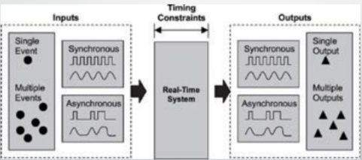
Create a new task and add it to the list of tasks that are ready to run.
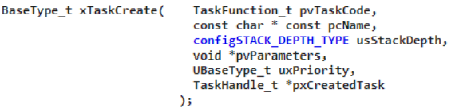
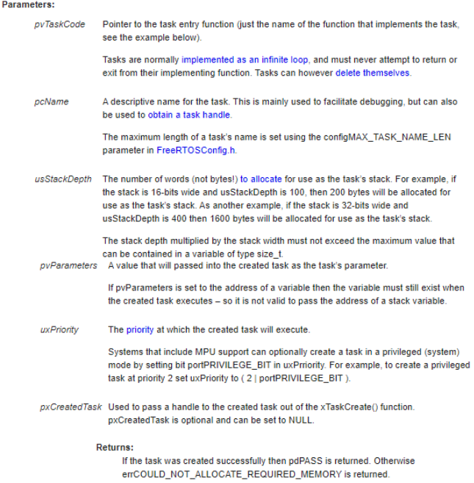
Delay a task for a given number of ticks.
The actual time that the task remains blocked depends on the tick rate. The constant portTICK_PERIOD_MS can be used to calculate real time from the tick rate – with the resolution of one tick period
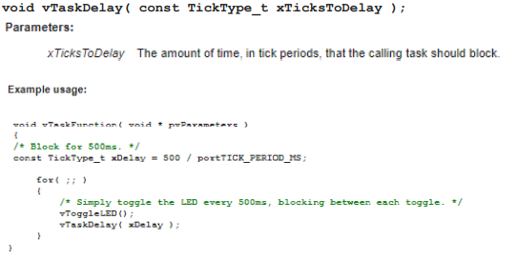
This experiment was performed successfully. In this lab session, it was learnt how to use freeRTOS for real time operating system with tm4c. A real-time system is a time-bound system which has well-defined, fixed time constraints. Processing must be done within the defined constraints or the system will fail. They either are event-driven or time-sharing. Event-driven systems switch between tasks based on their priorities, while time-sharing systems switch the task based on clock interrupts.
A real-time system is a time-bound system which has well-defined, fixed time constraints. Processing must be done within the defined constraints or the system will fail. They either are event-driven or time-sharing. Event-driven systems switch between tasks based on their priorities, while time-sharing systems switch the task based on clock interrupts.

Real-time systems are used in:
1. Airlines reservation system.
2. Air traffic control system.
3. Systems that provide immediate updating.
4. Used in any system that provides up to date and minute information on stock prices.
5. Defense application systems like RADAR.
6. Networked Multimedia Systems
7. Command Control Systems 8. Internet Telephony
9. Anti-lock Brake Systems
10. Heart Pacemaker
FreeRTOS supports all general kernel objects including task, semaphore, queues, messages etc. The demo project we are going to use in this lab follows a structure where each and every task or object has its own header file. Different attributes are defined in their own header file.

