Generate Javadoc

From Eclipse: Project -> Generate Javadoc…

Run the gentool and Javadoc in a localhost server

Eg: <http://localhost:81/doc/> and <http://localhost:81/gentool.html>

Copy the url of javadoc

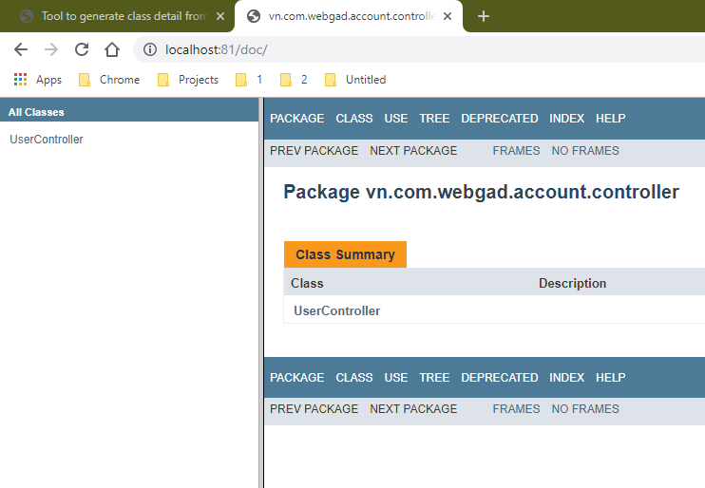

Paste to the gentool box and press OK

