Bi-Weekly Report of (Team #5 )
Week #5-6

What were the goals for the last 2 weeks?

Seoeun Park:
- Design overall system architecture (frontend & backend)
- Define core features (expense tracking, budget planning, group sharing, route planning)
- Design database schema

Jeongwoo Jang:
- API documentation
- Implementation: DB modeling, Schema, Backend architecture

Haein Park:
- Overall UI design (focused on basic screen, trip addition screen, route addition screen, budget screen)

Jungkyo In:
- Implement 3D globe using CesiumJS
- Develop Main Page UI (globe + trip list)
- Set up React Router for navigation
- Enable navigation from globe/list to Trip Detail Page
- Integrate Google Maps API for 2D map visualization

What goals were accomplished this week?

Seoeun Park:
- Finalized overall system structure
- Defined core features
- Completed initial database design

Jeongwoo Jang:
- API documentation is completed
- Implementation: DB modeling, Schema, Backend architecture

Haein Park
- Overall design format is completed.
- Above 3 screens except for budget screen is completed.

Jungkyo In:
- Successfully implemented Cesium-based globe with location pins
- Fixed coordinate issues for correct pin placement
- Completed Main Page UI and Trip List
- Implemented routing and navigation between pages
- Integrated Google Maps API and displayed markers
- Resolved API key and permission issues

Reflect critically on any goals not accomplished.

Seoeun Park: All planned goals were completed as scheduled

Jeongwoo Jang:
- Implementation: Basic CRUD and Login/Trip API

Haein Park
- Overall design for budget screen is completed, but detailed design for budget warning screen is not completed.
- Due to discussion of budgeting method and scope, it was not accomplished. As discussion is completed, I will work on it soon.

Jungkyo In:
- Route visualization were not completed
- Time was mainly spent on API setup and debugging
- Plan: Focus on implementing route visualization and interactive map features next

What are the goals for next two weeks?

Seoeun Park:
- Implement backend using FastAPI
- Start developing OCR model
- Define business logic

Jeongwoo Jang:
- Implementation: Basic CRUD and Login/Trip API
- Design Service Login for Backend (about expenses and budgets)
- Deploying: Using Render, deploy basic CRUD and Login/Trip API

Haein Park
- Completing full UI design
- Implementing Frontend on overall frame design

Jungkyo In:
- Implement overall page structure and button-based navigation
- Improve navigation flow between different features in the Trip Detail Page
- Implement route visualization (polyline) on the map
- Enhance UI/UX and refine the overall user experience

How many hours were spent on each goal noted above?

Seoeun:
- System architecture design: 3 hours
- Database design: 2 hours
- Logic design / Research: 1 hours

Jeongwoo Jang:
- API documentation (2 days)
- Implementation: DB modeling, Schema, Backend architecture (3 hours)

Haein Park
- About 2.5 hours for each screen (basic/ trip addition/ route addition/ budget screen)

Jungkyo In:
- Cesium integration: ~1 hour
- Routing & navigation logic: ~2 hours
- UI implementation: ~3 hours
- UI/UX design discussion and planning: ~3 hours
- Google Maps API integration: ~1 hour
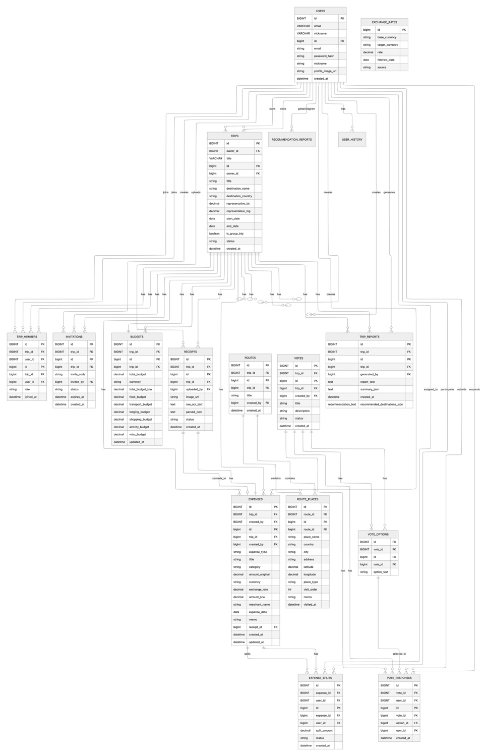
Figure 1. DB schema

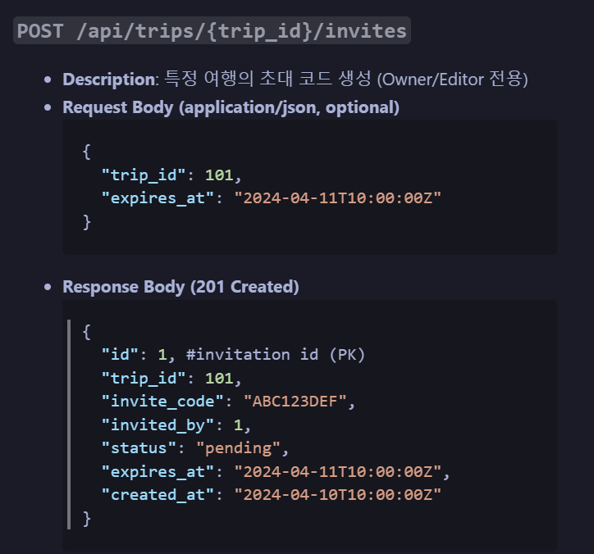
Figure 2. API Example 1

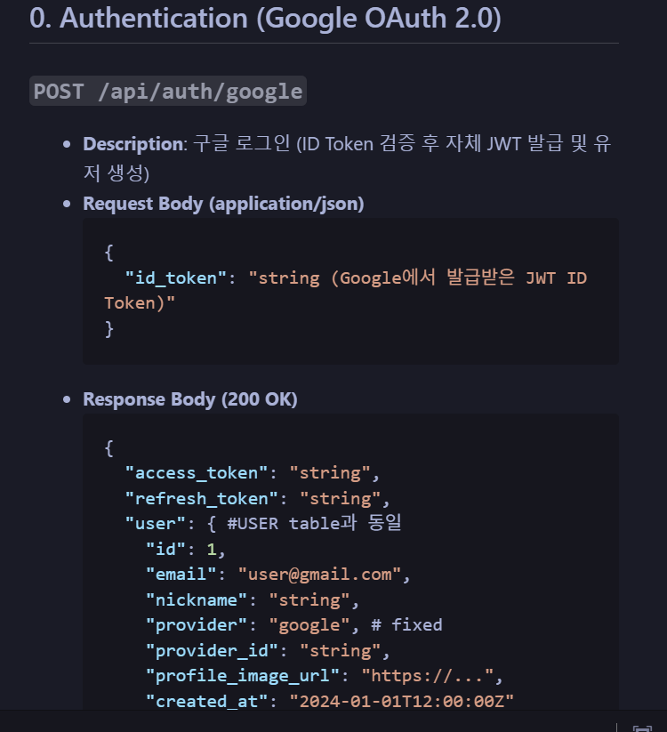
Figure 3. API Example 2

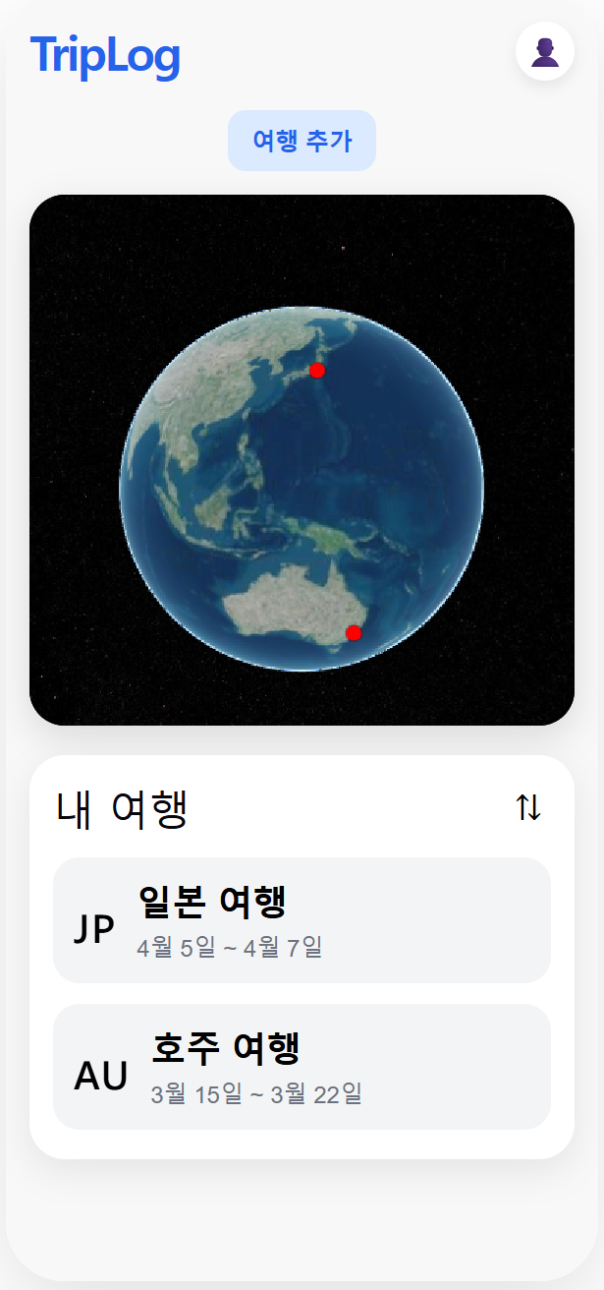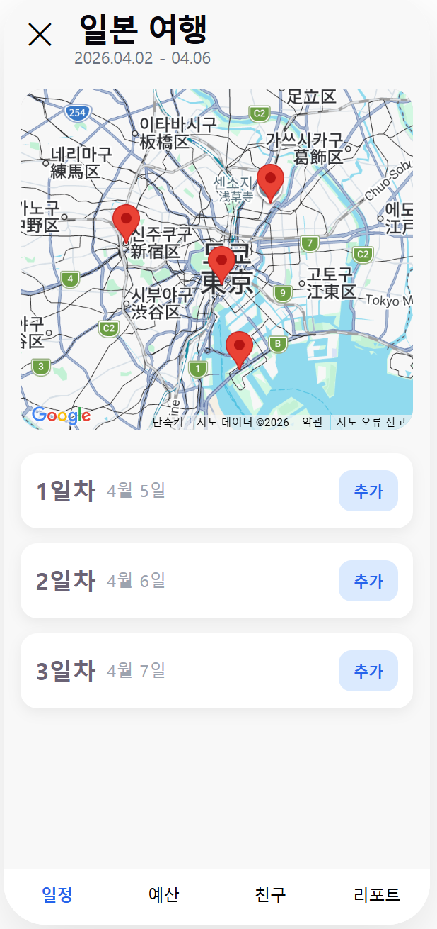
Figure 4. Frontend

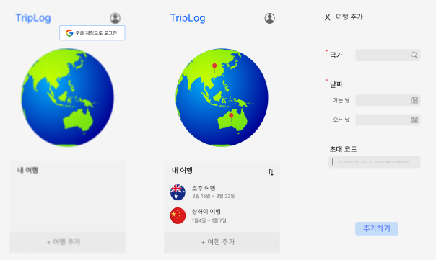
Figure 5. UI Design-1

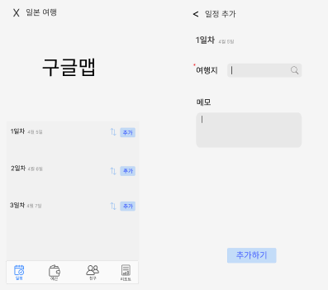
Figure 6. UI Design-2

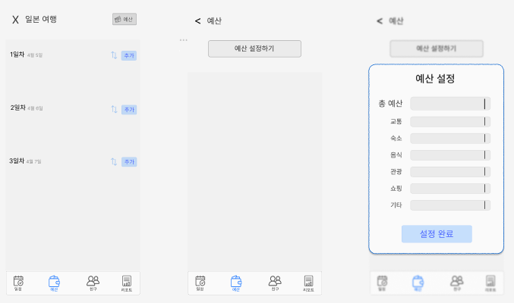
Figure 7. UI Design-3

