Student Name: Duc Tu Luong  
Last 3-digit ID: 122

# Homework #5

1. **Ford-Fulkerson Algorithm***Credit:* <http://www.geeksforgeeks.org/ford-fulkerson-algorithm-for-maximum-flow-problem/>  
     
   a) Pseudo code:  
   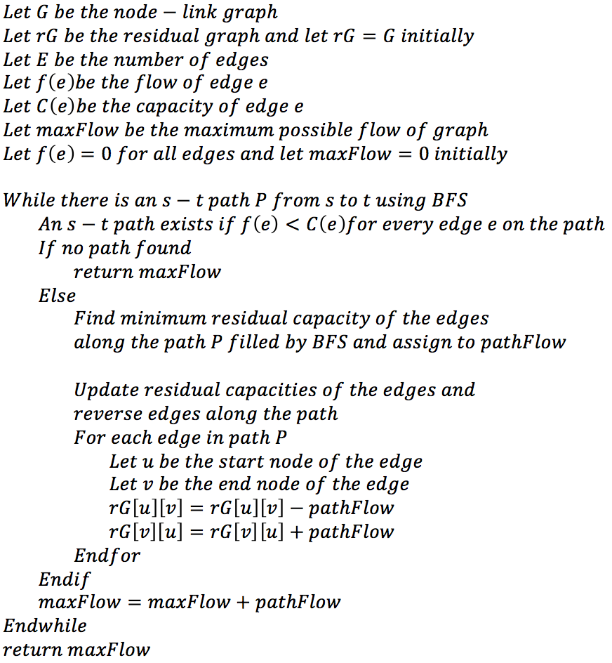

b) Let Fm be the max flow, E is the total number of nodes in graph. When we iterate while there is still augmenting path, the worst case is that we only add 1 unit in every iteration, as a result, the time complexity is bounded by O(Fm*E).

c) The maximum possible flow is 36, the flow graph is as following:  
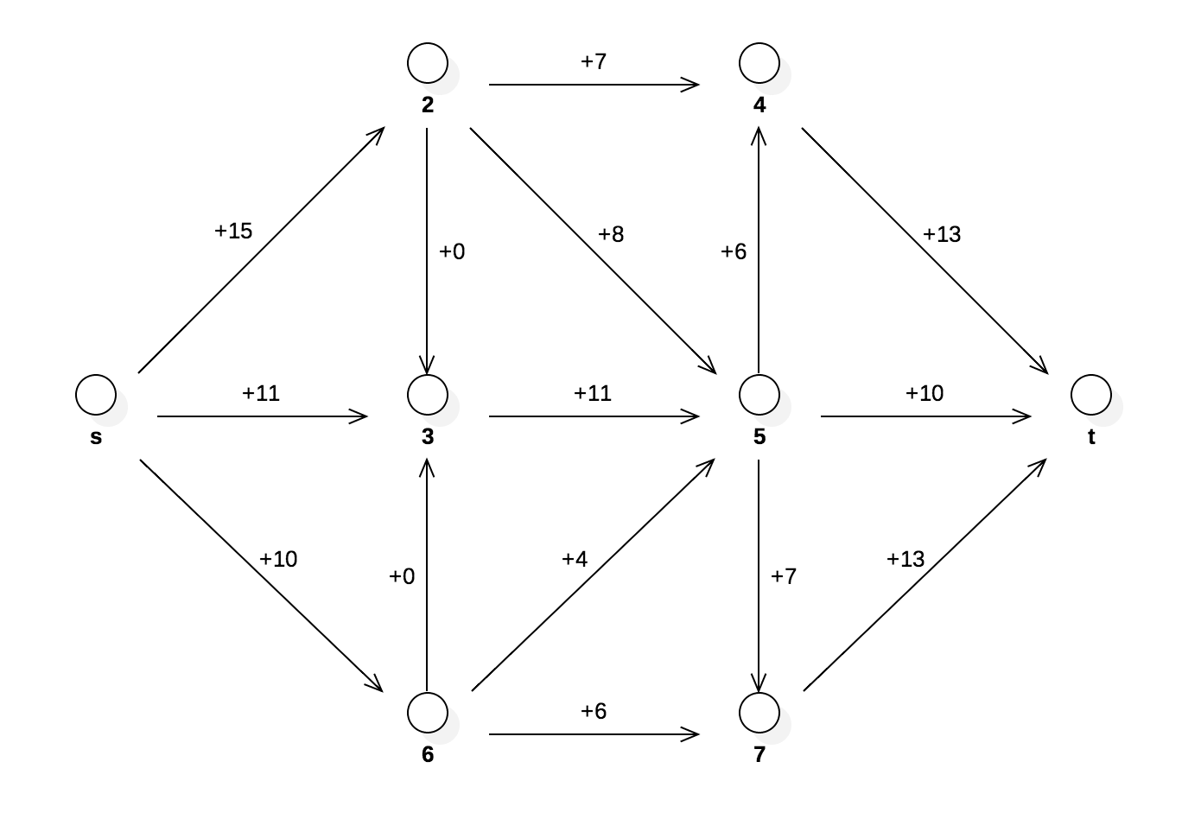

1. We model the problem using network flow diagram. The network flow of profit is as following:  
   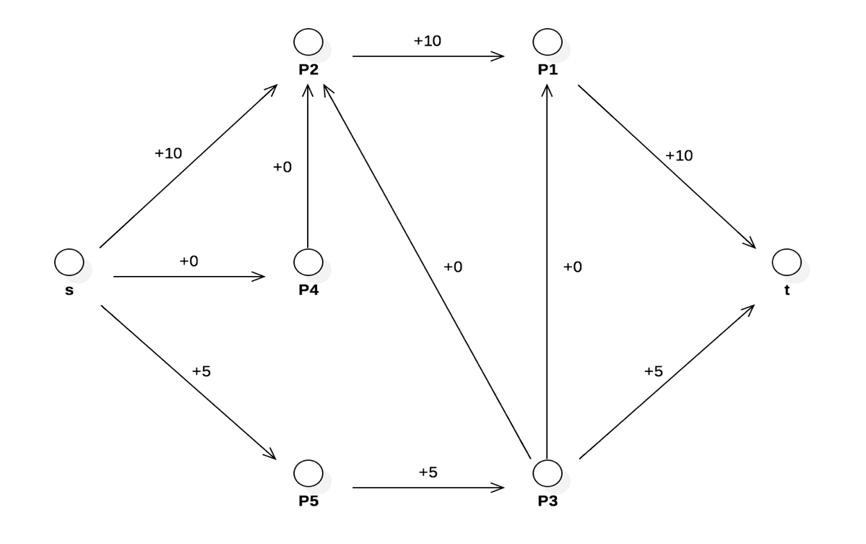  
     
   The maximum profit we can make is 15, we will take P1, P2, P3, P5 to generate this profit.
2. a)   
   *Problem*:  
   - n: number of doctors  
   - D: set of vacation days; |D|= d  
   - Si D: set of vacation-days doctor i can work  
   - k: vacation periods  
   - Dj D: days in period i  
   Give a polynomial algorithm which returns assignment of doctors to vacation days, or reports if no such assignment exists; and satisfies following constraints:  
   - For a given parameter c, each doctor should be assigned to work at most c vacation days total, and only days when he or she is available.  
   - For each vacation period j, each doctor should be assigned to work at most one of the days in the set Dj.

*Solution*:

We use network flow model to solve this problem. We have a node uirepresenting each doctor attached to a node vl representing each day when he or she can work; each edge has capacity of 1.   
We attach a super-source to each doctor node ui by an edge of capacity c, and we attach each day node vl to a super- sink tby an edge with upper and lower bounds of 1. Suppose there are d vacation days total; we put a demand of +d on the sink and -d on the source.

We include a new node wij with an incoming edge of capacity 1 from the doctor node ui, and with outgoing edges of capacity 1 to each day in vacation period j when doctor i is available to work. The network flow model is as following  
  
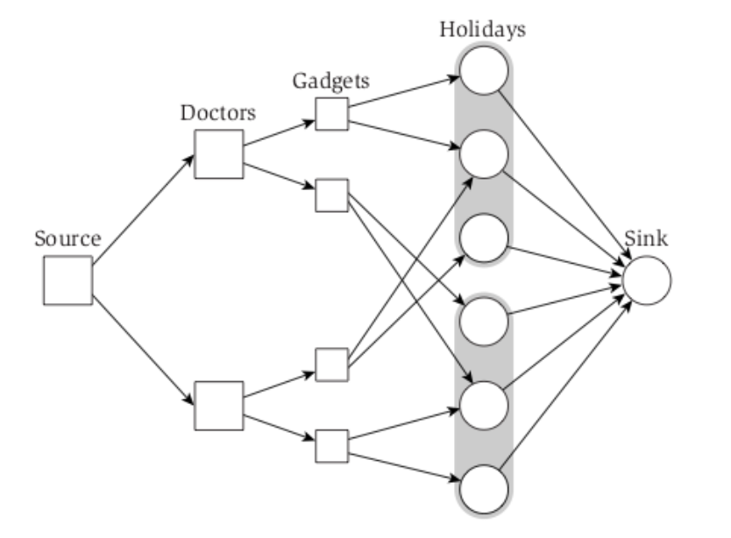

b) Problem instance with 4 doctors and 3 vacation periods. The network flow diagram is as following

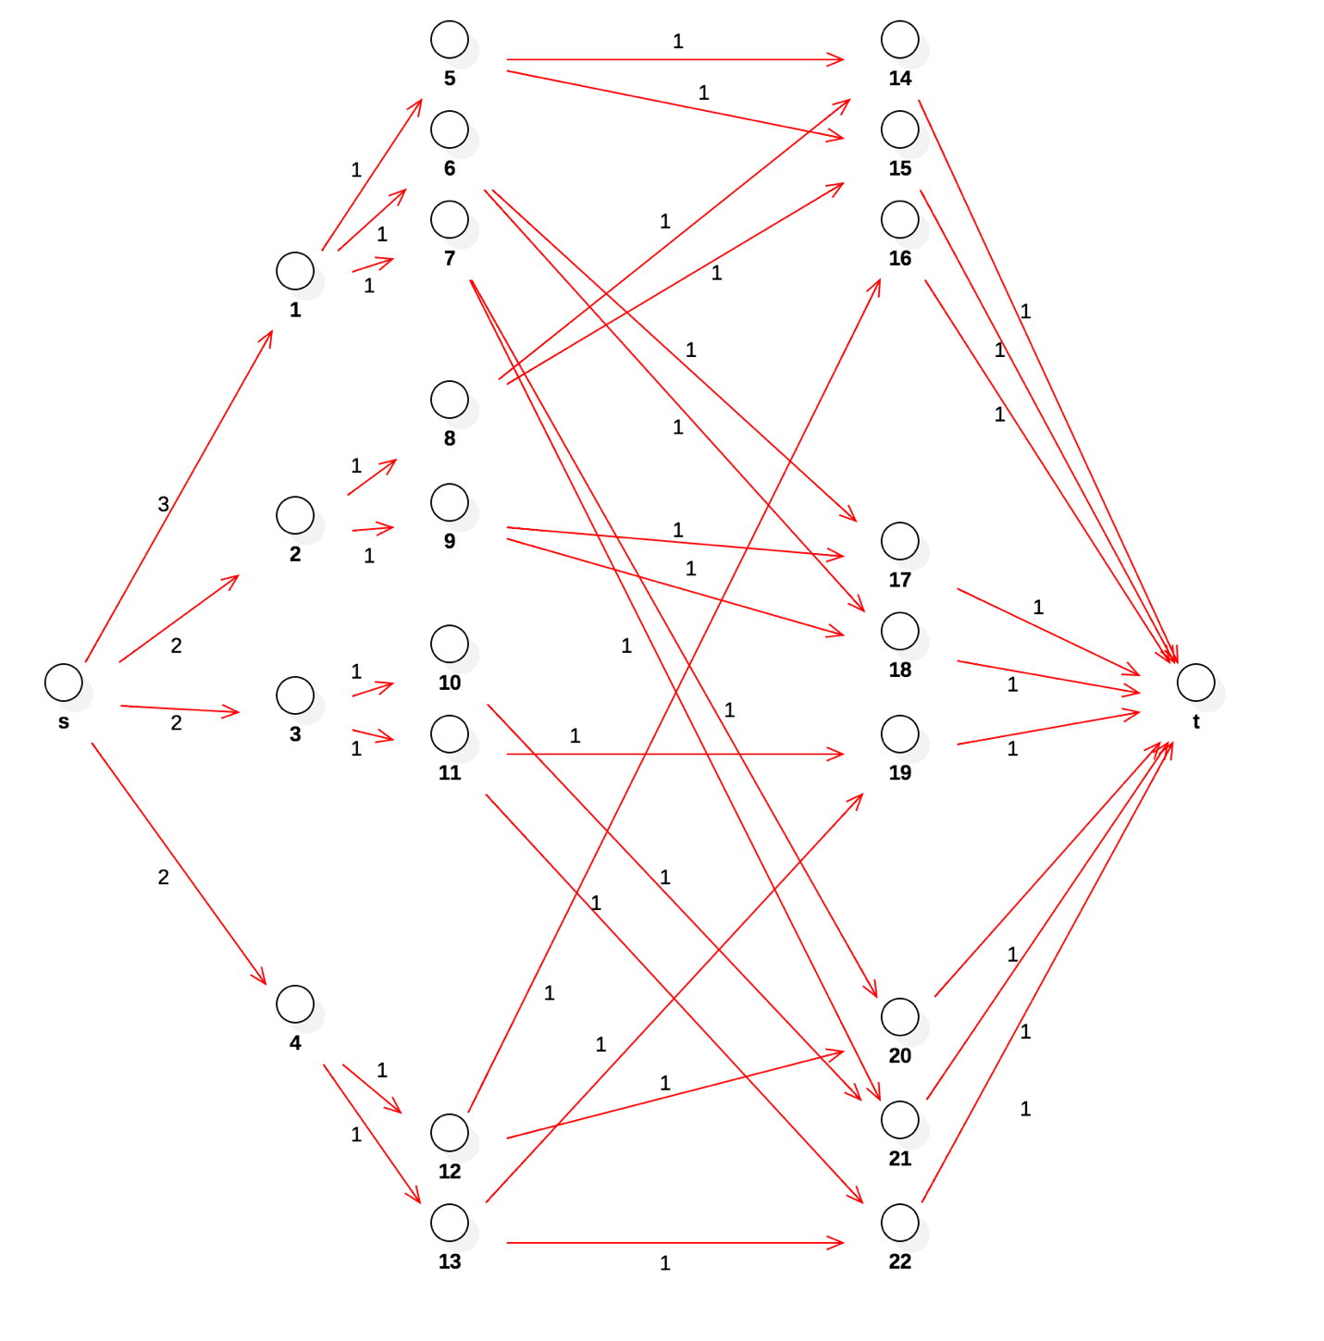  
  
- Vertices from 1 to 4 represent 4 doctors.  
- Vertices from 5 to 13 represent “gadgets” for 4 doctors, these gadgets guarantee each doctor only cover 1 day in each vacation period.

- Vertices from 14 to 22 represent vacation days, each 3-day block represents each vacation period.

c) We encode the network flow diagram into a matrix with values of each edge as following  
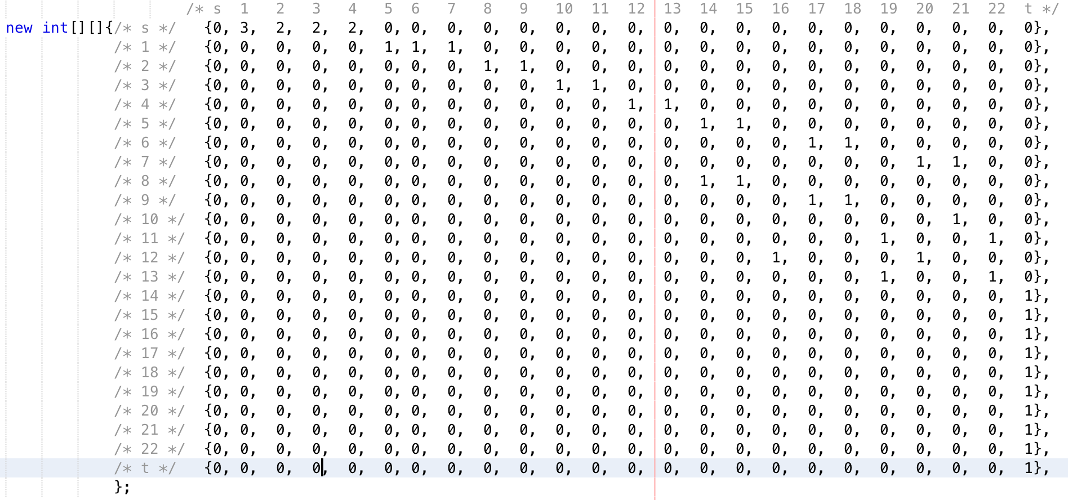

When applying to question 1 implementation, the result is as following:  
Maximum flow is 9, which is all vacation days are covered, the details are as following:  
- Day 1 of vacation period 1 is covered doctor 1

- Day 2 of vacation period 1 is covered doctor 2

- Day 3 of vacation period 1 is covered doctor 4

- Day 1 of vacation period 2 is covered doctor 1

- Day 2 of vacation period 2 is covered doctor 2

- Day 3 of vacation period 2 is covered doctor 3

- Day 1 of vacation period 3 is covered doctor 1

- Day 2 of vacation period 3 is covered doctor 3

- Day 3 of vacation period 3 is covered doctor 4

1. a)   
   *Problem:*  
   n users of the website

k groups from {G1…, Gk} of the demographic groups, which users belong to  
m advertisers  
Give an efficient algorithm to decide if there is a way to show a single ad to each user so that the site’s contracts with each of the madvertisers is satisfied for this minute? (That is, for each i = 1, 2, 3, …, m, can at least ri of the n users, each belonging to at least one demographic group in Xi {G1…, Gk}, be shown an ad provided by advertiser i?), and if so, to choose an ad to show each user.

*Solution:*  
We design a flow network G = (V, E) as following:  
- There is a source s  
- Vertices u1 to un for n users  
- Vertices g1 to gk for k demographic groups

- Vertices v1 to vm for m advertisers

- There is a sink t  
- There is an edge of capacity 1 from ui to each group gj for which user i belongs to a demographic group.

- There is an edge of capacity ∞ from each group gj to at least one advertiser vl.

- There is an edge with a capacity of 1 from s to each ui for each i.

- There is an edge with a capacity of the site contracts with each of m advertisers which is rj of the n users from vj to t for each j.

- The source s has supply of -n

- The sink t has demand of n  
  
If there is a valid circulation in this graph, meaning that advertiser vl shows ads to a subset of vertices of {g1,… gk}, in which a subset of {u1,… un} users belong to, which mean that advertiser shows ads to appropriate people. We will find out the maximum flow in this graph, if this maximum flow is equal to n, it means advertisers show their ads to all site’s users with appropriate content.  
  
b) Problem instance with k=4, n=15, m=5 is represented as following network flow diagram

* Each edge from s to vertices 1 to 15 has capacity of 1 (source to each user vertex)
* Each edge from vertices 1 to 15 to vertices 16 to 19 has capacity of 1 (user vertices to groups)
* Each edge from vertices 16 to 19 to vertices 20 to 24 has capacity of 15 (we choose 15 because n is 15 therefore the maximum flow to one edge is 15).
* Each edge from vertices 20 to 24 to sink t has capacity of site’s contract to that advertiser (advertisers to sink t).

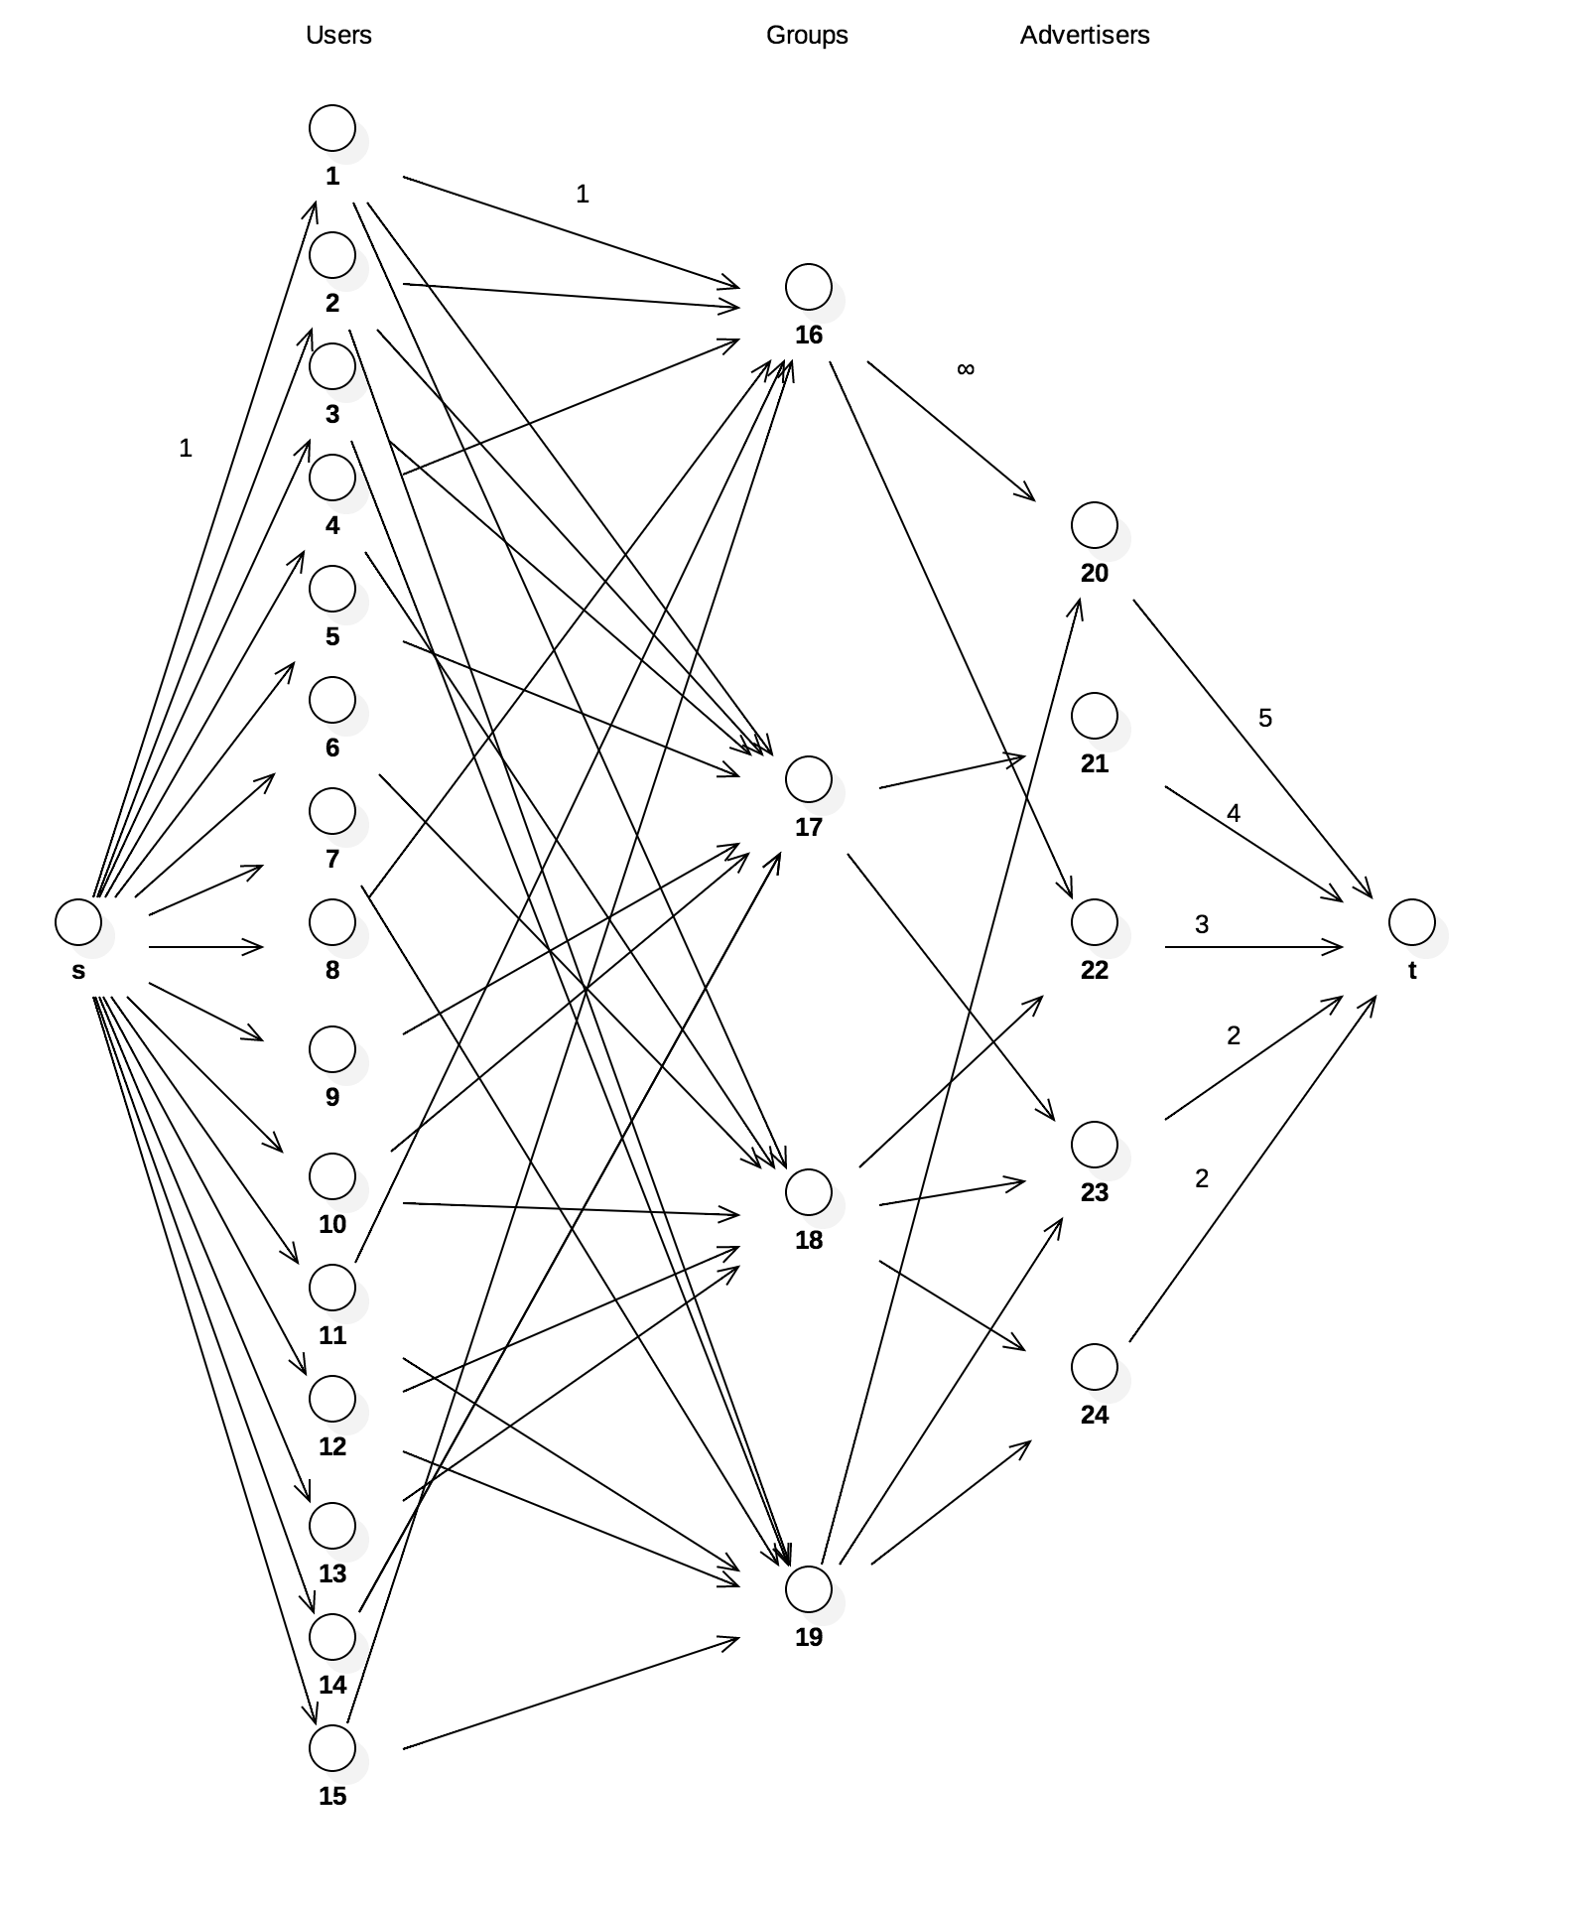

c) We encode the network flow diagram into a matrix with values of each edge as following

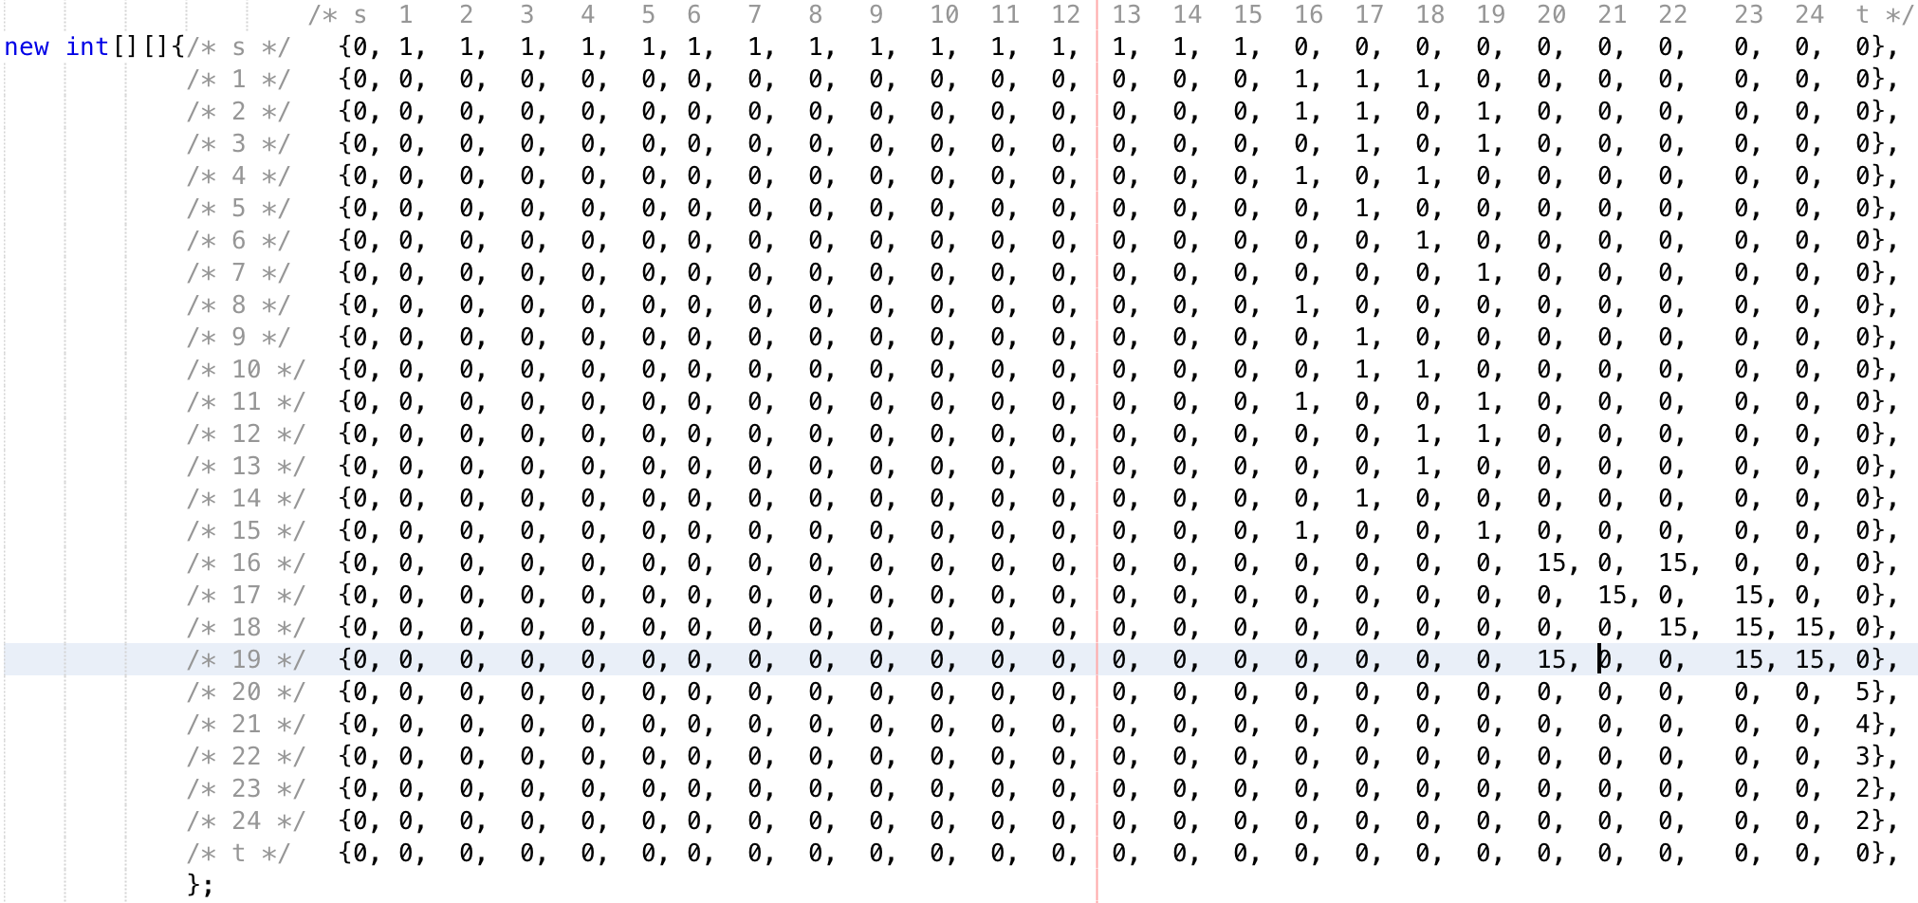

When applying to question 1 implementation, the result is as following:

The maximum flow is 15, which means all users are shown appropriate ads.

- Node 20 to sink t has flow of 5/5, which means the site’s contract between advertiser 20 has been met.

- Node 21 to sink t has flow of 4/4, which means the site’s contract between advertiser 21 has been met.

- Node 22 to sink t has flow of 3/3, which means the site’s contract between advertiser 22 has been met.

- Node 23 to sink t has flow of 2/2, which means the site’s contract between advertiser 23 has been met.

- Node 24 to sink t has flow of 1/2, which means the site’s contract between advertiser 24 has NOT been met.