Deploy to Server Instruction

# URL Configuration for Sub-Path Domain Deployment

Usually, if you deploy to base URL (e.g. <http://www.cis.umassd.edu/)>, you don’t need to configure these setting. However, if you plan to deploy to a sub-path (<http://www.cis.umassd.edu/~dluong1/csel/)>, you need to make changes to 4 files:

**1. index.html**

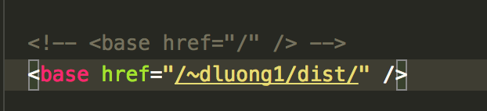

Inside <head> tag, you will find the <base> tag with attribute href, change this attribute’s value match your current sub-path (the part after main domain), for example, in this case the sub-path is /~dluong1/csel/. UI-Router module of AngularJS uses this tag to determine the base URL of your website, usually it will take the main domain, but if you deploy to sub-path, you need to make change to this tag.

**2. .htaccess**

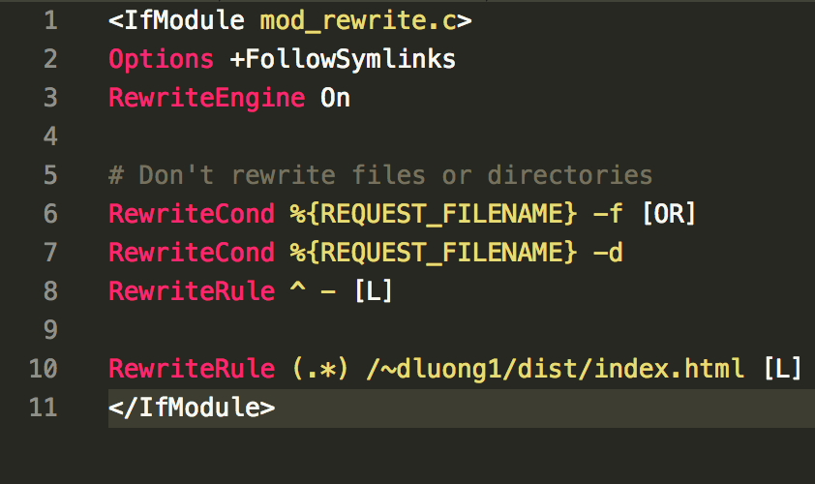

In the root folder, you will find the .htaccess file, change the RewriteRule value to match your current sub-path (the last line). Note that the .htaccess is only working when mode_rewrite of Apache server is turned on, read more at [this article](https://stackoverflow.com/questions/869092/how-to-enable-mod-rewrite-for-apache-2-2).

**3. app.js**

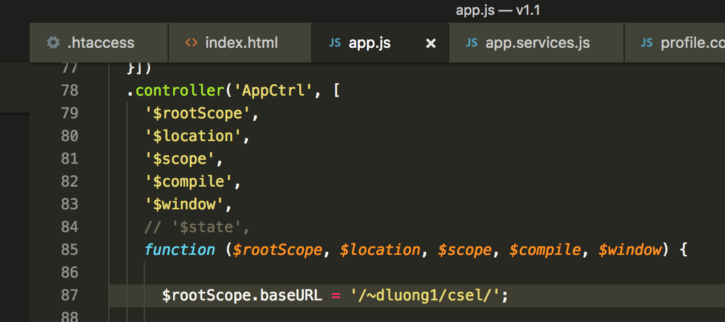

Please change value of $rootScope.baseURL variable in app.js file under scripts/app directory. This variable is used for the whole application.

# Deployment

After finishing configure URL for sub-path deployment (if any), you can now upload all the content to the root folder of your server. If the server does not support PHP, then you need to disable PHP features:

**1. Disable HTML markups in index.html**

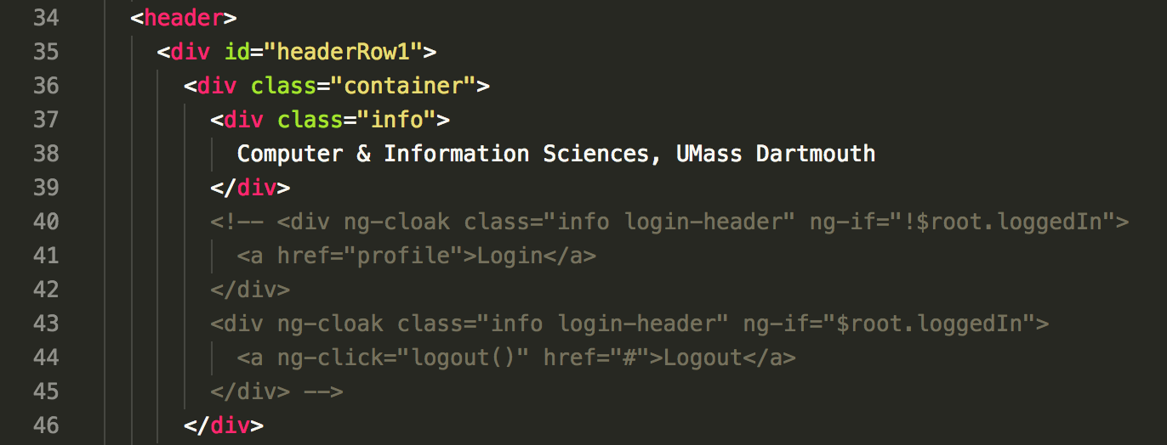

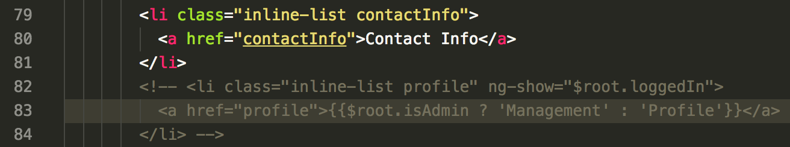

Please comment code from line 40 to line 45, and from line 82 to line 84.

**2. Disable Profile functionalities in app.js**

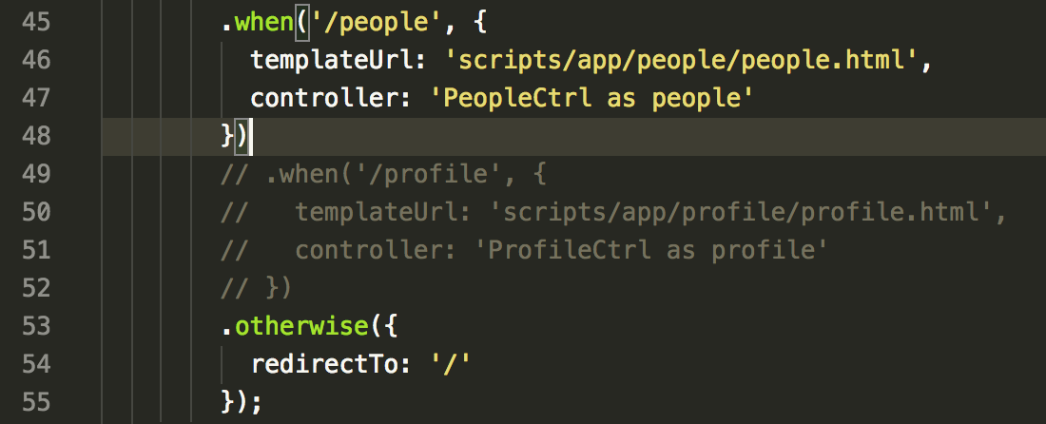

Please comment code from line 49 to line 52.