Sikizwa Voice 360°
Figures
Figure 1: Sikizwa Voice 360° Smart Pendant
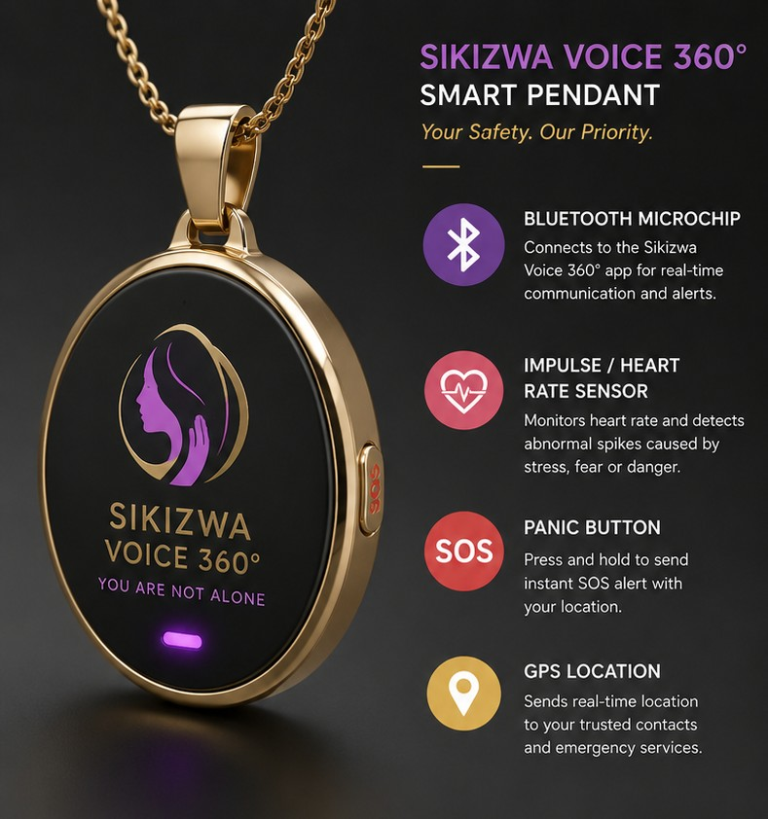
Figure 1 Sikizwa Voice 360° Smart Pendant Prototype
Figure 1 illustrates the external design and key functionalities of the Sikizwa Voice 360° Smart Pendant. The wearable safety device is designed to provide discreet personal protection and emotional support. The pendant integrates a Bluetooth communication module that connects to the Sikizwa Voice 360° mobile application for real-time alerts and communication. It incorporates a heart rate sensor to monitor physiological changes associated with stress, fear, or danger. An emergency SOS button enables users to instantly send distress alerts, while the built-in GPS functionality shares the user's location with trusted contacts and emergency responders. The compact and wearable design ensures continuous protection while maintaining user comfort and privacy.

Figure 2: Sikizwa Voice 360° Pendant Internal Circuit Architecture
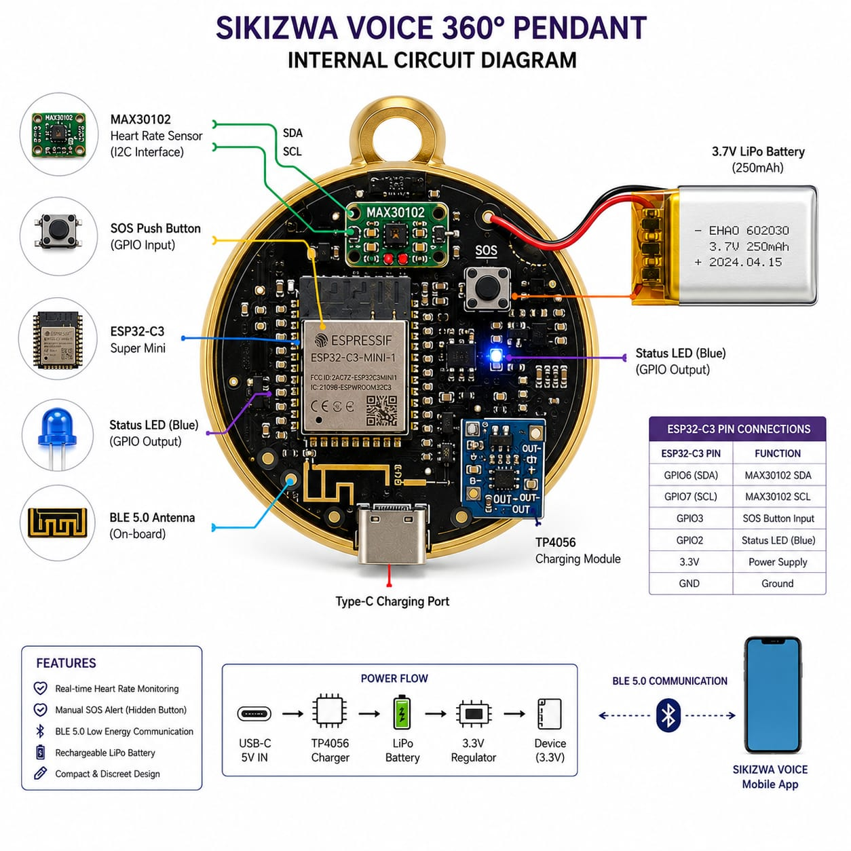
Figure 2 Internal Circuit Diagram of the Sikizwa Voice 360° Smart Pendant
Figure 2 presents the internal electronic architecture of the Sikizwa Voice 360° Smart Pendant. The system is built around an ESP32-C3 microcontroller, which serves as the central processing and communication unit. A MAX30102 sensor is connected through the I²C interface to monitor heart rate data in real time. User emergency requests are captured through an SOS push button connected to a GPIO input. Bluetooth Low Energy (BLE) communication is facilitated by the onboard ESP32-C3 antenna, enabling wireless data exchange with the mobile application.

The power subsystem consists of a rechargeable 3.7V lithium-polymer battery, a TP4056 charging module, and a voltage regulation circuit that supplies stable power to all components. Status LEDs provide visual feedback regarding device operation and connectivity. The diagram also illustrates the power flow from USB-C charging input to battery charging, voltage regulation, and system operation. Through BLE communication, collected sensor data and emergency alerts are transmitted to the Sikizwa Voice 360° mobile application for further processing and response.

Figure 3: Sikizwa Voice 360° Mobile Application Interface
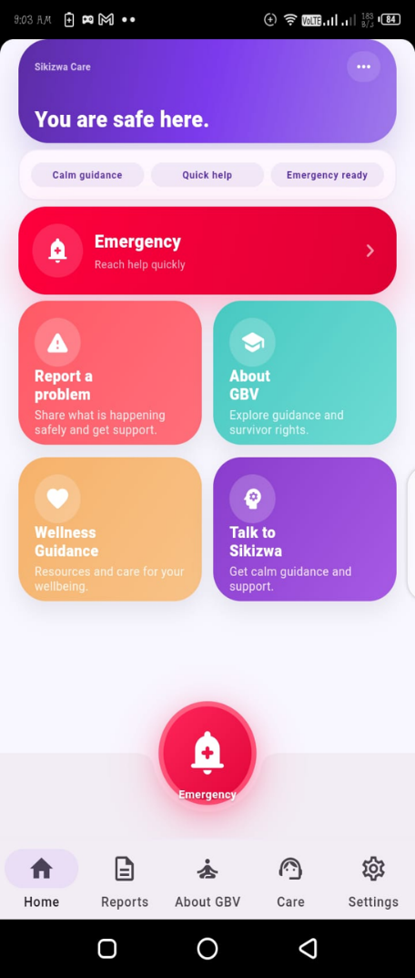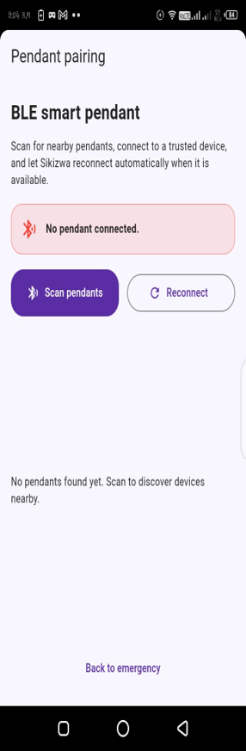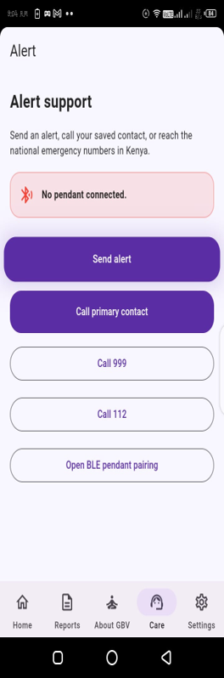

Figure 3 Sikizwa Voice 360° Mobile Application User Interface
Figure 3 presents the Sikizwa Voice 360° mobile application, which serves as the primary interface between users and the safety ecosystem. The application is designed to provide real-time personal safety monitoring, emergency response capabilities, and mental wellness support through an intuitive and user-friendly interface.

The figure specifically illustrates the Alert Support screen, a critical component of the application that enables users to access emergency assistance and support services during distressing situations. The interface displays the connection status of the Sikizwa Voice 360° smart pendant, allowing users to verify device connectivity and operational readiness.
The screen provides several emergency response functions, including a prominent Send Alert button that instantly notifies trusted contacts and designated responders. Users can also directly contact a preconfigured emergency contact through the Call Primary Contact feature. Additionally, dedicated emergency service buttons provide quick access to national emergency numbers, ensuring rapid communication during critical incidents.
To support wearable integration, the interface includes an Open BLE Pendant Pairing option that enables Bluetooth Low Energy (BLE) connectivity between the smart pendant and the mobile application. This functionality facilitates real-time transmission of sensor readings, emergency alerts, and device status information.
Beyond emergency response, the application allows users to securely manage their accounts, monitor vital information such as heart rate and device status, share live location data with trusted contacts, and access immediate assistance when required. The platform further incorporates AI-powered support capabilities that analyze voice interactions, detect indicators of emotional distress, and provide personalized guidance and wellbeing support.
The application maintains records of alerts, wellness assessments, and communication activities, enabling users and authorized support personnel to review historical incidents and monitor wellbeing trends over time. As the central hub of the Sikizwa Voice 360° ecosystem, the mobile application integrates wearable device data, location services, emergency communication, and AI-driven support into a unified smartphone-based platform.

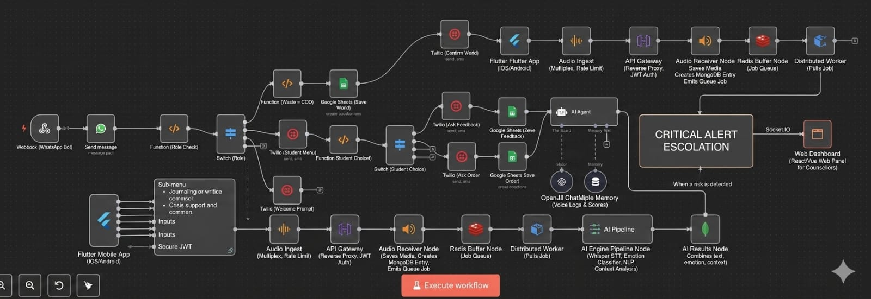
Figure 4: Sikizwa Voice 360° System Architecture and AI Crisis Escalation Framework
Figure 4 illustrates the overall system architecture of the Sikizwa Voice 360° platform, highlighting the integration of multiple communication channels, artificial intelligence processing components, and real-time crisis escalation mechanisms. The architecture is designed to support secure user interaction, emotional wellbeing monitoring, and rapid emergency response through a scalable and distributed infrastructure.
The diagram presents two primary communication pathways into the system. The first pathway utilizes WhatsApp and Twilio integration, enabling users to interact with the platform through automated messaging services. Incoming messages are processed through webhook endpoints, role validation modules, and workflow routing components that direct users to appropriate services based on their profile and interaction requirements. Supporting modules facilitate automated messaging, data collection, and information storage through external services such as Google Sheets.
The second pathway represents the native Flutter-based mobile application available on Android and iOS platforms. This serves as the primary user interface, allowing users to securely authenticate, access wellbeing services, maintain digital journals, communicate with support systems, and trigger emergency assistance when necessary. The application employs secure authentication mechanisms and encrypted communication channels to protect user privacy and data integrity.
To support voice-based interactions, the architecture incorporates an asynchronous audio processing pipeline. Audio recordings submitted through the mobile application pass through an API Gateway responsible for authentication, traffic management, and request validation. Audio files are then received, logged, and stored before being placed into a Redis-based job queue for background processing. Distributed worker services retrieve queued tasks and perform computationally intensive processing independently, ensuring high system performance and preventing user-facing delays.
At the core of the platform is the AI processing engine, which analyzes voice recordings and textual interactions to identify emotional and contextual indicators associated with user wellbeing. The engine integrates speech-to-text transcription, natural language processing, emotion classification, and contextual analysis to generate comprehensive assessments of user emotional states. Processed results are combined with historical interaction records and stored user data to improve accuracy and provide personalized support recommendations.
A critical feature of the architecture is the real-time crisis escalation framework. When the AI engine detects indicators of severe emotional distress, elevated risk levels, or potential crisis situations, an automated escalation process is initiated. Alerts are transmitted through a secure Socket.IO communication layer, enabling immediate delivery of notifications to the counsellor monitoring dashboard. This real-time mechanism allows trained support personnel and administrators to receive urgent alerts instantly, review relevant contextual information, and initiate timely human intervention to enhance user safety and wellbeing.
Overall, the architecture demonstrates how Sikizwa Voice 360° integrates mobile technologies, cloud-based infrastructure, artificial intelligence, and emergency response systems into a unified platform designed to deliver proactive mental wellness support, personal safety monitoring, and rapid crisis intervention.

