Contents

[1. URS](#_Toc380007225) 1

[1.1 List URS 15](#_Toc380007226)

[1.2 user Requirement Specification 16](#_Toc380007227)

[**URS-01**: Customer can registration themselves as customer. 16](#_Toc380007228)

[**URS-02**: Customer can login to the system. 18](#_Toc380007280)

[**URS-03**:Customer can view all the product category. 19](#_Toc380007302)

[**URS-04:** Customer can search the product. 20](#_Toc380007309)

[**URS-05**: Customer can add the product as many products as customer want to the shopping cart. 21](#_Toc380007326)

[**URS-06:** Customer can edit the product in the shopping cart. 22](#_Toc380007342)

[**URS-07:** Customer can save the product in the shopping cart. 23](#_Toc380007364)

[**URS-09:** Customer can view the shopping history. 25](#_Toc380007378)

[**URS-10:** Customer can logout. 26](#_Toc380007385)

[**URS-11**: Administrator can login to the system. 27](#_Toc380007392)

[**URS-12:** Administrator can view the shopping history of all customer. 28](#_Toc380007414)

[**URS-13:** Administrator can provide detail of the product. 29](#_Toc380007420)

[**URS-14:** Administrator can update all information of registration. 30](#_Toc380007451)

[**URS-15:** Administrator can logout……………………………………………………………………………………………………31](#_Toc380007503)

[2. SRS 34](#_Toc380008193)

[2.1 List SRS 34](#_Toc380008194)

[3. Use case Diagram 36](#_Toc380008195)

[List use cases 36](#_Toc380008196)

[3.1 Use case 37](#_Toc380008197)

[4. Class Diagram 37](#_Toc380008198)

[4.1 List Class Diagram 37](#_Toc380008199)

[4.2 Class Diagram 38](#_Toc380008200)

[4.2.1 Entity 38](#_Toc380008201)

[4.2.2 MVC of User Controller 39](#_Toc380008202)

[4.2.3 MVC of Product Controller 40](#_Toc380008203)

[4.2.4 MVC of Shopping Cart Controller 40](#_Toc380008204)

[4.2.5 MVC of History Controller 41](#_Toc380008205)

[5. Sequence Diagram 41](#_Toc380008206)

[5.1 List Sequence Diagram 41](#_Toc380008207)

[5.2 Sequence Diagram 42](#_Toc380008208)

[5.2.1 SQD-01: Add Product Shopping Cart 42](#_Toc380008209)

[5.2.2 SQD-02: Check Out 42](#_Toc380008210)

[5.2.3 SQD-03: Edit Product Shopping Cart 43](#_Toc380008211)

[5.2.4 SQD-04: Registration 45](#_Toc380008212)

[5.2.5 SQD-05: Save Product Shopping Cart 46](#_Toc380008213)

[5.2.6 SQD-06: View Product 46](#_Toc380008214)

[5.2.7 SQD-07: Search Product 47](#_Toc380008215)

[5.2.8 SQD-08: Add Product 48](#_Toc380008216)

[5.2.9 SQD-09: Update Registration 49](#_Toc380008217)

[5.2.10 SQD-10: Login 50](#_Toc380008218)

[5.2.11 SQD-11: Logout 50](#_Toc380008219)

[5.2.12 SQD-12: View History 51](#_Toc380008220)

[6. Method Design 51](#_Toc380008221)

[6.1 List method 51](#_Toc380008222)

[6.2 Proper method design 52](#_Toc380008223)

[6.2.1 Entity 52](#_Toc380008224)

[6.2.1.1 MTD-01: User 52](#_Toc380008225)

[6.2.1.2 MTD-02: Administrator 53](#_Toc380008226)

[6.2.1.3 MTD-03: Customer 54](#_Toc380008227)

[6.2.1.4 MTD-04: Product 55](#_Toc380008228)

[6.2.1.5 MTD-05: Shopping Cart 56](#_Toc380008229)

[6.2.1.6 MTD-06: History 57](#_Toc380008230)

[6.2.2 MVC Pattern of User Class 58](#_Toc380008231)

[6.2.2.1 MTD-07: UserDAO 58](#_Toc380008232)

[6.2.2.2 MTD-08: UserDAOImpl 59](#_Toc380008233)

[6.2.2.3 MTD-09: UserService 60](#_Toc380008234)

[6.2.2.4 MTD-10: UserServiceImpl 61](#_Toc380008235)

[6.2.2.5 MTD-11: UserController 62](#_Toc380008236)

[6.2.3 MVC Pattern of Product Class 63](#_Toc380008237)

[6.2.3.1 MTD-12: ProductDAO 63](#_Toc380008238)

[6.2.3.2 MTD-13: ProductDAOImpl 63](#_Toc380008239)

[6.2.3.3 MTD-14: ProductService 64](#_Toc380008240)

[6.2.3.4 MTD-15: ProductServiceImpl 64](#_Toc380008241)

[6.2.3.5 MTD-16: ProductController 65](#_Toc380008242)

[6.2.4 MVC Pattern of ShoppingCart Class 66](#_Toc380008243)

[6.2.4.1 MTD-17: ShoppingCartDAO 66](#_Toc380008244)

[6.2.4.2 MTD-18: ShoppingCartDAOImpl 66](#_Toc380008245)

[6.2.4.3 MTD-19: ShoppingCartService 67](#_Toc380008246)

[6.2.4.4 MTD-20: ShoppingCartServiceImpl 68](#_Toc380008247)

[6.2.4.5 MTD-21: ShoppingCartController 69](#_Toc380008248)

[6.2.5 MVC Pattern of History Class 70](#_Toc380008249)

[6.2.5.1 MTD-22: HistoryDAO 70](#_Toc380008250)

[6.2.5.2 MTD-23: HistoryDAOImpl 71](#_Toc380008251)

[6.2.5.3 MTD-24: HistoryService 72](#_Toc380008252)

[6.2.5.4 MTD-25: HistoryServiceImpl 73](#_Toc380008253)

[6.2.5. MTD-26: HistoryController 74](#_Toc380008254)

[Traceability 75](#_Toc380008255)

[Traceability matric between URS/SRS 75](#_Toc380008256)

[Traceability matric between URS/Class Diagram 75](#_Toc380008257)

[Traceability matric between URS/Use cases Diagram 75](#_Toc380008258)

[Traceability matric between URS/Sequence Diagram 75](#_Toc380008259)

[Traceability matric between URS/Method designs 75](#_Toc380008260)

[Traceability matric between SRS/Use cases Diagram 75](#_Toc380008261)

[Traceability matric between SRS/Class Diagram 75](#_Toc380008262)

[Traceability matric between SRS/Sequence Diagram 75](#_Toc380008263)

[Traceability matric between SRS/Method designs 75](#_Toc380008264)

[Traceability matric between Use cases Diagram / Class Diagram 75](#_Toc380008265)

[Traceability matric between Use cases Diagram /Sequence Diagram 75](#_Toc380008266)

[Traceability matric between Use cases Diagram /Method designs 75](#_Toc380008267)

[Traceability matric between Class Diagram/Sequence Diagram 75](#_Toc380008268)

[Traceability matric between Class Diagram/Method designs 75](#_Toc380008269)

[Traceability matric between Sequence Diagram/Method designs 75](#_Toc380008270)

# 1. URS

## 1.1 List URS

|  |  |
| --- | --- |
| **ID** | **Description** |
| **URS-01** | Customer can registration themselves as customer. |
| **URS-02** | Customer can login to the system. |
| **URS-03** | Customer can view all the product category. |
| **URS-04** | Customer can search the product. |
| **URS-05** | Customer can add the product as many products as customer want to the shopping cart. |
| **URS-06** | Customer can edit the product in the shopping cart. |
| **URS-07** | Customer can save the product in the shopping cart. |
| **URS-08** | Customer can check out for purchase the product. |
| **URS-09** | Customer can view the shopping history. |
| **URS-10** | Customer can logout. |
| **URS-11** | Administrator can login to the system. |
| **URS-12** | Administrator can view the shopping history of all customer. |
| **URS-13** | Administrator can provide detail of the product. |
| **URS-14** | Administrator can update all information of registration. |
| **URS-15** | Administrator can logout. |

## 1.2 User Requirement Specification

# **URS: CUSTOMER URS-01**: Customer can registration themselves as customer.

**Introduction:**  Customer register a customer’s information into the system.

**Input:** Customer request a registration Page.

|  |  |  |  |  |
| --- | --- | --- | --- | --- |
| **Name** | **Type** | **Description** | **Example** | **Remarks** |
| username | String | A username of customer | “camt1234” | 1-50 characters |
| password | String | A password of customer. | “camt1234” | 1-50 characters |
| name | String | A Full-Name of customer | “Putsacha” | 1-40 characters |
| birthDate | DATE | A birth date of customer. | “1993-02-25” | Format : yyyy/mm/dd |
| email | String | An email of customer. | “se542115000@vr.camt.info” | - |
| telephoneNumber | String | A telephone number of customer. | “0888888888” | 0-9 digits |
| address | String | An address of customer. | “CAMT” | 1-255 characters |
| picture | BLOB | A picture of customer. | C:\Users\wuthipong\Desktop\User\542115037.jpg | - |

**Flow of Execution:**

**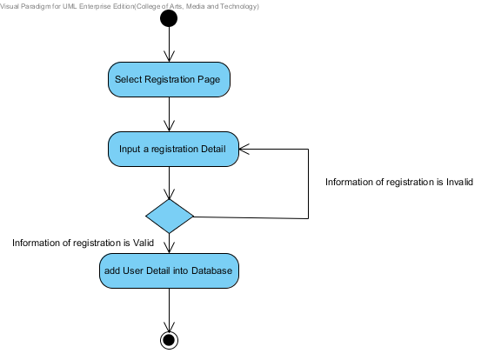**

**Output:**  The System add the registration of customer into database.

**System Requirement Specification**  
 **SRS-01:** The system provide an interface for registration which receive username, password,   
 name address and their picture for the registration.   
 **SRS-02:** The system can check the name format. The name format should be only a   
 character.  
 **SRS-03:** The system can check the address. The address format should be a characters   
 between 1-255 characters.  
 **SRS-04:** The system can check the picture that user uploading. The picture should be an   
 image format such as, .png, .jpg.  
 **SRS-05:** The system can check the username format. The username format should be   
 characters.  
 **SRS-06:** The system can check the password format. The password format should be   
 characters.  
 **SRS-07**: The system shall connect to the database.  
 **SRS-08**: The system retrieve information from the database.  
 **SRS-09:** The system shall add a new customer information to database using username,   
 password, name, address and their picture.  
 **SRS-10:** The system shall provide the successful registration page after registration is   
 complete.  
 **SRS-11:** The system shall display the error message “The username must be characters”.  
 **SRS-12:** The system shall display the error message “The password must be characters”.  
  **SRS-13:** The system shall display the error message “The name must be only characters”.  
 **SRS-14:** The system shall display the error message “The address must be a characters   
 between 1-255 characters”.  
 **SRS-15:** The system shall display the error message “The picture must be image format”.

# **URS-02**: Customer can login to the system.

**Introduction:**  Customer login into the system.

**Input:** Customer request a Login Page.

|  |  |  |  |  |
| --- | --- | --- | --- | --- |
| **Name** | **Type** | **Description** | **Example** | **Remarks** |
| username | String | A username of customer. | “camt1234” | 1-50 characters |
| password | String | A password of customer. | “camt1234” | 1-50 characters |

**Flow of Execution:**

**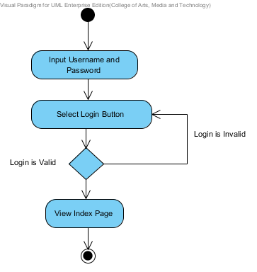**

**Output:**  Customer login to the system.

**System Requirement Specification**  
 **SRS-16:** The system provides the login interface which receive the user name and password.  
 **SRS-17:** The system can check the username format. The username format should be   
 characters.  
 **SRS-18:** The system can check the password format. The password must contain the   
 characters.  
 **SRS-19:** The system validates the username and password.  
 **SRS-20:** The system shall provide the successful login page.  
 **SRS-07**: The system shall connect to the database.  
 **SRS-08**: The system retrieve information from the database.  
 **SRS-21:** The system shall show the user status with a customer picture on the top-right of   
 the user interface to confirm his identity.

# **URS-03**:Customer can view all the product category.

**Introduction:**  Customer view all the product category in Product Page.

**Input:** Customer request a Product Page.

**Flow of Execution:**

**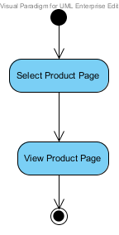**

**Output:**  The system show all the product detail in Product Page.

**System Requirement Specification**  
 **SRS-22:** The system provide an interface that show all the product category including, name,   
 description, price and image.   
 **SRS-07**: The system shall connect to the database.  
 **SRS-08**: The system retrieve information from the database.  
 **SRS-23:** The system show the product detail that consist of name, description, price and   
 image.

# **URS-04:** Customer can search the product.

**Introduction:**  Customer can search a product detail by using product’s name.

**Input:** Customer request a Product Page.

|  |  |  |  |  |
| --- | --- | --- | --- | --- |
| **Name** | **Type** | **Description** | **Example** | **Remarks** |
| name | String | A product’s name. | “C” | 1-50 characters |

**Flow of Execution:**

**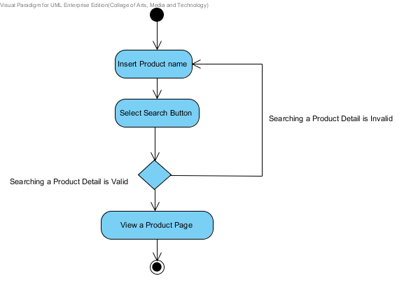**

**Output:**  The system show a product in Product Page.

**System Requirement Specification**  
 **SRS-24:** The system shall provide interface to search a product page which receive product   
 name for searching.  
 **SRS-07**: The system shall connect to the database.  
 **SRS-25**: The system retrieve information from the database by name.  
 **SRS-26:** The system shall provide detail page that consist with product name, product   
 description, and product picture.

# **URS-05**: Customer can add the product as many products as customer want to the shopping cart.

**Introduction:**  Customer can add a product into shopping Cart by click “Add Cart” button on Product page.

**Input:** Click “Add Cart” Button.

|  |  |  |  |  |
| --- | --- | --- | --- | --- |
| **Name** | **Type** | **Description** | **Example** | **Remarks** |
| Add Cart | Button | User Interface | Add Cart | 1 time |

**Flow of Execution:**

**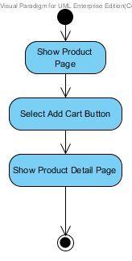**

**Output:**  The system show updating products on Shopping Cart Page.

**System Requirement Specification**   
 **SRS-27:** The system shall provide the interface to add new product which user selected.  
 **SRS-28:** The system add the product that user is selected into the shopping cart.

**SRS-07**: The system shall connect to the database.  
 **SRS-29:** The system shall update the product that user is selected into the database.  
 **SRS-30:** The system shall provide the successful add new product page after user add new   
 product into the shopping cart.

# **URS-06:** Customer can edit the product in the shopping cart.

**Introduction:**  Customer can delete or update product in Shopping Cart list.

**Input:** Customer select remove check box and input number of each product.

|  |  |  |  |  |
| --- | --- | --- | --- | --- |
| **Name** | **Type** | **Description** | **Example** | **Remarks** |
| Check box | True/False | The check box UI for remove item. | download | Checked box is remove and Empty box is keep the item |
| amount | number | The number increase one step per | spinner_gallery | - |

**Flow of Execution:**

**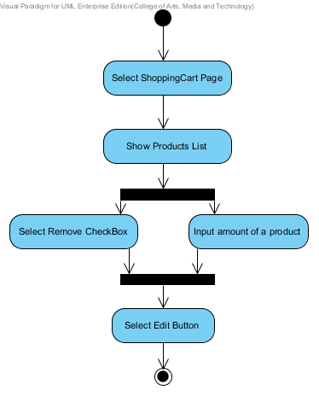**

**Output:**  The system update Shopping Cart Page.

**System Requirement Specification**  
 **SRS-07**: The system shall connect to the database.  
 **SRS-31**: The system shall delete the products from the database.  
 **SRS-32:** The system shall update amount of the products into database.  
 **SRS-33**: The system shall display the error message “The system cannot edit the new   
 updating”.  
 **SRS-34**: The system shall display the message “Edit Completed” when updated in the   
 database.  
 **SRS-35**: The system provide an interface for edit function.

# **URS-07:** Customer can save the product in the shopping cart.

**Introduction:**  Customer save products into Shopping Cart system.

**Input:** Customer select “save” button.

**Flow of Execution:**

**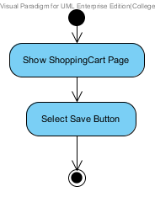**

**Output:**  Update product to Shopping Cart.

**System Requirement Specification**  
 **SRS-07**: The system shall connect to the database.  
 **SRS-36:** The system shall update information into the database.  
  **SRS-37:** The system shall display error message “The system cannot save the new product”.  
 **SRS-38:** The system shall display error message “The system cannot connect to the   
 database”.  
 **SRS-39:** The system shall display the message “Save Completed” when updated in the   
 database.  
 **SRS-40:** The system provide an interface for save function.

# **URS-08:** Customer can check out for purchase the product.

**Introduction:**  Customer can check out for purchase the product.

**Input:** Customer request a Check out Page.

**Flow of Execution:**

**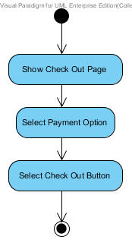**

**Output:**  The system show status of purchase.

**System Requirement Specification**  
 **SRS-07**: The system shall connect to the database.  
 **SRS-08**: The system retrieve information from the database.  
 **SRS-36**: The system update product information in database.  
 **SRS-41**: The system shall provide an interface for Check out function.  
 **SRS-22:** The system provide an interface that show all the product category including, name,   
 description, price and image  
 **SRS-42:** The system shall provide an interface for select the payment option including,   
 Transfer, Credit card and PayPal.  
 **SRS-43:** The system shall update payment option into the database.  
 **SRS-44:** The system shall display message “Purchase successful” when the transect amount   
 from banking system.

# **URS-09:** Customer can view the shopping history.

**Introduction:**  Customer can view the shopping history.

**Input:** Customer request History Page.

**Flow of Execution:**

**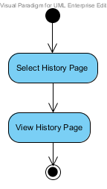**

**Output:**  The system show the history in History Page.

**System Requirement Specification**  
 **SRS-45:** The system provide an interface for the shopping history page.  
 **SRS-46**: The system retrieve shopping history form the database by reference from user.

# 

# **URS-10:** Customer can logout.

**Introduction:**  Customer logout off the system.

**Input:** Customer select a Logout Button.

**Flow of Execution:**

**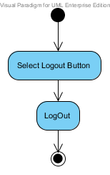**

**Output:**  Customer logout off the system.

**System Requirement Specification**  
 **SRS-47:** the system provide an interface for logout.  
 **SRS-48:** The system doesn’t show a user status on top right after logout successful.

# **URS: ADMINISTRATOR URS-11**: Administrator can login to the system.

**Introduction:**  Administrator login into the system.

**Input:** Administrator request a Login Page.

|  |  |  |  |  |
| --- | --- | --- | --- | --- |
| **Name** | **Type** | **Description** | **Example** | **Remarks** |
| username | String | A username of customer. | “camt1234” | 1-50 characters |
| password | String | A password of customer. | “camt1234” | 1-50 characters |

**Flow of Execution:**

****

**Output:**  Administrator login to the system.

**System Requirement Specification**  
  
 **SRS-16:** The system provides the login interface which receive the user name and password.  
 **SRS-17:** The system can check the username format. The username format should be   
 characters.  
 **SRS-18:** The system can check the password format. The password must contain the   
 characters.  
 **SRS-19:** The system validates the username and password.  
 **SRS-20:** The system shall provide the successful login page.  
 **SRS-07**: The system shall connect to the database.  
 **SRS-08**: The system retrieve information from the database.  
 **SRS-21:** The system shall show the user status with a customer picture on the top-right of   
 the user interface to confirm his identity

# **URS-12:** Administrator can view the shopping history of all customer.

**Introduction:**  Administrator view the shopping history of all customer.

**Input:** Administrator input Username or Date.

**Flow of Execution:**

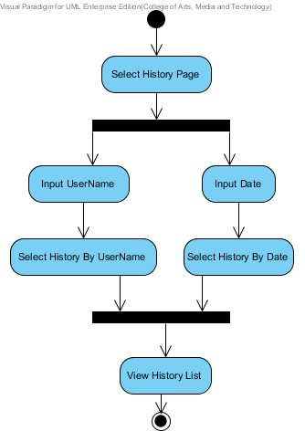

**Output:**  The system show all the history list in History Page.

**System Requirement Specification**  
 **SRS-44:** The system provide an interface for the shopping history page.  
 **SRS-45**: The system retrieve shopping history form the database by reference from user.  
 **SRS-49**: The system retrieve shopping history form the database by reference from date.  
 **SRS-50:** The system provide an interface that show all the shopping history of all customer.

# **URS-13:** Administrator can provide detail of the product.

**Introduction:**  Administrator add a product’s information into the system.

**Input:** Administrator request a Product Page.

|  |  |  |  |  |
| --- | --- | --- | --- | --- |
| **Name** | **Type** | **Description** | **Example** | **Remarks** |
| name | String | A name of product. | “channel” | 1-50 characters |
| description | String | A description of product. | “flat” | 1-255 characters |
| price | Double | A price of product. | “110.25” | - |
| Image | BLOB | An image of product. |  | - |

**Flow of Execution:**

**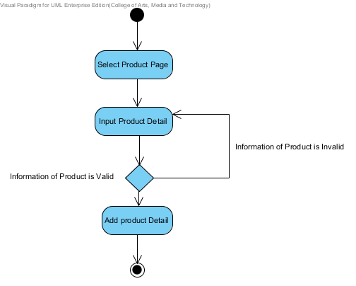**

**Output:**  The System add the product into database.

**System Requirement Specification**  
 **SRS-51:** The system provide an interface for update a product which receive name,   
 description, price and image.  
 **SRS-07**: The system shall connect to the database.  
 **SRS-36**: The system update information into database.

# **URS-14:** Administrator can update all information of registration.

**Introduction:**  Administrator can update a registration of customer into the system.

**Input:** Administrator request a registration Page.

|  |  |  |  |  |
| --- | --- | --- | --- | --- |
| **Name** | **Type** | **Description** | **Example** | **Remarks** |
| username | String | A username of customer | “camt1234” | 1-50 characters |
| password | String | A password of customer. | “camt1234” | 1-50 characters |
| name | String | A Full-Name of customer | “Putsacha” | 1-40 characters |
| birthDate | DATE | A birth date of customer. | “1993-02-25” | Format : yyyy/mm/dd |
| email | String | An email of customer. | “se542115000@vr.camt.info” | - |
| telephoneNumber | String | A telephone number of customer. | “0888888888” | 0-9 digits |
| address | String | An address of customer. | “CAMT” | 1-255 characters |
| picture | BLOB | A picture of customer. | C:\Users\wuthipong\Desktop\User\542115037.jpg | - |

**Flow of Execution:**

**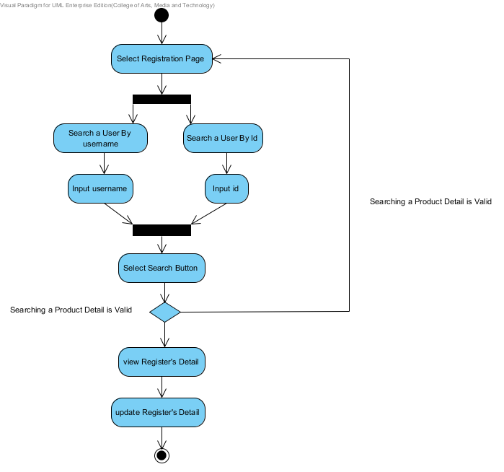**

**Output:**  The System update the registration of customer into database.

**System Requirement Specification**  
 **SRS-52:** The system provide an interface for update the registration which receive   
 username, password, name, address and their picture for the registration.  
 **SRS-07**: The system shall connect to the database.  
 **SRS-36:** The system shall update all information into database.

# **URS-15:** Administrator can logout.

**Introduction:**

Administrator logout off the system.

**Input:** Administrator select a Logout Button.

**Flow of Execution:**

****

**Output:**  Administrator logout off the system.

**System Requirement Specification**  
 **SRS-47:** the system provide an interface for logout.  
 **SRS-48:** The system doesn’t show a user status on top right after logout successful.

# 2. SRS

## 2.1 List SRS

|  |  |
| --- | --- |
| **ID** | **Description** |
| **SRS-01** | The system provide an interface for registration which receive username, password, name address and their picture for the registration. |
| **SRS-02** | The system can check the name format. The name format should be only a character. |
| **SRS-03** | The system can check the address. The address format should be a characters between 1-255 characters. |
| **SRS-04** | The system can check the picture that user uploading. The picture should be an image format such as, .png, .jpg. |
| **SRS-05** | The system can check the username format. The username format should be characters. |
| **SRS-06** | The system can check the password format. The password format should be characters. |
| **SRS-07** | The system shall connect to the database. |
| **SRS-08** | The system retrieve information from the database. |
| **SRS-09** | The system shall add a new customer information to database using username, password, name, address and their picture. |
| **SRS-10** | The system shall provide the successful registration page after registration is complete. |
| **SRS-11** | The system shall display the error message “The username must be characters”. |
| **SRS-12** | The system shall display the error message “The password must be characters”. |
| **SRS-13** | The system shall display the error message “The name must be only characters”. |
| **SRS-14** | The system shall display the error message “The address must be a characters between 1-255 characters”. |
| **SRS-15** | The system shall display the error message “The picture must be image format”. |
| **SRS-16** | The system provides the login interface which receive the user name and password. |
| **SRS-17** | The system can check the username format. The username format should be characters. |
| **SRS-18** | The system can check the password format. The password must contain the characters. |
| **SRS-19** | The system validates the username and password. |
| **SRS-20** | The system shall provide the successful login page. |
| **SRS-21** | The system shall show the user status with a customer picture on the top-right of the user interface to confirm his identity. |
| **SRS-22** | The system provide an interface that show all the product category including, name, description, price and image. |
| **SRS-23** | The system show the product detail that consist of name, description, price and image. |
| **SRS-24** | The system shall provide interface to search a product page which receive product name for searching. |
| **SRS-25** | The system retrieve information from the database by name. |
| **SRS-26** | The system shall provide detail page that consist with product name, product description, and product picture. |
| **SRS-27** | The system shall provide the interface to add new product which user selected. |
| **SRS-28** | The system add the product that user is selected into the shopping cart. |
| **SRS-29** | The system shall update the product that user is selected into the database. |
| **SRS-30** | The system shall provide the successful add new product page after user add new product into the shopping cart. |
| **SRS-31** | The system shall delete the products from the database. |
| **SRS-32** | The system shall update amount of the products into database. |
| **SRS-33** | The system shall display the error message “The system cannot edit the new updating”. |
| **SRS-34** | The system shall display the message “Edit Completed” when updated in the database. |
| **SRS-35** | The system provide an interface for edit function. |
| ID | Decription |
| **SRS-36** | The system shall update information into the database. |
| **SRS-37** | The system shall display error message “The system cannot save the new product”. |
| **SRS-38** | The system shall display error message “The system cannot connect to the database”. |
| **SRS-39** | The system shall display the message “Save Completed” when updated in the database. |
| **SRS-40** | The system provide an interface for save function. |
| **SRS-41** | The system shall provide an interface for Check out function. |
| **SRS-42** | The system shall provide an interface for select the payment option including, Transfer, Credit card and PayPal. |
| **SRS-43** | The system shall update payment option into the database. |
| **SRS-44** | The system shall display message “Purchase successful” when the transect amount from banking system. |
| **SRS-45** | The system provide an interface for the shopping history page. |
| **SRS-46** | The system retrieve shopping history form the database by reference from user. |
| **SRS-47** | The system provide an interface for logout. |
| **SRS-48** | The system doesn’t show a user status on top right after logout successful. |
| **SRS-49** | The system retrieve shopping history form the database by reference from date. |
| **SRS-50** | The system provide an interface that show all the shopping history of all customer. |
| **SRS-51** | The system provide an interface for update a product which receive name, description, price and image. |
| **SRS-52** | The system provide an interface for update the registration which receive username, password, name, address and their picture for the registration. |

# 3. Use case Diagram

## List use cases

|  |  |
| --- | --- |
| **ID** | **Description** |
| **UCD-01** | Registration. |
| **UCD-02** | ViewTheProductCategory. |
| **UCD-03** | SearchTheProduct. |
| **UCD-04** | AddShoppingcart. |
| **UCD-05** | ViewShoppingCart. |
| **UCD-06** | CheckOut. |
| **UCD-07** | SaveShoppingCart. |
| **UCD-08** | EditShoppingCart. |
| **UCD-09** | ViewTheShoppingHistory. |
| **UCD-10** | ManagementTheProduct. |
| **UCD-11** | Login. |
| **UCD-12** | Logout. |

## 3.1 Use case

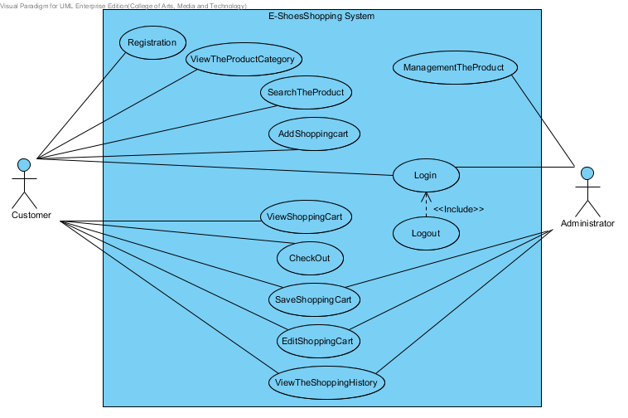

# 4. Class Diagram

## 4.1 List Class Diagram

|  |  |
| --- | --- |
| **ID** | **Description** |
| **CD-01** | User. |
| **CD-02** | Administrator. |
| **CD-03** | Customer. |
| **CD-04** | Product. |
| **CD-05** | ShoppingCart. |
| **CD-06** | History. |
| **CD-07** | UserDAO. |
| **CD-08** | UserDAOImpl. |
| **CD-09** | UserService. |
| **CD-10** | UserServiceImpl. |
| **CD-11** | UserController. |
| **CD-12** | ProductDAO. |
| **CD-13** | ProductDAOImpl. |
| **CD-14** | ProductService. |
| **CD-15** | ProductServiceImpl. |
| **CD-16** | ProductController. |
| **CD-17** | ShoppingCartDAO. |
| **CD-18** | ShoppingCartDAOImpl. |
| **CD-19** | ShoppingCartService. |
| **CD-20** | ShoppingCartServiceImpl. |
| **CD-21** | ShoppingCartController. |
| **CD-22** | HistoryDAO. |
| **CD-23** | HistoryDAOImpl. |
| **CD-24** | HistoryService. |
| **CD-25** | HistoryServiceImpl. |
| **CD-26** | HistoryController. |

## 4.2 Class Diagram

# 4.2.1 Entity

# 4.2.2 MVC of User Controller

***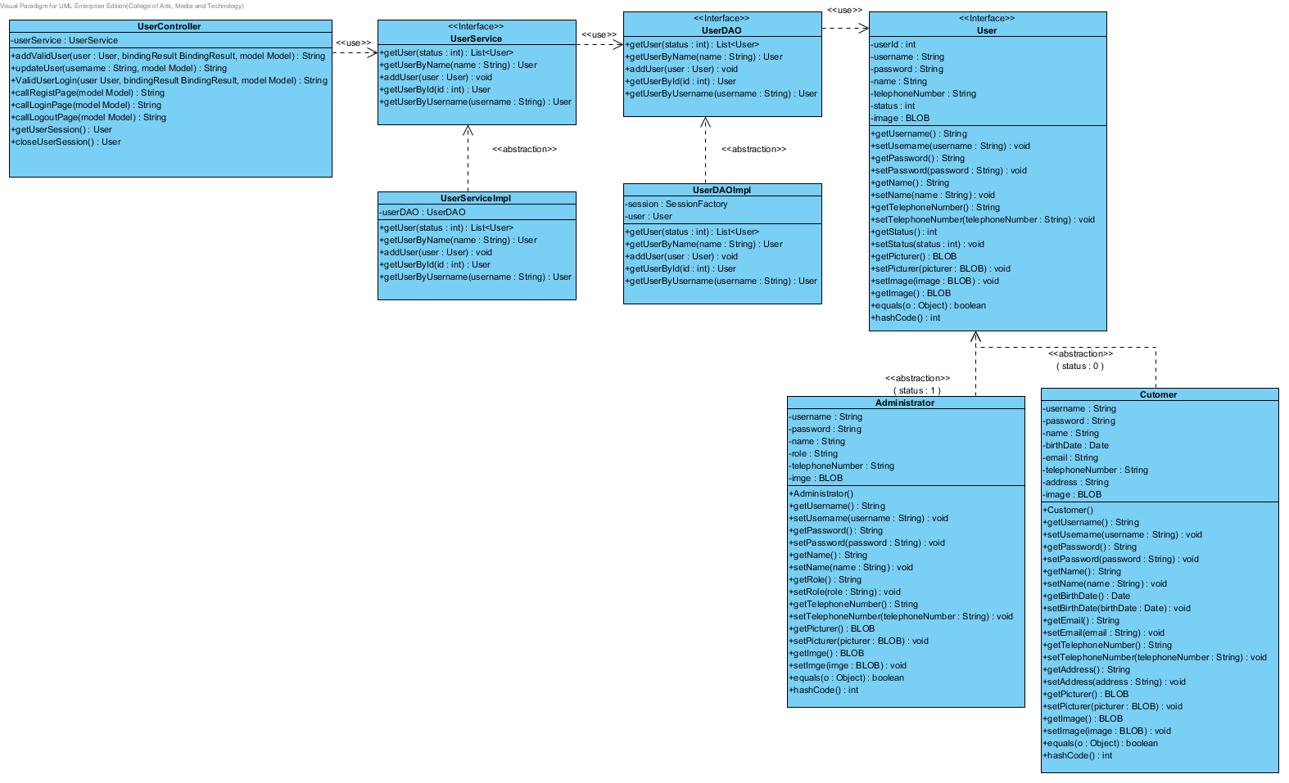***

# 4.2.3 MVC of Product Controller

**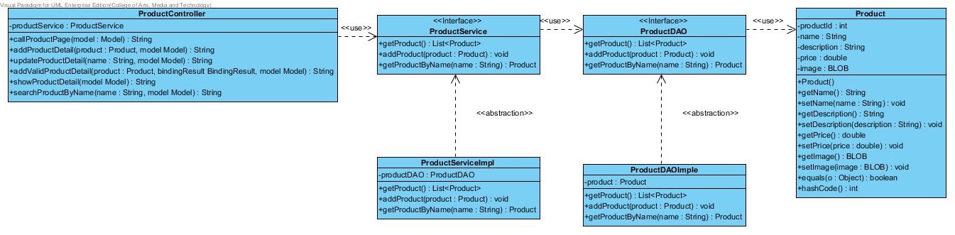**

# 4.2.4 MVC of Shopping Cart Controller

**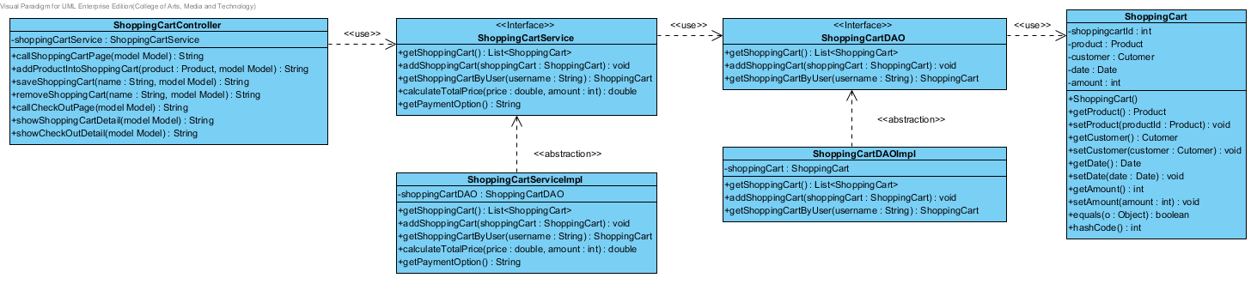**

# 4.2.5 MVC of History Controller

**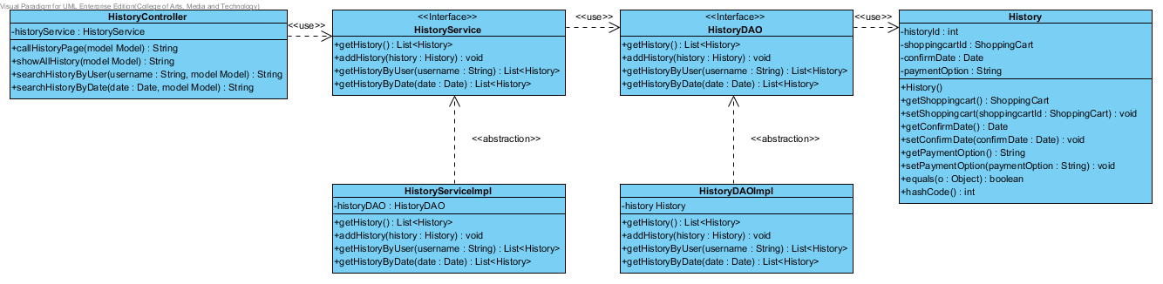**

# 5. Sequence Diagram

## 5.1 List Sequence Diagram

|  |  |
| --- | --- |
| **ID** | **Description** |
| **SQD-01** | AddProductShoppingCart. |
| **SQD-02** | CheckOut. |
| **SQD-03** | EditProductShoppingCart. |
| **SQD-04** | Registration. |
| **SQD-05** | SaveProductShopping. |
| **SQD-06** | ViewProduct. |
| **SQD-07** | SearchProduct. |
| **SQD-08** | AddProduct. |
| **SQD-09** | UpdateRegisteration. |
| **SQD-10** | Login. |
| **SQD-11** | Logout. |
| **SQD-12** | ViewHistory. |

## 5.2 Sequence Diagram

# AddProductShoppingCart5.2.1 SQD-01: Add Product Shopping Cart

# 5.2.2 SQD-02: Check Out

***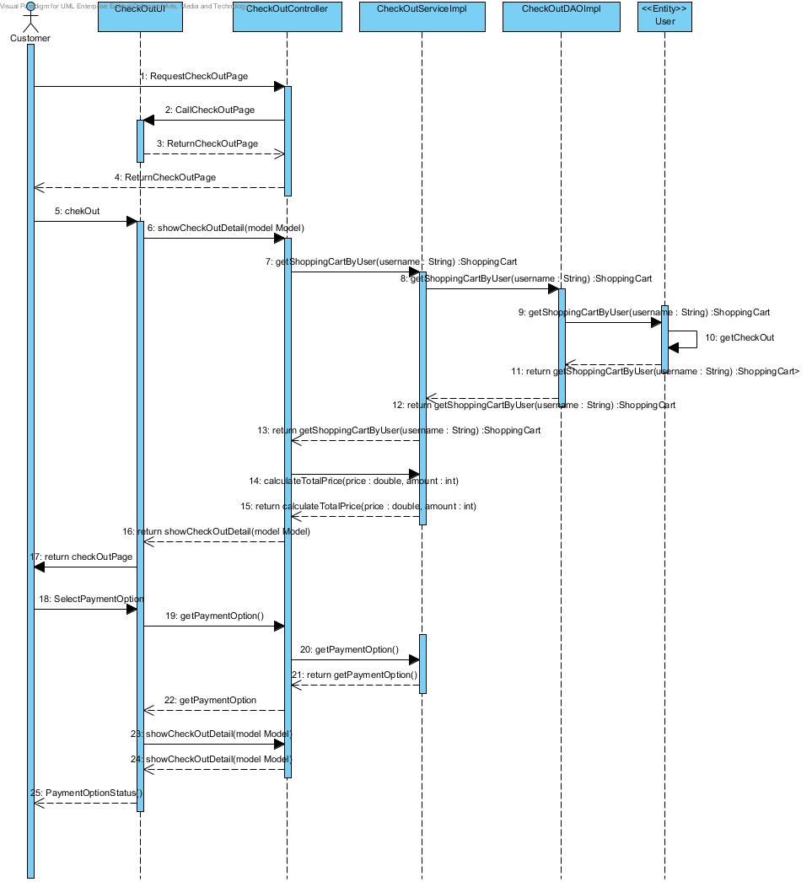***

# 5.2.3 SQD-03: Edit Product Shopping Cart

***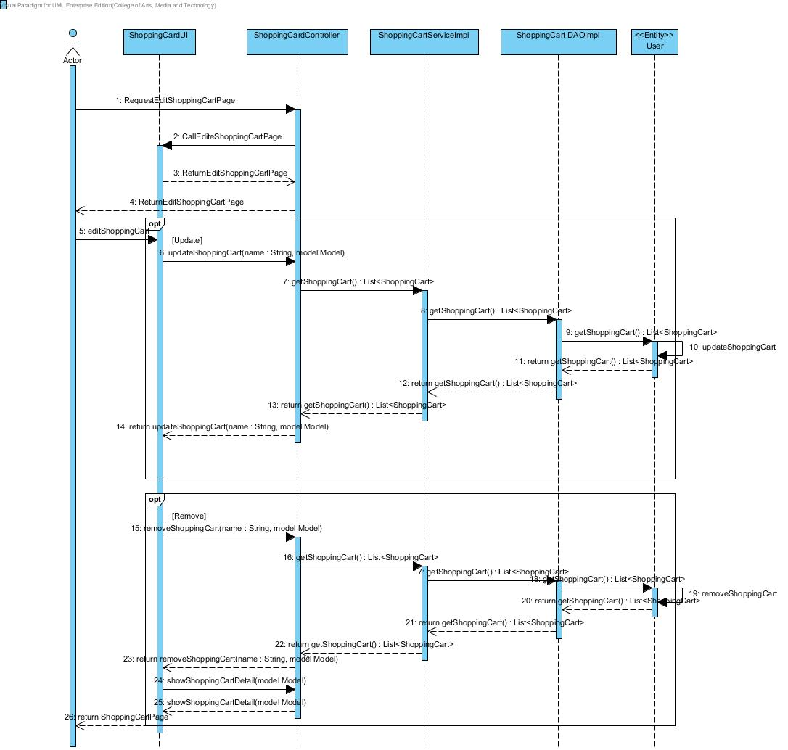***

# 5.2.4 SQD-04: RegistrationC:\Users\wuthipong\AppData\Local\Microsoft\Windows\INetCache\Content.Word\Registration.jpg

# 5.2.5 SQD-05: Save Product Shopping Cart

***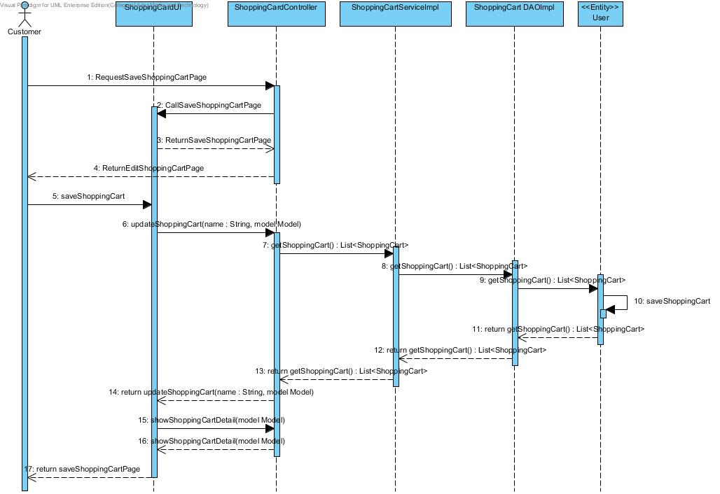***

# 5.2.6 SQD-06: View ProductViewProduct

# 5.2.7 SQD-07: Search Product

***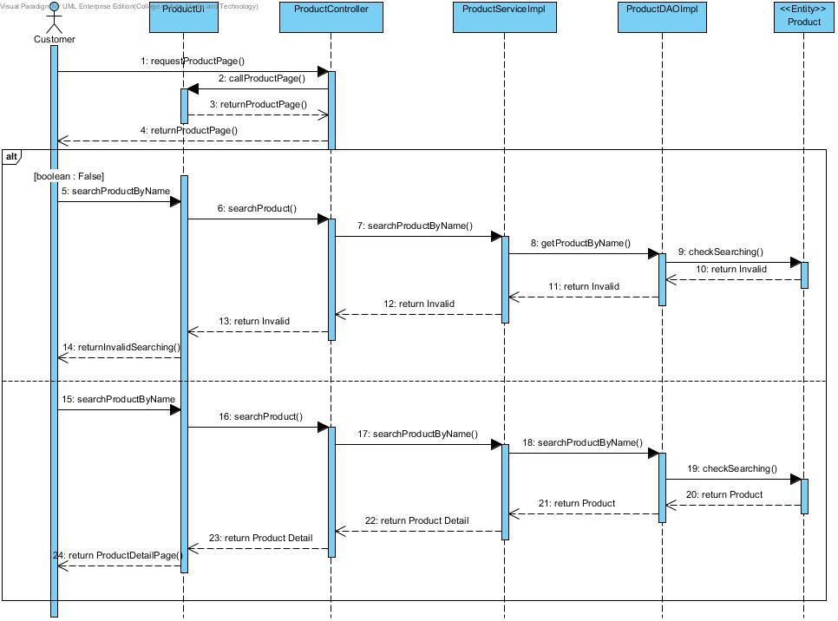***

# 5.2.8 SQD-08: Add Product

***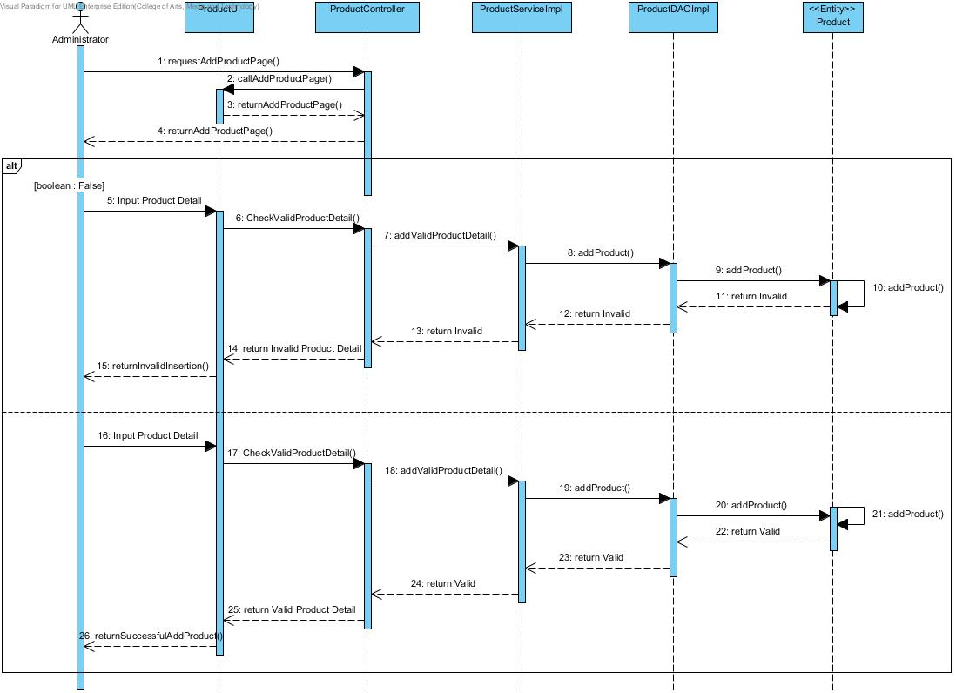***

# 5.2.9 SQD-09: Update Registration

***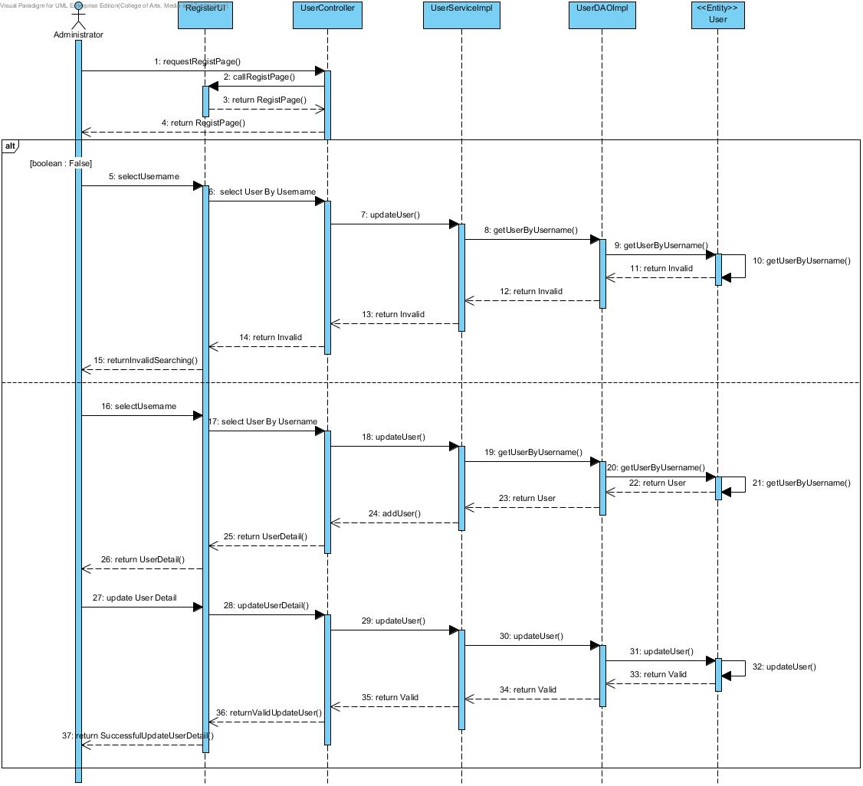***

# 5.2.10 SQD-10: Login

***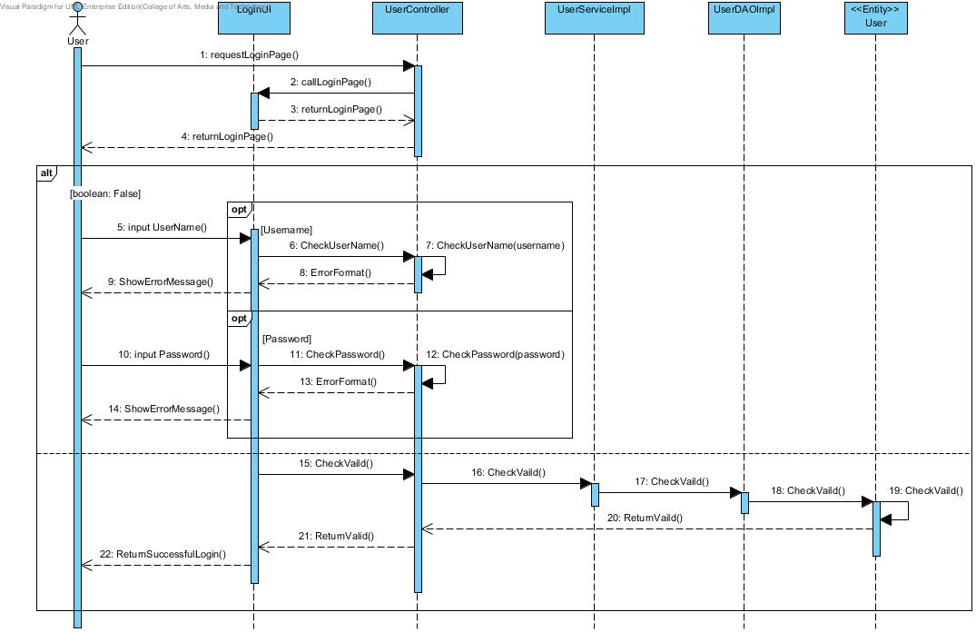***

# 5.2.11 SQD-11: Logout

***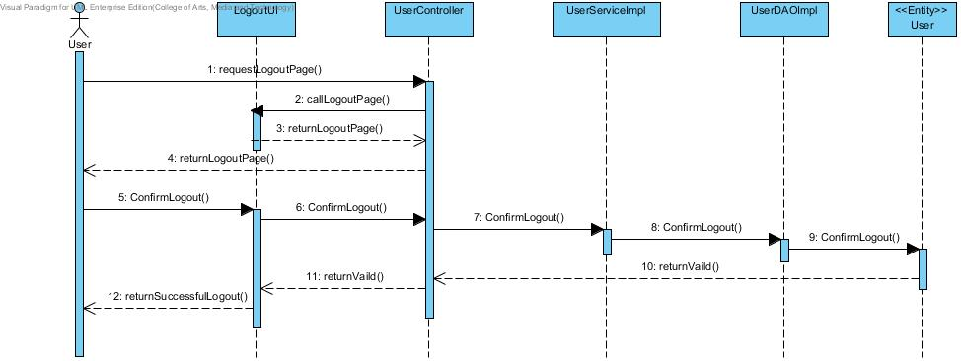***

# 5.2.12 SQD-12: View History

***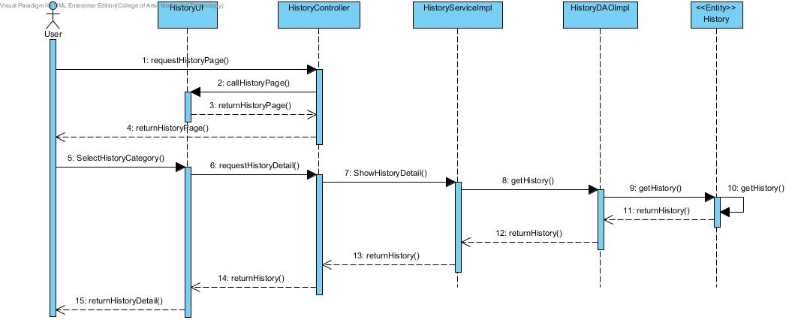***

# 6. Method Design

## 6.1 List method

|  |  |
| --- | --- |
| **ID** | **Description** |
| **MTD-01** | User. |
| **MTD-02** | Administrator. |
| **MTD-03** | Customer. |
| **MTD-04** | Product. |
| **MTD-05** | ShoppingCart. |
| **MTD-06** | History. |
| **MTD-07** | UserDAO. |
| **MTD-08** | UserDAOImpl. |
| **MTD-09** | UserService. |
| **MTD-10** | UserServiceImpl. |
| **MTD-11** | UserController. |
| **MTD-12** | ProductDAO. |
| **MTD-13** | ProductDAOImpl. |
| **MTD-14** | ProductService. |
| **MTD-15** | ProductServiceImpl. |
| **MTD-16** | ProductController. |
| **MTD-17** | ShoppingCartDAO. |
| **MTD-18** | ShoppingCartDAOImpl. |
| **MTD-19** | ShoppingCartService. |
| **MTD-20** | ShoppingCartServiceImpl. |
| **MTD-21** | ShoppingCartController. |
| **MTD-22** | HistoryDAO. |
| **MTD-23** | HistoryDAOImpl. |
| **MTD-24** | HistoryService. |
| **MTD-25** | HistoryServiceImpl. |
| **MTD-26** | HistoryController. |

### 6.2 Proper method design

# 6.2.1 Entity

# 6.2.1.1 MTD-01: User

**Class Name: User**

**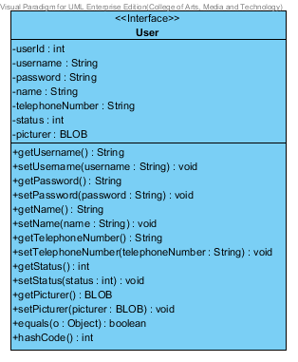**

**Entities**

|  |  |  |  |
| --- | --- | --- | --- |
| **ID** | **NAME** | **DESCRIPTION** | **REMARK** |
| 1 | userId | This is an id for identify the object of User Class. | **TYPE :** Integer |
| 2 | username | This is a username of user. | **TYPE :** String |
| 3 | password | This is a password of user. | **TYPE :** String |
| 4 | name | This is a Full-name of user. | **TYPE :** String |
| 5 | telephoneNumber | This is a telephone number of user. | **TYPE :** String |
| 6 | status | This is a status to separate the type of User Object. | **TYPE :** Integer |
| 7 | Picture | This is a picture of user. | **TYPE :** BLOB |

|  |  |  |  |
| --- | --- | --- | --- |
| **ID** | **NAME** | **DESCRIPTION** | **REMARK** |
| 1 | equals() | This method uses to equal the values. | **Return Type :** Boolean  **Parameters :** Object |
| 2 | hashCode() | This method uses to generate the hash value of variables. | **Return Type :** Integer |

**Method**

# 6.2.1.2 MTD-02: Administrator

**Class Name: Administrator**

**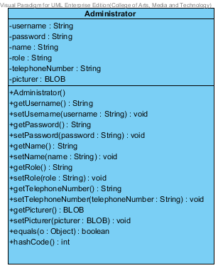**

**Entities**

|  |  |  |  |
| --- | --- | --- | --- |
| **ID** | **NAME** | **DESCRIPTION** | **REMARK** |
| 1 | username | This is a username of Administrator. | **TYPE :** String |
| 2 | password | This is a password of Administrator. | **TYPE :** String |
| 3 | name | This is a Full-name of Administrator. | **TYPE :** String |
| 4 | role | This is a role that Administrator responsibility. | **TYPE :** String |
| 5 | telephoneNumber | This is a telephone number of Administrator. | **TYPE :** String |
| 6 | Picture | This is a picture of Administrator. | **TYPE :** BLOB |

|  |  |  |  |
| --- | --- | --- | --- |
| **ID** | **NAME** | **DESCRIPTION** | **REMARK** |
| 1 | equals() | This method uses to equal the values. | **Return Type :** Boolean  **Parameters :** Object |
| 2 | hashCode() | This method uses to generate the hash value of variables. | **Return Type :** Integer |

**Method**

# 6.2.1.3 MTD-03: Customer

**Class Name: Customer**

**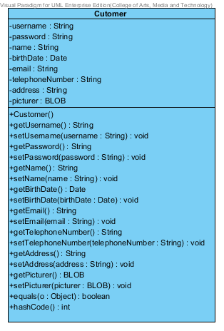**

**Entities**

|  |  |  |  |
| --- | --- | --- | --- |
| **ID** | **NAME** | **DESCRIPTION** | **REMARK** |
| 1 | username | This is a username of customer. | **TYPE :** String |
| 2 | password | This is a password of customer. | **TYPE :** String |
| 3 | name | This is a Full-name of customer. | **TYPE :** String |
| 4 | birthDate | This is a birth date of customer | **TYPE :** String |
| 5 | email | This is an email of customer. | **TYPE :** String |
| 6 | telephoneNumber | This is a telephone number of customer. | **TYPE :** String |
| 7 | address | This is an address of customer. | **TYPE :** String |
| 8 | Picture | This is a picture of customer. | **TYPE :** BLOB |

|  |  |  |  |
| --- | --- | --- | --- |
| **ID** | **NAME** | **DESCRIPTION** | **REMARK** |
| 1 | equals() | This method uses to equal the values. | **Return Type :** Boolean  **Parameters :** Object |
| 2 | hashCode() | This method uses to generate the hash value of variables. | **Return Type :** Integer |

**Method**

# 6.2.1.4 MTD-04: Product

**Class Name: Product**

**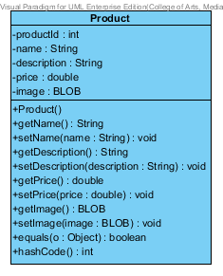**

**Entities**

|  |  |  |  |
| --- | --- | --- | --- |
| **ID** | **NAME** | **DESCRIPTION** | **REMARK** |
| 1 | productId | This is an id for identify the object of Product Class. | **TYPE :** Integer |
| 2 | Name | This is a name of product. | **TYPE :** String |
| 3 | description | This is a description of product. | **TYPE :** String |
| 4 | Price | This is a price of product | **TYPE :** Double |
| 5 | Image | This is an image of product. | **TYPE :** BLOB |

|  |  |  |  |
| --- | --- | --- | --- |
| **ID** | **NAME** | **DESCRIPTION** | **REMARK** |
| 1 | equals() | This method uses to equal the values. | **Return Type :** Boolean  **Parameters :** Object |
| 2 | hashCode() | This method uses to generate the hash value of variables. | **Return Type :** Integer |

**Method**

# 6.2.1.5 MTD-05: Shopping Cart

**Class Name: Shopping Cart**

**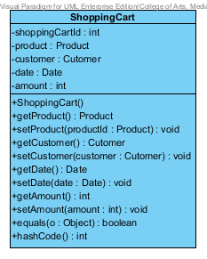**

**Entities**

|  |  |  |  |
| --- | --- | --- | --- |
| **ID** | **NAME** | **DESCRIPTION** | **REMARK** |
| 1 | shoppingCartId | This is an id for identify the object of shopping Cart Class. | **TYPE :** Integer |
| 2 | product | This is an object to hold product information. | **TYPE :** Product |
| 3 | customer | This is an object to hold customer information. | **TYPE :** Customer |
| 4 | date | This is a date when customer is adding a product into The shopping Cart. | **TYPE :** Date |
| 5 | amount | This is an amount of product which is customer adding into the shopping Cart. | **TYPE :** Integer |

|  |  |  |  |
| --- | --- | --- | --- |
| **ID** | **NAME** | **DESCRIPTION** | **REMARK** |
| 1 | equals() | This method uses to equal the values. | **Return Type :** Boolean  **Parameters :** Object |
| 2 | hashCode() | This method uses to generate the hash value of variables. | **Return Type :** Integer |

**Method**

# 6.2.1.6 MTD-06: History

**Class Name: History**

**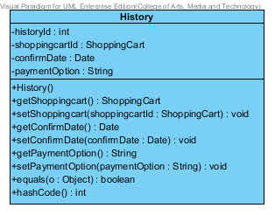**

**Entities**

|  |  |  |  |
| --- | --- | --- | --- |
| **ID** | **NAME** | **DESCRIPTION** | **REMARK** |
| 1 | historyId | This is an id for identify the object of History Class. | **TYPE :** Integer |
| 2 | shoppingCartId | This is an object to hold shopping Cart information. | **TYPE :** ShoppingCart |
| 3 | confirmDate | This is a date when customer confirm to purchase a product. | **TYPE :** Date |
| 4 | paymentOption | This is a payment Option which consist of transfer, credit card and Paypal. | **TYPE :** String |

|  |  |  |  |
| --- | --- | --- | --- |
| **ID** | **NAME** | **DESCRIPTION** | **REMARK** |
| 1 | equals() | This method uses to equal the values. | **Return Type :** Boolean  **Parameters :** Object |
| 2 | hashCode() | This method uses to generate the hash value of variables. | **Return Type :** Integer |

**Method**

# 6.2.2 MVC Pattern of User Class

# 6.2.2.1 MTD-07: UserDAO

**Class Name: UserDAO**

**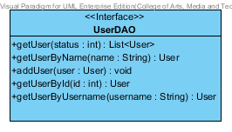**

|  |  |  |  |
| --- | --- | --- | --- |
| **ID** | **NAME** | **DESCRIPTION** | **REMARK** |
| 1 | getUser() | This method uses for getting a user. | **Return Type :** List<User>  **Parameters :** status |
| 2 | getUserByName() | This method uses for getting a user by using user’s name from database. | **Return Type :** User  **Parameters :** name |
| 3 | addUser() | This method uses for adding a user into a database. | **Return Type :** void  **Parameters :** user |
| 4 | getUserById() | This method uses for getting a user by using user’s id from database. | **Return Type :** User  **Parameters :** id |
| 5 | getUserByUsername() | This method uses for getting a user by using user’s username from database. | **Return Type :** User  **Parameters :** username |

**Method**

# 6.2.2.2 MTD-08: UserDAOImpl

**Class Name: UserDAOImpl**

**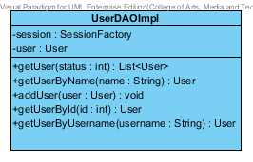**

**Entities**

|  |  |  |  |
| --- | --- | --- | --- |
| **ID** | **NAME** | **DESCRIPTION** | **REMARK** |
| 1 | session | This is an object to hold sessionFactory. | **TYPE :** SessionFactory |
| 2 | user | This is an object to hold user’s information. | **TYPE :** User |

**Method**

|  |  |  |  |
| --- | --- | --- | --- |
| **ID** | **NAME** | **DESCRIPTION** | **REMARK** |
| 1 | getUser() | This method uses for getting a user. | **Return Type :** List<User>  **Parameters :** status |
| 2 | getUserByName() | This method uses for getting a user by using user’s name from database. | **Return Type :** User  **Parameters :** name |
| 3 | addUser() | This method uses for adding a user into a database. | **Return Type :** void  **Parameters :** user |
| 4 | getUserById() | This method uses for getting a user by using user’s id from database. | **Return Type :** User  **Parameters :** id |
| 5 | getUserByUsername() | This method uses for getting a user by using user’s username from database. | **Return Type :** User  **Parameters :** username |

# 6.2.2.3 MTD-09: UserService

**Class Name: UserService**

**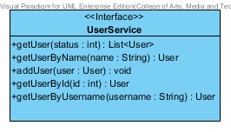**

**Method**

|  |  |  |  |
| --- | --- | --- | --- |
| **ID** | **NAME** | **DESCRIPTION** | **REMARK** |
| 1 | getUser() | This method uses for getting a user. | **Return Type :** List<User>  **Parameters :** status |
| 2 | getUserByName() | This method uses for getting a user by using user’s name from database. | **Return Type :** User  **Parameters :** name |
| 3 | addUser() | This method uses for adding a user into a database. | **Return Type :** void  **Parameters :** user |
| 4 | getUserById() | This method uses for getting a user by using user’s id from database. | **Return Type :** User  **Parameters :** id |
| 5 | getUserByUsername() | This method uses for getting a user by using user’s username from database. | **Return Type :** User  **Parameters :** username |

# 6.2.2.4 MTD-10: UserServiceImpl

**Class Name: UserServiceImpl**

**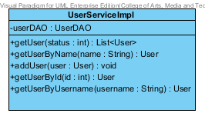**

**Entities**

|  |  |  |  |
| --- | --- | --- | --- |
| **ID** | **NAME** | **DESCRIPTION** | **REMARK** |
| 1 | userDAO | This is an object to hold userDAO Class. | **TYPE :** UserDAO |

**Method**

|  |  |  |  |
| --- | --- | --- | --- |
| **ID** | **NAME** | **DESCRIPTION** | **REMARK** |
| 1 | getUser() | This method uses for getting a user. | **Return Type :** List<User>  **Parameters :** status |
| 2 | getUserByName() | This method uses for getting a user by using user’s name from database. | **Return Type :** User  **Parameters :** name |
| 3 | addUser() | This method uses for adding a user into a database. | **Return Type :** void  **Parameters :** user |
| 4 | getUserById() | This method uses for getting a user by using user’s id from database. | **Return Type :** User  **Parameters :** id |
| 5 | getUserByUsername() | This method uses for getting a user by using user’s username from database. | **Return Type :** User  **Parameters :** username |

# 6.2.2.5 MTD-11: UserController

**Class Name: UserController**

**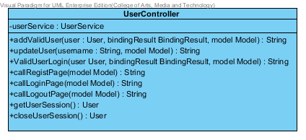**

**Entities**

|  |  |  |  |
| --- | --- | --- | --- |
| **ID** | **NAME** | **DESCRIPTION** | **REMARK** |
| 1 | userService | This is an object to hold userService Class. | **TYPE :** UserService |

**Method**

|  |  |  |  |
| --- | --- | --- | --- |
| **ID** | **NAME** | **DESCRIPTION** | **REMARK** |
| 1 | addValidUser() | This method uses for adding a valid user into database. | **Return Type :** String  **Parameters :** user, bindingResult, model |
| 2 | updateUser() | This method uses for update a user into a database. | **Return Type :** String  **Parameters :** username, model |
| 3 | validUserLogin() | This method uses for validate a user when user is login. | **Return Type :** String  **Parameters :** user, bindingResult, model |
| 4 | callRegistPage() | This method uses for connecting with Register Page . | **Return Type :** String  **Parameters :** model |
| 5 | callLoginPage() | This method uses for connecting with Login Page . | **Return Type :** String  **Parameters :** model |
| 6 | callLogoutPage() | This method uses for connecting with Logout Page. | **Return Type :** String  **Parameters :** model |
| 7 | getUserSession() | This method uses to get a user’s session. | **Return Type :** User |
| 8 | closeUserSession() | This method uses to close a user’s session. | **Return Type :** User |

# 6.2.3 MVC Pattern of Product Class

# 6.2.3.1 MTD-12: ProductDAO

**Class Name: ProductDAO**

**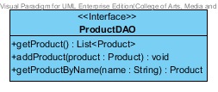**

|  |  |  |  |
| --- | --- | --- | --- |
| **ID** | **NAME** | **DESCRIPTION** | **REMARK** |
| 1 | getProduct() | This method uses for getting a product. | **Return Type :** List<Product> |
| 2 | addProduct() | This method uses for adding a product into a database. | **Return Type :** void  **Parameters :** product |
| 3 | getProductByName() | This method uses for getting a product by using product’s name from database. | **Return Type :** User  **Parameters :** name |

**Method**

# 6.2.3.2 MTD-13: ProductDAOImpl

**Class Name: ProductDAOImpl**

**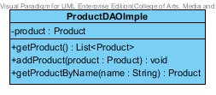**

**Entities**

|  |  |  |  |
| --- | --- | --- | --- |
| **ID** | **NAME** | **DESCRIPTION** | **REMARK** |
| 1 | product | This is an object to hold product’s information. | **TYPE :** Product |

**Method**

|  |  |  |  |
| --- | --- | --- | --- |
| **ID** | **NAME** | **DESCRIPTION** | **REMARK** |
| 1 | getProduct() | This method uses for getting a product. | **Return Type :** List<Product> |
| 2 | addProduct() | This method uses for adding a product into a database. | **Return Type :** void  **Parameters :** product |
| 3 | getProductByName() | This method uses for getting a product by using product’s name from database. | **Return Type :** User  **Parameters :** name |

# 6.2.3.3 MTD-14: ProductService

**Class Name: ProductService**

**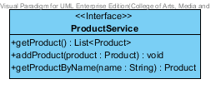**

**Method**

|  |  |  |  |
| --- | --- | --- | --- |
| **ID** | **NAME** | **DESCRIPTION** | **REMARK** |
| 1 | getProduct() | This method uses for getting a product. | **Return Type :** List<Product> |
| 2 | addProduct() | This method uses for adding a product into a database. | **Return Type :** void  **Parameters :** product |
| 3 | getProductByName() | This method uses for getting a product by using product’s name from database. | **Return Type :** User  **Parameters :** name |

# 6.2.3.4 MTD-15: ProductServiceImpl

**Class Name: ProductServiceImpl**

**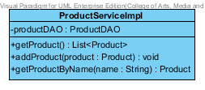**

**Entities**

|  |  |  |  |
| --- | --- | --- | --- |
| **ID** | **NAME** | **DESCRIPTION** | **REMARK** |
| 1 | productDAO | This is an object to hold ProductDAO Class. | **TYPE :** ProductDAO |

**Method**

|  |  |  |  |
| --- | --- | --- | --- |
| **ID** | **NAME** | **DESCRIPTION** | **REMARK** |
| 1 | getProduct() | This method uses for getting a product. | **Return Type :** List<Product> |
| 2 | addProduct() | This method uses for adding a product into a database. | **Return Type :** void  **Parameters :** product |
| 3 | getProductByName() | This method uses for getting a product by using product’s name from database. | **Return Type :** User  **Parameters :** name |

# 6.2.3.5 MTD-16: ProductController

**Class Name: ProductController**

**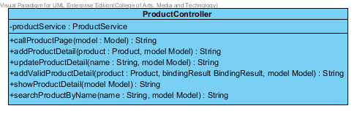**

**Entities**

|  |  |  |  |
| --- | --- | --- | --- |
| **ID** | **NAME** | **DESCRIPTION** | **REMARK** |
| 1 | productService | This is an object to hold Product Service Class. | **TYPE :** ProductService |

**Method**

|  |  |  |  |
| --- | --- | --- | --- |
| **ID** | **NAME** | **DESCRIPTION** | **REMARK** |
| 1 | callProductPage() | This method uses for connecting with Product Page. | **Return Type :** String  **Parameters :** model |
| 2 | addProductDetail() | This method uses for adding a product detail into a database. | **Return Type :** String  **Parameters :** product, model |
| 3 | updateProductDetail() | This method uses for update a product when user is login. | **Return Type :** String  **Parameters :** name, model |
| 4 | addValidProductDetail() | This method uses for adding a valid product into database. | **Return Type :** String  **Parameters :** product, bindingResult, model |
| 5 | showProductDetail() | This method uses for showing a product detail into Product Page. | **Return Type :** String  **Parameters :** model |
| 6 | searchProductByName() | This method uses for searching a product by using product’s name from database. | **Return Type :** String  **Parameters :** name, model |

# 6.2.4 MVC Pattern of ShoppingCart Class

# 6.2.4.1 MTD-17: ShoppingCartDAO

**Class Name: ShoppingCartDAO**

**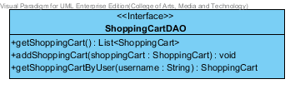**

|  |  |  |  |
| --- | --- | --- | --- |
| **ID** | **NAME** | **DESCRIPTION** | **REMARK** |
| 1 | getShoppingCart () | This method uses for getting a Shopping Cart. | **Return Type :** -  **Parameters :** List<ShoppingCart> |
| 2 | addShoppingCart () | This method uses for adding a shopping cart by using shoppingCart. | **Return Type :** void  **Parameters :**shoppingCart |
| 3 | getShoppingCartByUser() | This method uses for getting a ShoppingCart by username. | **Return Type :** ShoppingCart  **Parameters :** username |

# 6.2.4.2 MTD-18: ShoppingCartDAOImpl

**Class Name: ShoppingCartDAOImpl**

**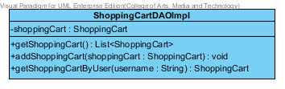**

**Entities**

|  |  |  |  |
| --- | --- | --- | --- |
| **ID** | **NAME** | **DESCRIPTION** | **REMARK** |
| 1 | shoppingCart | This is an object to hold ShoppingCart. | **TYPE :** ShoppingCart |

**Method**

|  |  |  |  |
| --- | --- | --- | --- |
| **ID** | **NAME** | **DESCRIPTION** | **REMARK** |
| 1 | getShoppingCart () | This method uses for getting a ShoppingCart. | **Return Type :** List< ShoppingCart >  **Parameters :** status |
| 2 | addShoppingCart() | This method uses for adding ShoppingCart into database. | **Return Type :** Void  **Parameters :** ShoppingCart |
| 3 | getShoppingCartByUser() | This method uses for getting a ShoppingCart by username from a database. | **Return Type :** ShoppingCart  **Parameters :** username |

# 6.2.4.3 MTD-19: ShoppingCartService

**Class Name: ShoppingCartService**

**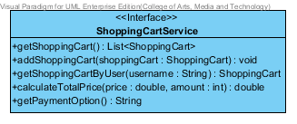**

**Method**

|  |  |  |  |
| --- | --- | --- | --- |
| **ID** | **NAME** | **DESCRIPTION** | **REMARK** |
| 1 | getShoppingCart () | This method uses for getting a Shopping Cart. | **Return Type :** List<ShoppingCart>  **Parameters :** status |
| 2 | addShoppingCart () | This method uses for adding a shoppingCart in to a database. | **Return Type :** void  **Parameters :** name |
| 3 | getShoppingCart () | This method uses for adding a user into a database. | **Return Type :** ShoppingCart  **Parameters :** username |
| 4 | calculateTotalPrice() | This method uses for calculate the total price by using a price and amount. | **Return Type :** double  **Parameters :** price, amount |
| 5 | getPaymentOption() | This method uses for getting a payment option detail. | **Return Type :** String  **Parameters :** - |

# 6.2.4.4 MTD-20: ShoppingCartServiceImpl

**Class Name: ShoppingCartServiceImpl**

**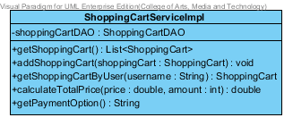**

**Entities**

|  |  |  |  |
| --- | --- | --- | --- |
| **ID** | **NAME** | **DESCRIPTION** | **REMARK** |
| 1 | shoppingCartDAO | This is an object to hold shoppingCartDAO Class. | **TYPE :** shoppingCartDAO |

**Method**

|  |  |  |  |
| --- | --- | --- | --- |
| **ID** | **NAME** | **DESCRIPTION** | **REMARK** |
| 1 | getShoppingCart () | This method uses for getting a Shopping Cart. | **Return Type :** List<ShoppingCart>  **Parameters :** status |
| 2 | addShoppingCart () | This method uses for adding a shoppingCart in to a database. | **Return Type :** void  **Parameters :** name |
| 3 | getShoppingCart () | This method uses for adding a user into a database. | **Return Type :** ShoppingCart  **Parameters :** username |
| 4 | calculateTotalPrice() | This method uses for calculate the total price by using a price and amount. | **Return Type :** double  **Parameters :** price, amount |
| 5 | getPaymentOption() | This method uses for getting a payment option detail. | **Return Type :** String  **Parameters :** - |

# 6.2.4.5 MTD-21: ShoppingCartController

**Class Name: ShoppingCartController**

**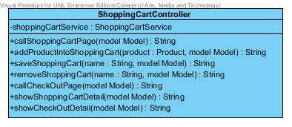**

**Entities**

|  |  |  |  |
| --- | --- | --- | --- |
| **ID** | **NAME** | **DESCRIPTION** | **REMARK** |
| 1 | shoppingCartService | This is an object to hold shoppingCartService Class. | **TYPE :** ShoppingCartService |

**Method**

|  |  |  |  |
| --- | --- | --- | --- |
| **ID** | **NAME** | **DESCRIPTION** | **REMARK** |
| 1 | callShoppingCartPage() | This method uses for connecting with shoppingCart page from ShoppingCartUI. | **Return Type :** String  **Parameters :** model |
| 2 | addProductIntoShoppingCart() | This method uses for adding product into a database. | **Return Type :** String  **Parameters :** product, model |
| 3 | saveShoppingCart () | This method uses for adding shoppingCart by using name into database. | **Return Type :** String  **Parameters :** name, model |
| 4 | removeShoppingCart() | This method uses for delete shoppingCart by using name from database. | **Return Type :** String  **Parameters :** name, model |
| 5 | callCheckOutPage() | This method uses for connecting with check Out Page. | **Return Type :** String  **Parameters :** model |
| 6 | showShoppingCartDetail () | This method uses for showing with shopping Cart Page. | **Return Type :** String  **Parameters :** model |
| 7 | showCheckOutDetai() | This method uses for showing with check out page | **Return Type :** String  **Parameters :** model |

# 6.2.5 MVC Pattern of History Class

# 6.2.5.1 MTD-22: HistoryDAO

**Class Name: HistoryDAO**

**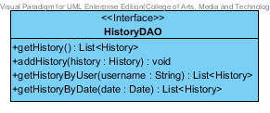**

|  |  |  |  |
| --- | --- | --- | --- |
| **ID** | **NAME** | **DESCRIPTION** | **REMARK** |
| 1 | getHistory() | This method uses for getting a history. | **Return Type :** List<History> |
| 2 | addHistory() | This method uses for adding a history into a database. | **Return Type :** void  **Parameters :** history |
| 3 | getHistoryByName() | This method uses for getting a history list by using user’s name from database. | **Return Type :** List<History>  **Parameters :** username |
| 4 | getHistoryByDate() | This method uses for getting a history list by using date from database. | **Return Type :** List<History>  **Parameters :** date |

**Method**

# 6.2.5.2 MTD-23: HistoryDAOImpl

**Class Name: HistoryDAOImpl**

**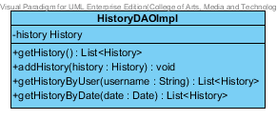**

**Entities**

|  |  |  |  |
| --- | --- | --- | --- |
| **ID** | **NAME** | **DESCRIPTION** | **REMARK** |
| 1 | history | This is an object to hold history’s information. | **TYPE :** History |

**Method**

|  |  |  |  |
| --- | --- | --- | --- |
| **ID** | **NAME** | **DESCRIPTION** | **REMARK** |
| 1 | getHistory() | This method uses for getting a history. | **Return Type :** List<History> |
| 2 | addHistory() | This method uses for adding a history into a database. | **Return Type :** void  **Parameters :** history |
| 3 | getHistoryByName() | This method uses for getting a history list by using user’s name from database. | **Return Type :** List<History>  **Parameters :** username |
| 4 | getHistoryByDate() | This method uses for getting a history list by using date from database. | **Return Type :** List<History>  **Parameters :** date |

# 6.2.5.3 MTD-24: HistoryService

**Class Name: HistoryService**

**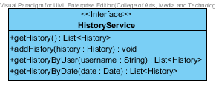**

**Method**

|  |  |  |  |
| --- | --- | --- | --- |
| **ID** | **NAME** | **DESCRIPTION** | **REMARK** |
| 1 | getHistory() | This method uses for getting a history. | **Return Type :** List<History> |
| 2 | addHistory() | This method uses for adding a history into a database. | **Return Type :** void  **Parameters :** history |
| 3 | getHistoryByName() | This method uses for getting a history list by using user’s name from database. | **Return Type :** List<History>  **Parameters :** username |
| 4 | getHistoryByDate() | This method uses for getting a history list by using date from database. | **Return Type :** List<History>  **Parameters :** date |

# 6.2.5.4 MTD-25: HistoryServiceImpl

**Class Name: HistoryServiceImpl**

**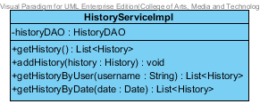**

**Entities**

|  |  |  |  |
| --- | --- | --- | --- |
| **ID** | **NAME** | **DESCRIPTION** | **REMARK** |
| 1 | historyDAO | This is an object to hold HistoryDAO Class. | **TYPE :** HistoryDAO |

**Method**

|  |  |  |  |
| --- | --- | --- | --- |
| **ID** | **NAME** | **DESCRIPTION** | **REMARK** |
| 1 | getHistory() | This method uses for getting a history. | **Return Type :** List<History> |
| 2 | addHistory() | This method uses for adding a history into a database. | **Return Type :** void  **Parameters :** history |
| 3 | getHistoryByName() | This method uses for getting a history list by using user’s name from database. | **Return Type :** List<History>  **Parameters :** username |
| 4 | getHistoryByDate() | This method uses for getting a history list by using date from database. | **Return Type :** List<History>  **Parameters :** date |

# 6.2.5. MTD-26: HistoryController

**Class Name: HistoryController**

**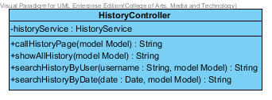**

**Entities**

|  |  |  |  |
| --- | --- | --- | --- |
| **ID** | **NAME** | **DESCRIPTION** | **REMARK** |
| 1 | historyService | This is an object to hold History Service Class. | **TYPE :** HistoryService |

**Method**

|  |  |  |  |
| --- | --- | --- | --- |
| **ID** | **NAME** | **DESCRIPTION** | **REMARK** |
| 1 | callHistoryPage() | This method uses for connecting with History Page. | **Return Type :** String  **Parameters :** model |
| 2 | showAllHistory() | This method uses for showing all history list into History Page. | **Return Type :** String  **Parameters :** model |
| 3 | searchHistoryByUser() | This method uses for searching a history list by using user’s name from database. | **Return Type :** String  **Parameters :** name, model |
| 4 | searchHistoryByDate() | This method uses for searching a product by using date from database. | **Return Type :** String  **Parameters :** date, model |

# Traceability

## Traceability matric between URS/SRS

## Traceability matric between URS/Class Diagram

## Traceability matric between URS/Use cases Diagram

## Traceability matric between URS/Sequence Diagram

## Traceability matric between URS/Method designs

## Traceability matric between SRS/Use cases Diagram

## Traceability matric between SRS/Class Diagram

## Traceability matric between SRS/Sequence Diagram

## Traceability matric between SRS/Method designs

## Traceability matric between Use cases Diagram / Class Diagram

## Traceability matric between Use cases Diagram /Sequence Diagram

## Traceability matric between Use cases Diagram /Method designs

## Traceability matric between Class Diagram/Sequence Diagram

## Traceability matric between Class Diagram/Method designs

## Traceability matric between Sequence Diagram/Method designs