Theia

## Team Members:

| Rupin Jairaj | [rxj200003@utdallas.edu](mailto:rxj200003@utdallas.edu) |
| --- | --- |
| Wenlong Yang | [wxy200000@utdallas.edu](mailto:wxy200000@utdallas.edu) |
| Mohit Anand | [mohit.anand@utdallas.edu](mailto:mohit.anand@utdallas.edu) |
| Sailesh Sriram | [sxs170005@utdallas.edu](mailto:SXS170005@utdallas.edu) |
| Madhura Banerjee | [mxb162730@utdallas.edu](mailto:mxb162730@utdallas.edu) |
| Jeya Visshwak Jeyakumar | [jxj190055@utdallas.edu](mailto:jxj190055@utdallas.edu) |

Team Website

<https://se6361vision.github.io>

For SE6361.001

Professor: Dr. Lawrence Chung

April 19, 2022

# **B. Revision History**

| Version | Date | Updated by | Update Comments |
| --- | --- | --- | --- |
| 1.0 | 27th Jan, 2022 | Team | Initial Doc |
| 1.1 | March 22, 2022 | Team | WRS Template |
| 1.2 | April 19, 2022 | Team | WRS Template |

# 

# **C. Process**

| Participant | Activity | Input | Output | Resources |
| --- | --- | --- | --- | --- |
| all members | slides construction | general project requirements | slides for presentation | requirement specifications from course website |
| all members | interim project | Requirement specifications, presentation slides, feedback from presentation | Interim project documentation | project description and feedback |

# 1 **Introduction**

Theia is a smartphone application that helps visually challenged people navigate the indoors of UTD easily. The application helps contact emergency services in case it detects the user is in need of immediate assistance.

# **2 Issues with preliminary definition given**

## **2.1 Issues with the domain, stakeholders, functional and non-functional objectives**

### **2.1.1 Issue-1**

Description: What if the user is blind and deaf?

Options:

* This application will give user the option to use a customizable braille keyboard that can be attached to the app screen and navigate the user
* This application will utilize a buzzing sound technique that will notify the user where he or she is at respective to the current location and navigate the user that way
* This application uses a combination of both techniques. [selected]

Decision and rationale:

* This team chose the third option, because it utilizes the sense of touch, which the user is presumed to have. By utilizing a buzzing sound technique that informs the user where he or she is at and which way they need to go (e.g. 2 Buzzing Sounds for Going Left, 3 Buzzing Sounds for Going Right, and Hard Buzz for Obstacles), the user can still utilize GPS and the app’s functionality without having to hear anything. Also, a customizable braille keyboard allows for the user to communicate to the app his or her preferences.

### **2.1.2 Issue-2**

Description: What if the secondary stakeholder assistant is not computer savvy?

Options:

* This application will give manuals to secondary stakeholders on how to use the app and set it up. [selected]
* This application offer tutorials for the secondary stakeholder on how to use the app (e.g. Video tutorials or live session)
* This application does both

Decision and rationale:

* A manual will somehow be the better option for the secondary stakeholder. Nowadays, almost every person knows how to operate a smartphone app whether it is on IOS or Android and giving tutorials is time-consuming and sometimes misleading. Rather, a manual can give proper instructions and guide the stakeholder on how to operate it in different situations.

## **2.2 Issues with Software System Requirements: FR**

### **2.2.1 Issue-1**

### Description: Phone damaged and impacting app features

Options:

* Utilizing alternate means to guide user to destination like allowing system to convey user to use his or her walking stick or place call to emergency contact
* Automatic App Refresh
* Combination of both. [selected]

Decision and rationale:

* This team decided to utilize a combination of both of these techniques to handle the issue of phones being damaged and impacting app features. Normally, restarting software is the best solution to do when apps or software freeze or take a while to load up. There might be one logic-hole within the software that can be erased by restarting. However, this does not always happen and sometimes, there is a big error within the design or implementation that needs to be fixed. That is why this team decided that the user should be allowed to firstly restart his or her app through active voice commands and if the issue persists, then the system will notify the user to utilize alternate means like walking sticks or emergency contact calling. The user does not have all day to wait for the error to be resolved by the dev team.

### **2.2.2 Issue-2**

### Description: Not enough charge in battery for app to operate

Options:

* Utilizing alternate means to guide users to their destination like allowing the system to convey user to use his or her walking stick or place call to emergency contact. [selected]
* Have phone connected to a powering device (e.g. Android phones allow this option)
* Making sure the phone is charged before every navigation

Decision and rationale:

* The system must be able to react in-real time. While making sure the phone is charged before every navigation is a viable option, sometimes the phone does not charge as fast as expected, especially with aging phones. Also, iPhones do not have the powering device capability; therefore, it is impossible to use that solution for every smartphone. That is why when the charge reaches below a certain limit, the system shall convey to the user to use his or her walking stick or place a call to the emergency contact.

### **2.2.3 Issue-3**

### Description: Intermittent GPS issues.

Options:

* Utilizing alternate means to guide the user to destination like allowing the system to convey user to use his or her walking stick or place call to emergency contact. [selected]
* Using number of steps and distance to calculate how far user is from destination
* Use the system's knowledge of the map of the building to indicate the number of steps to the next braille. [selected]
* Having user restart the app functionality

Decision and rationale:

* Software can run into many unexpected issues. If it uses GPS, then definitely there can be problems with accuracy and connections. Since the main functionality of the app is navigation, when GPS isn’t working, then the user will be lost. That is why this team has the app direct the user towards using his walking stick or placing a call to emergency contact during these issues so he can get to his destination safely without any hassle. Also, since GPS is only accurate beyond a certain distance, the system won’t be accurate in navigating to destinations that are close to the current location of the user. That is why this team utilizes the system’s knowledge of the building map to guide the user to the nearest braille. If this team uses the number of steps and distance to calculate how far the user is from the destination, there will be some errors to account for like the step size of the user and whether he has moved forward or not; hence, this team did not pick that option. This team also did not have the user restart the app functionality because there will be no one to help him do so when the user faces GPS issues during the navigation.

### **2.2.4 Issue-4**

### Description: How will the system know maintenance activities? (e.g., Restroom maintenance, new building)

Options:

* Actively identifying bathroom maintenance or wet floor signs through image detection features and calculating paths around the maintenance area. [selected]
* Automatic updates to the system when maintenance is being done within the building. System is connected to the email of the user and UTD APIs.

Decision and rationale:

* This team chose to use image classification to handle this issue. The system needs to know how to respond in real-time, because issues mainly become prevalent on-the-spot. First of all, the system can receive automatic updates when maintenance is being done within the building, but wet floor signs and other smaller construction work may not be notified to the system. That will cause a huge problem for the user because he or she is dependent on the system and the system does not know how to handle the obstacle. Rather, this team chose the first option, because the system will actively spot obstacles during the navigation, inform the user what kind of obstacle is in front of them, and calculate a path that the user can take to avoid that obstacle. It will react on the spot rather than having to be prepared beforehand, which is much safer for the user to utilize.

### **2.2.5 Issue-5**

### Description: How will the system handle static and dynamic obstacles?

Options:

* Calculate path around static obstacle. [selected]
* Have user stop when any sort of obstacle is detected
* Have the user slow or speed up his pace and direction depending on velocity of the obstacle. [selected]

Decision and rationale:

* This team chose to calculate a path around when a static obstacle is detected. The second option won’t work in this case because the obstacle such as a wet floor sign won’t move so therefore, the user has to move around it. But in a dynamic obstacle environment, people are moving at different paces and this team cannot have the user stop every time or else it ruins the NFR of reaching the destination in the fastest manner. That is why the system coordinates the user to adjust his pace or direction depending on the velocity of the obstacle so he can reach the destination faster and safely.

## **2.3 Issues with Software System: NFR**

### **2.3.1 Issue-1**

### Description: If secondary contact does not attend the call, should the call be forwarded to the police?

Options:

* Allowing access to user’s contacts and allowing user to say who they want to contact
* Have call go to the UTD police
* Have the user decide
* Have the call go to the UTD police if the user is unconscious; else, have the user decide. [selected]

Decision and rationale:

* If the user were conscious, then he or she should decide who to call based on the given circumstances. Having the police come for non-emergency situations is a big hassle. However, if the user were to be unconscious, then he or she would not have a say in who to call. They would need help immediately. That is why having the call go to the UTD police would be the best option.

### **2.3.2 Issue-2**

Description: How fast should the app respond to emergency situations and commands issued by the user?

Options:

* Fast enough that the user gets what he needs on time. Immediately calling the police when an emergency is detected. [selected]
* Some latency to decide the best option given the circumstances
* A combination of both

Decision and rationale

* The system is smart enough to know when there is an emergency or not. And this team is talking about life matters here. The system is hooked up to the email system and has active fall detection. That is why the system should take immediate steps to call the police when an emergency is detected and not allow for any latency, which can be life-threatening for the user.

### **2.3.2 Issue-3**

Description: How often should the user change their phones to meet the minimum hardware specification?

Options:

* If the phone’s hardware or software does not meet the minimum specification to run the app, the user must update or change his or her phone. Somewhat frequently. [selected]
* The user does not need to change their phones because their phones are smartphones and are the most up-to-date tech

Decision and rationale

* While this team does have the assumption that the user will use smartphones, not all smartphones have the most up-to-date software or hardware. Some newer devices may be running older software and phones naturally slow down after a while. Therefore, it is important for the user to change the phone or update the software somewhat frequently to run the app.

…

# **3. WRS**

## 3.1 W

### 3.1.1 Problem

Navigation techniques have a huge impact on people’s daily lives. Compared to people without eyesight problems, the visually-impaired community has greater difficulty in navigating, especially in terms of indoor navigation. Using a cane, having a service dog aside and the braille indicator can assist to some extent. However, the risk is still relatively high and this solution is not intelligent enough. For instance, a cane might fail to successfully detect an obstacle that is attached to the wall and is a half meter above the ground. Meanwhile, neither a cane nor a service dog can tell the visually impaired person the correct path to follow in order to reach a specific destination.

### 3.1.2 Goal

The general purpose of this project is to create a smartphone app to help visually-impaired people navigate indoors. In comparison with a service dog, cane and the braille, this application applies advanced electronic sensors to ensure improved efficiency, enhanced security and more comprehensive functionalities. To navigate a user from one location to another, this system would indicate the direction to walk towards, calculate the approximate distance or steps, and notify the user to avoid any detected obstacles. In addition, this application also aims to achieve higher efficiency by choosing short paths for a user to follow. In this document, detailed system specifications will be respectively discussed.

### 3.1.3 Improved understanding of Domain, Stakeholders, Functional and Non-Functional Objectives

#### Domain:

* Application uses the phone’s camera sensor for visual input.
* Application uses the phone’s GPS to accurately (up to 3ft) figure out the current location of the user.
* The user hangs his/her phone around his/her neck with the camera sensors facing the front.

#### Stakeholders:

| For | Visually challenged people, People assisting visually challenged people set up the application. |
| --- | --- |
| By | Requirement Engineers, Software Architect, Testers. |
| Of | Team. |

#### Functional Objectives:

* Navigation - The system shall calculate the shortest path from the user’s current location to the desired target destination.
* Obstacle detection - The system shall alert the user of any obstacles that are in their path.
* Contact emergency service - The system shall contact emergency services in case of an emergency.

#### Non-Functional Objectives:

The primary objective is to ensure the system provides safe navigation and shall always be reliable.

## **3.2 RS**

### **3.2.1 Functional RS**

| FR-1 | The app shall continue to stay in foreground once opened. |
| --- | --- |
| FR-2 | The app shall calculate the most convenient path from the current location to the destination. |
| FR-3 | The app shall be able to detect an obstacle and determine how to avoid it. |
| FR-4 | The app shall be able to place an emergency call to the secondary contact. |
| FR-5 | The app shall allow users to choose a route based on their own comfortability. |
| FR-6 | The app shall allow users to customize their emergency protocol in case something happens. |
| FR-7 | The app shall pass Section 508 accessibility requirements. |
| FR-8 | The app shall recognize images (standard warning signs) for obstacle detection. |
| FR-9 | The app shall give the user an estimated time of arrival. |

### 

### **3.2.2 Non-functional RS**

| NFR-1 | Supportability - The user shall install the app in a real-time environment. |
| --- | --- |
| NFR-2 | User-Friendly - The user shall access the app easily with no additional guidance required. |
| NFR-3 | Reliability - The app shall perform all tasks without failure. |
| NFR-4 | Enhanceability - The system shall offer updates easily whenever a newer version is available. |
| NFR-5 | Responsiveness - The app shall respond with a quick response time. |
| NFR-6 | Adaptability - The app shall work irrespective of the environment. |
| NFR-7 | Understandability - The app shall have a simple user interface and a clear user-manual. |
| NFR-8 | Customizable - The app shall be customized as per the user’s preferences. |
| NFR-9 | Reusability - The app shall be reused to improve its capabilities |
| NFR-10 | Useability - The app shall be easily controlled via user inputs. |

# **4. Preliminary Prototype and User Manual**

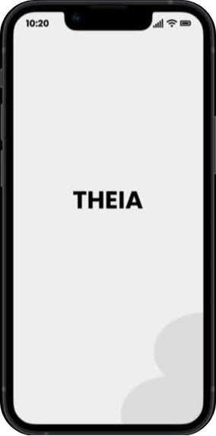 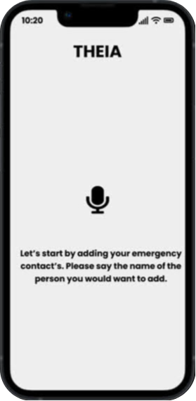 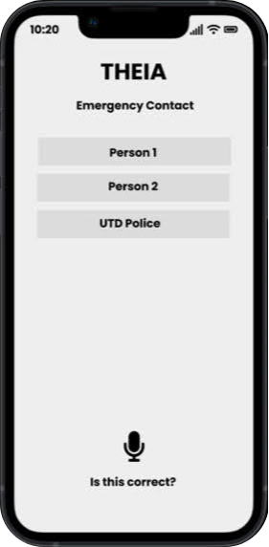

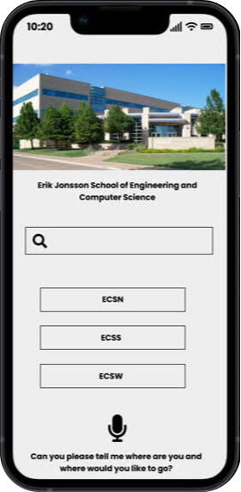 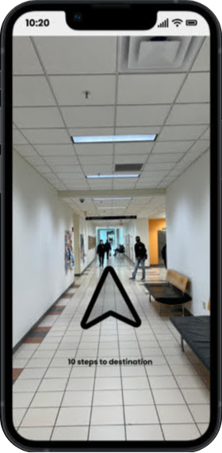 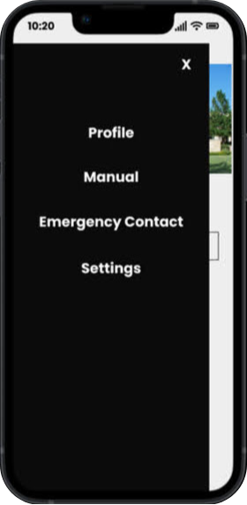

# **5. Traceability**

## **5.1 FR-NFR**

|  | FR-1 | FR-2 | FR-3 | FR-4 | FR-5 | FR-6 | FR-7 | FR-8 | FR-9 |
| --- | --- | --- | --- | --- | --- | --- | --- | --- | --- |
| NFR-1 | + |  |  | + |  |  |  | + | + |
| NFR-2 |  | + |  | + | + | + |  |  |  |
| NFR-3 | + | + | + | + | + |  |  | + | + |
| NFR-4 |  |  |  |  |  |  |  | + |  |
| NFR-5 | + |  | + | + | + | + |  | + | + |
| NFR-6 |  |  |  |  | + |  |  |  | + |
| NFR-7 |  |  |  |  | + | + |  |  | + |
| NFR-8 |  |  |  |  |  |  |  | + |  |
| NFR-9 |  |  |  |  |  | + |  |  |  |
| NFR-10 |  | + |  | + | + | + |  |  |  |

# 

# References

* Team Website:
  + <https://se6361vision.github.io>
* Project Scope:
  + <https://personal.utdallas.edu/~chung/RE/Project1.pdf>
  + <https://personal.utdallas.edu/~chung/RE/Project2.pdf>
* Course Home Page:
  + <https://personal.utdallas.edu/~chung/RE/syllabus.htm>
* Definitions, acronyms, and abbreviations:

Abbreviations:

* FR: Functional Requirements
* NFR: Non-Functional Requirements
* WRS: World Requirements Specifications
* UTD: University of Texas at Dallas
* GPS: Global Positioning System

# Appendix

# Index

Team Members: 1

**B. Revision History** **2**

**C. Process** **2**

**1 Introduction** **3**

**2 Issues with preliminary definition given** **3**

2.1 Issues with the domain, stakeholders, functional and non-functional objectives 3

2.1.1 Issue-1 3

2.1.2 Issue-2 3

2.2 Issues with Software System Requirements: FR 4

2.2.1 Issue-1 4

Description: Phone damaged and impacting app features 4

2.2.2 Issue-2 5

Description: Not enough charge in battery for app to operate 5

2.2.3 Issue-3 5

Description: Intermittent GPS issues. 5

2.2.4 Issue-4 6

Description: How will the system know maintenance activities? (e.g., Restroom maintenance, new building) 6

2.2.5 Issue-5 6

Description: How will the system handle static and dynamic obstacles? 6

2.3 Issues with Software System: NFR 7

2.3.1 Issue-1 7

Description: If secondary contact does not attend the call, should the call be forwarded to the police? 7

2.3.2 Issue-2 7

2.3.2 Issue-3 8

**3. WRS** **8**

3.1 W 8

3.1.1 Problem 8

3.1.2 Goal 9

3.1.3 Improved understanding of Domain, Stakeholders, Functional and Non-Functional Objectives 9

Domain: 9

Stakeholders: 9

Functional Objectives: 9

Non-Functional Objectives: 10

3.2 RS 10

3.2.1 Functional RS 10

3.2.2 Non-functional RS 10

**4. Preliminary Prototype and User Manual** **11**

**5. Traceability** **12**

5.1 FR-NFR 12

**References** **13**

**Appendix** **13**

**Index** **13**