Theia

Vision

Version 1.0

## Team Members:

| Rupin Jairaj | [rxj200003@utdallas.edu](mailto:rxj200003@utdallas.edu) |
| --- | --- |
| Wenlong Yang | [wxy200000@utdallas.edu](mailto:wxy200000@utdallas.edu) |
| Mohit Anand | [mohit.anand@utdallas.edu](mailto:mohit.anand@utdallas.edu) |
| Sailesh Sriram | [sxs170005@utdallas.edu](mailto:SXS170005@utdallas.edu) |
| Madhura Banerjee | [mxb162730@utdallas.edu](mailto:mxb162730@utdallas.edu) |
| Jeya Visshwak Jeyakumar | [jxj190055@utdallas.edu](mailto:jxj190055@utdallas.edu) |

# 

Revision History

| **Date** | **Version** | **Description** | **Author** |
| --- | --- | --- | --- |
| 19/04/2022 | 1.0 | Initial version | Team |
|  |  |  |  |
|  |  |  |  |
|  |  |  |  |

Table of Contents

1. **Introduction** **6**

1.1 Purpose 6

1.2 Scope 6

1.3 Definitions, Acronyms, and Abbreviations 6

1.4 References 6

1. **Positioning** **6**

2.1 Business Opportunity 6

2.2 Problem Statement 6

2.3 Product Position Statement 7

1. **Stakeholder and User Descriptions** **7**

3.1 Market Demographics 7

3.2 Stakeholder Summary 8

3.3 User Summary 9

3.4 User Environment 9

3.5 Stakeholder Profiles 9

3.5.1 Caretaker 9

3.5.2 Blind Person 9

3.6 User Profiles  10

3.7 Key Stakeholder or User Needs 10

3.8 Alternatives and Competition 11

3.8.1 Sullivan+Lookout by Google 11

3.8.2 BlindSquare 11

1. **Product Overview** **12**

4.1 Product Perspective 12

4.2 Summary of Capabilities 12

4.3 Assumptions and Dependencies 13

4.4 Cost and Pricing 13

4.5 Licensing and Installation 13

1. **Product Features** **13**

5.1 View Initial Screen 13

5.2 Create an emergency contact 14

5.3 View Home Screen 14

5.4 View Sidebar Screen 14

5.5 View Profile 14

5.6 View Manual 14

5.7 View Emergency Contact 14

5.8 View Settings 14

5.9 Change Name in Profile 14

5.10 Add a New Emergency Contact 14

5.11 Change Route Option- Elevator Only in Settings 14

5.12 Input ECSN 2.102 Destination 14

5.13 Speak ECSW 4.302 Destination 15

5.14 Hear the Sequence- Directions to Destination ECSW 4.302 15

5.15 Hear the Sequence- Calling Jack 15

5.16 Hear GPS Obstacle Detection and Rerouting 15

5.17 Change Emergency Contact Prioritization via Voice Command 15

5.18 View Recent Locations 15

5.19 Hear the Sequence - It looks like you’ve taken a hard fall. Calling UTD Police now. 15

5.20 Cont’d from 5.19 - Speak “I’m OK” to Fall Detection Alert 15

5.21 Turn on Braille Keyboard Option 15

5.22 View Fastest Route Option 15

5.23 Customize Approaching Obstacle Warning to Vibration 16

5.24 Customize Reached Destination Setting to Turn Off App 16

5.25 Speak the Sequence - “I need to use the restroom, where’s the nearest one?” 16

1. **Constraints** **16**
2. **Quality Ranges** **16**
3. **Precedence and Priority** **16**
4. **Other Product Requirements** **16**

9.1Applicable Standards 16

9.2 System Requirements 17

9.3 Performance Requirements 17

9.4 Environmental Requirements 17

1. **Documentation Requirements** **17**

10.1 User Manual 17

10.2 Online Help 19

10.3 Installation Guides, Configuration, and Read Me File 19

10.4 Labeling and Packaging 19

**A Feature Attributes** **19**

A.1 Status 19

A.2 Benefit 19

A.3 Effort 20

A.4 Risk 20

A.5 Stability 20

A.6 Target Release 20

A.7 Assigned To 20

A.8 Reason 20

**References** **21**

Vision

# Introduction

## Purpose

The purpose of this document is to collect, analyze, and define high-level needs and features of the application Theia. It focuses on the capabilities needed by the stakeholders and the target users, and **why** these needs exist. The details of how Theia fulfills these needs are detailed in the use-case and supplementary specifications.

## Scope

This vision document applies to Theia which will be developed by our team. The team will develop this smartphone-based application to allow visually challenged users to navigate the UTD campus and interface with existing UTD emergency services to allow the primary users to get assistance as quickly as needed.

## Definitions, Acronyms, and Abbreviations

* UTD - the University of Texas at Dallas
* GPS - Global Positioning System

## References

WIP

[This subsection provides a complete list of all documents referenced elsewhere in the **Vision** document. Identify each document by title, report number if applicable, date, and publishing organization. Specify the sources from which the references can be obtained. This information may be provided by reference to an appendix or to another document.]

# Positioning

## Business Opportunity

Providing access to all parts of the campus for the visually challenged will make UTD an attractive destination for visually challenged students to pursue their education goals. The primary user will be able to easily navigate in and around campus buildings and have easier access to campus features like the library, restrooms, food courts, etc. This system will provide these features and more to ensure safe and easy navigation for the visually challenged.

## Problem Statement

| The problem of | safe and quick navigation on the UTD campus |
| --- | --- |
| affects | the visually challenged people |
| the impact of which is | uncertainty in the safety and path to take to move around campus |
| a successful solution would be | a smartphone application that can aid the user in navigating from their current location on campus to their desired destination. The application would support calling emergency services or an emergency contact in case the user is in need of immediate assistance. |

## Product Position Statement

| For | Visually challenged people |
| --- | --- |
| Who | need assistance navigating the UTD campus safely and quickly |
| Theia | is a smartphone application |
| That | provides route navigation and object detection to provide the shortest and safest path to traverse from the current position to the destination |
| Unlike | using a cane, service dog or relying on solutions like indoor google maps |
| Our product | offers safe and updated routes to navigate around campus, takes into account construction sites on route and warns or automatically selects a different path. The system uses computer vision to alert the user of any warning signs that lay ahead. The system also provides the user with the functionality to contact emergency services when required. |

# Stakeholder and User Descriptions

## Market Demographics

The market for visually impaired technologies is around 1 billion dollars (Assistive technologies for visually impaired market size and forecast 2021). People who are visually impaired face challenges in the socioeconomic spectrum and need the right resources to alleviate lower levels of employment, health care, and job opportunities (Assistive technologies for visually impaired market size and forecast 2021). Our organization Theia does not have as big a reputation as companies Smart Glasses and Magnifying Lenses in the market (They own the largest share in the market); however, this team believes it is possible to alleviate visually impaired people’s challenges so they can also have an equal footing as healthy people (Assistive technologies for visually impaired market size and forecast 2021). This team remains a growing company.

This team likes for our app to grow beyond the walls of UTD. This team want our app to scale so it can be used by millions of users worldwide. Plus, the power of the cloud allows our app to be utilized by many users simultaneously through Auto-Scale features. Also, our app utilizes GPS and is interchangeable and malleable to fit the needs of different types of visually impaired people. Therefore, this team wants our app to be the main navigation guide that walking sticks and dogs are to blind people right now.

Our main goal is to be the solution for the problems that visually impaired people face in life. This product supports our goal by helping visually impaired people navigate to where they want to go and help them achieve their goals in life.

## Stakeholder Summary

| **Name** | **Description** | **Responsibilities** |
| --- | --- | --- |
| The Blind Person Caretaker | The person who assists the blind person with setting up the app and is possibly one of the emergency contacts | * Ensures that the system is operational for the blind person to use * Ensures that there is enough charge in the phone * Ensures that the blind person is ready with all the setup before navigating to his destination |
| UTD Police | One of the emergency contacts for blind person in case of any injury or other circumstances like bad weather or power outage | * Ensures that the blind person gets the proper help on time * Comes to the aid of blind person when in need * Ensures that blind people are safe when in danger |
| Software Engineering Team (Development, Testing, and Release) | The team(s) that develops the app and puts it in production | * Ensures that the app fulfills the problem to be solved * Ensures that the app meets all the Functional and Non-Functional Requirements * Ensures that the app is tested for significant and non-significant bugs * Ensures that the app is pushed to the production environment for end-users to use |
| Project Manager | Leading the development of the navigation system | * Plans out the resources to be used by each team * Coordinates with customers and users on project updates * Establishes a set of practices like Agile to ensure deliverables are delivered on time |

## User Summary

| **Name** | **Description** | **Responsibilities** | **Stakeholder** |
| --- | --- | --- | --- |
| Blind Person | End-User of System | * Utilizes system for navigation * Defines where to go and chooses the best path that the system gives to destination based on different factors * Chooses emergency contact to call in emergency situations | Self |
| Product Owner | End-User of System | * Utilizes system for navigation * Defines where to go and chooses the best path that the system gives to destination based on different factors * Choose emergency contact to call in emergency situations | Self |

## User Environment

The target user has a working environment that involves him only. While the user is helped by his or her caretaker before using the system to navigate, the number of people involved to complete the task is only 1 and that is the end-user. A task cycle depends on the number of minutes it takes for the end-user to go from the start location to the destination location. It is never constant, because the visually impaired person will go to different locations based on his or her schedule. Also, the person will only be using the system to travel indoors. There are some unique environmental constraints in that there will be stairs and obstacles for the visually impaired person to cross before he reaches the destination. The ability to identify and help the visually impaired person navigate through these obstacles is integrated within the system. Also, the system is only operational through mobile and not web so it is mandatory that the user has a smartphone that is compatible with running the app. IOS and Android are the system platforms that the app can run on. Any future platform to be used depends on any other popular mobile OS that comes out in the future. Some other applications that are in use are GPS and the UTD Emergency System and our application integrates with them through their APIs.

## Stakeholder Profiles

### **Caretaker**

| **Representative** |  |
| --- | --- |
| **Description** | A private individual that will help the visually challenged user set up their preferences for Theia. |
| **Type** | This is a casual user who knows how to operate a smartphone and can make system specific preference changes if required. |
| **Responsibilities** | The caretaker’s input is key to the design decisions on the application. |
| **Success Criteria** | Success is completely defined by the caretaker being able to successfully modify the application preferences based on the needs of the visually challenged user. |
| **Involvement** | This team will have a focus group of caretakers to review our user interface. |
| **Deliverables** |  |
| **Comments Issues** |  |

* + 1. **Blind Person**

| **Representative** |  |
| --- | --- |
| **Description** | A private individual that will use the application to navigate the UTD campus safely. |
| **Type** | This is a casual user who knows how to use a smartphone with accessibility features like the braille keyboard enabled. |
| **Responsibilities** | Ensure that the features provided by Theia allow for a safe navigation of UTD. |
| **Success Criteria** | Success is completely defined by the user being an active daily user of the application. |
| **Involvement** | We will have a focus group to review our features and guide our improvements to the system. |
| **Deliverables** |  |
| **Comments Issues** |  |

## User Profiles Refer to section 3.5.1 and 3.5.2

## Key Stakeholder or User Needs

Problem: (How to detect falls and injuries?)

If the blind person falls and gets injured, he or she will need to contact the police and ambulance as soon as possible. Existing solutions on many Android devices have this feature but are not integrated with an app that also helps with navigation(How it works - fallsafety with fall detection and fall alerts 2020). The integration is really important when the blind person must safely reach his or her destination. Plus, the fall detection feature in Android apps take up to 45 seconds before a call or email is sent to the police, which is longer than what is actually needed (How it works - fallsafety with fall detection and fall alerts 2020).

This team has integrated the fall-detection feature, similar to ones already used, within our app to spot falls and injuries while navigating, which is really important. Plus this team has reduced the time to 20 seconds before a call is sent to the police to make sure that the blind person gets what he needs on time.

The stakeholder wants an efficient and safe travel to the destination and the visually impaired person will get the correct help on time. Our solution will ensure this in the correct manner.

Problem: (Handling of Obstacle Detection)

A lot of apps like Google and Sullivan+ offer image detection but are not entirely accurate and limited in what they can identify (Nanou, 8 essential apps to help the blind and visually impaired navigate better 2021). This will present a problem for the end-user in that they won’t know what action steps to take to cross the obstacle if they don’t even sometimes know what it is.

This team has trained our system over more than 200 images, which are potential obstacles that appear indoors. Our system finds a better path to cross the obstacle and tells the user what to do in the case of encountering one. Some obstacles may be static and some may be dynamic. Active identification with good accuracy is helpful in that it provides more information to the end-user and gives him the decision to choose alternative paths around the obstacle.

The stakeholders want the user to safely reach the destination and want active identification of obstacles that allows the user to decide what alternative path he or she wants to take. The stakeholders also want this to be dynamic considering obstacles can pop out any time anywhere. Therefore, this solution matches what they want.

[It is important to understand the **relative** importance the stakeholder or user places on solving each problem. Ranking and cumulative voting techniques indicate problems that **must** be solved versus issues they would like addressed.

Fill in the following table—if using Rational RequisitePro to capture the Needs, this could be an extract or report from that tool.]

| **Need** | **Priority** | **Concerns** | **Current Solution** | **Proposed Solutions** | |
| --- | --- | --- | --- | --- | --- |
| Broadcast messages |  |  |  | |  |

## Alternatives and Competition

### **Sullivan+Lookout by Google**

* Strengths: Can identify objects and text (Nanou, 8 essential apps to help the blind and visually impaired navigate better 2021)
* Weaknesses: Does not help with navigation from one location to another and is simply an identification of environment tool (Nanou, 8 essential apps to help the blind and visually impaired navigate better 2021)
  + 1. **BlindSquare**
* Strengths: Communicates to users via voice, determines your current location, tracks and marks the locations you’ve been to using GPS, having filters to make it malleable for different users (What is blindsquare?)
* Weaknesses: Does not have ability to integrate to a user schedule (What is blindsquare?)
* Unknown: Active obstacle detection (What is blindsquare?)

# Product Overview

## Product Perspective



***Figure 1 Overview of the architecture of Theia***

## Summary of Capabilities

**Table 4-1 Customer Support System**

| **Customer Benefit** | **Supporting Features** |
| --- | --- |
| Secure access to the system. | The system shall use UTD SSO. |
| Convenient and accessible. | The system shall provide accessibility across the application using both voice control and braille keyboard. |
| System responds quickly. | The system shall respond with the best possible navigation instructions to reach the destination within 4 seconds. All object detection and warning sign detections functionality will run on the user’s smartphone ensuring a much quicker response than a round trip request made to the server. |
| Scalable. | The system can handle a large number of users making simultaneous requests since it only needs to calculate the path and object detection is offloaded to the user’s smartphone. |
| Contact emergency services.. | The system shall allow the user to contact emergency services or their preferred emergency contact when they request for it via voice or braille keyboard input.  The system shall contact the UTD emergency services in case it detects the user has fallen or is not responsive. |

## Assumptions and Dependencies

* The smartphone meets the minimum hardware requirements, i.e., camera, gyroscope, GPS.
* The smartphone is connected to a stable internet connection (Carrier data/WiFi).
* The smartphone is running either iOS or Android.
* The user is wearing a pair of earphones paired with the smartphone running the application.

## Cost and Pricing

TBD

## Licensing and Installation

The application will be made available via the application store of major mobile operating systems (App Store for iOS and Play Store for Android). The system will use UTD SSO to avoid additional development overhead of managing user accounts and credential information.

# Product Features

## View Initial Screen

Users will be able to add their emergency contacts. A microphone icon is displayed on this page.

## Create an emergency contact

Users will be able to click on the microphone icon, state the emergency’s contact name, phone number and relationship. They can add up to three and UTD Police will be defaulted as priority number one.

## View Home Screen

Users will be able to access the home screen easily. There will be a search box for a user to input a destination, a list of recent destinations for quick access, and a microphone icon for a user to speak into.

## View Sidebar Screen

Four buttons are shown: Profile, Manual, Emergency Contact and Settings. Users will be able to click on the button and it will send them to the designated page.

## View Profile

Users will be able to see information about themselves such as Name, Address, Cell Phone Number. There will be an option to Delete Account.

## View Manual

Users will be able to view instructions on how to use the Theia app.

## View Emergency Contact

Users will be able to view listed Emergency Contacts and their respective information - Name, Phone Number, Relationship.

## View Settings

Users will be able to view different settings such as text size, background color, font color, route options, obstacle warnings.

## Change Name in Profile

Users will click on the Sidebar, Profile, then edit their name.

## Add a New Emergency Contact

A user will click on the Sidebar, Emergency Contact button, plus sign, add in new emergency contact information.

## Change Route Option- Elevator Only in Settings

Users will go to the Sidebar and click on the Settings button. Then change the route option to ‘Elevator Only’ according to their needs.

## Input ECSN 2.102 Destination

Users will go to the Home Page, click on the destination search bar, input ECSN 2.102 via braille keyboard.

## Speak ECSW 4.302 Destination

Users will go to Home Page and say “ I want to go to ECSW 4.302”

## Hear the Sequence- Directions to Destination ECSW 4.302

Users will hear “Starting route to ECSW 4.302. Head north on Rutford Ave for 0.2 miles”

## Hear the Sequence- Calling Jack

Users will hear “Calling Jack”.

## Hear GPS Obstacle Detection and Rerouting

Users will be notified by the GPS - “Warning: Person detected. Please stop and move 2 steps to the right.”

## Change Emergency Contact Prioritization via Voice Command

Users will tap on the microphone icon and say “I want to edit my Emergency Contacts”. The app will take the user to the page and ask, “what would you like to do?” User will say “Change Jack to first and Maria to second.”

## View Recent Locations

Users will go to home page and see the last three locations they have been to

## Hear the Sequence - It looks like you’ve taken a hard fall. Calling UTD Police now.

Users will hear “It looks like you’ve taken a hard fall. Calling UTD Police now.”

## Cont’d from 5.19 - Speak “I’m OK” to Fall Detection Alert

If a user is ok and doesn’t not want to call the police, this user will say “I’m OK” which will cancel the call.

## Turn on Braille Keyboard Option

A user will go to the Sidebar, Settings, and turn on the Braille keyboard.

## View Fastest Route Option

A user will input their destination and the app will alert the first option as the fastest route.

## Customize Approaching Obstacle Warning to Vibration

A user will go to the Sidebar, settings, and change from phone ringing to vibration.

## Customize Reached Destination Setting to Turn Off App

User will go to Sidebar, settings, and select ‘turn off app’

## Speak the Sequence - “I need to use the restroom, where’s the nearest one?”

A user will say “I need to use the restroom, where’s the nearest one?” and the app will calculate the best route to the restroom and direct the user.

# Constraints

**6.1** The phone has a limited battery supply.

**6.2** In a power outage, the app might not function well due to being kicked off wi-fi (user might not have unlimited data)

**6.3** The user must have an updated phone/software to meet the minimum specification

# Quality Ranges

The application will provide top-quality performance, robustness, fault tolerance, usability, and similar characteristics

# Precedence and Priority

Safety of the user will be given the highest and top-most priority and hence all the features related to safety are of the highest importance.

# Other Product Requirements

In this section, additional requirements related to applicable standards, platform, performance and environment will be respectively specified.

## Applicable Standards

Unified Standards: Uniform Commercial Code (UCC), The Privacy Act of 1974

Communication Standards: TCP/IP

Platform Standards: Android and iOS

Safety Standards: ISO, CMM

## System Requirements

On Android platform, the system version shall be Android 9 (Pie) or newer, with RAM no less than 4 GBs. On iOS platform, the system version shall be iOS 11 or newer with RAM equal or greater than 3 GBs.

## Performance Requirements

In general, the response time of obstacle detection shall be no longer than 0.2 second. When it comes to calculating an optimal path from the current location to one destination, the response time shall be no longer than 1.5 seconds.

## Environmental Requirements

This app shall be equipped with a regular camera, depth detection sensors such as lidar and ToF, and gyroscope. The ideal temperature for devices running this application is between -20º and 45º C (-4º to 113º F).

# Documentation Requirements

In this part, instructions and guidelines will be specified. In addition, how this app will evolve in the future will also be mentioned.

## User Manual

This document aims to aid users to get acquainted with the services provided by this application. Users will get familiar with different icons and interaction methods.

**Setup**

Firstly, the person who takes care of the visually impaired shall help the user set up relevant profile information. For the first time, the system will represent a welcome message and instruct the caretaker to fill out the user profile step by step, as shown in Figure 2. Once the setup is finished, the user should hang the phone on his/her chest, with the backside (sensor side) facing the front, and wear earphones if needed. To start navigation, the caretaker can press the Navigate button or the user can long press anywhere except the information icon for more than 5 seconds.

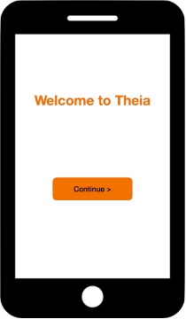 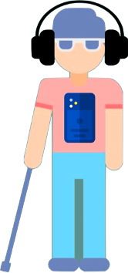 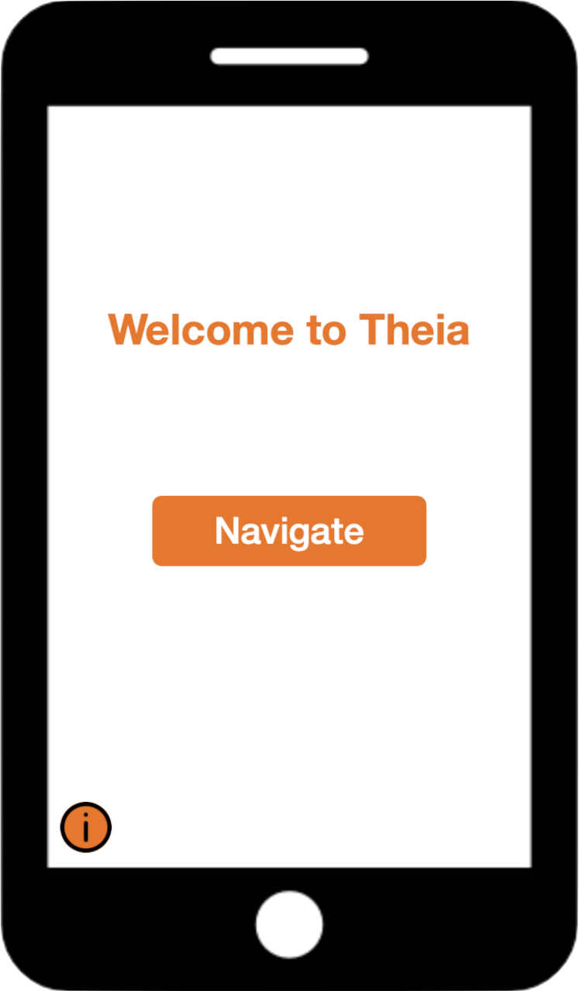

***Figure 2: Initial Setup Figure 3: Hanging Phone Figure 4: Main page***

**Functionalities**

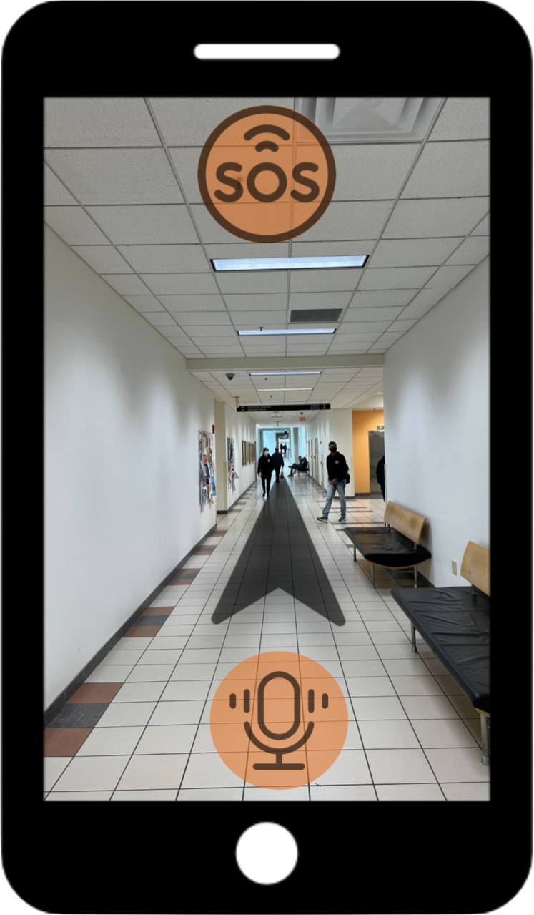

***Figure 5: Navigating***

As shown in Figure 5 above, while navigating, this app works as the mock-up shown above. There will be a black pointer in the center, rotating to point out the correct direction this user should walk towards. While approaching an obstacle, the phone will vibrate more intensely while approaching closer, and the headphones will instruct the user to avoid the collision. To reach another destination, the user only needs to hold the microphone button and tell this application the new place. For usability concerns, the voice control will be activated if the user long presses the lower 1/3 screen area for more than 5 seconds. If the user encounters an emergency, this user can long press the upper ⅓ screen area for more than 5 seconds to activate emergency assistance.

Hint: although the developers do not expect the user to see the screen, this image data is still needed for future improvements on product iterations.

## Online Help

This team significantly evaluates users’ feedback and exhausts every possibility to surmount any difficulty encountered by any user. In the information page, there is a ‘contact us’ section, through which the caretaker can start a live chat or leave a message to inquire about specific issues. In the meantime, all solved inquiries will be listed in the ‘Q&A’ page.

## Installation Guides, Configuration, and Read Me File

This application would be available for download in iOS App Store and Google Play. A start-up tutorial page will automatically show up when users open this software for the first time and when downloading new releases containing new features.

## Labeling and Packaging

Since it is an application for visually challenging people, this team seeks to make the user interfaces concise, simple and consistent. All non-navigation related contents are classified into an information page, which is usually accessed by a respective caretaker. In the information page, corresponding copyright, patent notices and related user policies can be found.

# A Feature Attributes

## A.1 Status

[Set after negotiation and review by the project management team. Tracks progress during definition of the project baseline.]

| Proposed | Finding the most optimal path, Moving obstacle detection, Idle obstacle detection, Fall detection, Emergency calling |
| --- | --- |
| Approved | Fall detection, Emergency calling |
| Incorporated | [Features incorporated into the product baseline at a specific point in time.] |

## A.2 Benefit

[Set by Marketing, the product manager or the business analyst. All requirements are not created equal. Ranking requirements by their relative benefit to the end user opens a dialog with customers, analysts, and members of the development team. Used in managing scope and determining development priority.]

| Critical | Emergency calling, Fall detection |
| --- | --- |
| Important | Idle obstacle detection, Moving obstacle detection |
| Useful | Finding the most optimal path |

## A.3 Effort

[Set by the development team. Because some features require more time and resources than others, estimating the number of team or person-weeks, lines of code required or function points, for example, is the best way to gauge complexity and set expectations of what can and cannot be accomplished in a given time frame. Used in managing scope and determining development priority.]

## A.4 Risk

[Set by development team based on the probability the project will experience undesirable events, such as cost overruns, schedule delays or even cancellation. Most project managers find categorizing risks, as high, medium, and low, is sufficient, although finer gradations are possible. Risk can often be indirectly assessed by measuring the uncertainty (range) of the projects team’s schedule estimate.]

## A.5 Stability

[Set by the analyst and development team, this is based on the probability that features will change or the team’s understanding of the feature will change. Used to help establish development priorities and determine those items for which additional elicitation is the appropriate next action.]

## A.6 Target Release

[Records the intended product version in which the feature will first appear. This field can be used to allocate features from a **Vision** document into a particular baseline release. When combined with the status field, your team can propose, record, and discuss various features of the release without committing them to development. Only features whose Status is set to Incorporated and whose Target Release is defined will be implemented. When scope management occurs, the Target Release Version Number can be increased so the item will remain in the **Vision** document but will be scheduled for a later release.]

## A.7 Assigned To

[In many projects, features will be assigned to "feature teams" responsible for further elicitation, writing the software requirements, and implementation. This simple pull-down list will help everyone on the project team to understand responsibilities better.]

## A.8 Reason

[This text field is used to track the source of the requested feature. Requirements exist for specific reasons. This field records an explanation or a reference to an explanation. For example, the reference might be to a page and line number of a product requirement specification or to a minute marker on a video of an important customer review.]

# References

* Assistive technologies for visually impaired market size and forecast. Verified Market Research. (2021, December 16). Retrieved April 18, 2022, from https://www.verifiedmarketresearch.com/product/assistive-technologies-for-visually-impaired-market/#:~:text=According%20to%20Verified%20Market%20Research,6.92%25%20from%202021%20to%202028
* How it works - fallsafety with fall detection and fall alerts. Health & Safety solutions for Work and for Home. (2020, September 5). Retrieved April 18, 2022, from https://fallsafetyapp.com/how-it-works
* What is blindsquare? BlindSquare. (n.d.). Retrieved April 18, 2022, from https://www.blindsquare.com/about/
* Nanou, E. (2021, April 21). 8 essential apps to help the blind and visually impaired navigate better. MUO. Retrieved April 18, 2022, from https://www.makeuseof.com/apps-for-blind-and-visually-impaired/

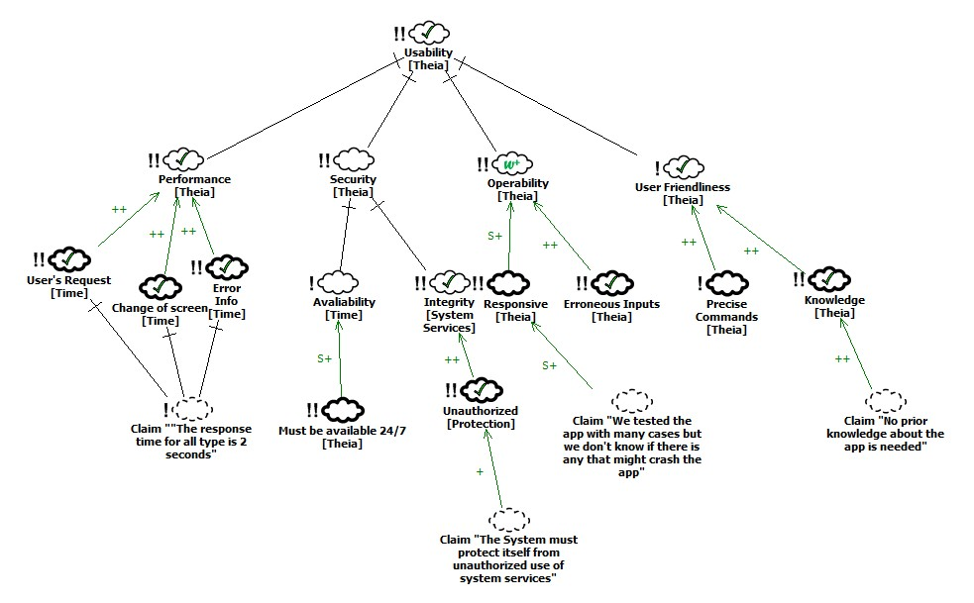

***Figure 6: SIG***

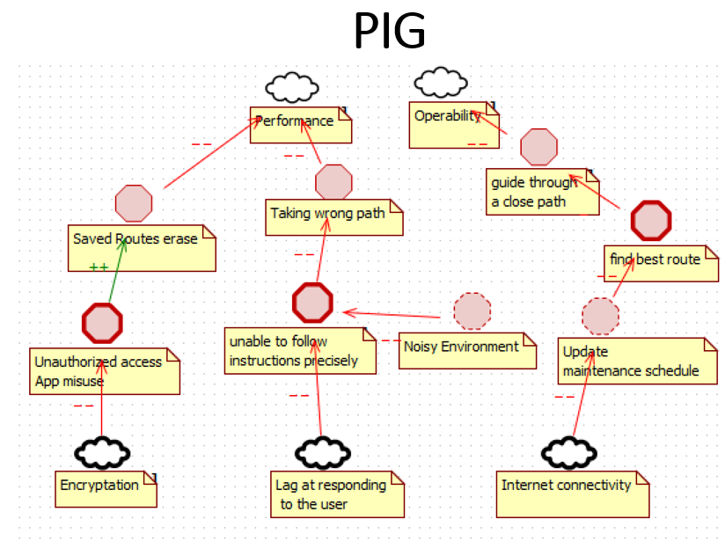

***Figure 7: PIG***

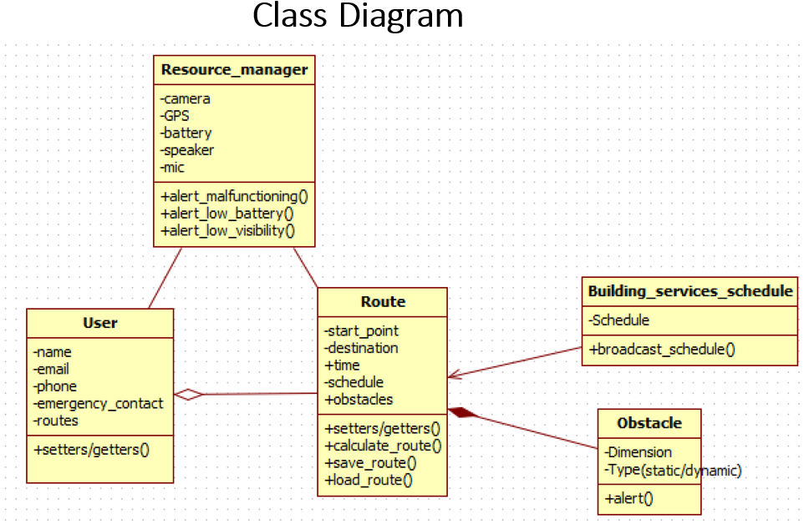

***Figure 8: Class Diagram***

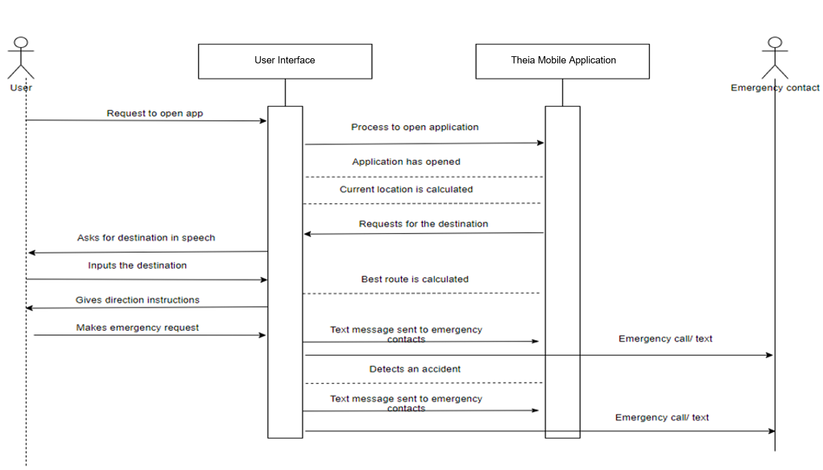

***Figure 9: Sequence Diagram***