Shawn Frye

Comparison against the Castillo & Wrobel minesweeper solver with 8 by 8 board with 10 mines

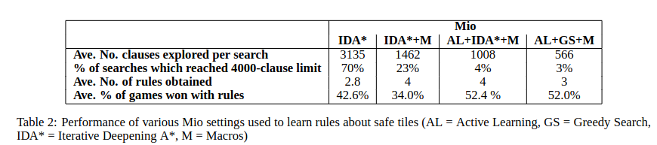

(Castillo & Wrobel, 2003)

Our results

43.34% with neighbor checking without A\* calling (0,0,u) as first move

41.57% with neighbor checking without A\* calling (random, random,u) as first move

23.02% with neighbor checking with A\* calling (random, random,u) as first move

25.80% with neighbor checking withA\* calling (0,0,u) as first move

27.04% with neighbor checking with A\* calling a random corner as first move

44.86% with neighbor checking without A\* calling a random corner as first move

Reference

Peña-Castillo, Lourdes & Wrobel, Stefan. (2003). Learning Minesweeper with Multirelational Learning. 533-540. IJCAI’03.