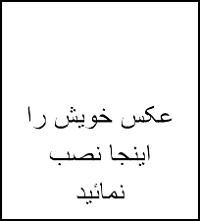
Staff Personal Information Form
فورم معلومات شخصی کارمند

Please Fill the Form Below and Return It to Staff Affairs Department
لطفا فورم ذیل را خانه پری نموده و به آمریت امور کارکنان تسلیم نمایید.
Name |  |  |  |  |  | Father s Name
NIC (Tazkira)  نمبر |  |  |  |  |  | Place of Issue  محل
Age سن |  |  |  |  |  | Date of Birth
Gender | Male |  |  |  |  | Female
Marital Status | Single |  |  |  | Married |  |  |  |  |  |  | Divorced  جدا شده
Position |  |  |  |  |  |  |  |  |  |  |  | ID #
Department/ Unit |  |  |  |  |  | Duty Station
Educational Qualification | Not yet graduate  فارغ التحصیل نشده است |  |  | High Schools Graduate  فارغ صنف 12 |  |  |  |  | Bachelor |  |  |  |  |  |  |  | Master
Work Experience in  total | Job Related |  |  |  |  | Different
Contact Numbers

Email Address

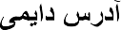
Permanent Address

Current Address


Emergency Contacts | Name اسم |  | Relationship |  |  |  | Numbers |  |  |  |  |  |  | Email ایمیل آدرس

Languages (please indicate proficiency: fluent, conversational, and basic)
(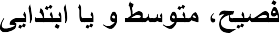)

Language | Speaking | Writing | Reading

Please list any of your family members/ close relatives working with Lamen Microfinance Institution:

لطفا اعضای فامیل/خویشاوندان خویش را که در موسسه تمویلات مالی خرد لمن ایفای وظیفه مینماید لست نمایید:
Name اسم | F/Name اسم | Relationship | Position | Department

Please list three references (Professional), which in case of any need could be contacted:
: 3

Name اسم | Relationship | Contact Number | Email ایمیل آدرس | Addressآدرس

