# **A9 - Float, Position, and Display**

## **Goal**

To use what you've learned in this module and previous modules to modify your layout using the following properties: **float**, **position**, and **display**.

## **Description**

For this assignment, we're going to focus only on our front page (index.html) and our a CSS document that will be only for our index.html document

## **Requirements**

### **First Steps**

**General Requirements:**

Make sure you duplicate your last a8-1 folder and change it to: **a9_1-*lastname***

[**Download new images for this assignment**](https://drive.google.com/drive/folders/1X3AN1uJaiqFQ_eKbzrCSGuggPKWTwzjZ?usp=sharing) and *place them into your images folder*

Also, **before starting your assignment**, make sure you read any feedback I gave for assignment a8_1 and make the appropriate changes.!

### **Home Page Modifications**

**First, we're going to slightly modify our index.html document:**

First, add a new **<link>** element immediately ***after*** the previous **<link>**element (for your **css/site.css** document) -- the **value** for the new **<link>** **href** should be **css/homepage.css**

To the opening **<body>** tag, add the following **attribute & value**: **id="homepage**"

Next, update the **li** elements for the **ul** element (see image)

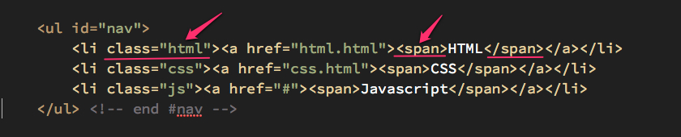

**Notice** the additions of the **class** attribute and **span** elements for each item.

That's it for the index.html document, let's move onto creating your CSS document.

### **New CSS Document**

**In your text editor or GitHub,** create a ***new*** CSS document and save it in your "css" folder and name it: **homepage.css**

Next, we have a number of new rules we need to enter. Make sure you go through each step very carefully:

**Make a new rule for the ID (#) selector with the value header**

Set the **height** to **160px;**

**Make a new rule for the img selector**

Have it **float** to the **left;**

Have the **margin-right** set to **20px;**

**Make a new rule for the ul with the ID selector with the value nav**

Set the **padding** (all sides) to **0;**

Set the **background-color** to **transparent** ... (this overwrites our rule in **site.css** for the background color of our unordered list).

**Make a new rule for the #nav selector with the descendant li selector**

Set the **display** to **inline-block;**

Set the **position** to **relative;**

Set the **vertical-align** to **bottom;**

Set the **margin-right** to **25px;**

**Make a new rule for the #nav selector with the descendant li with the pseudo-class selector :last-child**

Set the **margin-right** to **0px;**

**Make a new rule for the li selector with the descendant a selector**

Set the **display** to **block;**

Set the **width** to **300px;**

Set the **height** to **175px;**

Set the **padding-top** to **20px;**

Set the **text-decoration** to **none;**

Set the **border-radius** to **10px;**

**Make a new rule for the a selector with the descendant span selector**

Set the **font-family** to **"Courier New", monospace;**

Set the **font-size** to **1.5em;**

Set the **position** to **absolute;**

Set the **bottom** to **5px;**

Set the **width** to **inherit;**

Set the **text-align** to **center;**

**Develop the following rules:**

Set the **li a:link,** **li a:visited,** *and* **li a:active** to have a **background-color** of **#333;** also set the **color** to **#eee;**

Set the **li a:hover** to have a **background-color** with a value of **#aaa;**

**For the final step**, I'm going to help you set up the first rule, but you have to do the last two on your own. Check the screenshot below to see if you got what I have!

**Write a new rule for the li selector with the class (.) selector that has a value html and the descendant selector of a**

Set the **background-image** to find the **icon-html.png** in the **images** folder

Set the **background-repeat** to **no-repeat;**

Set the **background-position** to **center 50%**

**Write new rules for the other two images.**

## **Submission**

* Validate your html code and your css code
* Send me an email with the results of your validation tests.
* Include a link to your GitHub version of your homework OR tell me that you have uploaded a compressed folder (**a9_1-lastname**) to Google Drive.

## 

## **Screenshot**

