# **A10.1 - Interior Layout**

## **Purpose**

To develop a separate layout for interior pages using the information used from lecture and reading.

## **Description**

Follow the steps below and develop a two-column layout for the **html.html** and **css.html** documents. *You will be creating and using a separate stylesheet for this project*.

## **Requirements**

### **Step 1: Add New DIVs**

In the **html.html** and **css.html** documents **only**, add the the following to your **DIV** structure. **NOTE**, the **new DIV elements** (and their attributes). Don't forget to place the closing **</div>** tags!

|  |
| --- |

### **Step 2: Add New Resources**

In this step, just focus on entering content on the **html.html** page. You'll then copy and paste this information into the **css.html** document.

| **In the new div you added, with the id= value of "secondary"**  Add the text: Resources  Add the text: Learning  Add the text: Inspiration  **Note:** Use your critical "thinking caps" and determine what HTML sub-header text element you should use for each title. Clue: "Resources" should not be the same as "Learning HTML" or "Learning CSS" (as it's a sub-topic of the page's main topic) and "Learning" and "Inspiration" are sub-topics of "Resources". |
| --- |

| **For the content listing of "Learning"**  The content of the Learning section can be 3-5 sites of your choice or you can use what he has supplied – if it is still in existence. You need to replace anything no longer available.  The list should be a **description list** (**dl**) with at least 3 (no more than 5) **Definition Title**s (**dt**)  The **dt** should have:   * The name of the website (e.g. Sitepoint) * An anchor tag (**<a>...</a>**) wrapped around the name of the website * Make sure you include the **href** attribute and it's value of the website's URL address, so it's a clickable link (e.g. [Sitepoint](http://www.sitepoint.com/))   The **dd** should contain a brief description of the website (*often found in an about page -- but not always.*) |
| --- |

**REMINDER:** A single **description list** can contain multiple **description title**s and **definition description**s — as long as they all relate to the same topic. In this case, your topic is about learning Web Design.

| **For the content listing of "Inspiration"**  The content of the Inspiration section can be 3-5 sites of your choice or you can use what he has supplied – if it is still in existence. You need to replace anything no longer available.  The list should be within the **ul** element  The **ul** should contains at least 3 (no more than 5) **li** elements  Each **li** element should contain:   * The names of the website (e.g. CSS Drive) * Anchor tags (**<a>...</a>**) surrounding the name that have a link to the site (e.g. [CSS Drive](http://www.cssdrive.com/)) |
| --- |

### **Step 3: Copy information**

Make sure you test your html.html document and that the secondary information works as it should (you should be able to click a link and go to the website you've linked to).

If it all works, and the page validates with the new code, copy this information into your **css.html** document. **Remember this goes within the div element that has the id with the value of "secondary"**

Both the **html.html** and **css.html** documents should now have the same **DIV** structure and **Resources** content. See screenshot below!

### **Step 4: Validation**

[Make sure you validate](http://validator.w3.org/) your **html.html** and **css.html** pages!! your **css.html** document should have no errors and the **html.html** document should only have errors pertaining to your video (**iframe** embedded code).

### **Step 5: CSS**

| **Create a new css document**  Save it as: **interior.css**  Make sure to save it to your: a8_1-*lastname* > css (folder)  Make sure you add a **<link rel=" " href=" ">** element to your **html.html** and **css.html** documents for the **interior.css** document — like you did for the **homepage.css document** for the **index.html** |
| --- |

| **Make a new rule for the CLASS selector (.) with the value of content**  Set the **padding-bottom** to **20px**  Set the **background-color** to **#EEE**  Set the **overflow** to **auto** |
| --- |

| **Make a new rule for the ID selector (#) with the value of main**  Set the **width** to **620px**  Set the **margin-right** to **10px**  Set the **margin-left** to **10px**  Set the **float** to **left** |
| --- |

| **Make a new rule for the ID selector with the value of secondary**  Set the **width** to **300px**  Set the **margin-right** to **10px**  Set the **margin-left** to **10px**  Set the **float** to **left** |
| --- |

| **Make a new rule for a definition description dd**  Set the **line-height** to **1.5em**  Set the **margin-bottom** to **1.5em** |
| --- |

### **Advanced: Fluid Layout**

| **In the css.html document go to the opening body tag**  Add an **id=** attribute and give it the value of **"fluid"** |
| --- |

| **Make a new rule for the ID selector with the value of fluid and its descendant div selector that has an id attribute with the value of container**  Set the **width** to **90%**  Set the **max-width** to **960px**  Set the **min-width** to **650px** |
| --- |

| **Make a new rule for the ID selector with the value of fluid and its descendant div selector that has an id attribute with the value of main**  Set the **width** to **65%**  Set the **margin-right** to **1%**  Set the **margin-left** to **1%**  Set the **float** to **left** |
| --- |

| **Make a new rule for the ID selector with the value of fluid and its descendant div selector that has the ID selector with the value of secondary**  Set the **width** to **31%**  Set the **margin-right** to **1%**  Set the **margin-left** to **1%**  Set the **float** to **left** |
| --- |

| **Make a new rule for the ID selector with the value of fluid and its descendant imgselector**  Set the **width** to **100%** |
| --- |

In this next step, you'll need to type out the word "**and**" between **@media** and **screen**

| **Make a new rule for the @media query that is for screen and (max-width: 800px)**  Make sure you add the curly brackets **{ }**, as all the information that comes next will need to go *within* the curly brackets.  Make a new rule for the ID selector with the value of **fluid** and its descendant **div** selector that has the ID selector with the value of **container**   * Set the **width** to **90%** * Set the **min-width** to **0**   Make another new rule for the the ID selector with the value of **fluid** and its descendant **div**selector that has the ID selector with the value of **main**   * Set the **width** to **auto** * Set **float** to **none** * Set **background-color** to **#fff**   Make another new rule for the **id** attribute with the value of **fluid** and its descendant **div** selector that has the ID selector with the value of **secondary**   * Set the **width** to **auto** * Set **float** to **none** |
| --- |

### **Validate CSS**

[Make sure you validate the CSS](http://jigsaw.w3.org/css-validator/). For the advanced, you'll have one "Feature width doesn't exist" error for the @media rule.

### **Thinking about Accessibility**

Look at the html structure of your three web pages with the various divs and classes and IDs. Try to match them with the accessibility landmarks that we talked about in class. To refresh your memory, go to W3Schools [Accessibility Landmarks](https://www.w3schools.com/accessibility/accessibility_landmarks.php). Match the landmark (if it exists) with the appropriate div, class, id, element,....

## **Submission**

* Same as before:
  + GitHub
    - Add the files to your repository (if you didn’t create them there)
    - Send me ([lcbane@mix.wvu.edu](mailto:lcbane@mix.wvu.edu)) an email telling me that you are submitting your assignment
      * Include a link to the Pages version of your GitHub index page
      * Tell me how your validation went.
      * Give me your list of page sections/divs/elements and their role values.
  + Google Docs
    - Compress your assignment folder
    - Upload it to your shared Homework folder
    - Send me ([lcbane@mix.wvu.edu](mailto:lcbane@mix.wvu.edu)) an email telling me
      * That you have uploaded your assignment
      * How your validation went.
      * Give me your list of page sections/divs/elements and their role values.

## **Screenshots**

**HTML.HTML**

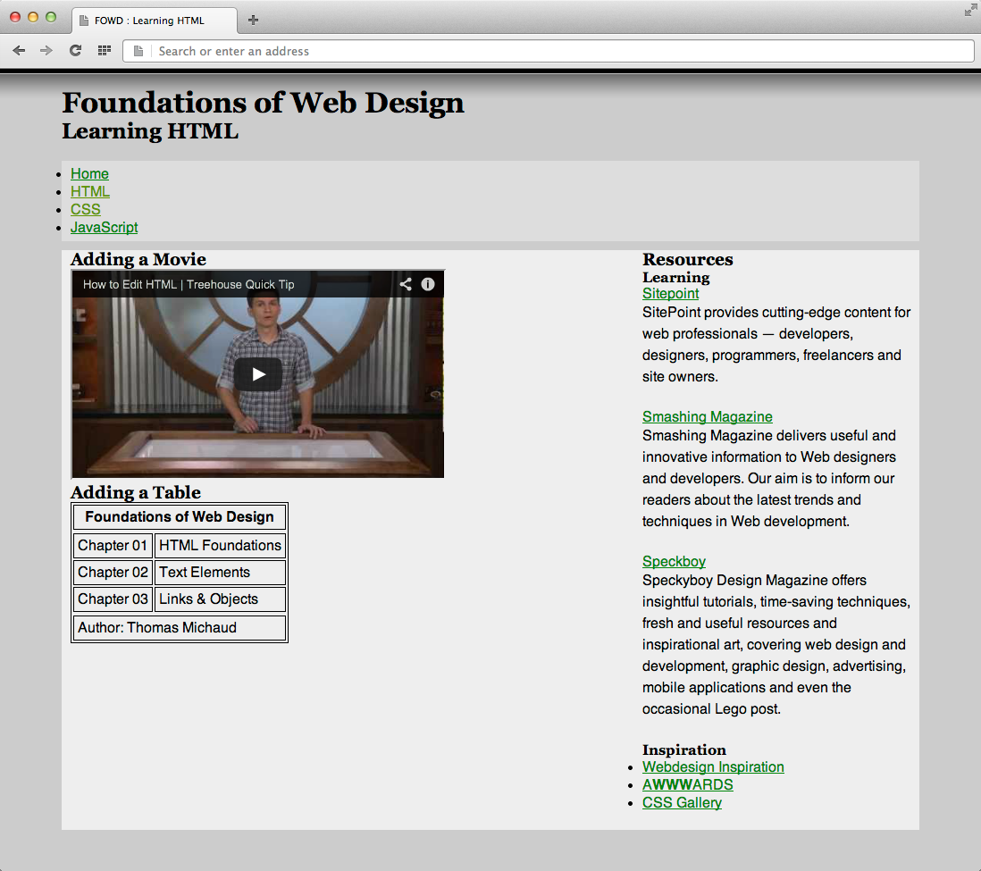

**CSS.HTML**

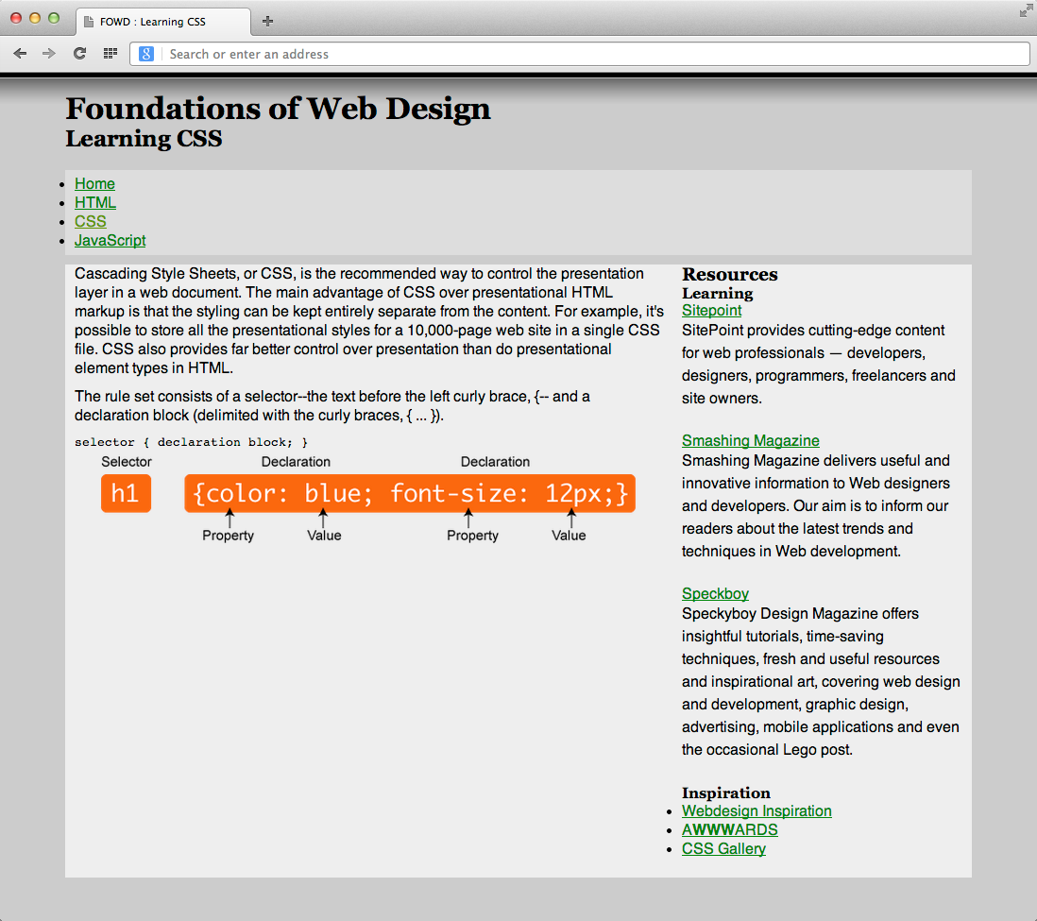

**CSS.HTML - Responsive**

Resize your browser to the most narrow width it will allow -- some allow more than others.

