# **A11.1 - Navigation Style & Role Landmarks**

## **Goal**

To add “role” landmarks to allow screen readers to access content areas easily for viewers with visual impairments.

To use CSS to transform the look of your Navigation content.

## **Description**

For this assignment, you'll:

* Add “role” landmarks to various sections on each of your pages to allow screen readers to easily scroll through page content.
* Continue to **use the interior.css stylesheet** to transform your unordered list into a horizontal navigation element.

### **HTML**

#### **Documents: index.html, html.html, css.html (For more information about** [**role**](https://docs.google.com/document/u/0/d/15rIe61Uk2649OrLsILj_rlZygdEfPd7XzQKludF1kY0/edit)**)**

| **In your html coding add the following “role” landmarks:**   * **For the div tag with the id attribute with the value "header", add role=”banner"** * **For the ul with the id attribute with the value "nav", add role="navigation"** * **For the div with the id attribute with the value "main", add role="main"**   **Documents: html.html & css.html**   * **For the div with the id attribute with the value "secondary", add role="complementary"** |
| --- |

#### **Document: html.html**

| **In your unordered list's list-item, add the following class attribute — *only* to the HTML li opening tag**  **<li class="current"><a href="html.html">HTML</a></li>** |
| --- |

#### **Document: css.html**

| **In your unordered list's list-item, add the following class attribute — *only* to the CSS li opening tag**  **<li class="current"><a href="css.html">CSS</a></li>** |
| --- |

### **CSS**

#### **Document: interior.css**

Start writing these new rules immediately after the rule set for the **dd** (definition description) you created for Assignment 10.

dd {

line-height:1.5em;

margin-bottom: 1.5em;

}

/* New rules go here */

#fluid div#container {

width: 90%;

max-width: 960px;

min-width: 650px;

}

| **Make a new rule for the ID selector with the value of container**  Set the **position** to **relative** |
| --- |

| **Make a new rule for the ID selector with the value of header**   * Set the **float** to **left** * Set the **width** to **280px** |
| --- |

| **Make a new rule for the ul selector with the value of nav**   * Set the **background-color** to **transparent** * Set the **float** to **right** * Set the **width** to **350px** * Set the **margin-top** to **20px** |
| --- |

| **Make a new rule for the ul selector with the value of nav and with the descendant selector of li**   * Set the **display** to **block** * Set the **padding** to **5px** for top/bottom **10px** for left/right * Set the **background-color** to **#ddd** * Set the **border-radius** to **4px** * Set the **border** to **1px solid #aaa** * Set the **text-decoration** to **none** * See the highlighted box below for the **box-shadow** declaration. |
| --- |

| To add a "drop-shadow" to the background of a box element, you need to use some **CSS3**! It's a little complex, so the code is provided for you to copy and paste into the rule above. **Copy** the following **box-shadow** rules below and **paste** them *immediately after* the **text-decoration** rule:  **box-shadow: 0 1px 4px rgba(0, 0, 0, 0.27), 0 0 40px rgba(0, 0, 0, 0.06) inset;** |
| --- |

| **Make a new rule for the ul selector with the ID selector of nav with the descendant selector of a with the pseudo-class of :hover**   * Set the **background-color** to **#eee** |
| --- |

| **Make a new rule for the ul selector with the ID selector of nav with the descendant selector with the CLASS selector of current with the descendant selector of a**   * Set the **background-color** to **#fff** |
| --- |

| **Make a new rule for the CLASS selector of content**   * Set the property **clear** to the value of **both** |
| --- |

### **Advanced @media rules**

We need to go into the @media rule from Assignment 10 and **add two more rules**.

@media screen and (max-width:800px){

**...**

#fluid div#secondary {

width: auto;

float: none;

}

/* new rules go here */

}

}

| **Make a new rule for the ID selector of fluid with the descendant selector of ul that has the ID selector of nav**   * Set the **margin-top** to **0** * Set the **width** to **98%** * Set the **padding** to **4px** (all sides) |
| --- |

| **Make a new rule for the ID selector of fluid with the descendant selector of ul that has the ID selector of nav with the descendant selector of li**   * Set the **display** to **block** * Set the **text-align** to **center** |
| --- |

## **Validation**

Make sure you validate your:

* All your [HTML documents](http://validator.w3.org/)
* All your [CSS documents](http://jigsaw.w3.org/css-validator/)

**Previous errors that have not been corrected will have an increase in penalties**

Make sure that your pages look like the screenshots at the end of this document.

## **Submission**

* Same as before:
  + GitHub
    - Add the files to your repository (if you didn’t create them there)
    - Send me ([lcbane@mix.wvu.edu](mailto:lcbane@mix.wvu.edu)) an email telling me that you are submitting your assignment
      * Include a link to the Pages version of your GitHub index page
      * Tell me how your validation went.
  + Google Docs
    - Compress your assignment folder
    - Upload it to your shared Homework folder
    - Send me ([lcbane@mix.wvu.edu](mailto:lcbane@mix.wvu.edu)) an email telling me
      * That you have uploaded your assignment
      * How your validation went.

## **Screenshots**

### **html.html Navigation**

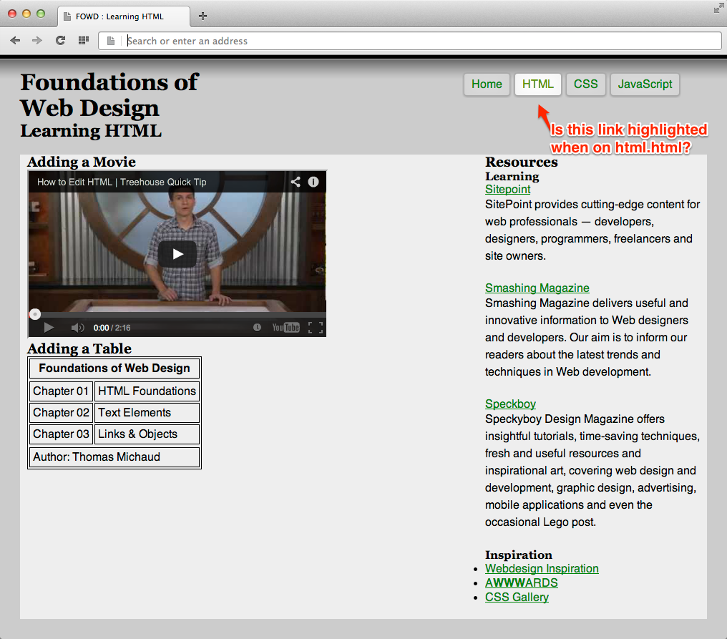

### **css.html Navigation**

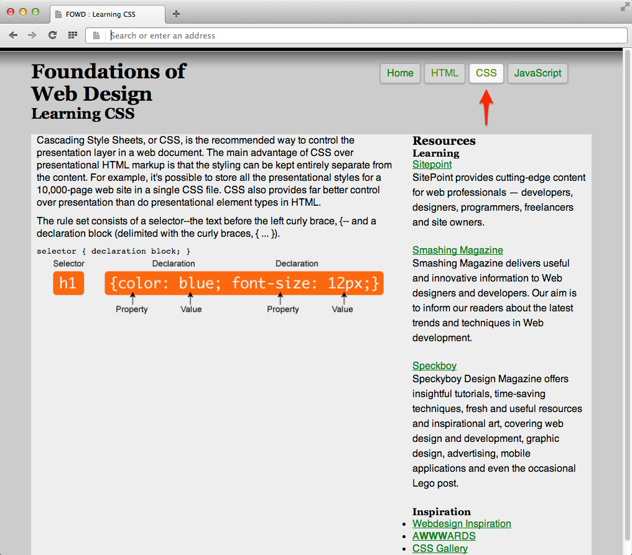

### **css.html Responsive Navigation**

