# **A5.1 - CSS & GitHub**

## **Purpose**

From what you learned in this module, you'll add a little CSS to your website, check for any validation errors, and upload your site to a web-server for the world to see! Goal

This assignment will be more about learning how to upload your website to the GitHub server and learning how validation works than doing much with your HTML and CSS.

## **Requirements**

Work through the following steps, paying attention to each step in detail. If you have questions—or need clarification—make sure you ask. However, make sure you try and work through each step as much as possible before asking.

### **Preparation for a5_1**

Edit a4_1 by correcting/adding suggestions from Ms. Bane. Also go through the code of html.html to make sure that you have the correct div elements. Ms. Bane sent you a template via email and also posted it in the HTML5 Code Template.

### **Task 1: Upload Your a5_1 Folder to GitHub**

1. After fixing any problems from Module 4, make a copy of your Module 4 assignment folder.
   1. Take out any unnecessary files: comments from me, saved copies of instructions, extra photos, and so on.
   2. Your folder should contain only: index.html, html.html, and the images folder containing one jpg photo (150X150)
2. If you are using your own repository, rename the folder as **a5_1**.
   1. If you are using my Assns repository, rename the folder to **a5_1-[yourlastname]**.

### **Task 2: Make Sure Your Repository Is Set Up for Pages**

1. Open a new browser tab/window, and type in the URL
   1. [your_user_name].github.io/[your_repository_name]/a5_1/index.html
2. Can you see your index page? If so, you’re ready to go.
   1. If not, take a look at the instructions for how to set up your repository to work with Pages: [Quickstart for GitHub Pages - GitHub Docs](https://docs.github.com/en/pages/quickstart)

### **Task 3: Creating the css.html Page**

1. Go to your a5_1 folder and click on the html.html file. Copy the code for the page.
2. Click on the a5_1 folder link. You should see a list of files in the folder.
3. Click on Add File in the upper right corner. Name the file css.html
4. Click on the Edit icon and paste the code from html.html into the new file.

### **Task 4: Editing the css.html Page**

1. Change the title in the head to FOWD: Learning CSS
2. In the header div, change the subheading to Learning CSS
3. In the nav unordered list, add a relative link from “HTML” to the html.html file.
   1. Don’t link the css.html file to itself. The fact that the page is unlinked should indicate “You are here” to the viewer.
4. Delete the Adding a Video and Adding a Table sections.
5. In the main div, insert the following content in paragraph elements.:
   1. Cascading Style Sheets, or CSS, is the recommended way to control the presentation layer in a web document. The main advantage of CSS over presentational HTML markup is that the styling can be kept entirely separate from the content. For example, it's possible to store all the presentational styles for a 10,000-page website in a single CSS file. CSS also provides far better control over presentation than do presentational element types in HTML.
   2. The rule set consists of a selector--the text before the left curly brace, {-- and a declaration block (delimited with the curly braces, { ... }).
6. Still in the main div, add the following text just as you see it between the preformatted pre tags:

selector { declaration block; }

* 1. Note: You don’t need a paragraph element. [Help for pre tags.](https://www.w3schools.com/tags/tag_pre.asp)

1. I’ve sent you the css-syntax.jpg file as an email attachment. Download the file to your computer and then upload it to your images folder.
2. Directly after the closing pre tag, add an image link to the css-syntax.png file. Don’t forget to add the alt text and size information to your source link.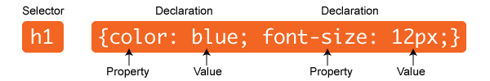

### **Task 5: Using CSS to Style**

1. Make sure the style tags are in the head section of the document just before the </head> tag.
2. Within the style element, we want to select the heading level 2 element and set the font color to orange.
   1. Remember:
      1. The text heading level 2 (h2) is the *selector*.
      2. The color is the *property.*
      3. Orange is the *value.*
3. Add the CSS Rule to the style section.
4. Save/commit your file and open it as a web page.
   1. Your h2 line of text should be orange. Is it?

### **Task 6: Updating the index.html and html.html Pages**

Now that you have three html files in your website, you have to go back to the index.html and html.html files and update them by linking to your new css.html file.

For the html.html file, you need to add a new row for Chapter 5 to the table.

### **Task 7: Compare Your Pages to the Screenshots**

Now that all your editing has been done, you need to compare your web pages with screenshots from Michaud and Bane. Do they look the same as Ms. Bane’s? There will be some differences between hers and Michaud’s.

| css.html | Ms. Bane’s version | Mr. Michaud’s version |
| --- | --- | --- |
| index.html | Ms. Bane’s version | Mr. Michaud’s version |
| html.html | Ms. Bane’s version | Mr. Michaud’s version |

### **Task 8: Validation**

Your text suggests using the [W3C Markup Validation Service](https://validator.w3.org/) to validate your code, but there are a lot of free online html validators that you can use. Take a look at [*15 Most Popular HTML Validator Online Tools In 2022*](https://www.softwaretestinghelp.com/html-validator/) by Software Testing Help. It is not comprehensive, but it gives you choices and explanations of how the various services work.

Pick one and run your three web pages through it to see if you have any problems. If there are major problems, go back and fix them.

## **Submission**

You don’t need to submit anything.

Send me an email telling me:

1. You’ve invited me to collaborate with you on your repository (If you haven’t, do it now!)
2. A link to your GitHub Pages
3. A statement about what validator you used and how well your code worked

## 

## **Screenshots**

### Ms. Bane’s css.html - back to Task 7

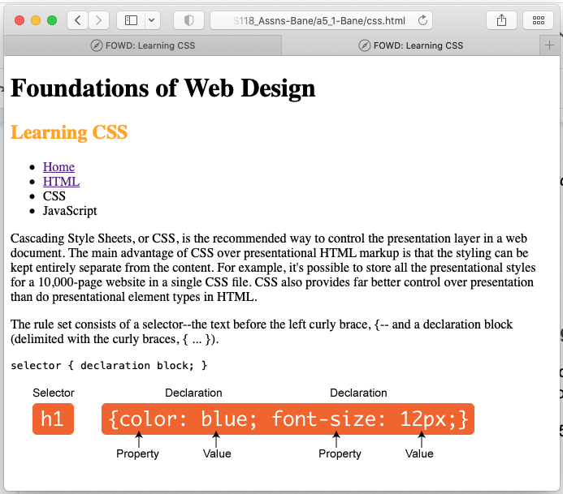

### Mr. Michaud’s css.html - back to Task 7

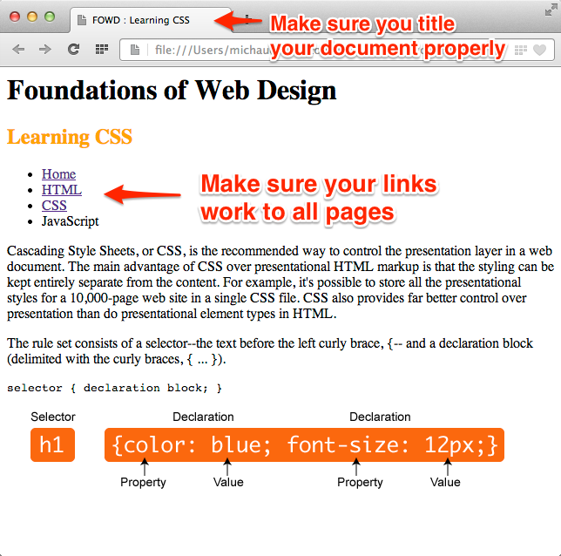

### Ms. Bane’s index.html - back to Task 7

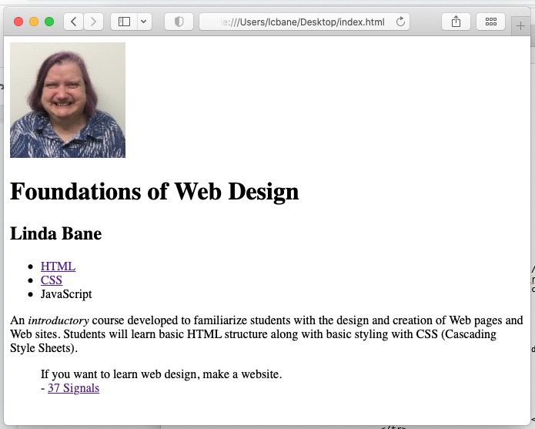

### Mr. Michaud’s index.html - back to Task 7

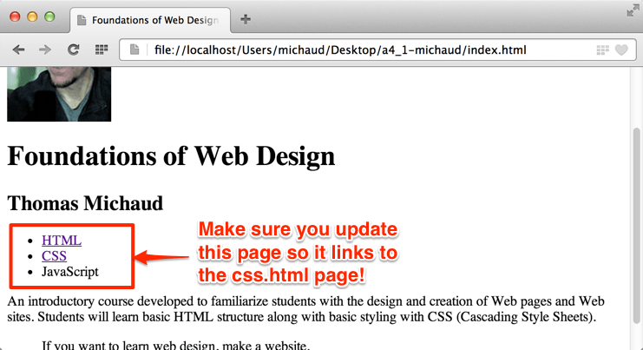

### Ms. Bane’s html.html - back to Task 7

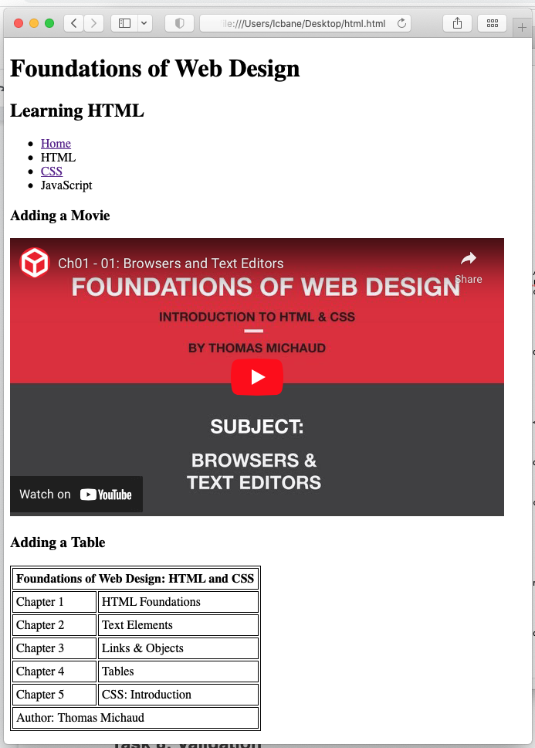

### Mr. Michaud’s html.html - back to Task 7

### 