# **A7.1 - A Letter from Camp**

## **Purpose**

In this assignment, you'll use a single stylesheet to change fonts, colors, line spacing, and more to recreate a letter home from camp as a web page.

## **Requirements**

Work through the following steps, paying attention to each step in detail. If you have questions—or need clarification—make sure you ask. However, make sure you try and work through each step as much as possible before asking.

### **Preparation for a7_1**

This is a standalone assignment.

### **Task 1: Create an Assignment Folder, an Letter Page, a CSS Folder, a CSS Page and an Images Folder**

1. On your local computer or USB drive, create a folder named a7.
   1. Inside the folder, create two more folders: css and images.
   2. Load [camp-granada-trans.png](https://drive.google.com/file/d/1gLtTtheFwyXcSWtCn1q0eAEvZu2c04g-/view?usp=sharing) into the images folder.
   3. Open Notepad and create a file called letter.html in the a7 folder.
   4. Then create a file called letter.css and save it in the css folder.
      1. a7 folder
         1. css folder
            1. letter.css
         2. images folder
            1. camp-granada-trans.png
         3. letter.html
2. Upload the folder to your/my GitHub repository.
3. If you are using your own repository, the folder name is **a7_1**.
   1. If you are using my Assns repository or a USB drive, the folder is **a7_1-[yourlastname]**.

### **Task 2: Open Up a7_1 and Check GitHub Pages**

1. Open a new browser tab/window, and type in the URL
   1. [your_user_name].github.io/[your_repository_name]/a7_1/letter.html
2. Can you see your blank letter.html page? If so, you’re ready to go.
   1. If not, take a look at the instructions for how to set up your repository to work with Pages: [Quickstart for GitHub Pages - GitHub Docs](https://docs.github.com/en/pages/quickstart)

### **Task 3: Set Up letter.html**

1. Copy the following html into your letter document:

<!DOCTYPE html>

<html>

<head>

<style>

div {

background-color: white;

width: 600px;

border: 100px solid saddlebrown;

padding: 50px;

margin: 20px;

}

</style>

</head>

<body>

<div>

</div>

</body>

</html>

1. Add lang attribute to the html tag.
2. Add the following under the head tag:
   1. Charset meta tag
   2. Author meta tag
   3. Title: Letter from Camp
   4. Link from this document to your letter.css file
3. Cut the div styling and paste it into your letter.css file
4. Delete the empty style tags.
5. Save both files and preview your page. You should see a brown box.

### **Task 4: Add the Letterhead and the Letter Text to the Document**

1. Insert an image link to the letterhead logo in the images folder. Location = images/camp-granada-trans.png Don’t forget to add the alt text and dimensions (600 x 241) to the link.
2. Copy the text from the Text of Letter and insert it into the div section of the webpage underneath the img link.
3. Notice that the strikethroughs have disappeared.
4. Wrap each paragraph in **<p>**...**</p>**
5. In the **<p>** tag in front of:
   1. The date add the **id** attribute with a value of **date**
   2. The greeting add the **id** attribute with a value of **greeting**
   3. Love, add the **id** attribute with a value of **farewell**
   4. Allan add the **id** attribute with a value of **signature**
6. For the nine paragraphs in the body of the letter add the **class** attribute with a value of **bodyText**
7. Compare the original text with the html text and locate all the text that had strikethroughs.
   1. Wrap each phrase with **<span class="misspelledText">**...**</span>**
      1. Hello, Muddah! Hello, Faddah!
      2. towmane
      3. ulissies
      4. ya
      5. preshus
      6. bruddah
      7. bettah
8. In the 3rd paragraph of the body of the letter locate the phrase: ulissies Ulysses.
   1. Wrap each word with **<span class="underlineText">**...**</span>**
9. In the 6th paragraph of the body of the letter locate the phrase: one whole day!
   1. Wrap it with **<span class="emphaticText">**...**</span>**

**Reminder: Make sure you nest your p and span tags properly, especially the two tags wrapping around *ulissies*.**

1. Finally, let’s credit the source of the text, the song lyrics
2. Underneath the </div> tag, insert a footer element with the following text on three lines ending the first two lines with <br> tag:
   1. Body of the letter: “Hello Muddah, Hello Faddah (A Letter From Camp)” lyrics © Songtrust Ave, Warner Chappell Music, Inc
   2. Songwriters: Allan Sherman / Lou Busch
   3. More about the song and Allan Sherman from The Songs of America
   4. Link <http://bmpaudio.com/the-sounds-of-america-hello-muddah-hello-fadduh/> to The Songs of America

### **Task 5: Styling the Fonts and Text**

In the letter.css document, you need to add the following rules:

#### **Styling the Paragraphs**

1. Add a rule that has a **body** selector with the following declarations:
   1. The **font-family** should be set to **"Lucida Handwriting", cursive**
   2. The **font-size** should be set to **20px**
   3. The **background-color** should be set to **saddlebrown**
2. Add the rule that makes the **p** selector with the **id** of **date** with the following declarations:
   1. The **text-align** should be **right**
   2. The **font-size** should be **22px**
   3. The **line-height** should be **1.25**
3. Add the rule that makes **p** selector with the **id** of **greeting** with the following declarations:
   1. The **font-size** should be **26px**
   2. The **line-height** should be **1.5**
4. Add the rule that makes the **p** selector with the **class** of **bodyText** with the following declarations
   1. The **text-indent** should be **50px**
   2. The line-height should be **1**
5. Add the rule that makes the **p** selector with the **id** of **farewell** with the following declarations
   1. The **text-align** should be **right**
   2. The **font-size** should be **26px**
   3. The **line-height** should be **1**
6. Add the rule that makes **p** selector with the **id** of **signature** with the following declarations:
   1. The **text-align** should be **right**
   2. The **font-size** should be **40px**
   3. The **line-height** should be **1**
7. Add a rule that has a **footer** selector with the following declarations:
   1. The **color** should be **yellow**
   2. The **font-family** should be **Arial**
   3. The **font-size** should be **12px**
   4. The **line-height** should be **1.25**
8. Finally we need to add a rule that the link/<a> in the footer should always be yellow because blue and purple won’t show up well on a brown background.
   1. Look at a6_1 for hints on how to do this.

#### **Styling the In-Line Text**

1. Add a rule that has a **span** selector with the **class** of **misspelledText** with the following declarations:
   1. The **text-decoration** should be **line-through wavy**
2. Add a rule that has a **span** selector with the **class** of **underlineText** with the following declarations:
   1. The **text-decoration** should be **underline**
3. Add a rule that has a **span** selector with the **class** of **emphaticText** with the following declarations:
   * 1. The **text-transform** should be **uppercase**
     2. The **font-weight** should be **bolder**
4. Save both files and open letter.html in a browser.
5. Does your webpage look like this? Sigh…not much like a young boy’s handwriting!

### **Task 7: Optional Challenge (Extra Credit)**

The Lucida Handwriting font doesn’t look much like a young boy’s handwriting.

Let’s try adding a cooler handwriting font(s)?

Free Google Fonts will add some more exciting cursive fonts to the letter. They will download to the 02letter.css file, so they should work on any OS and any browser.

1. Save your letter.html file as 02letter.html
   1. Open your 02letter.html file
   2. Go to the head and change the ref link location to css/02letter.css
   3. Save your file.
   4. Now open it in a web browser.
2. Save your letter.css file as 02letter.css in the css folder
   1. Open your 02letter.css file.
      1. To import two Google fonts, use the @import command.
      2. At the very top of the css file before any other styling rules, copy and paste the following (without the numbers, of course):

## @import url('https://fonts.googleapis.com/css?family=Gloria+Hallelujah&display=swap');

## @import url('<https://fonts.googleapis.com/css?&family=Cedarville+Cursive&display=swap>');

* + 1. Then go to the body rule:
       1. Change “Lucida Handwriting” to “Gloria Hallelujah”.
       2. Keep the generic cursive just in case.
    2. Go to the #signature rule:
       1. Insert the declaration: font-family: "Cedarville Cursive", cursive;
    3. Save the file.

1. Refresh 02letter.html in a browser.
2. Does your screen look like this. If so, it looks a lot more like a young boy wrote it.

### **Task 8: Testing Your Site**

Test your site. Did it work?

Compare your pages to the **Screenshots** at the end of this assignment.

### **Task 9: Validation**

Remember to [validate your HTML documents](http://validator.w3.org/)

Don’t forget to [VALIDATE YOUR CSS](http://jigsaw.w3.org/css-validator/#validate_by_upload) as well.

## **Submission**

You don’t need to submit anything if you are using GitHub.

If you are using Google Drive, zip your folder and upload it to your shared homework folder.

When you are satisfied with your webpages, send me an email giving me:

1. A link to your GitHub Pages index.html file or tell me that it is on Google Drive
2. A statement about how well your html and css code worked with the validators
3. If you want the extra credit, send me the GitHub link for 02letter.html or include 02letter.html and 02letter.css in your zipped folder.

## 

## **Text of Letter**

Monday, July 11, 2022

~~Hello, Muddah! Hello, Faddah!~~ Hello, Mother! Hello, Father!

Here I am at Camp Granada. Camp is very entertaining and they say we'll have some fun if it stops raining.

I went hiking with Joe Spivy. He developed poison ivy. You remember Leonard Skinner.

He got ~~towmane~~ Ptomaine poisoning last night after dinner.

All the counselors hate the waiters, and the lake has alligators, and the head coach wants no sissies, so he reads to us from something called ~~ulissies~~ Ulysses.

Now I don't want this should scare ~~ya~~ you, but my bunkmate has malaria. You remember Jeffrey Hardy. They're about to organize a searching party.

Take me home, oh Mother, Father! Take me home! I hate Granada! Don't leave me out in the forest where I might get eaten by a bear.

Take me home! I promise I will not make noise, or mess the house with other boys.

Oh, please don't make me stay! I've been here one whole day!

Dearest Father, darling Mother, how's my ~~preshus~~ precious little ~~bruddah~~ brother? Let me come home if you miss me. I would even let Aunt Bertha hug and kiss me.

Wait a minute! It's stopped hailing. Guys are swimming. Guys are sailing. Playing baseball! Gee, that's ~~bettah~~ better.

Mother, Father, kindly disregard this letter!

Love,

Allan

## 

## **Screenshot letter.html**

Does yours look similar?

letter.html & letter.css

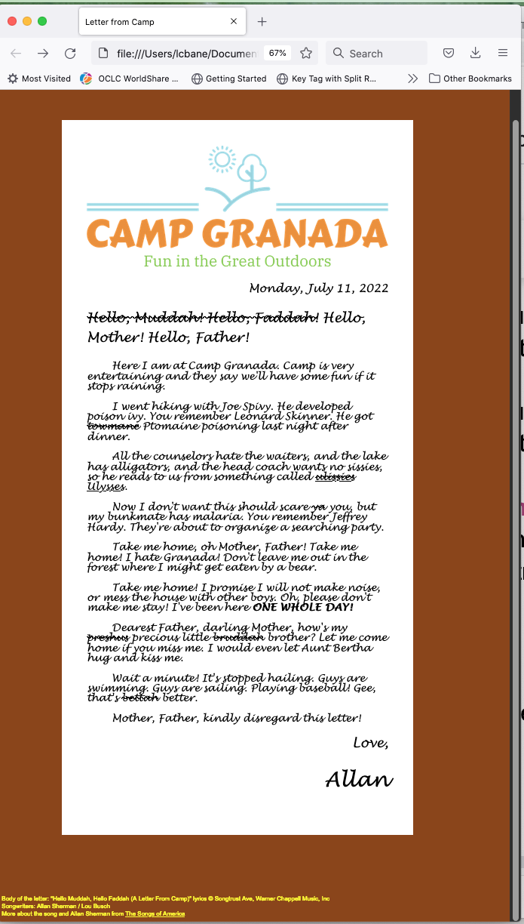

## **Screenshot 02letter.html (Extra Credit)**

Does yours look similar?

02letter.html & 02letter.css

### 