# **A6 - Box Model Layout**

## **Overview**

In this assignment, you'll be adding additional structure to your HTML documents, using the Box Model properties to enhance the look of the layout, and styling links and text a bit further.

## **Requirements**

**Adding DIV elements**

>> First off, modify ***each*** of your HTML documents (index.html, html.html, and css.html) to have the following structure: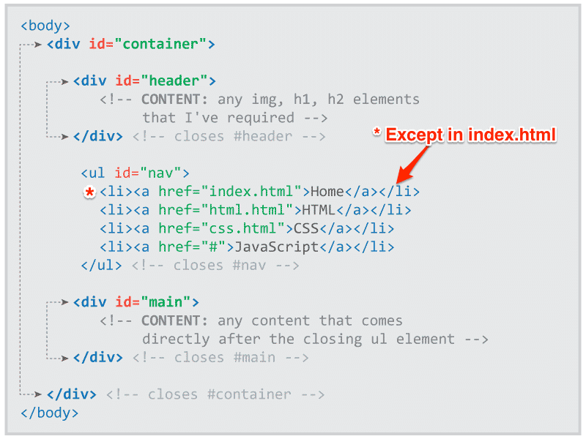

**NOTE:** Your *index.html* document already has the **div** element with the **id** attributes with the value of **header** and **main**. Use it as a reference for your *html.html* and *css.html*. Make sure you have no other **div** elements than the one's noted above.

**STOP:** Make sure you [DOWNLOAD new images](https://drive.google.com/drive/folders/1HejQy0P65EbFE79F26sqgtIscTh5ttVS?usp=sharing) (a8_1images) for this assignment (NOTE: take them out of the folder and add them to your images folder)

**Box Sizing**

>> At the very top of your **site.css** document, and above the rule for the body (done in assignment 6), add the following rule:

Use the universal selector (**\***) to

Set the **padding** and **margin** (on all sides) to a value of **0**;

Set **box-sizing:** to **border-box**;

>> This may not seem like they do much, but these rules really help in the layout of our site and help to make browsers act a little better (more consistently) with margin and padding.

**Adding Background Images**

>> In this next step, make sure you have the *bg_body.png* image—you downloaded at the top of this page—in your "images" folder!

>> In the previous assignment, for the **body** selector, you already established the following properties: **background-color** and **font-family**, let's add more…

Set the **font-size** to **1em;**

Set the **background-image** to **url(../images/bg_body.png);**

Set the **background-repeat** is set to **repeat-x;**

Set the **background-position** is set to **left top;**

>> If done correctly, you should now see a graphic (black and white line with a drop shadow) at the top of you web page that runs the length of your web browser.

**Adding Space to Paragraphs**

>> For the **p** selector, set the **margin-bottom** to **.625em**

This adds spacing after each closing paragraph (**</p>**) tag

**Add New Declaration blocks to the Navigation**

>> In the previous assignment, you had already established the **background-color** for the **ul** selector with the **id** attribute of **nav**

Set the **padding** and set it to **5px** on top and bottom and **10px;** on left and right.

Then, set the **margin-bottom** (only) at **10px;**

This adds some spacing to our navigation list.

Now, move to the bottom (end) of your CSS (*site.css*) document...

**Setting the Container Width**

>> In your HTML (index.html, html.html, and css.html), I hope you added in the **div** with the **id** attribute that has a value of **container** (refer back to the screenshot at the top of this page), because in the CSS you need to create a new rule for the **div** with the **#** (ID selector) that has the value **container**:

Set its **width** to **960px;**

(or better yet, to **60em**... Why? It's more responsive to user settings!).

Set its **margin** to **0** on top and bottom and **auto;** to the left and right

(Remember the shorthand method!).

>> The contents of your website (mainly the paragraphs) should no longer extend to the very edges of your browser when you increase the width to the sides of your screen.

**Spacing Up Top**

>> Next, let's create another new rule.

This time we'll select the **div** with the id selector (**#**) with the value of **header**:

Set the **margin-top** to **20px**

Set the **margin-bottom** to **20px**

>> This gives us a little spacing above and below the contents for that div

Let's have your CSS add some styling to your photograph ...

**Styling Your Picture**

>> Make a new rule for the **div** with the id selector (**#**) with the value of **header** with the descendant selector **img** (remember the difference between child and descendant). To it…

Set the **border** to **1px** **solid** and make it black -- but use the HEX (#123456) value (you need to figure out what that value is)!

Set the **background-color** to white -- **yes, the HEX value**!

Set the **padding** to **5px;** (on all sides -- **use the shorthand method**!)

>> You should now have a white edge around your photo with a thin black border.

Okay, this next section is the *biggie* ... it affects (at this point) the text on the *index.html* page (where the **blockquote** is) ... take a look at the screenshots below, if you need to check how you're doing.

ALERT: Now we are going to find out why he had such a strange blockquote & header combination. Check Ms. Bane’s index.html file. If your code doesn’t match hers, cut and paste her code into your index.html file. Otherwise, you are going to have a mess!

**Styling Blockquote Text**

>> So, let's create a rule for the **blockquote** with the following properties and values:

Set the **font-size** to 2.5em;

Note: This makes the font size 40px, if the default font size is 16px ... this also alters the value of all ems inside our blockquote as our font size has changed ... but only in our blockquote!)

Set the **width** to **16.5em;**

Note: This is equal to 660px ... 16px x 2.5em = 40px (font-size) ... 40px x 16.5em = 660px)

Set the **margin** to **0** (top and bottom) and **auto** (left and right) -- shorthand!

Set the **padding** to **10px** (top) **10px** (right) **10px** (bottom) **45px**(left)

Set the font **color** to **#777;**

Set the **font-family** to **Georgia, serif;**

Set the **font-style** to **oblique;**

Set the **background-image** to **url(../images/bigquote.png);**

Set the **background-repeat** to **no-repeat;**

Set the **background-position** to **left** (top/bottom) and **8%;**(left/right).

WHEW! That's it for that rule!

The quoted text should look quite a bit different now (larger and centered) with a large graphic (quote mark) to the left of the text.

However, the citation (-37 Signals) needs some help—let's address that next!

**Styling the Citation**

>> Write a rule to select the **blockquote** with the descendant selector **footer**

Set the **display** to **block;**

**Note:** While modern browsers recognize the footer element as a block-level element, older browsers do not.

Set the **font-size** to **.4em;** (This brings the font-size down to 20px)

Set the font **color** to **#888;**

Set the **text-align** to **right;**

Ah, we now can see the citation! It's smaller and off to the lower right of our quoted text.

That's it — WOW! Do you see how many lines of CSS you have? We could actually have less ... and, if you know now, give it a shot; but be warned, you'll get penalized if things don't work.

**Don’t forget** to update the table on the html.html file with rows for Chapters 7 & 8.

Compare your website with the Screenshots at the end of the assignment. Check all of them to make sure you didn’t change anything you shouldn’t have. (Ignore his teeny, tiny table.)

## **Validate**

1. Remember to [validate your HTML documents](http://validator.w3.org/)
2. [Validate your CSS documents](http://jigsaw.w3.org/css-validator/#validate_by_upload) too!

## **Submission**

GitHub Users:

To submit your homework,

Send me an email with:

1. The results of your validation tests
2. The Pages link for your index.html file on GitHub – github.io

Google Drive Users:

To submit your homework,

1. Upload your a8_1 folder as a zipped file to Google Drive
2. Send me an email with:
   1. The results of your validation tests
   2. A reminder that your assignment is a zipped file on Google Drive

## 

## **Screenshots**

### **index.html**

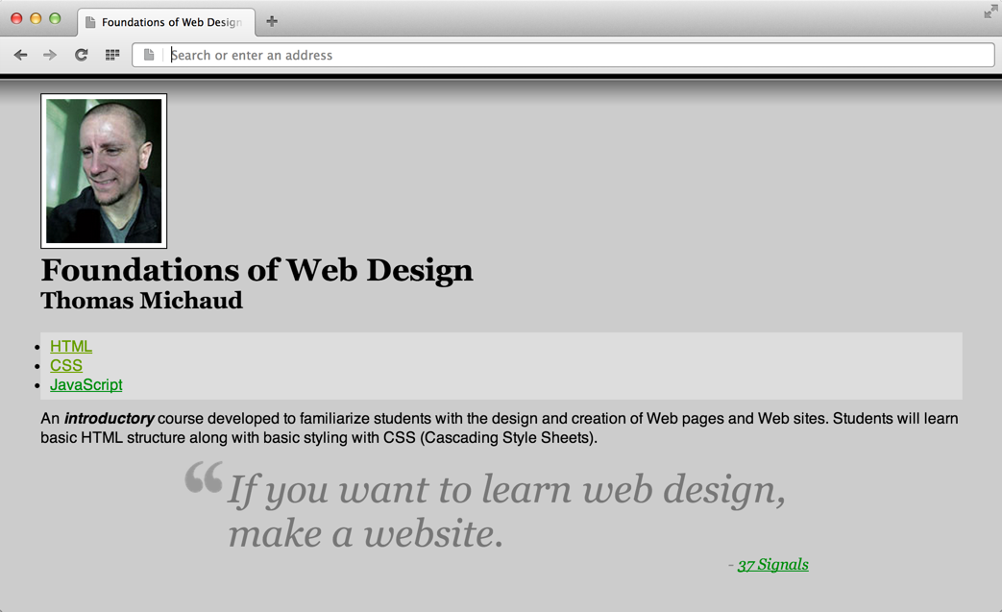

### **html.html**

### **css.html**

