**step 1**: Mark all vertex as unvisited 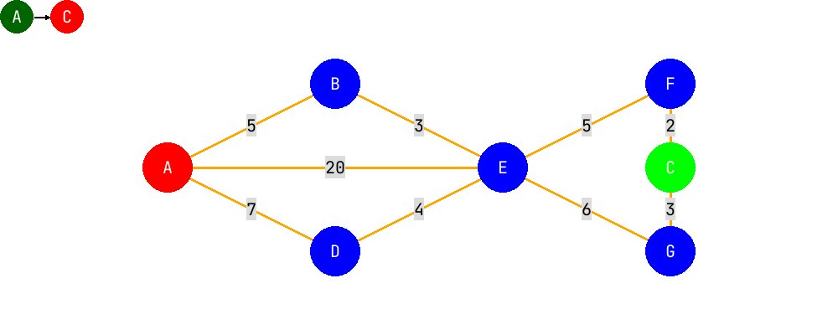 unvisited_vertex: ['A', 'B', 'C', 'D', 'E', 'F', 'G']

| vertex | distance from start | previous vertex |
| --- | --- | --- |
| A | inf | None |
| B | inf | None |
| C | inf | None |
| D | inf | None |
| E | inf | None |
| F | inf | None |
| G | inf | None |

**step 2**: Mark all other nodes to infinity 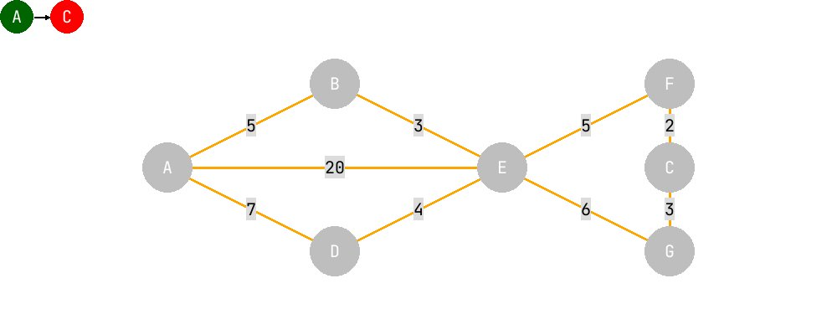 unvisited_vertex: ['A', 'B', 'C', 'D', 'E', 'F', 'G']

| vertex | distance from start | previous vertex |
| --- | --- | --- |
| A | 0 | None |
| B | inf | None |
| C | inf | None |
| D | inf | None |
| E | inf | None |
| F | inf | None |
| G | inf | None |

**step 3**: start a while loop

**step 3a**: For the current node, calculate all unvisited neighbors. Place the previous node on it.

**step 3b**: Update the shortest distance, if new distance is shorter

**step 3c**: Mark current node as visited 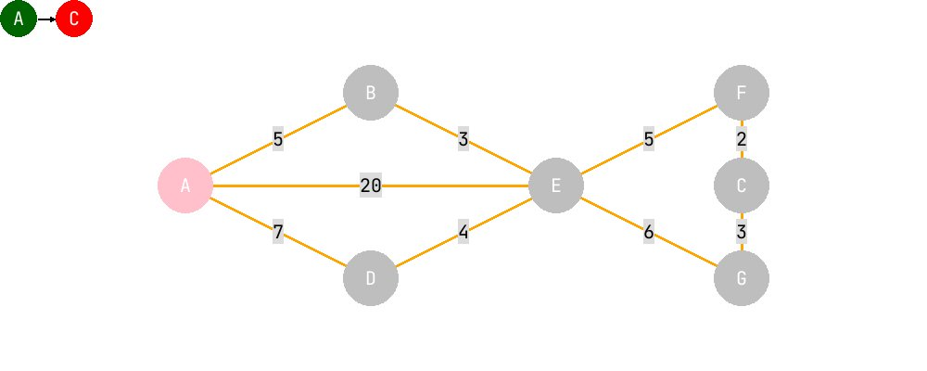 unvisited_vertex: ['B', 'C', 'D', 'E', 'F', 'G']

| vertex | distance from start | previous vertex |
| --- | --- | --- |
| A | 0 | None |
| B | 5 | A |
| C | inf | None |
| D | 7 | A |
| E | 20 | A |
| F | inf | None |
| G | inf | None |

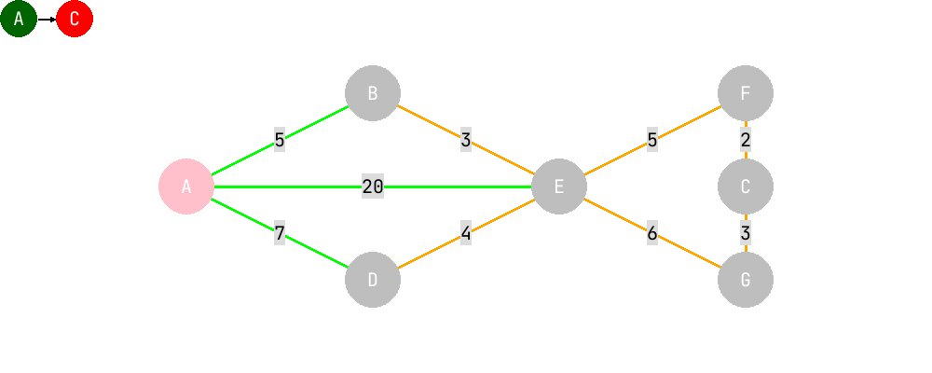 unvisited_vertex: ['C', 'D', 'E', 'F', 'G']

| vertex | distance from start | previous vertex |
| --- | --- | --- |
| A | 0 | None |
| B | 5 | A |
| C | inf | None |
| D | 7 | A |
| E | 8 | B |
| F | inf | None |
| G | inf | None |

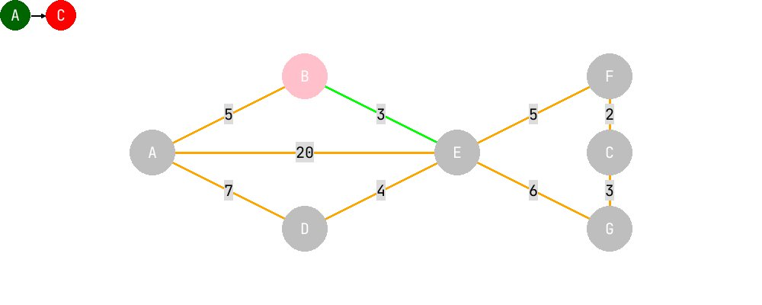 unvisited_vertex: ['C', 'E', 'F', 'G']

| vertex | distance from start | previous vertex |
| --- | --- | --- |
| A | 0 | None |
| B | 5 | A |
| C | inf | None |
| D | 7 | A |
| E | 8 | B |
| F | inf | None |
| G | inf | None |

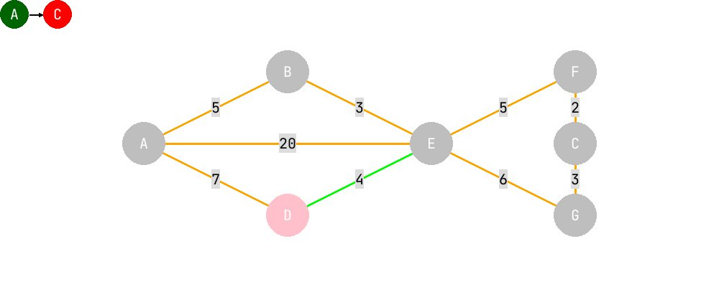 unvisited_vertex: ['C', 'F', 'G']

| vertex | distance from start | previous vertex |
| --- | --- | --- |
| A | 0 | None |
| B | 5 | A |
| C | inf | None |
| D | 7 | A |
| E | 8 | B |
| F | 13 | E |
| G | 14 | E |

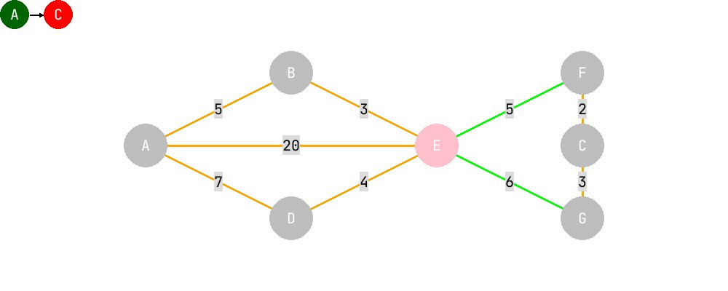 unvisited_vertex: ['C', 'G']

| vertex | distance from start | previous vertex |
| --- | --- | --- |
| A | 0 | None |
| B | 5 | A |
| C | 15 | F |
| D | 7 | A |
| E | 8 | B |
| F | 13 | E |
| G | 14 | E |

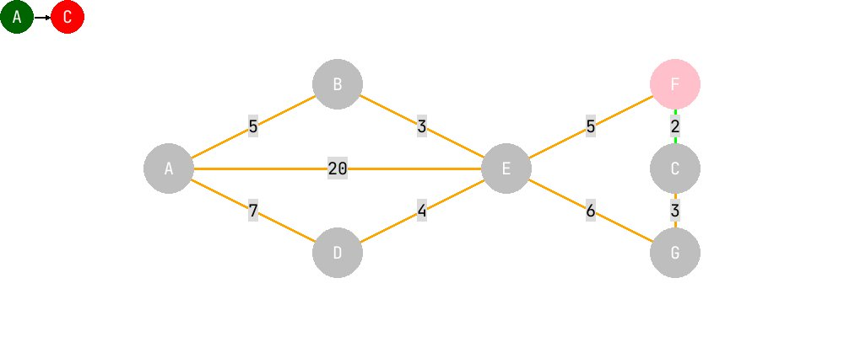 unvisited_vertex: ['C']

| vertex | distance from start | previous vertex |
| --- | --- | --- |
| A | 0 | None |
| B | 5 | A |
| C | 15 | F |
| D | 7 | A |
| E | 8 | B |
| F | 13 | E |
| G | 14 | E |

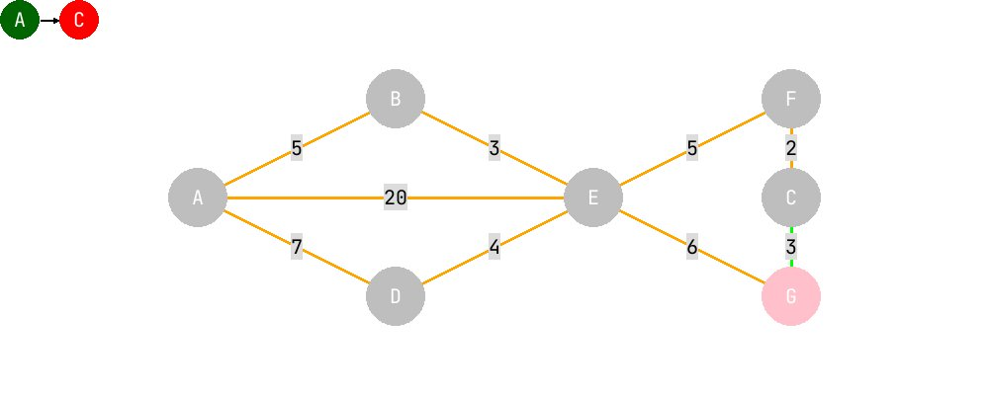 unvisited_vertex: []

| vertex | distance from start | previous vertex |
| --- | --- | --- |
| A | 0 | None |
| B | 5 | A |
| C | 15 | F |
| D | 7 | A |
| E | 8 | B |
| F | 13 | E |
| G | 14 | E |

**step 5**: after there are no unvisited_node, calculate the paths

**step 5a**: the path are calculated by tracing back the previous node 