Adoption and impact of non-pharmaceutical interventions for COVID-19

Natsuko Imai1,3, Katy Gaythorpe1,3, Sam Abbot2,3, Sangeeta Bhatia1, Sabine Van Elsand1, Keisha Prem2, Yang Liu2, and Neil Ferguson1

09 March, 2020

1 Imperial College London, London, UK  
2 London School of Hygiene, London, UK  
3 These authors contributed equally.

# Summary

* School closures, remote working and quarantine have been the most common social distancing interventions applied for COVID-19 to date.
* Symptomatic COVID-19 cases thus far have been disproportionately reported amongst the elderly population compared to children - it is unclear whether school closures will have the same benefits as have been shown for pandemic influenza.
* Travel restrictions have been widely implemented and found to be effective at slowing geographic spread by a few days and reducing initial case numbers.
* Timely implementation of control measures will have a greater impact on the COVID-19 epidemic, but the early lifting of control measures could lead to an increase in case numbers, as shown for influenza control. At this stage, data on this for COVID-19 are still sparse.
* A number of non-pharmaceutical interventions have been implemented at this point of time, most stringently in China. The assessment of these measures has been limited, especially concerning more recent interventions such as school closures. In many countries, it is too early to evaluate the effect of interventions.
* Empirical and modelling studies of pandemic influenza suggest that measures implemented at an earlier stage of the epidemic (compared to later stages), either locally or nationally, are likely to have greater impact on reducing the potential epidemic size.

# Background

## Measures in use

Social distancing (SD) measures can be effective control measures in outbreak settings. These can be broadly defined as: i) isolation, the separation of ill individuals from non-infected individuals; ii) quarantine, the separation of individuals who have been assumed to be exposed and; iii) community containment, an intervention applied to an entire community aimed at reducing contacts and movements [1]. However, the timing and duration of SD interventions will impact its effectiveness. Studies from pandemic influenza have emphasised the restricted benefits of time-limited interventions, with the potential reduction in mortality by up to 30% being eroded if the control was applied too late or lifted too early [2].

SD interventions have been implemented to different degrees by countries affected by the COVID-19 epidemic. Interventions have been most stringent in Hubei province, where the effective lockdown of cities have affected 40-60 million residents in Hubei province and Wuhan City in particular [3, 4]. Across other provinces in China, huge public health efforts including quarantine, cancellation of large gatherings, and travel restrictions have been implemented. Outside of mainland China, countries and regions worst affected by COVID-19 have or have started to introduce SD interventions in efforts to contain and limit the spread of COVID-19. For example, Singapore has implemented extensive contact tracing and quarantine measures for confirmed cases.

The most common SD measures in Hubei province (China) and the eight countries and regions reporting the highest COVID-19 case numbers outside of mainland China to date, were school closures followed by remote working and quarantine (see appendix for most common non-SD measures). Table 1 summarises the SD intervention and the potential effects on mixing patterns.

Figure 1 shows the timing of interventions in different countries and regions relative to the reported cases over time. There has been substantial variation in interventions adopted. Some countries and regions such as the USA have implemented reactive and selective local school closures only, whereas Hong Kong, for similar case counts, has introduced a large number of voluntary (e.g. advice on avoiding crowded places) and mandatory (e.g. quarantine, contact tracing, wide-scale proactive school closures) SD measures. It is important to note that while the figure shows interventions by specific date of introduction, most countries and regions shown have implemented contact tracing and quarantine of cases in response to the first imported cases from Hubei, China (Japan, Thailand, South Korea, USA, Singapore since mid- to late-January). Other countries have implemented interventions in response to a large number of newly reported cases (Italy and Iran) more recently (supplementary table 3).

# Impact of interventions

A range of non-pharmaceutical interventions (extension of school holidays, flexible working hours and remote working, quarantine of travellers from mainland China, and flight restrictions) have been implemented in Hong Kong resulting in behaviour change of the general public (measured through telephone surveys). Using influenza incidence rates as a proxy, Cowling et al showed that influenza transmission declined substantially (uncertainty range 24 - 53% reduction in transmissibility) after introduction of control measures and changes in population behaviours (avoidance of crowded places and consistent use of face masks) in early February. However, it is unclear how long Hong Kong will be able to sustain these measures. It is difficult to disentangle the most effective interventions; however, the combination of isolation, contact tracing, and quarantine appear to be “working” and Hong Kong has not observed infections in healthcare workers to date (Cowling, personal communication).

Assessing travel restrictions, Tian et al. examined the impact of quarantine and movement restrictions in Wuhan. They found that travel restrictions slowed the rate of spread between cities, delaying the arrival by approximately 2.9 days (95%CI: 2.5-3.3 days) [5]. They also found that measures implemented pre-emptively could reduce cases in the first week of introduction by 37%. Further travel restrictions were examined by Anzai et al. who suggest that, due to the lockdown of Wuhan city, 226 cases were prevented from global exportation (95% CI 86, 449) corresponding to a reduction in exported cases of 70% [6]. Lai et al. found further support for travel restrictions and non-pharmaceutical interventions (NPIs) in general, estimating that without them there would have been a 67-fold increase in cases in Baidu. They also highlighted that had interventions been applied earlier, for example by 3 weeks, the effects would have been even greater, leading to a 95% reduction in cases [7].

**Table 1: Summary of social distancing interventions implemented in Wuhan City, China and the 8 countries or regions1 reporting the highest number of COVID-19 cases. Countries and regions considered here are: Hong Kong, Italy, Japan, Singapore, South Korea and Wuhan. Many countries have been implementing quarantine measures of travellers. [The number refers to countries or regions where we have identified exact dates of implementation].**

| **Intervention** | **Number of regions where intervention is implemented** | **Description** | **Postulated mechanism of impact** |
| --- | --- | --- | --- |
| School closure across region/country | 4 | Closure of junior and/or senior schools across a region/country | Reduction in mixing amongst children |
| Individual School closure | 1 | Reactive closure of specific schools in response to suspected cases |
| School closure (not related to outbreak) | 2 | Scheduled school holiday |
| School restrictions | 2 | Cancellation of exams or assembly, staggered break times |
| Extension of school closure | 1 | Extension of school holidays |
| Remote working | 4 | Businesses allow or enforce workers to work from home | Reduction in mixing amongst adults |
| University closure | 2 | Teaching cancellation |
| Work closure (not related to outbreak) | 2 | Closure of workplaces over the New Year |
| Work closure extension | 1 | Closure of workplaces over the New Year |
| Restrictions on number of visitors | 1 | Nursing homes and hospitals restricting visitor numbers |
| Quarantine | 3 | Isolation of potentially infected individuals incl. enforced quarantine of travellers from affected areas for 14 days | Reduction in transmission |
| Isolation | 2 | Isolation of ill case |
| Contact tracing | 1 | Active case finding and surveillance |
| Lockdown | 3 | Enforced restriction of all travel and non-essential movement of the population | Reduction in community contact and mixing |
| Mass gathering advisory | 2 | Public health advise against attending large social gatherings |
| Mass gathering cancellation | 2 | Enforced cancellation of events incl. prayers, concerts |
| Mass gathering ban | 1 | Enforced cancellation of events incl. prayers, concerts |
| Social event cancellation | 2 | Cancellation of smaller gatherings |
| Reduced shop hours | 1 | Subset of services with reduced operating hours |
| Communication and advice | all | Advice on avoidance behaviours or travel advice |

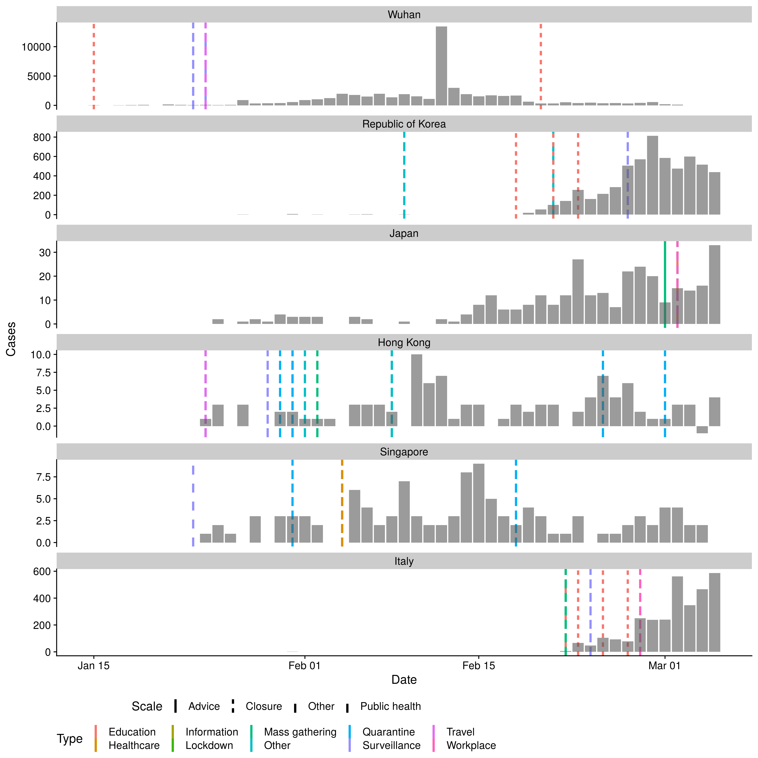

Figure 1: Number of cases by date of report for the 6 regions/countries with the highest number of cases outside of mainland China and Wuhan City as reported by WHO (taken from the WHO situational reports and Hubei Health Commission press releases). Note cases in Japan do not include the international conveyance. Each line represents the date of implementation of a social distancing measure. Note that some countries/regions had travel advice in place in response to the growing epidemic in China before the report of the first case in-country/ region. See supplementary information for NPIs other than SD.

# References

[1] WILDER-SMITH, A a DO FREEDMAN. Isolation, quarantine, social distancing and community containment: pivotal role for old-style public health measures in the novel coronavirus (2019-nCoV) outbreak. *Journal of travel medicine*. 2020.

[2] BOOTSMA, Martin CJ a Neil M FERGUSON. The effect of public health measures on the 1918 influenza pandemic in US cities. *Proceedings of the National Academy of Sciences*. 2007, **104**(18), 7588–7593.

[3] WU, Zunyou a Jennifer M MCGOOGAN. Characteristics of and important lessons from the coronavirus disease 2019 (COVID-19) outbreak in China: summary of a report of 72 314 cases from the Chinese Center for Disease Control and Prevention. *Jama*. 2020.

[4] WORLD HEALTH ORGANISATION. Report of the WHO-China Joint Mission on Coronavirus Disease 2019 (COVID-19). 2020.

[5] TIAN, Huaiyu, Yonghong LIU, Yidan LI, Moritz UG KRAEMER, Bin CHEN, Chieh-Hsi WU, Jun CAI, Bingying LI, Bo XU, Qiqi YANG a OTHERS. Early evaluation of transmission control measures in response to the 2019 novel coronavirus outbreak in China. *medRxiv*. 2020.

[6] ANZAI, Asami, Tetsuro KOBAYASHI, Natalie M LINTON, Ryo KINOSHITA, Katsuma HAYASHI, Ayako SUZUKI, Yichi YANG, Sung-mok JUNG, Takeshi MIYAMA, Andrei R AKHMETZHANOV a OTHERS. Assessing the impact of reduced travel on exportation dynamics of novel coronavirus infection (COVID-19). *Journal of Clinical Medicine*. 2020, **9**(2), 601.

[7] LAI, Shengjie, Nick W RUKTANONCHAI, Liangcai ZHOU, Olivia PROSPER, Wei LUO, Jessica R FLOYD, Amy WESOLOWSKI, Chi ZHANG, Xiangjun DU, Hongjie YU a OTHERS. Effect of non-pharmaceutical interventions for containing the COVID-19 outbreak: an observational and modelling study. *medRxiv*. 2020.

# Supplementary information

## Transmissability over time

ADD FIGURE

## Interventions not realted to social distancing

**Supplemental table 1: Table of common non-social distancing interventions in the eight countries/regions with the highest number of cases outside of mainland China and Wuhan City, China.**

| **Intervention** | **Description** |
| --- | --- |
| Travel advisory [4] | Advice to travellers to avoid non-essential travel to affected areas |
| Travel restriction [3] | Enforced travel restrictions on inbound travellers from affected areas |
| Travel or entry ban [3] | Enforced travel or entry ban on inbound travellers from affected areas |
| Suspension of flights [2] | Suspension of flights from some affected areas |
| Border checks [2] | Temperature screening implemented to inbound travellers from affected areas |
| Border control [1] | Strengthening border health measures, travellers to complete travel declaration form |
| Medical surveillance of inbound travellers [2] | Inbound travellers from affected areas will be required to undergo medical surveillance for 14 days |
| Government alert [5] | Government raised alert level on the coronavirus situation |
| Enhancements to care [2] | Strengthening of primary and tertiary care response |
| Health screening [4] | Health screening at various locations within the country or region |
| Surveillance [1] | Stepping up surveillance and risk communication |
| Raise awareness flights [1] | Public health messaging on flights to help raise awareness amongst inbound travellers on flights from affected areas |
| Raise awareness of public and health care workers [2] | Surveillance and risk communication |



Supplemental figure 1: Cases numbers by date of report for the ten countries with the highest number of cases outside of mainland China as reported by WHO (taken from the WHO situational reports and from Hubei Health Commission press releases). Note cases in Japan do not include the international conveyance. Bar fill is related to the introduction of non-pharmaceutical interventions other than social distancing.

## Data Dictionary

1. Contact Tracing: Identifying individuals who might have been in contact with a confirmed case
2. Isolation: Separation of ill persons with contagious diseases from non-infected persons
3. Quarantine: Restriction of persons who are presumed to have been exposed to a contagious disease but are not ill, either because they did not become infected or because they are still in the incubation period
4. School Closures. Closure of schools across a region or nation-wide. This is distinct from reactive closure of schools in response to an identified case.
5. Workplace Closure and Measures. Closure of workplaces and advisories to work remotely.
6. Crowding: Advisories to avoid crowded places such as concerts. This includes mandatory cancellations of mass gatherings such as conferences, weddings, funerals etc.
7. University closure. Regional or nationwide closure of universities