Adoption and impact of non-pharmaceutical interventions for COVID-19

Sam Abbott

2020-02-02

## Package

## Extract variables of potential interest from linelist

## Parsed with column specification:  
## cols(  
## .default = col_character(),  
## ID = col_double(),  
## `wuhan(0)_not_wuhan(1)` = col_double(),  
## latitude = col_double(),  
## longitude = col_double(),  
## data_moderator_initials = col_logical(),  
## V34 = col_logical(),  
## V35 = col_logical(),  
## V36 = col_logical(),  
## V37 = col_logical(),  
## V38 = col_logical(),  
## V39 = col_logical(),  
## V40 = col_logical(),  
## V41 = col_logical()  
## )

## See spec(...) for full column specifications.

## Warning: 656 parsing failures.  
## row col expected actual file  
## 5835 data_moderator_initials 1/0/T/F/TRUE/FALSE SL 'raw-data/linelist.csv'  
## 5836 data_moderator_initials 1/0/T/F/TRUE/FALSE SL 'raw-data/linelist.csv'  
## 5837 data_moderator_initials 1/0/T/F/TRUE/FALSE SL 'raw-data/linelist.csv'  
## 5838 data_moderator_initials 1/0/T/F/TRUE/FALSE SL 'raw-data/linelist.csv'  
## 5839 data_moderator_initials 1/0/T/F/TRUE/FALSE SL 'raw-data/linelist.csv'  
## .... ....................... .................. ...... .......................  
## See problems(...) for more details.

## # A tibble: 14,619 x 6  
## country city province date_confirmation travel_history_l… import_status  
## <chr> <chr> <chr> <chr> <chr> <chr>   
## 1 China Chaohu Ci… Anhui 22.01.2020 Wuhan imported   
## 2 China Baohe Dis… Anhui 23.01.2020 Luzhou Hunan, vi… imported   
## 3 China High-Tech… Anhui 23.01.2020 Yinzhou Hunan, v… imported   
## 4 China High-Tech… Anhui 23.01.2020 <NA> local   
## 5 China Feidong C… Anhui 23.01.2020 Wuhan imported   
## 6 China Lu'an City Anhui 24.01.2020 <NA> local   
## 7 China Fuyang Ci… Anhui 22.01.2020 Wuhan imported   
## 8 China Huaibei C… Anhui 25.01.2020 Wuhan imported   
## 9 China Huainan C… Anhui 26.01.2020 Wuhan imported   
## 10 China Hefei City Anhui 23.01.2020 Wuhan imported   
## # … with 14,609 more rows

## Estimate fraction that are imported

* Based on linelist data alone. Only countries with at least 20 total cases present are shown.
* Based on linelist data and WH0 sit reps
* Summarise and report

|  |  |  |  |
| --- | --- | --- | --- |
| Country | Cases | Fraction imported (linelist only) | Fraction imported (WHO sit reps) |
| Vietnam | 16 | 0.69 | 0.69 |
| Kuwait | 58 | 1.00 | 0.64 |
| Canada | 30 | 0.75 | 0.50 |
| Bahrain | 49 | 1.00 | 0.41 |
| Netherlands | 38 | 0.67 | 0.32 |
| Thailand | 47 | 0.34 | 0.30 |
| Singapore | 110 | 0.34 | 0.29 |
| United Arab Emirates | 27 | 0.35 | 0.26 |
| Australia | 66 | 0.88 | 0.23 |
| Malaysia | 50 | 0.65 | 0.22 |
| Iraq | 36 | 0.44 | 0.22 |
| Japan | 317 | 0.07 | 0.17 |
| United States | 129 | 0.50 | 0.16 |
| India | 29 | 0.14 | 0.14 |
| Spain | 198 | 0.44 | 0.12 |
| United Kingdom | 89 | 0.59 | 0.11 |
| Germany | 262 | 0.32 | 0.07 |
| Norway | 56 | 0.25 | 0.07 |
| France | 282 | 0.20 | 0.03 |
| Italy | 3089 | 0.02 | 0.00 |
| South Korea | 5766 | 0.02 | 0.00 |
| Austria | 37 | 0.00 | 0.00 |
| Iran | 2922 | 0.00 | 0.00 |
| NA | NA | 0.58 | NA |

## Plot cases over time

* Wrangle for countries of interest (with at least 40 cases)

## Parsed with column specification:  
## cols(  
## date = col_date(format = ""),  
## country = col_character(),  
## cases = col_double()  
## )

* Get date of first report

|  |  |
| --- | --- |
| Country | Date of first case report |
| Wuhan | 2020-01-15 |
| Republic of Korea | 2020-01-20 |
| Japan | 2020-01-20 |
| Thailand | 2020-01-20 |
| Taiwan | 2020-01-21 |
| United States | 2020-01-23 |
| Hong Kong | 2020-01-23 |
| Singapore | 2020-01-24 |
| Italy | 2020-01-31 |
| Iran | 2020-02-20 |

* Get case counts
* Plot curves in countries of interest

## Warning: Removed 11 rows containing missing values (position_stack).

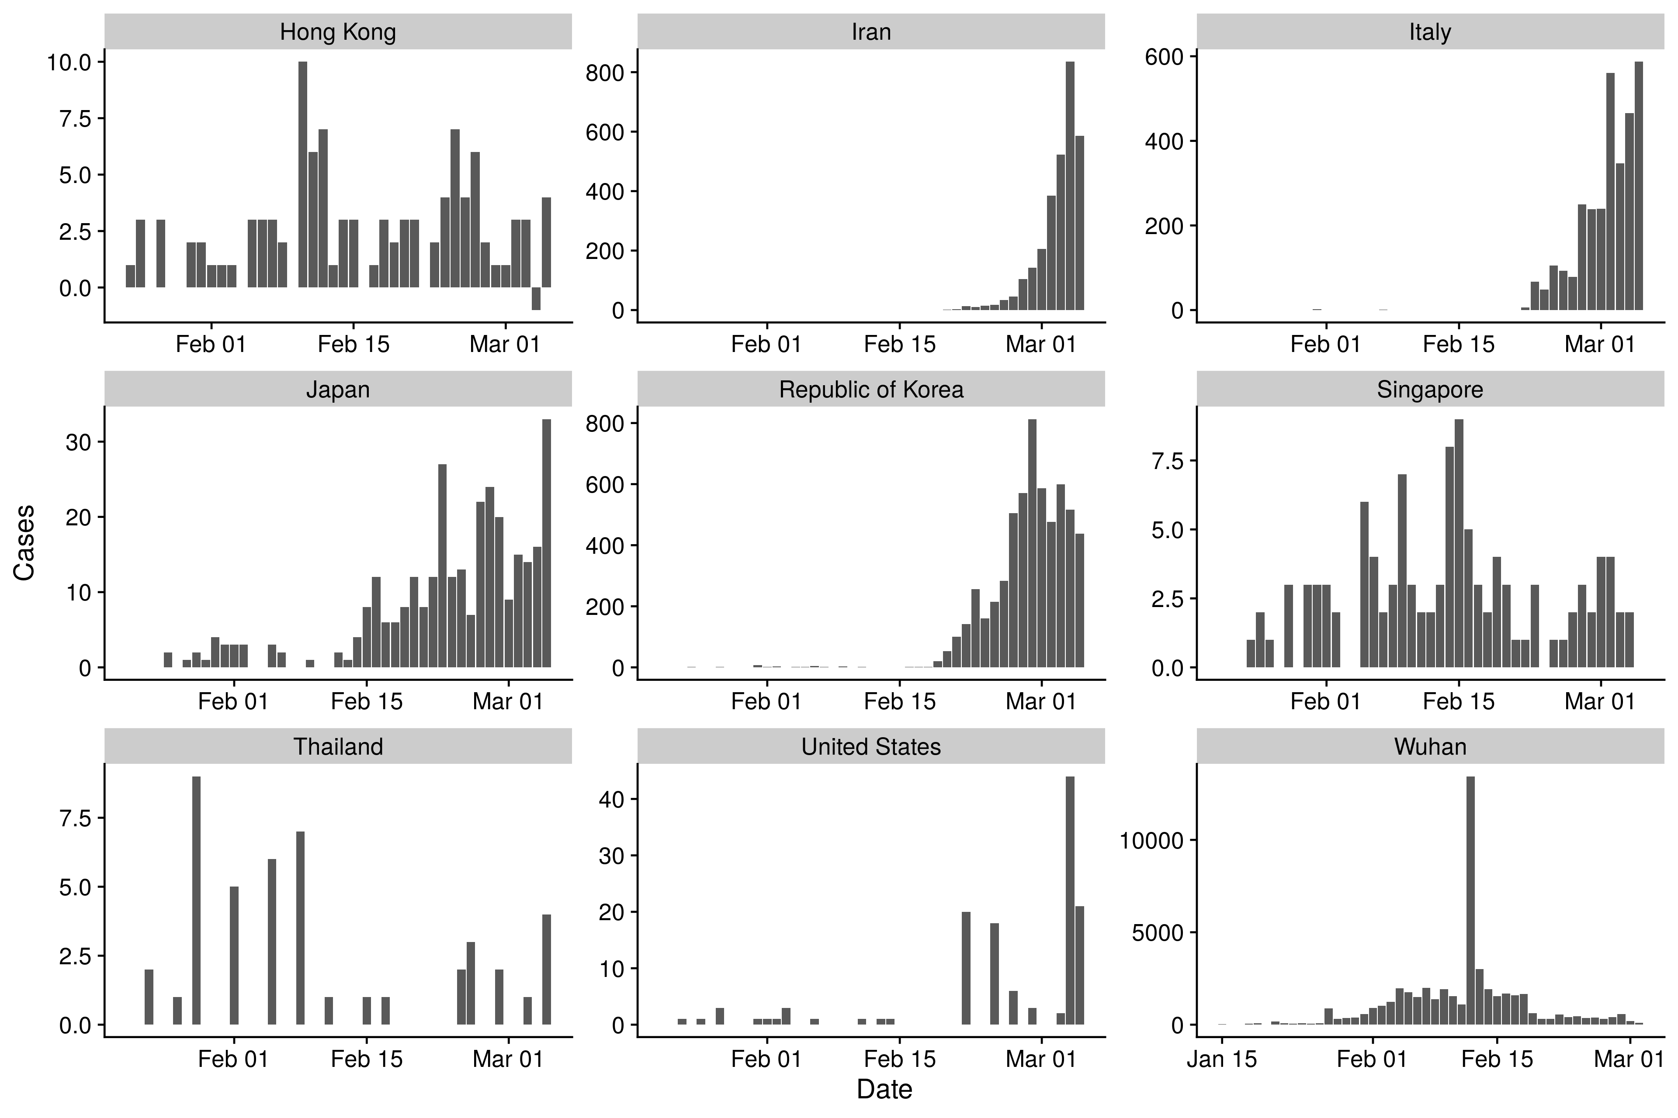

## Get interventions

* Plot overall interventions

## Warning: Missing column names filled in: 'X8' [8]

## Parsed with column specification:  
## cols(  
## date_intervention = col_date(format = ""),  
## intervention = col_character(),  
## social_distancing = col_character(),  
## country = col_character(),  
## notes = col_character(),  
## ref1 = col_character(),  
## ref2 = col_character(),  
## X8 = col_character()  
## )

|  |  |
| --- | --- |
| Intervention | Countries that have implemented |
| Health screening | 5 |
| School closure | 5 |
| Remote working | 4 |
| Travel advisory | 4 |
| Government on alert | 3 |
| Lockdown | 3 |
| Quarantine | 3 |
| School closure (not related to outbreak) | 3 |
| Travel restriction | 3 |
| Isolation | 2 |
| Mandatory quarantine | 2 |
| Mass gathering advisory | 2 |
| Mass gathering cancellation | 2 |
| School restrictions | 2 |
| Social event cancellation | 2 |
| Suspending flights | 2 |
| Travel ban | 2 |
| University closure | 2 |
| Work closure (not related to outbreak) | 2 |
| [Extension] school and work closure | 1 |
| Border checks | 1 |
| Border control | 1 |
| Communication distancing | 1 |
| Communication general | 1 |
| Contact tracing | 1 |
| Containment to mitigation | 1 |
| Decontamination | 1 |
| Enhanced care | 1 |
| Entry ban | 1 |
| Government announcement | 1 |
| Healthcare restrictions | 1 |
| Mass gathering ban | 1 |
| Medical surveillance | 1 |
| Prevention measures school | 1 |
| Public information | 1 |
| Raise awareness flights | 1 |
| Raise awareness healthcare staff | 1 |
| Raise awareness public | 1 |
| Reduced shop hours | 1 |
| Resumption public services | 1 |
| Social distancing misc | 1 |
| Strengthening primary care response | 1 |
| Supply | 1 |
| Surveillance | 1 |
| Travel advice | 1 |

* Social interventions only

|  |  |
| --- | --- |
| Intervention | Countries that have implemented |
| School closure | 5 |
| Remote working | 4 |
| Lockdown | 3 |
| Quarantine | 3 |
| School closure (not related to outbreak) | 3 |
| Isolation | 2 |
| Mandatory quarantine | 2 |
| Mass gathering advisory | 2 |
| Mass gathering cancellation | 2 |
| School restrictions | 2 |
| Social event cancellation | 2 |
| University closure | 2 |
| Work closure (not related to outbreak) | 2 |
| [Extension] school and work closure | 1 |
| Communication distancing | 1 |
| Contact tracing | 1 |
| Healthcare restrictions | 1 |
| Mass gathering ban | 1 |
| Prevention measures school | 1 |
| Reduced shop hours | 1 |
| Social distancing misc | 1 |
| Travel advice | 1 |
| Travel restriction | 1 |

* Non-social interventions

|  |  |
| --- | --- |
| Intervention | Countries that have implemented |
| Health screening | 5 |
| Travel advisory | 4 |
| Government on alert | 3 |
| Travel restriction | 3 |
| Suspending flights | 2 |
| Travel ban | 2 |
| Border checks | 1 |
| Border control | 1 |
| Communication general | 1 |
| Containment to mitigation | 1 |
| Decontamination | 1 |
| Enhanced care | 1 |
| Entry ban | 1 |
| Government announcement | 1 |
| Medical surveillance | 1 |
| Public information | 1 |
| Raise awareness flights | 1 |
| Raise awareness healthcare staff | 1 |
| Raise awareness public | 1 |
| Resumption public services | 1 |
| Strengthening primary care response | 1 |
| Supply | 1 |
| Surveillance | 1 |
| Travel advice | 1 |

* Plot social interventions

## Warning: Removed 11 rows containing missing values (position_stack).

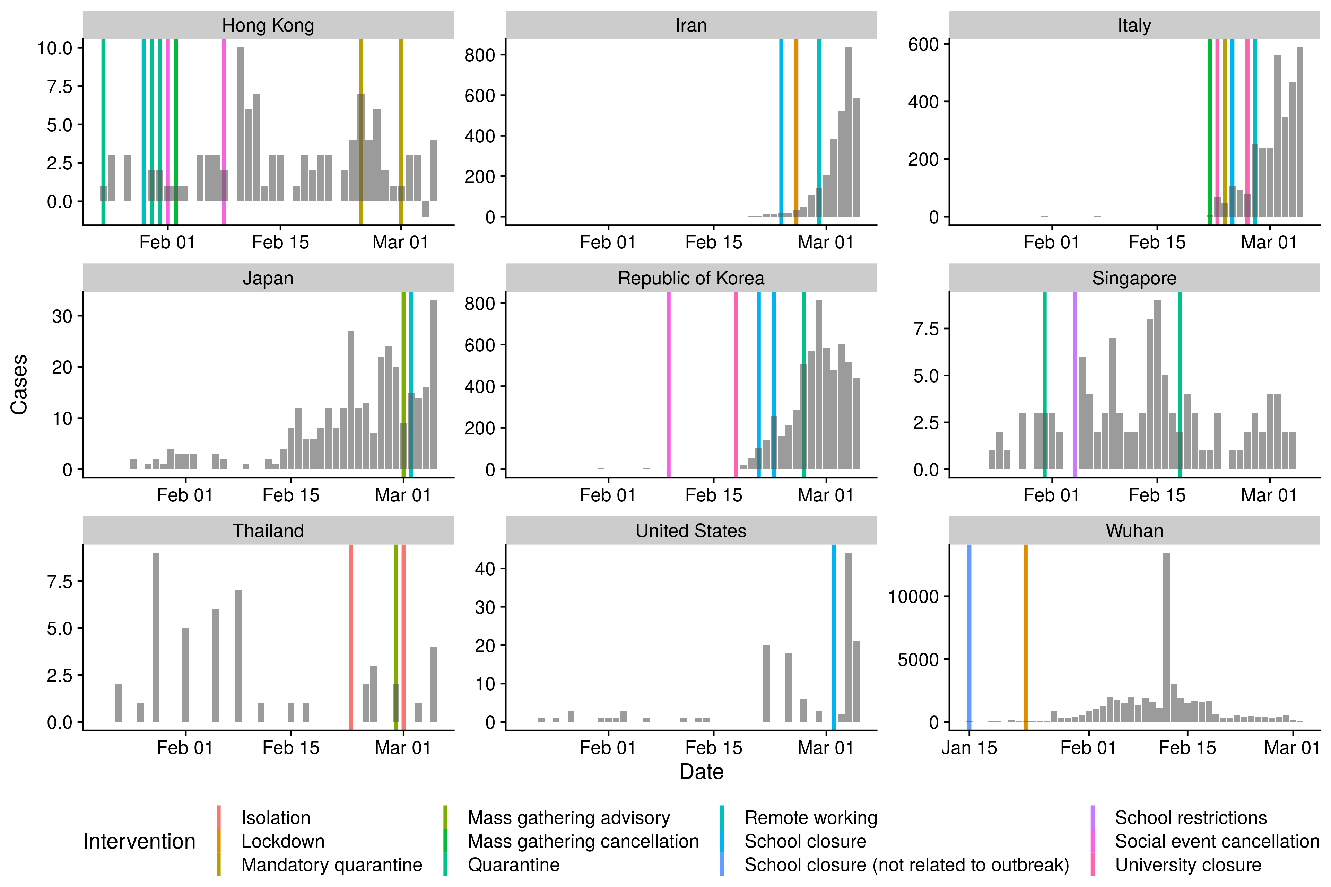

* Plot non-social interventions

## Warning: Removed 11 rows containing missing values (position_stack).

