Chapter 3: Physiology

Colleen Bove

14 January 2020

# Results

### (**A**) Coral host and algal endosymbiont physiology

Coral host total tissue energy reserves (mg cm-2) was calculated as the sum of each protein, lipid, and carbohydrate value per coral host. Total host energy reserves of *P. astreoides* at T0 were clearly greater than the total energy reserves quantified in coral hosts maintained under at control treatment at T90 (**Figure 1A**). There was no difference in total energy reserves between T0 and T90 control coral hosts in either *S. siderea* or *P. strigosa*. Elevated temperature (31°C) resulted in a clear reduction in total coral host energy reserves in only *P. strigosa* across all *p*CO2 treatments (**Figure 1A**). No overall effect of *p*CO2 was quantified in any of the four species examined.

Algal endosymbiont cell density (106 cells cm-2) in *P. astreoides* T0 densities were clearly lower than those measured under all treatments at T90 (**Figure 1B**). Algal endosymbiont cell densities did not exhibit a statistically clear difference between T0 fragments and T90 fragments maintained at the control treatment in *S. siderea* or *P. strigosa*. Neither *p*CO2 nor temperature exhibited a statistically clear overall effect on algal endosymbiont cell densities quantified at T90 in any of the three coral species (**Figure 1B**). Algal endosymbiont chlorophyll a content (ug cm-2) of *S. siderea* and *P. strigosa* at T0 was lower than the measured chlorophyll a in fragments maintained in the control treatment at T90 (**Figure 1C**). Conversely, chlorophyll a measured at T0 was not clearly different than in fragments reared in the control treatment at T90 for *P. astreoides*. All species exhibited reduced algal endosymbiont chlorophyll a in the highest *p*CO2 treatment, while elevated temperature (31°C) only clearly reduces chlorophyll a in the algal endosymbionts associated with *P. strigosa* (**Figure 1C**).

### (**B**) Principal component analysis of coral holobiont physiology

Two principal components (PCs) explained approximately 69% of the variance in physiological responses of the *S. siderea* holobiont to ocean acidification and warming treatments (**Figure 2A**). Treatment *p*CO2 predominantly drove physiological responses (*P* = 0.026), while temperature and reef environment were not significant (*P* > 0.05). Samples with higher host energy reserves (lipid, protein, carbohydrate) seperated out from samples with higher calcification rates, while samples with greater endosymbiont physiology (chlorophyll a, cell density) were more similar to samples with higher calcification rates. Further, samples with greater endosymbiont physiology and calcification rates were more present in low *p*CO2 treatments (**Figure 2A**). For *P. strigosa*, 78% of the variance in the holobiont responses to treatments was explained by two PCs (**Figure 2B**). Both treatment temperature (*P* = 0.013) and *p*CO2 (*P* = 0.013) drove coral holobiont phsyiology, however native reef environment again did not impact overall phsyiology (*P* = 0.07). Samples within the elevated temperature treatment clusted closely together at the low end of all measured parameters, however, samples from each *p*CO2 treatment were less clearly similar (**Figure 2B**). Finally, two PCs explained about 63% of the total variance of the *P. astreoides* holobiont response to treatment (**Figure 2C**). Again, temperature (*P* = 0.039) and *p*CO2 (*P* = 0.011) drove separations in holobiont phsyioligy, while reef environment was nonsignificant (*P* = 0.744). Coral holobiont samples separated most clearly along PC1 (43.6%) with overall higher physiology, while PC2 (19.8%) exhibited separation of samples with higher protein, carbohydrate, and calcification rates from those with higher endosymbiont physiology and lipid content (**Figure 2C**).

### (**C**) Host transcriptomic responses

I will talk about HOST trends/findings about gene expression here. (**Figure 3**)

### (**D**) Algal endosymbiont transcriptomic responses

I will talk about symbiont trends/findings about gene expression here. (**Figure 4**)

### (**E**) Overall physiological response

This will discuss overall responses and the WGCNA here.

# Figure 1: Holobiont physiology

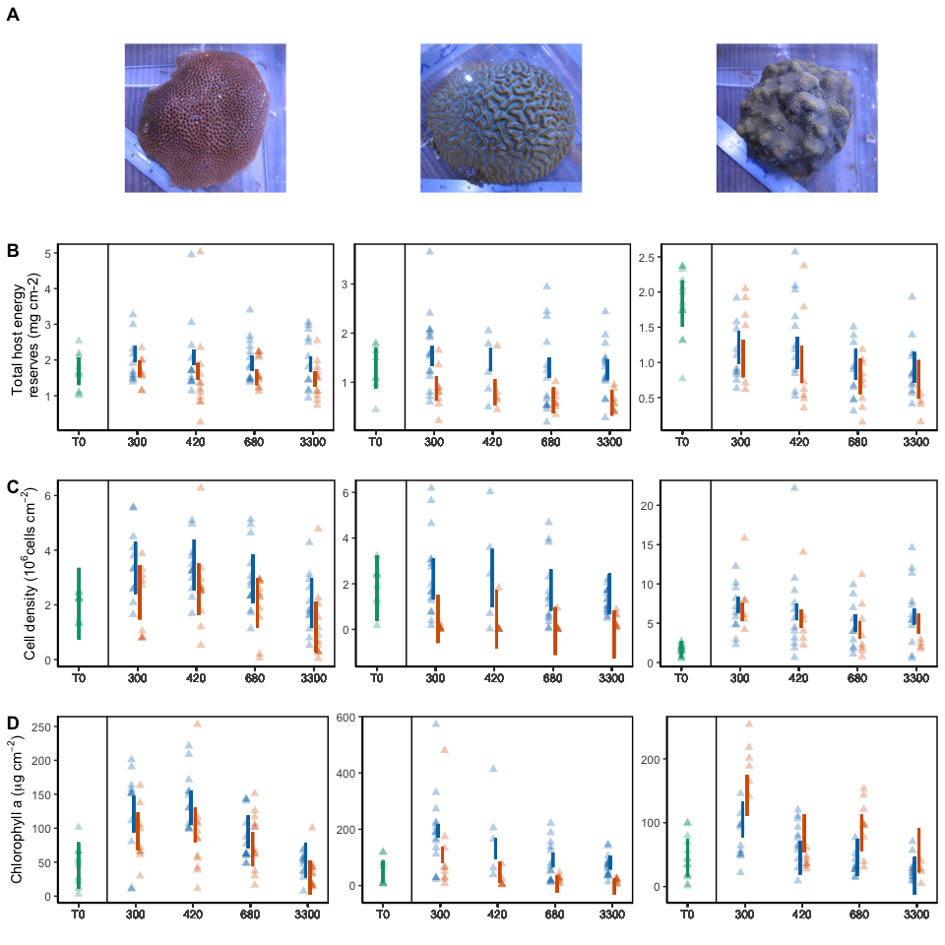 **Figure 1.** Modeled 95% confidence interval of (**A**) total host energy reserves (mg cm-2), (**B**) cell density (106 cells cm-2), and (**C**) Chlorophyll a (ug cm-2) for *S. siderea*, *P. strigosa*, and *P. astreoides* at T0 (green) or T90 (red/blue), with individual coral fragment physiology denoted by points. Blue denotes 28°C and red denotes 31°C, with *p*CO2 treatment along the x axis.

# Figure 2: Holobiont PCAs

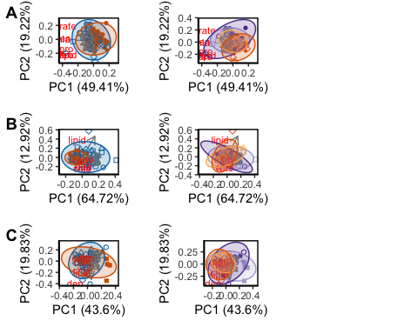

## Saving 5 x 4 in image

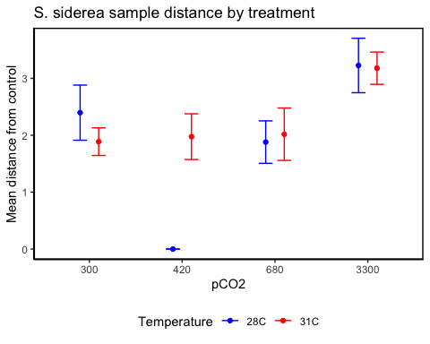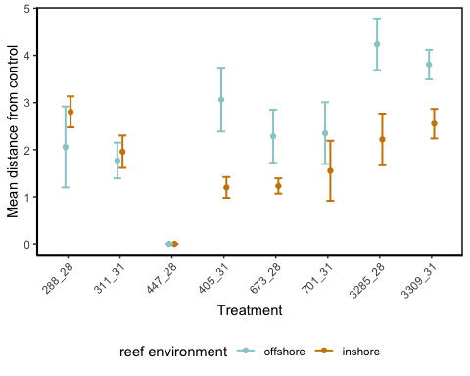

## Df Sum Sq Mean Sq F value Pr(>F)   
## treat2 7 79.93 11.418 7.989 3.19e-07 ***  
## reef 1 15.31 15.305 10.709 0.00161 **   
## treat2:reef 7 18.64 2.662 1.863 0.08777 .   
## Residuals 75 107.19 1.429   
## ---  
## Signif. codes: 0 '***' 0.001 '**' 0.01 '*' 0.05 '.' 0.1 ' ' 1

## diff lwr upr p adj  
## N-F -0.8118561 -1.311446 -0.3122663 0.00179815

## diff lwr upr p adj  
## 311_31-288_28 -0.509911451 -2.2420587 1.2222358 9.834085e-01  
## 447_28-288_28 -2.396902736 -3.9864301 -0.8073754 2.962322e-04  
## 405_31-288_28 -0.422087582 -1.9781474 1.1339723 9.897169e-01  
## 673_28-288_28 -0.517687876 -2.0448564 1.0094806 9.635321e-01  
## 701_31-288_28 -0.378978975 -1.9350388 1.1770809 9.946317e-01  
## 3285_28-288_28 0.829354857 -0.7267050 2.3854147 7.111894e-01  
## 3309_31-288_28 0.781755622 -0.7743042 2.3378155 7.683101e-01  
## 447_28-311_31 -1.886991285 -3.6191386 -0.1548440 2.308599e-02  
## 405_31-311_31 0.087823869 -1.6136635 1.7893112 9.999998e-01  
## 673_28-311_31 -0.007776425 -1.6828825 1.6673297 1.000000e+00  
## 701_31-311_31 0.130932477 -1.5705549 1.8324198 9.999975e-01  
## 3285_28-311_31 1.339266308 -0.3622211 3.0407537 2.314197e-01  
## 3309_31-311_31 1.291667073 -0.4098203 2.9931544 2.727261e-01  
## 405_31-447_28 1.974815154 0.4187553 3.5308750 4.053529e-03  
## 673_28-447_28 1.879214860 0.3520464 3.4063833 6.001004e-03  
## 701_31-447_28 2.017923762 0.4618639 3.5739836 3.041000e-03  
## 3285_28-447_28 3.226257593 1.6701977 4.7823175 2.526815e-07  
## 3309_31-447_28 3.178658358 1.6225985 4.7347182 3.780239e-07  
## 673_28-405_31 -0.095600294 -1.5879034 1.3967028 9.999993e-01  
## 701_31-405_31 0.043108607 -1.4787480 1.5649652 1.000000e+00  
## 3285_28-405_31 1.251442439 -0.2704141 2.7732990 1.857622e-01  
## 3309_31-405_31 1.203843204 -0.3180134 2.7256998 2.259848e-01  
## 701_31-673_28 0.138708902 -1.3535942 1.6310120 9.999907e-01  
## 3285_28-673_28 1.347042734 -0.1452604 2.8393459 1.068006e-01  
## 3309_31-673_28 1.299443498 -0.1928596 2.7917466 1.341602e-01  
## 3285_28-701_31 1.208333832 -0.3135227 2.7301904 2.219524e-01  
## 3309_31-701_31 1.160734596 -0.3611220 2.6825912 2.672106e-01  
## 3309_31-3285_28 -0.047599235 -1.5694558 1.4742573 1.000000e+00

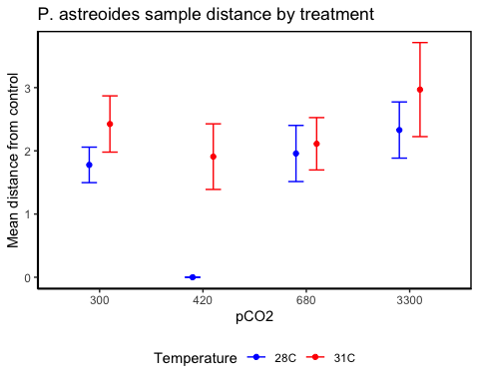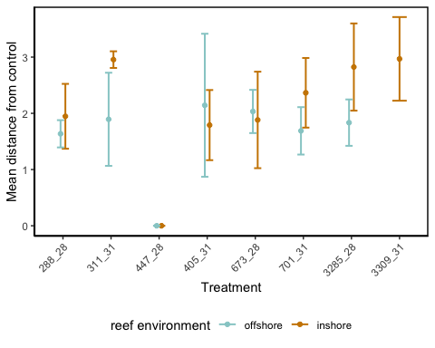

## Df Sum Sq Mean Sq F value Pr(>F)   
## treat2 7 47.89 6.842 4.723 0.000356 ***  
## reef 1 2.17 2.170 1.498 0.226374   
## treat2:reef 6 3.80 0.633 0.437 0.850704   
## Residuals 53 76.78 1.449   
## ---  
## Signif. codes: 0 '***' 0.001 '**' 0.01 '*' 0.05 '.' 0.1 ' ' 1

## diff lwr upr p adj  
## N-F 0.347785 -0.2418396 0.9374096 0.2420604

## diff lwr upr p adj  
## 311_31-288_28 0.64700960 -1.2803288 2.5743480 0.9623672411  
## 447_28-288_28 -1.77749973 -3.3967878 -0.1582116 0.0220356537  
## 405_31-288_28 0.13061183 -1.7967265 2.0579502 0.9999988128  
## 673_28-288_28 0.18034695 -1.4789296 1.8396235 0.9999694410  
## 701_31-288_28 0.33390645 -1.4306719 2.0984848 0.9987777686  
## 3285_28-288_28 0.55134404 -1.0338500 2.1365381 0.9546001914  
## 3309_31-288_28 1.19105279 -1.0262488 3.4083544 0.6904511955  
## 447_28-311_31 -2.42450933 -4.3518477 -0.4971710 0.0050228195  
## 405_31-311_31 -0.51639777 -2.7089242 1.6761287 0.9951517391  
## 673_28-311_31 -0.46666265 -2.4277179 1.4943926 0.9948356948  
## 701_31-311_31 -0.31310315 -2.3640239 1.7378176 0.9996995973  
## 3285_28-311_31 -0.09566556 -1.9944492 1.8031181 0.9999998484  
## 3309_31-311_31 0.54404319 -1.9072759 2.9953623 0.9966429159  
## 405_31-447_28 1.90811156 -0.0192268 3.8354499 0.0541420045  
## 673_28-447_28 1.95784668 0.2985701 3.6171232 0.0105133144  
## 701_31-447_28 2.11140617 0.3468279 3.8759845 0.0090087185  
## 3285_28-447_28 2.32884376 0.7436497 3.9140378 0.0005896305  
## 3309_31-447_28 2.96855251 0.7512509 5.1858541 0.0022613664  
## 673_28-405_31 0.04973512 -1.9113202 2.0107904 0.9999999987  
## 701_31-405_31 0.20329461 -1.8476261 2.2542153 0.9999837047  
## 3285_28-405_31 0.42073221 -1.4780514 2.3195158 0.9966766215  
## 3309_31-405_31 1.06044096 -1.3908782 3.5117601 0.8687399835  
## 701_31-673_28 0.15355950 -1.6477848 1.9549038 0.9999942106  
## 3285_28-673_28 0.37099709 -1.2550241 1.9970182 0.9960138919  
## 3309_31-673_28 1.01070584 -1.2359652 3.2573769 0.8442593933  
## 3285_28-701_31 0.21743759 -1.5159068 1.9507820 0.9999192473  
## 3309_31-701_31 0.85714634 -1.4683792 3.1826718 0.9387945788  
## 3309_31-3285_28 0.63970875 -1.5528177 2.8322352 0.9826979773

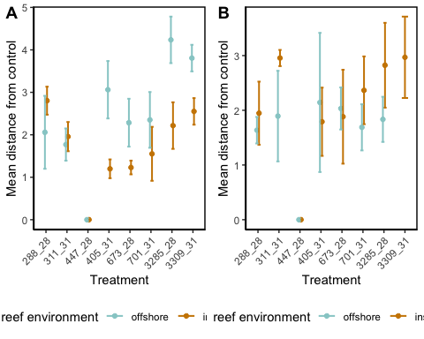

## Saving 5 x 4 in image

s.df90 <- subset(s.df, T0_T90 == "T90")  
  
sl.plot <- ggplot(data = s.df90, aes(x = lipid, y = rate, colour = fpco2, shape = ftemp)) +  
 theme(legend.position = "none") +  
 xlab(llab) +   
 ylab(rlab) +  
 scale_colour_manual("pCO2", labels = c("pre industrial", "current", "end-of-century", "extreme"), values = c("#b2abd2", "#5e3c99", "#fdb863", "#e66101")) +  
 scale_shape_manual("temperature", labels = c("28C", "31C"), values = c(19,1)) +  
 geom_point()  
  
sp.plot <- ggplot(data = s.df90, aes(x = pro, y = rate, colour = fpco2, shape = ftemp)) +  
 theme(legend.position = "none") +  
 xlab(plab) +   
 ylab(rlab) +  
 scale_colour_manual("pCO2", labels = c("pre industrial", "current", "end-of-century", "extreme"), values = c("#b2abd2", "#5e3c99", "#fdb863", "#e66101")) +  
 scale_shape_manual("temperature", labels = c("28C", "31C"), values = c(19,1)) +  
 geom_point()  
  
sca.plot <- ggplot(data = s.df90, aes(x = carb, y = rate, colour = fpco2, shape = ftemp)) +  
 theme(legend.position = "none") +  
 xlab(calab) +   
 ylab(rlab) +  
 scale_colour_manual("pCO2", labels = c("pre industrial", "current", "end-of-century", "extreme"), values = c("#b2abd2", "#5e3c99", "#fdb863", "#e66101")) +  
 scale_shape_manual("temperature", labels = c("28C", "31C"), values = c(19,1)) +  
 geom_point()  
  
sh.plot <- ggplot(data = s.df90, aes(x = host, y = rate, colour = fpco2, shape = ftemp)) +  
 theme(legend.position = "none") +  
 xlab("Total host energy reserves") +   
 ylab(rlab) +  
 scale_colour_manual("pCO2", labels = c("pre industrial", "current", "end-of-century", "extreme"), values = c("#b2abd2", "#5e3c99", "#fdb863", "#e66101")) +  
 scale_shape_manual("temperature", labels = c("28C", "31C"), values = c(19,1)) +  
 geom_point()  
  
sd.plot <- ggplot(data = s.df90, aes(x = den, y = rate, colour = fpco2, shape = ftemp)) +  
 theme(legend.position = "none") +  
 xlab(dlab) +   
 ylab(rlab) +  
 scale_colour_manual("pCO2", labels = c("pre industrial", "current", "end-of-century", "extreme"), values = c("#b2abd2", "#5e3c99", "#fdb863", "#e66101")) +  
 scale_shape_manual("temperature", labels = c("28C", "31C"), values = c(19,1)) +  
 geom_point()  
  
sc.plot <- ggplot(data = s.df90, aes(x = chla, y = rate, colour = fpco2, shape = ftemp)) +  
 theme(legend.position = "none") +  
 xlab(clab) +   
 ylab(rlab) +  
 scale_colour_manual("pCO2", labels = c("pre industrial", "current", "end-of-century", "extreme"), values = c("#b2abd2", "#5e3c99", "#fdb863", "#e66101")) +  
 scale_shape_manual("temperature", labels = c("28C", "31C"), values = c(19,1)) +  
 geom_point()  
  
plot_grid(sl.plot, sp.plot, sca.plot, sh.plot, sd.plot, sc.plot, labels = "AUTO", ncol = 2, scale = 0.9)

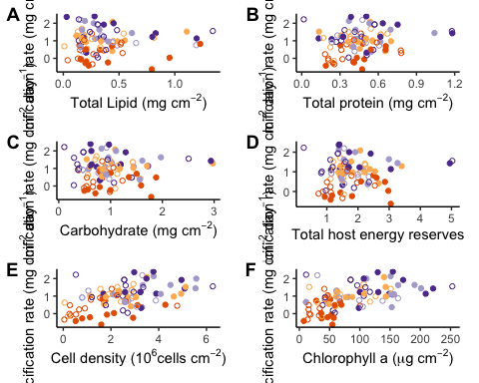

#ggsave("Ch3_appFig_SSIDscatter_29Jan20.pdf", width = 7, height = 8, units = "in")

p.df90 <- subset(p.df, T0_T90 == "T90")  
  
pl.plot <- ggplot(data = p.df90, aes(x = lipid, y = rate, colour = fpco2, shape = ftemp)) +  
 theme(legend.position = "none") +  
 xlab(llab) +   
 ylab(rlab) +  
 scale_colour_manual("pCO2", labels = c("pre industrial", "current", "end-of-century", "extreme"), values = c("#b2abd2", "#5e3c99", "#fdb863", "#e66101")) +  
 scale_shape_manual("temperature", labels = c("28C", "31C"), values = c(19,1)) +  
 geom_point()  
  
pp.plot <- ggplot(data = p.df90, aes(x = pro, y = rate, colour = fpco2, shape = ftemp)) +  
 theme(legend.position = "none") +  
 xlab(plab) +   
 ylab(rlab) +  
 scale_colour_manual("pCO2", labels = c("pre industrial", "current", "end-of-century", "extreme"), values = c("#b2abd2", "#5e3c99", "#fdb863", "#e66101")) +  
 scale_shape_manual("temperature", labels = c("28C", "31C"), values = c(19,1)) +  
 geom_point()  
  
pca.plot <- ggplot(data = p.df90, aes(x = carb, y = rate, colour = fpco2, shape = ftemp)) +  
 theme(legend.position = "none") +  
 xlab(calab) +   
 ylab(rlab) +  
 scale_colour_manual("pCO2", labels = c("pre industrial", "current", "end-of-century", "extreme"), values = c("#b2abd2", "#5e3c99", "#fdb863", "#e66101")) +  
 scale_shape_manual("temperature", labels = c("28C", "31C"), values = c(19,1)) +  
 geom_point()  
  
ph.plot <- ggplot(data = p.df90, aes(x = host, y = rate, colour = fpco2, shape = ftemp)) +  
 theme(legend.position = "none") +  
 xlab("Total host energy reserves") +   
 ylab(rlab) +  
 scale_colour_manual("pCO2", labels = c("pre industrial", "current", "end-of-century", "extreme"), values = c("#b2abd2", "#5e3c99", "#fdb863", "#e66101")) +  
 scale_shape_manual("temperature", labels = c("28C", "31C"), values = c(19,1)) +  
 geom_point()  
  
pd.plot <- ggplot(data = p.df90, aes(x = den, y = rate, colour = fpco2, shape = ftemp)) +  
 theme(legend.position = "none") +  
 xlab(dlab) +   
 ylab(rlab) +  
 scale_colour_manual("pCO2", labels = c("pre industrial", "current", "end-of-century", "extreme"), values = c("#b2abd2", "#5e3c99", "#fdb863", "#e66101")) +  
 scale_shape_manual("temperature", labels = c("28C", "31C"), values = c(19,1)) +  
 geom_point()  
  
pc.plot <- ggplot(data = p.df90, aes(x = chla, y = rate, colour = fpco2, shape = ftemp)) +  
 theme(legend.position = "none") +  
 xlab(clab) +   
 ylab(rlab) +  
 scale_colour_manual("pCO2", labels = c("pre industrial", "current", "end-of-century", "extreme"), values = c("#b2abd2", "#5e3c99", "#fdb863", "#e66101")) +  
 scale_shape_manual("temperature", labels = c("28C", "31C"), values = c(19,1)) +  
 geom_point()  
  
plot_grid(pl.plot, pp.plot, pca.plot, ph.plot, pd.plot, pc.plot, labels = "AUTO", ncol = 2, scale = 0.9)

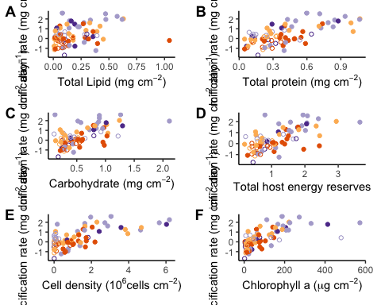

#ggsave("Ch3_appFig_PSTRscatter_29Jan20.pdf", width = 7, height = 8, units = "in")

a.df90 <- subset(a.df, T0_T90 == "T90")  
  
al.plot <- ggplot(data = a.df90, aes(x = lipid, y = rate, colour = fpco2, shape = ftemp)) +  
 theme(legend.position = "none") +  
 xlab(llab) +   
 ylab(rlab) +  
 scale_colour_manual("pCO2", labels = c("pre industrial", "current", "end-of-century", "extreme"), values = c("#b2abd2", "#5e3c99", "#fdb863", "#e66101")) +  
 scale_shape_manual("temperature", labels = c("28C", "31C"), values = c(19,1)) +  
 geom_point()  
  
ap.plot <- ggplot(data = a.df90, aes(x = pro, y = rate, colour = fpco2, shape = ftemp)) +  
 theme(legend.position = "none") +  
 xlab(plab) +   
 ylab(rlab) +  
 scale_colour_manual("pCO2", labels = c("pre industrial", "current", "end-of-century", "extreme"), values = c("#b2abd2", "#5e3c99", "#fdb863", "#e66101")) +  
 scale_shape_manual("temperature", labels = c("28C", "31C"), values = c(19,1)) +  
 geom_point()  
  
aca.plot <- ggplot(data = a.df90, aes(x = carb, y = rate, colour = fpco2, shape = ftemp)) +  
 theme(legend.position = "none") +  
 xlab(calab) +   
 ylab(rlab) +  
 scale_colour_manual("pCO2", labels = c("pre industrial", "current", "end-of-century", "extreme"), values = c("#b2abd2", "#5e3c99", "#fdb863", "#e66101")) +  
 scale_shape_manual("temperature", labels = c("28C", "31C"), values = c(19,1)) +  
 geom_point()  
  
ah.plot <- ggplot(data = a.df90, aes(x = host, y = rate, colour = fpco2, shape = ftemp)) +  
 theme(legend.position = "none") +  
 xlab("Total host energy reserves") +   
 ylab(rlab) +  
 scale_colour_manual("pCO2", labels = c("pre industrial", "current", "end-of-century", "extreme"), values = c("#b2abd2", "#5e3c99", "#fdb863", "#e66101")) +  
 scale_shape_manual("temperature", labels = c("28C", "31C"), values = c(19,1)) +  
 geom_point()  
  
ad.plot <- ggplot(data = a.df90, aes(x = den, y = rate, colour = fpco2, shape = ftemp)) +  
 theme(legend.position = "none") +  
 xlab(dlab) +   
 ylab(rlab) +  
 scale_colour_manual("pCO2", labels = c("pre industrial", "current", "end-of-century", "extreme"), values = c("#b2abd2", "#5e3c99", "#fdb863", "#e66101")) +  
 scale_shape_manual("temperature", labels = c("28C", "31C"), values = c(19,1)) +  
 geom_point()  
  
ac.plot <- ggplot(data = a.df90, aes(x = chla, y = rate, colour = fpco2, shape = ftemp)) +  
 theme(legend.position = "none") +  
 xlab(clab) +   
 ylab(rlab) +  
 scale_colour_manual("pCO2", labels = c("pre industrial", "current", "end-of-century", "extreme"), values = c("#b2abd2", "#5e3c99", "#fdb863", "#e66101")) +  
 scale_shape_manual("temperature", labels = c("28C", "31C"), values = c(19,1)) +  
 geom_point()  
  
plot_grid(al.plot, ap.plot, aca.plot, ah.plot, ad.plot, ac.plot, labels = "AUTO", ncol = 2, scale = 0.9)

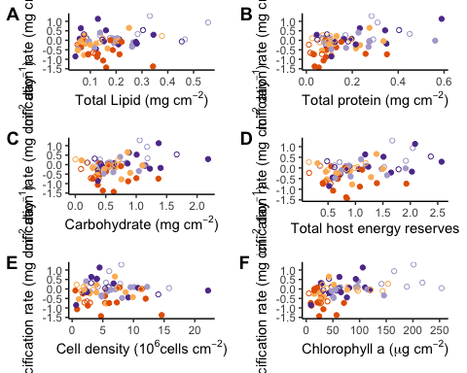

#ggsave("Ch3_appFig_PASTscatter_29Jan20.pdf", width = 7, height = 8, units = "in")

sessionInfo()

## R version 3.5.2 (2018-12-20)  
## Platform: x86_64-apple-darwin15.6.0 (64-bit)  
## Running under: macOS Mojave 10.14.6  
##   
## Matrix products: default  
## BLAS: /Library/Frameworks/R.framework/Versions/3.5/Resources/lib/libRblas.0.dylib  
## LAPACK: /Library/Frameworks/R.framework/Versions/3.5/Resources/lib/libRlapack.dylib  
##   
## locale:  
## [1] en_US.UTF-8/en_US.UTF-8/en_US.UTF-8/C/en_US.UTF-8/en_US.UTF-8  
##   
## attached base packages:  
## [1] grid stats graphics grDevices utils datasets methods   
## [8] base   
##   
## other attached packages:  
## [1] magick_2.2 lme4_1.1-21 Matrix_1.2-17 kableExtra_1.1.0  
## [5] ggfortify_0.4.7 cowplot_1.0.0 Rmisc_1.5 shiny_1.4.0   
## [9] vegan_2.5-6 lattice_0.20-38 permute_0.9-5 forcats_0.4.0   
## [13] stringr_1.4.0 purrr_0.3.3 tibble_2.1.3 tidyverse_1.2.1   
## [17] plotly_4.9.0 openxlsx_4.1.0.1 tidyr_1.0.0 ggbiplot_0.55   
## [21] scales_1.0.0 plyr_1.8.4 dplyr_0.8.3 ggplot2_3.2.1   
## [25] readr_1.3.1 knitr_1.25   
##   
## loaded via a namespace (and not attached):  
## [1] nlme_3.1-141 lubridate_1.7.4 webshot_0.5.1   
## [4] httr_1.4.1 tools_3.5.2 backports_1.1.5   
## [7] R6_2.4.0 lazyeval_0.2.2 mgcv_1.8-28   
## [10] colorspace_1.4-1 withr_2.1.2 tidyselect_0.2.5   
## [13] gridExtra_2.3 compiler_3.5.2 cli_1.1.0   
## [16] rvest_0.3.4 xml2_1.2.2 labeling_0.3   
## [19] digest_0.6.22 minqa_1.2.4 rmarkdown_1.16   
## [22] pkgconfig_2.0.3 htmltools_0.4.0 highr_0.8   
## [25] fastmap_1.0.1 htmlwidgets_1.5.1 rlang_0.4.1   
## [28] readxl_1.3.1 rstudioapi_0.10 generics_0.0.2   
## [31] jsonlite_1.6 zip_2.0.4 magrittr_1.5   
## [34] Rcpp_1.0.2 munsell_0.5.0 lifecycle_0.1.0   
## [37] stringi_1.4.3 yaml_2.2.0 MASS_7.3-51.4   
## [40] parallel_3.5.2 promises_1.1.0 crayon_1.3.4   
## [43] haven_2.1.1 splines_3.5.2 hms_0.5.1   
## [46] zeallot_0.1.0 pillar_1.4.2 boot_1.3-23   
## [49] glue_1.3.1 evaluate_0.14 data.table_1.12.6  
## [52] modelr_0.1.5 vctrs_0.2.0 nloptr_1.2.1   
## [55] httpuv_1.5.2 cellranger_1.1.0 gtable_0.3.0   
## [58] assertthat_0.2.1 xfun_0.10 mime_0.7   
## [61] xtable_1.8-4 broom_0.5.2 later_1.0.0   
## [64] viridisLite_0.3.0 cluster_2.1.0 ellipsis_0.3.0