Chapter 3: Physiology

Colleen Bove

17 December 2019

# Results

#### (A) Coral host and algal endosymbiont physiology

Coral host total tissue energy reserves (mg/cm2) was calculated as the sum of each protein, lipid, and carbohydrate value per coral host. Total host energy reserves of P. astreoides at T0 were clearly greater than the total energy reserves quantified in coral hosts maintained under at control treatment at T90 (Figure 1A). There was not statistically clear difference in total energy reserves between T0 and T90 control coral hosts in both S. siderea and P. strigosa. Elevated temperature (31C) resulted in a statistically clear reduction in total coral host energy reserves in only P. strigosa across all pCO2 treatments (Figure 1A). No overall effect of pCO2 was quantified in any of the four species examined.

Algal endosymbiont cell density (10^6 cells/cm2) in S. siderea fragments at T0 was lower than densities measured in fragments under the control treatment at T90, while P. astreoides T0 densities were clearly lower than those measured under the control treatment at T90 (Figure 1B). Algal endosymbiont cell densities did not exhibit a statistically clear difference between T0 fragments and T90 fragments maintained at the control treatment in P. strigosa. Neither pCO2 nor temperature exhibited a statistically clear overall effect on algal endosymbiont cell densities quantified at T90 in any of the four coral species (Figure 1B). Algal endosymbiont chlorophyll a content (ug/cm2) of S. siderea and P. strigosa at T0 was lower than the measured chlorophyll a in fragments maintained in the control treatment at T90 (Figure 1C). Conversely, chlorophyll a measured at T0 was not clearly different than in fragments reared in the control treatment at T90 for P. astreoides. All species have algal endosymbionts with statistically clear reductions in chlorophyll a content with increasing pCO2, while elevated temperature (31C) only clearly reduces chlorophyll a in the algal endosymbionts associated with P. strigosa (Figure 1C).

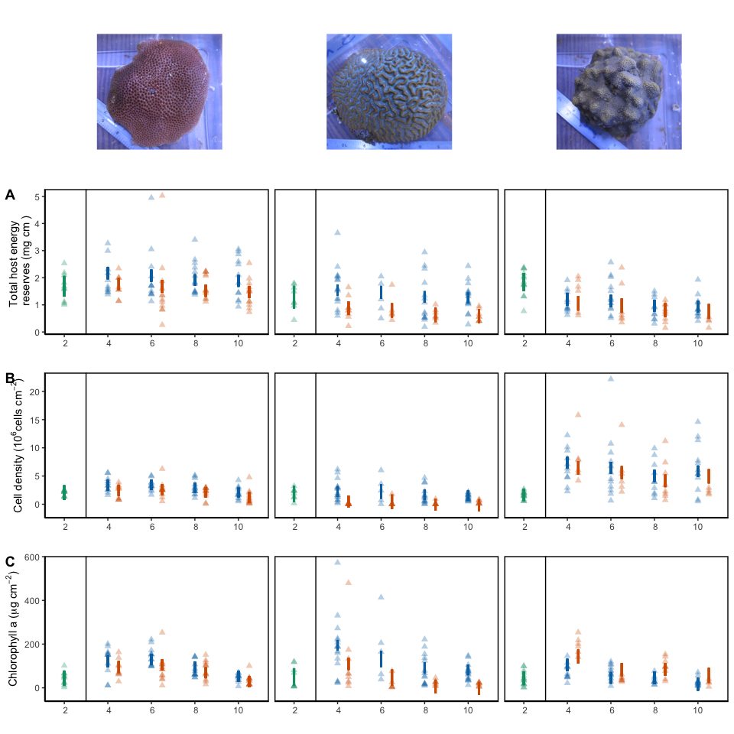

Figure 1. Modeled 95% confidence interval of (A) total host energy reserves (mg/cm2), (B) cell density (10^6 cells/cm2), and (C) Chlorophyll a (ug/cm2) for S. siderea, P. strigosa, and P. astreoides at T0 (green) or T90 (red/blue), with individual coral fragment physiology denoted by points. Blue denotes 28C and red denotes 31C, with pCO_2_ treatment along the x axis.

sessionInfo()

## R version 3.5.1 (2018-07-02)  
## Platform: x86_64-apple-darwin15.6.0 (64-bit)  
## Running under: macOS High Sierra 10.13.6  
##   
## Matrix products: default  
## BLAS: /Library/Frameworks/R.framework/Versions/3.5/Resources/lib/libRblas.0.dylib  
## LAPACK: /Library/Frameworks/R.framework/Versions/3.5/Resources/lib/libRlapack.dylib  
##   
## locale:  
## [1] en_US.UTF-8/en_US.UTF-8/en_US.UTF-8/C/en_US.UTF-8/en_US.UTF-8  
##   
## attached base packages:  
## [1] stats graphics grDevices utils datasets methods base   
##   
## other attached packages:  
## [1] magick_2.2 lme4_1.1-21 Matrix_1.2-17 kableExtra_1.1.0  
## [5] ggfortify_0.4.7 cowplot_1.0.0 Rmisc_1.5 plyr_1.8.4   
## [9] lattice_0.20-38 shiny_1.4.0 forcats_0.4.0 stringr_1.4.0   
## [13] purrr_0.3.2 tibble_2.1.3 tidyverse_1.2.1 plotly_4.9.0   
## [17] openxlsx_4.1.2 tidyr_0.8.3 dplyr_0.8.3 ggplot2_3.2.1   
## [21] readr_1.3.1 knitr_1.25   
##   
## loaded via a namespace (and not attached):  
## [1] httr_1.4.0 jsonlite_1.6 viridisLite_0.3.0  
## [4] splines_3.5.1 modelr_0.1.4 assertthat_0.2.1   
## [7] highr_0.8 cellranger_1.1.0 yaml_2.2.0   
## [10] pillar_1.4.2 backports_1.1.4 glue_1.3.1   
## [13] digest_0.6.20 promises_1.1.0 rvest_0.3.4   
## [16] minqa_1.2.4 colorspace_1.4-1 htmltools_0.4.0   
## [19] httpuv_1.5.2 pkgconfig_2.0.2 broom_0.5.2   
## [22] haven_2.1.1 xtable_1.8-4 scales_1.0.0   
## [25] webshot_0.5.1 later_1.0.0 generics_0.0.2   
## [28] withr_2.1.2 lazyeval_0.2.2 cli_1.1.0   
## [31] magrittr_1.5 crayon_1.3.4 readxl_1.3.1   
## [34] mime_0.7 evaluate_0.14 nlme_3.1-140   
## [37] MASS_7.3-51.4 xml2_1.2.0 tools_3.5.1   
## [40] data.table_1.12.2 hms_0.5.0 munsell_0.5.0   
## [43] zip_2.0.3 compiler_3.5.1 rlang_0.4.0   
## [46] grid_3.5.1 nloptr_1.2.1 rstudioapi_0.10   
## [49] htmlwidgets_1.3 labeling_0.3 rmarkdown_1.16   
## [52] boot_1.3-23 gtable_0.3.0 R6_2.4.0   
## [55] gridExtra_2.3 lubridate_1.7.4 fastmap_1.0.1   
## [58] zeallot_0.1.0 stringi_1.4.3 Rcpp_1.0.1   
## [61] vctrs_0.2.0 tidyselect_0.2.5 xfun_0.8