R Assignment #3 Key

*Marine Biology: Spring 2024*

## **Third R Assignment:**

Using the data we have collected as a class for lab skills (Lab_Skills_Data.xlsx), you will complete the following tasks. For each figure you create, make sure you use descriptive X and Y axis labels with units where applicable and write an informative figure caption. All figures, captions, and tables should be saved and placed within a Word document to submit along with a brief description of your results.

1. Make a bar plot of average (+/- standard deviation) value per sample for each of the following parameters:
   * pH
   * temperature
   * salinity
   * weights
   * calipers (L x W x H)
2. Make a scatter plot of the following parameters:
   * salinity versus temperature
   * shell width versus height
3. Find a new data visualization/figure to create in R to present some other relationship in your data that we have not learned yet in another R assignment (i.e., no line, scatter, or bar plots). Be creative and have fun!
4. Perform a statistical test in R (I recommend a T test or ANOVA) on one of the parameters you plotted in part 1 above. Present the results of your statistical test in a table.
5. Finally, write a brief results-style section discussing the statistical test you performed in part 4. In this section, present the p-value and discuss if your results were statistically different or not.

### Question 1: bar plot of average (+/- standard deviation)

library(tidyverse)

## ── Attaching core tidyverse packages ──────────────────────── tidyverse 2.0.0 ──  
## ✔ dplyr 1.1.4 ✔ readr 2.1.4  
## ✔ forcats 1.0.0 ✔ stringr 1.5.1  
## ✔ ggplot2 3.4.4 ✔ tibble 3.2.1  
## ✔ lubridate 1.9.3 ✔ tidyr 1.3.0  
## ✔ purrr 1.0.2   
## ── Conflicts ────────────────────────────────────────── tidyverse_conflicts() ──  
## ✖ dplyr::filter() masks stats::filter()  
## ✖ dplyr::lag() masks stats::lag()  
## ℹ Use the conflicted package (<http://conflicted.r-lib.org/>) to force all conflicts to become errors

library(readxl)

# load temp/salinity data  
temp_sal_df <- read_excel("~/Dropbox/Git/teaching_Rtutorial/Part_3/Lab_Skills_Data.xlsx", sheet = "Station 1 Salinity and Temp")

## New names:  
## • `` -> `...14`

# load pH data  
pH_df <- read_excel("~/Dropbox/Git/teaching_Rtutorial/Part_3/Lab_Skills_Data.xlsx", sheet = "Station 2 pH")

## New names:  
## • `` -> `...1`  
## • `` -> `...9`

# load weight data  
weight_df <- read_excel("~/Dropbox/Git/teaching_Rtutorial/Part_3/Lab_Skills_Data.xlsx", sheet = "Station 5 Byoyant Weight")  
  
# load length/width data  
calip_df <- read_excel("~/Dropbox/Git/teaching_Rtutorial/Part_3/Lab_Skills_Data.xlsx", sheet = "Station 4 Calipers")

## New names:  
## • `` -> `...8`

#### pH

# remove the first two rows of pH data (one is fake, the other is blank)  
pH_df <- pH_df[-1:-2,]  
  
# convert from wide to long to use all pH data  
pH_long <- pH_df %>%   
 pivot_longer(names_to = "pH_meas", values_to = "pH", pH_1:pH_3)   
  
# summary of pH data by beaker ID  
pH_sum <- pH_long %>%   
 group_by(Beacker_ID) %>%   
 summarise(pH_mean = mean(pH),  
 pH_sd = sd(pH))

ggplot(data = pH_sum, aes(x = Beacker_ID, y = pH_mean, fill = Beacker_ID)) +  
 geom_bar(stat = "identity") +  
 geom_errorbar(aes(ymin = pH_mean - pH_sd, ymax = pH_mean + pH_sd)) +  
 labs(x = "Beaker ID", y = "pH")

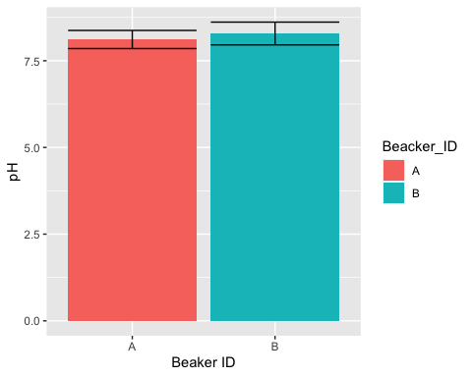

#### temperature

# remove the first two rows of temp data (one is fake, the other is blank)  
temp_sal_df <- temp_sal_df[-1,] %>%   
 drop_na(Beacker_ID)  
  
# convert from wide to long to use all temp data  
temp_sal_long <- temp_sal_df %>%   
 pivot_longer(names_to = "temp_meas", values_to = "temp", Temp1:Temp3) %>%   
 pivot_longer(names_to = "sal_meas", values_to = "sal", Sal_probe_1:Sal_probe_3)

# summary of temp data by beaker ID  
temp_sum <- temp_sal_long %>%   
 group_by(Beacker_ID) %>%   
 summarise(temp_mean = mean(temp),  
 temp_sd = sd(temp))

ggplot(data = temp_sum, aes(x = Beacker_ID, y = temp_mean, fill = Beacker_ID)) +  
 geom_bar(stat = "identity") +  
 geom_errorbar(aes(ymin = temp_mean - temp_sd, ymax = temp_mean + temp_sd)) +  
 labs(x = "Beaker ID", y = "Temperature (C)")

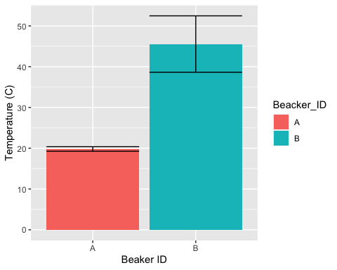

#### salinity

# summary of sal data by beaker ID  
sal_sum <- temp_sal_long %>%   
 group_by(Beacker_ID) %>%   
 summarise(sal_mean = mean(sal),  
 sal_sd = sd(sal))

ggplot(data = sal_sum, aes(x = Beacker_ID, y = sal_mean, fill = Beacker_ID)) +  
 geom_bar(stat = "identity") +  
 geom_errorbar(aes(ymin = sal_mean - sal_sd, ymax = sal_mean + sal_sd)) +  
 labs(x = "Beaker ID", y = "Salinity (PSU)")

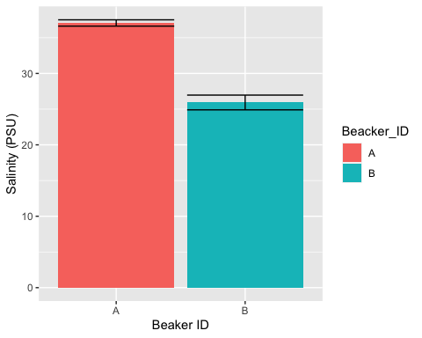

#### weights

# convert from wide to long to use all weight data  
weight_long <- weight_df %>%   
 drop_na(weight_1) %>%   
 pivot_longer(names_to = "weight_meas", values_to = "weight", weight_1:weight_3)  
  
# summary of weight data by beaker ID  
weight_sum <- weight_long %>%   
 group_by(ID) %>%   
 summarise(weight_mean = mean(weight),  
 weight_sd = sd(weight))

ggplot(data = weight_sum, aes(x = ID, y = weight_mean, fill = ID)) +  
 geom_bar(stat = "identity") +  
 geom_errorbar(aes(ymin = weight_mean - weight_sd, ymax = weight_mean + weight_sd)) +  
 labs(x = "Item", y = "Weight (g)")

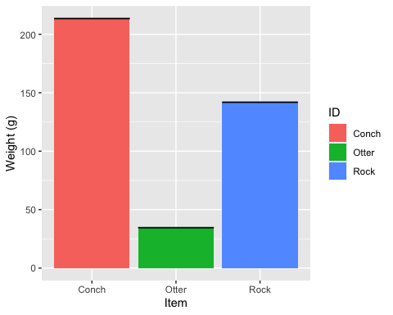

#### calipers (L x W x H)

# convert from wide to long to use all calip data  
calip_long <- calip_df[-1,] %>%   
 drop_na(Shell_ID) %>%   
 pivot_longer(names_to = "calip_meas", values_to = "measure", length_mm:height_mm)  
  
# summary of calip data by beaker ID  
calip_sum <- calip_long %>%   
 group_by(Shell_ID, calip_meas) %>%   
 summarise(calip_mean = mean(measure),  
 calip_sd = sd(measure))

## `summarise()` has grouped output by 'Shell_ID'. You can override using the  
## `.groups` argument.

ggplot(data = calip_sum, aes(x = Shell_ID, y = calip_mean, fill = Shell_ID)) +  
 geom_bar(stat = "identity") +  
 geom_errorbar(aes(ymin = calip_mean - calip_sd, ymax = calip_mean + calip_sd)) +  
 labs(x = "Shell ID", y = "Measure (mm)") +  
 facet_wrap(~calip_meas)

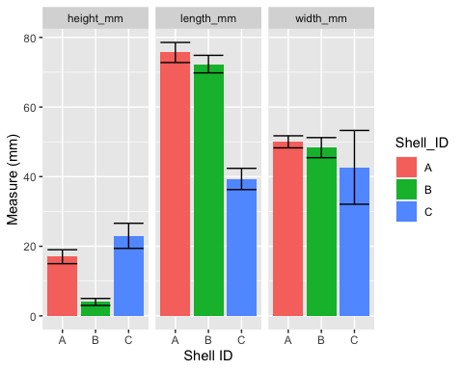

### Question 2:

ggplot(data = temp_sal_long, aes(x = sal, y = temp, color = Beacker_ID)) +  
 geom_point() +  
 labs(x = "Salinity (PSU)", y = "Temperature (C)")

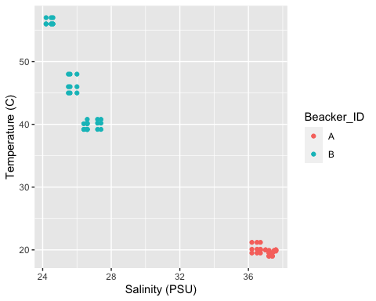

ggplot(data = calip_df[-1,], aes(x = width_mm, y = height_mm, color = Shell_ID)) +  
 geom_point() +  
 labs(x = "Width (mm)", y = "Height (mm)")

## Warning: Removed 4 rows containing missing values (`geom_point()`).

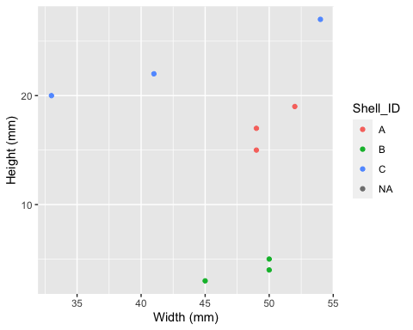

### Question 3:

Anything goes here! But this website has some great examples of different data visualization options: <https://r-graph-gallery.com/>

### Question 4:

T test option:

library(knitr)  
  
# comparing pH across two beakers  
t.test(pH ~ Beacker_ID, data = pH_long)

##   
## Welch Two Sample t-test  
##   
## data: pH by Beacker_ID  
## t = -1.4305, df = 20.961, p-value = 0.1673  
## alternative hypothesis: true difference in means between group A and group B is not equal to 0  
## 95 percent confidence interval:  
## -0.42534030 0.07867363  
## sample estimates:  
## mean in group A mean in group B   
## 8.112500 8.285833

# OR using the rempsyc package:  
library(rempsyc)  
  
ttest2 <- nice_t_test(data = pH_long, response = "pH", group = "Beacker_ID")  
kable(ttest2)

| Dependent Variable | t | df | p | d | CI_lower | CI_upper |
| --- | --- | --- | --- | --- | --- | --- |
| pH | -1.430545 | 20.96095 | 0.1673001 | -0.5840175 | -1.39604 | 0.2406335 |

ANOVA option:

summary(aov(pH ~ Group, data = pH_long))

## Df Sum Sq Mean Sq F value Pr(>F)   
## Group 4 1.5992 0.3998 14.64 1.29e-05 ***  
## Residuals 19 0.5189 0.0273   
## ---  
## Signif. codes: 0 '***' 0.001 '**' 0.01 '*' 0.05 '.' 0.1 ' ' 1

### Question 5:

Again, this section with vary but key details I am looking for here include:

* the parameter being tested (*e.g.*, pH, temperature, etc.)
* statement of what statistical test was run
* the p value and interpretation of the p value
* broad conclusion of what this may mean

*This answer key was created by Colleen Bove, please feel free to update as needed for your own assignments!*