Marine Biology R Assignment #4

*Spring 2024*

## Fourth R Assignment

**This R assignment will be due by 3PM on Tuesday, March 26th**. You will submit both your R markdown code and the Word output of your work. This assignment can be completed with other members from your lab section but if you work with others, please include their names on your submission.

Using the MarineBio_ExampleData.csv data that can be found on Canvas, you will complete the following tasks:

1. **Create a R markdown document that will knit as a Word document.** You will submit both the R markdown code and the Word document for this assignment so this will be assessed as a part of your submission.
2. **Recreate Figure 1 (below) as closely as possible** See if you can figure out what data are shown in this figure and then ask for help if you are unsure. Using what you have learned about R so far, try to recreate the figure with captions, labels, colors, shapes, etc. as closely as possible.
3. **Recreate Figure 2 (below) as closely as possible** See if you can figure out what data are shown in this figure and then ask for help if you are unsure. Using what you have learned about R so far, try to recreate the figure with captions, labels, colors, line types, etc. as closely as possible.
4. **Perform an Analysis of Variance (ANOVA) of the effect of *p*CO2 on calcification rate (rate)** Show your code for how you performed your statistical test and then have your markdown file report your p-values from your different treatment. Include a brief (~2-3 sentences) interpreting your results from your ANOVA citing statistics in your statement.

df <- read.csv("./Part_4/MarineBio_ExampleData.csv", header = TRUE)  
str(df)

## 'data.frame': 310 obs. of 38 variables:  
## $ coral : chr "CFAA1" "CFAA14" "CFAA15" "CFAA2" ...  
## $ tank : chr "280_31_1" "400_28_1" "400_28" "280_28_1" ...  
## $ treat : chr "311_31" "447_28" "447_28" "288_28" ...  
## $ pco2 : int 311 447 447 288 673 3285 673 447 447 288 ...  
## $ temp : int 31 28 28 28 28 28 28 28 28 28 ...  
## $ T0_T90 : chr "T90" "T90" "T0" "T90" ...  
## $ reef : chr "F" "F" "F" "F" ...  
## $ species : chr "A" "A" "A" "A" ...  
## $ fpco2 : chr "280" "400" "T0" "280" ...  
## $ ftemp : chr "31" "28" "T0" "28" ...  
## $ colony : chr "AA_F" "AA_F" "AA_F" "AA_F" ...  
## $ SA : num 10.55 10.42 12 8.63 12.19 ...  
## $ den : num 5524415 7570309 1487617 2911507 1706254 ...  
## $ pro : num 0.45 0.197 0.266 0.116 0.234 0.351 0.095 0.233 0.175 0.561 ...  
## $ chla : num 229.7 114.9 14.4 18.9 19.1 ...  
## $ sum_bw5 : num 126 266 NA 350 431 ...  
## $ red_bw1 : num 114 NA NA 123 146 ...  
## $ green_bw1: num 79.7 NA NA 88.1 103.1 ...  
## $ blue_bw1 : num 16.2 NA NA 4.2 9.7 12 28.3 NA NA 13.4 ...  
## $ sum_bw1 : num 210 NA NA 445 258 ...  
## $ red_bw2 : num 118.2 93.8 NA 122.4 145.1 ...  
## $ green_bw2: num 90 51.2 NA 92 109 87.7 87.9 55.4 NA 68.8 ...  
## $ blue_bw2 : num 16.6 18.3 NA 41.8 42 33.1 33.6 22.4 NA 19.4 ...  
## $ sum_bw2 : num 225 163 NA 256 296 ...  
## $ red_bw3 : num 98.1 92 NA 129.8 167.5 ...  
## $ green_bw3: num 62.5 59 NA 88 123.7 ...  
## $ blue_bw3 : num 12.5 28 NA 25.1 57 37.2 28.5 36.6 NA 13.3 ...  
## $ sum_bw3 : num 173 179 NA 243 348 ...  
## $ red_bw4 : num 145 100 NA 132 185 ...  
## $ green_bw4: num 110.3 65.4 NA 89.9 143 ...  
## $ blue_bw4 : num 28.4 28.4 NA 34 89.2 49.3 64.8 18.3 NA 17.1 ...  
## $ sum_bw4 : num 284 194 NA 255 417 ...  
## $ red_bw5 : num 69.2 137.5 NA 166.2 193.9 ...  
## $ green_bw5: num 52.3 93.3 NA 126.4 159.5 ...  
## $ blue_bw5 : num 4.4 35.6 NA 56.9 78 53.4 38.7 57.3 NA 18.2 ...  
## $ rate : num 0.333 0.079 NA -0.148 -0.255 -0.739 -0.179 0.634 NA -0.018 ...  
## $ carb : num 1.186 0.638 1.94 0.547 0.359 ...  
## $ lipid : num 0.2833 0.0586 0.119 0.1919 0.054 ...

library(tidyverse)

## ── Attaching core tidyverse packages ──────────────────────── tidyverse 2.0.0 ──  
## ✔ dplyr 1.1.4 ✔ readr 2.1.4  
## ✔ forcats 1.0.0 ✔ stringr 1.5.1  
## ✔ ggplot2 3.4.4 ✔ tibble 3.2.1  
## ✔ lubridate 1.9.3 ✔ tidyr 1.3.0  
## ✔ purrr 1.0.2   
## ── Conflicts ────────────────────────────────────────── tidyverse_conflicts() ──  
## ✖ dplyr::filter() masks stats::filter()  
## ✖ dplyr::lag() masks stats::lag()  
## ℹ Use the conflicted package (<http://conflicted.r-lib.org/>) to force all conflicts to become errors

## Question 1:

For full credit, you should submit both the Rmarkdown (.Rmd) and resulting Word (.doc or .docx) documents demonstrating your code and the resulting output.

## Question 2: Figure 1

lipid_sum <- df %>%   
 group_by(treat, species) %>%   
 summarise(mean = mean(lipid),  
 sd = sd(lipid))

## `summarise()` has grouped output by 'treat'. You can override using the  
## `.groups` argument.

ggplot(data = lipid_sum, aes(x = treat, colour = species)) +  
 geom_point(aes(y = mean), shape = 8, position = position_dodge(width = 0.5)) +  
 geom_errorbar(aes(ymin = mean - sd, ymax = mean + sd), position = position_dodge(width = 0.5)) +  
 scale_colour_brewer("Coral Species", labels = c("PAST", "PSTR", "SSID", "UTEN"), palette = "Dark2") +  
 labs(x = "Treatment",  
 y = "Lipids (mg/cm2)",  
 title = "Coral Lipid Content Under Ocean Acidification and Warmging",  
 subtitle = "Mean +/- standard deviation") +  
 theme_classic()

## Warning: Removed 3 rows containing missing values (`geom_point()`).

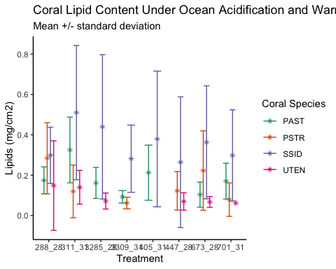

## Question 3: Figure 2

T90_df <- df %>%   
 filter(T0_T90 == "T90")

ggplot(data = T90_df, aes(x = rate, y = den, colour = ftemp, linetype = ftemp)) +  
 geom_point(alpha = 0.5) +  
 scale_color_manual("Temperature", values = c("blue", "red"), labels = c("28 C", "31 C")) +  
 scale_linetype_manual("Temperature", values = c("dotted", "dashed"), labels = c("28 C", "31 C")) +  
 geom_smooth(method = lm, se = FALSE) +  
 facet_wrap(~ species, scales = "free_y", labeller = as_labeller(c("A" = "PAST", "P" = "PSTR", "S" = "SSID", "T" = "UTEN"))) +  
 labs(x = "Calcification Rate (mg/cm2/day)",  
 y = "Symbiont Density (cells/cm2)",  
 title = "Coral calcification rate versus chlorophyll a content") +  
 theme_bw()

## `geom_smooth()` using formula = 'y ~ x'

## Warning: Removed 2 rows containing non-finite values (`stat_smooth()`).

## Warning: Removed 2 rows containing missing values (`geom_point()`).

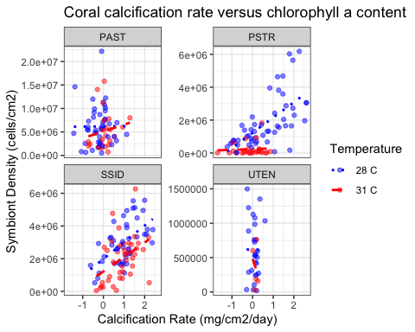

## Question 4:

# run a 1-way ANOVA of the effect of pCO2 treatment on calcification rate  
anova_out <- aov(rate ~ pco2, data = df)  
  
# view summary of ANOVA model output  
summary(anova_out)

## Df Sum Sq Mean Sq F value Pr(>F)   
## pco2 1 24.97 24.971 41.55 5.35e-10 ***  
## Residuals 267 160.47 0.601   
## ---  
## Signif. codes: 0 '***' 0.001 '**' 0.01 '*' 0.05 '.' 0.1 ' ' 1  
## 41 observations deleted due to missingness

**Results:** After performing a one-way analysis of variance to assess the effects of *p*CO2 treatment on coral calcification rate, we can determine that *p*CO2 treatment significantly alters coral calcification rate (F = 41.55; p < 0.001). We thus reject the null hypothesis in favor of the alternate hypothesis that our experimental treatment had a significant effect on our response variable.

*This answer key was created by Colleen Bove, please feel free to update as needed for your own assignments!*