Geo-Seas
Pan-European infrastructure for management of marine and ocean geological and geophysical data


Ends_And_Bends_V2.2.0_User_Manual

Organisation name for lead contractor for this deliverable: Ifremer

Project acronym: Geo-Seas
Project full title: Pan-European infrastructure for management of marine and ocean geological and geophysical data
Grant Agreement Number: 238952
Start date of project: 1st May 2009

Co-ordinator: Helen Glaves




Deliverable number | Short Title
D8.1 | Ends And BendsUser Manual
Long Title
Ends_And_Bends_V2.2.0_User_Manual
Short Description
This document is the user manual ofEnds&Bends, a software used to sample raw navigation (ship routes) and to generate the spatial objects to be included in CDI records to describe the geometries of the observations
Keywords
Navigation, sampling, GML, CDI
Authors / Organisation(s) | Editor / Organisation
Moussat Eric, Ifremer | H. Glaves (NERC-BGS)
File name
Ends_And_Bends_V2.2.0_User_Manual.doc
Deliverable due date | Deliverable submitted date
NA | 15 February 2011
Comments
Not a deliverable. Ends&Bends is a software adapted and proposed by Ifremer to partners to help them to sample their navigation files and to produce the spatial objects in the CDI xml files.

History
Version | Author(s) | Status | Date | Comments
V0 | Eric Moussat, Ifremer  Sophie Bregent | FINAL | 15 February 2011 | On-line help
V1 | Eric Moussat, Ifremer  Sophie Bregent | FINAL | 26 Nov. 2011 | Separate downloadable document
V2 | Eric Moussat, Ifremer  Sophie Bregent | FINAL | 09 April 2013 | Update §1.1: correct linux launch script name  Update figures 5 &17: improve fields labels
V2.06 | Eric Moussat, Ifremer  Sophie Bregent | FINAL | 21 March 2014 | Update §5.5.4: New format ISO 19139
V2.1.0 | Eric Moussat, Ifremer  Sophie Bregent | FINAL | 03 April 2014 | Update §5.5.4: File CSR format ISO 19139
V2.2.0 | Cécile Pertuisot, Ifremer  Sébastien Crouzille, CapGemini Engeneering | FINAL | 15 January 2026 | Upgrade to java21  Implementation of OpenJDK, Azul Zulu Build

Dissemination level
PU | Public | X
CO | Confidential, for project partners and the European Commission only

Executive Summary
Ends&Bends is used to generate spatial objects from raw navigation (ship routes) to be included in CDI or CSR records files to describe the geometries of the observations :
- Typical navigation log files record more than one location / 10 seconds (ex : GPS outputs),
- Size of these navigation log files are not practical to be managed or visualized using standard GIS software or services (WMS, WFS and GML)
Navigation log files must be subset, but sub setting must:
- Keep the same geographical shape of the vessel route to allow accurate spatial queries
- Reduce significantly the number of geographical locations to preserve response time (e.g. 1000 points for one month of deep sea navigation,1000 points for a week of inshore navigation).

Content

1 Running the application 7
1.1 Prerequisites 7
1.2 Windows 7
1.3 Linux 7
2 Loading data, geographical projection and splitting into segments 7
2.1 Coordinate projection 7
2.2 Acquisition stops detection 8
2.3 Projection constraints 8
3 Subsampling algorithm 8
3.1 Default algorithm 8
3.2 Optimized computation 9
3.3 Segment customized computation 9
4 Main window 10
4.1 Main window areas 10
4.2 Input / Output management 10
4.2.1 Buttons 10
4.3 Segments list 11
4.3.1 List status 12
4.3.2 Handling lines representing a segment 13
4.3.3 « Total » line handling 13
4.4 Options 14
5 Functions on files 14
5.1 Opening a navigation file 14
5.1.1 NETCDF NVI Format 16
5.1.2 CSV Format 17
5.1.3 UKOOA Format 17
5.2 Default computation 20
5.3 Farthest point optimization 20
5.4 Error optimization 20
5.5 Saving processed data 20
5.5.1 Ifremer ASCII Format 21
5.5.2 ASCII columns format 22
5.5.3 WKT format 23
5.5.4 GML format 24
5.5.5 Shape format 25
6 Segment handling 25
6.1 Segment visualization 26
6.2 Default computation 30
6.3 Customized computation 30
7 Options 30
7.1 Thresholds 31
7.2 Projection 32
7.3 Very long distance 33
8 Log 36

Running the application
The application can be executed from the command line as follow, either on Windows or Linux.

Prerequisites
The application requires Java 21 or higher and is built with Azul Zulu build.

Windows
Download EAB_*_win.zip archive (https://www.seadatanet.org/Software/EndsAndBends/)
Extrcat the archive while preserving the folder’s structure.
Double-cick on EAB.bat, EAB_FR.bat or EAB_EN.bat

Linux
Download EAB_*_linux.tar.gz
Extract: tar -xzf EAB_*_linux.tar.gz
Make executable: chmod +x *.sh
Launch: ./EAB.sh, ./EAB_FR.sh or ./EAB_EN.sh

The application canalso be manually launched from the DOS / Linux command line terminal when located in the installation folder :
java -jar EndsAndBends.jar # Default language
java -jar EndsAndBends.jar -nl fr # French Interface
java -jar EndsAndBends.jar -nl en # English Interface

Loading data, geographical projection and splitting into segments

Coordinate projection
The algorithm detailed below computes distances from geographical coordinates (angles). In order to do so, all the geographical coordinates must be projected on a plane.However, the original geographical coordinates in latitudes and longitudes are preserved and are never recomputed from planar coordinates. Projected coordinates are only used to compute distances between points, hence there is no precision loss when writing output data results.

Acquisition stops detection
Multibeamechosounder navigation files contain data harvested during a whole survey. Sometimes the positionning data stops which entails gaps in the navigation outline.
Consequently, once the navigation file is loaded, data survey aresplitted into segments. Each segment contains contiguous data.The splitting process is based on two information : time and distance. A 10 minutes maximum gap (and the corresponding distance for an average speed of 10 knots) is used by default.

Projection constraints
The only geographical projection provided in the application is the Gauss-Krueger projection. It is Ends&Bends basic projection.The limitation of this projection lies in the distances deformation for very long distances. Projected points in the same reference system must not be separated by more than 5° in latitude. This is an indicative limit, the application permits modifying it.
In order to project all points without drawbacks, the application splits segments which are too long. This operation is performed just after the acquisition stops detection, when loading the data.

Subsampling algorithm

Default algorithm
The implemented algorithm can be summed up in three steps :
- First, the two ends of a segment are chosen,
- Then we add the other points one by one choosing first the farthest from the polyline going through the already selected points.
- The adding process stops when the global error reaches the desired level of error.
The operating principle is described by the following picture.
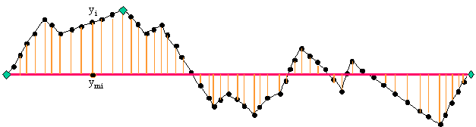
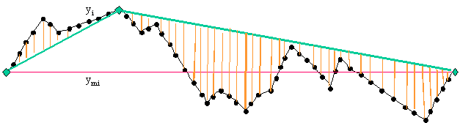

In the original basic programEnds&Bends (J. Bolotosky and K. Koschyk,2000) , the global error between the real and the simplified outline is estimated by the mean of the squared distance between the original points and the simplified outline, divided by the total length of the real outline.Thanks to this error, the software defines 5 models each corresponding to a particular level of error (10⁻¹ for the model 1, to 10⁻⁵ for the model 5).
This algorithm has been improved to better take into account the 999 points limit. The « models » technique drawback is that those models do not depend of the number of obtained points : it often happens that a model has much less than 999 points when the next one has much more than that and finally the user has to select the less acurate model in order to respect the 999 points limit.
The algorithm works adding points one by one, so one can decide to stop it using any criterion.
The implemented algorithm in the new application Ends&Bends uses this feature to compute intermediate models which have a multiple of 999 points. The result is no longer limited to 5 models and can contain up to 10.
Two criteria are then used to define a model :
- Either the error falls under a threshold in 10^{-n},
- Or the number of point is less than or equal to a multiple of 999.

Optimized computation
Eventually, an ultimate algorithm has been implemented, still taking advantages of the fact that points are adding one by one and changing the stop adding criterion.This computation is intended for taking into account the 999 points limit on the whole survey and not only on one segment.
To do so, the algorithme process all the segments at the same time. At each iteration it determines which segment has to be optimized and then add a point to this segment. The algorithm stops when the total number of points reaches 999.
There are two ways to choose which segment has to be optimized :
- either we choose the one which has the most distant point from the simplified outline : it is the Farthest point optimization
- or we choose the one which has the highest global error : it is the Error optimization

Segment customized computation
To tune with more accuracy the subsampling on a segment, another algorithm has been implemented : the operator is asked to chose the number of points he wants to obtain.
In this case, the algorithm is unchanged, but only one model is computed. This model is associated to the chosen segment and contains the exact number of points asked.

Main window

Main window areas
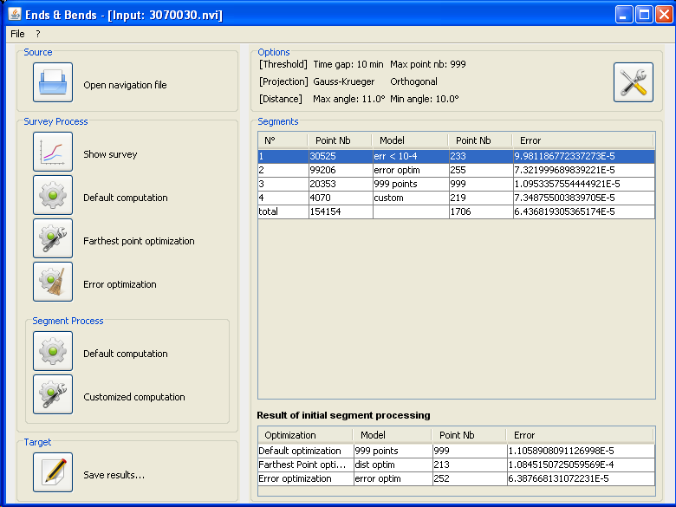
Figure 1 Main window
The main window consists in two areas :
- Left area : buttons which permit global handling of a navigation file.
The buttons in the " Survey Process" area are always enabled, they permit global operations on the navigation file.The buttons in the " Segment Process" area are only enabled when a segment is selected, they permit operations on one segment.
- Right Area : a table which contains a list of loaded segments from a navigation file.

Input / Output management

Buttons
Source area :
 | Open a navigation file  Permits loading into memory a new navigation file. Previously loaded data are lost.

Survey process area :
 | Show survey  Permits to show all the survey outline.
 | Default Computation  Perfoms the default computation model for all segments (details).
 | Farthest point optimization  Performs a model computation for each segment, in order to get exactly 999 total points with distance criterion (details).
 | Error optimization  Performs a model computation for each segment, in order to get exactly 999 total points with global error criterion (details).

Segment process area :
Default Computation
Perfoms the default computation model on the selected segment.
Customized computation
Performs a computation on the selected segment we can customized by changing the number of points (details).

Target area :
 | Save results  Save subsampled data.

Segments list
The table contains the list of segments which are loaded into memory.

List status
When running the application, this list comes empty. After having loaded a file navigation, the columns are filled.
In this status, the list appears as follow :
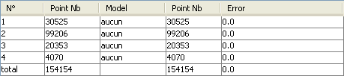
The table "Result of initial segment processing" is empty.
The table appears as follow :
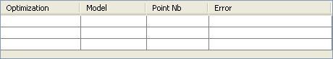
After the default computation on the survey, the other columns are filled.
In this status, the list appears as follow :
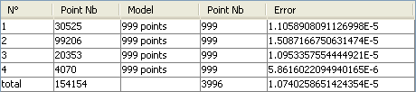
The first line of the table "Result of initial segment processing" is filled.
In this status, the table appears as follow :
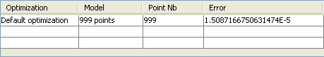
After the farthest point optimization the columns are filled as follow :
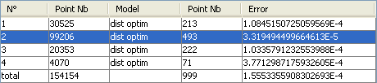
In the example above, the 4 first lines of the segment list represent each a segment. The last line represent the total number of points and the total error on all segments.
Then the second line of the table "Result of initial segment processing" is filled.
In this status, the table appears as follow :
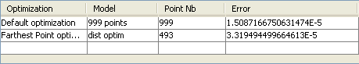

Handling lines representing a segment

The columns have the following meaning :
N° | segment identification number
Point Nb | segment number of points before optimization
Model | selected model name (see combo list use below)
Point Nb | optimized segment number of points
Error | error due to segment optimization

Once an optimization has been computed either on the survey or on a segment, up to 10 models are available on a segment. In this case, a combo list displaying the computed models appears through a mouse clic on the frame « model ». The combo list contains the model names, see the following chapters.
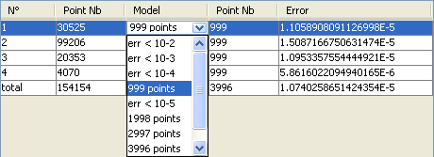
Figure 2 Models list

« Total » line handling
The columns have the following meaning :
N° | segment identification number
Point Nb | total number of points in the navigation file
Model | usually empty, except when a global model is chosen (see combo list use below)
Point Nb | optimized total number of points, this value must be less than or equal to 999 so that the output result file be valid.
Error | error sum on every segment.
The "model" frame of the total line is usually empty. A combo list appears on a mouse clic, suggesting criteria on the error. This list permits defining segments default model.
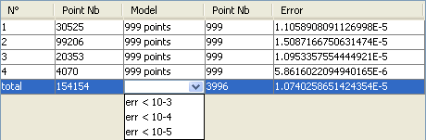
If an error level is selected, the application will choose amongst available models, for each segment, the first with which the error is less than the selected level. If none of them fits, the segment has no selected models and the application considers the segment not optimized.

Options
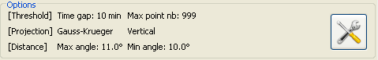
Figure 3 Options area

There is an Options area at the top of the window. This area is composed of :
- A text which sums up the selected threshold, projection and distance.
- An « Options… » button, which opens the Options dialog window, described in paragraph 7.

Functions on files

Opening a navigation file
To load a navigation file clic on the button "Open navigation file". The application permit using a parameter file. If you don't choose to use any parameter file the window opens on the NETCDF NVI format.
When this function is called, the application flushes all the data that would have been previously loaded into memory.

When data are loaded into memory, the application performs the following operations :
- Projection of the points (see details in paragraph 2)
- The whole survey is divided into continuous navigation segments (see details in paragraph 2)
- Segments which are too large for the selected projection are also divided into sub-segments (see details in paragraph 2)

As these operations use the selected projection, like other options, data loaded into memory must be updated when the projection is changed.
Once the file is properly loaded, the application displays the list of segments from the navigation file in the central table.

The detail of split causes is available in the endsAndBends.log file, in the root directory installation of Ends&Bends. The log lists each segment with information on split type for begin and end of segment.
Types are:
- ABSOLUTE_START: start of the hole trajectory (first point of first trajectory segment)
- TIME_GAP: TIME between this segment and next or previous one is greater the TIME threshold
- DISTANCE_GAP: DISTANCE between this segment and next one is greater the DISTANCE threshold
- PROJECTION_SPLIT: an artifical cut has been forced because the segment area was too big for projection
- ABSOLUTE_END: end of the hole trajectory (last point of last trajectory segment)

Example:

-------------------
split summary for file dummy.nvi
-------------------

2013-04-09 15:49:16,609 INFO [MainForm] seg. no 0 127621 pts ABSOLUTE_START - TIME_GAP - LON: -70.01776079999999 - LAT: 18.424972999999998
2013-04-09 15:49:16,609 INFO [MainForm] seg. no 1 106212 pts TIME_GAP - PROJECTION_SPLIT - LON: -72.3505938 - LAT: 18.55417755
2013-04-09 15:49:16,609 INFO [MainForm] seg. no 2 8577 pts PROJECTION_SPLIT - ABSOLUTE_END - LON: -65.1611712 - LAT: 15.66506415
The trajectory into the dummy.nvi file has been splitted into 3 segments :

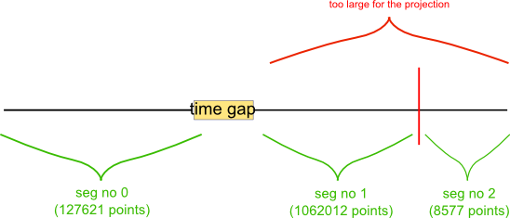

In the "Input navigation file" window we have the choice between two formats :
- NETCDF NVI Format
- CSV

NETCDF NVI Format
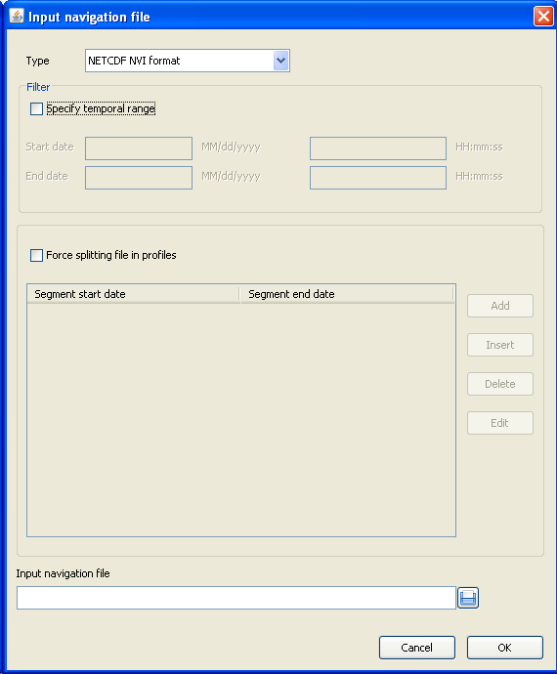
Figure 4 Input navigation file window, netCDF NVI format
The window consists in two areas :
- in the first one we can filter the data between two dates
- the second one forces the splitting specifying start and stop dates

CSV Format
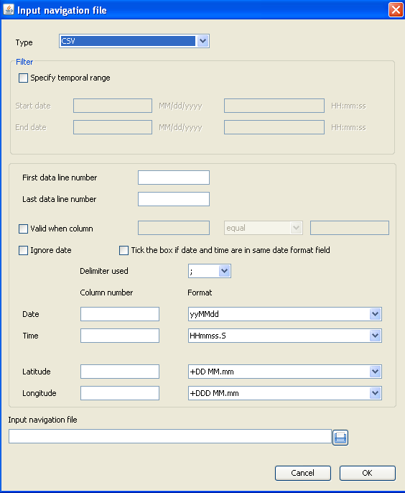
Figure 5Input navigation file window, CSV format
The window consists in two areas :
- in the first one we can filter the data between two dates
- the second one specifies the input file format

UKOOA Format
Date/time values are not read in the UKOOA file if present. Thus, you MUST use gap limit using distance in the Thresholds Options. If a gap limit using time is choosen, the following error message will be displayed:
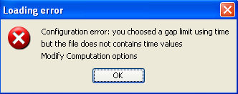

Open a UKOOA file:
- Check if thresholds is set to “distance” in the Options panel (see 7.1)
- choose the UKOOA file with the browse button at the bottom of the window
- choose angular unit: Grades or Degrees (default is Degrees)
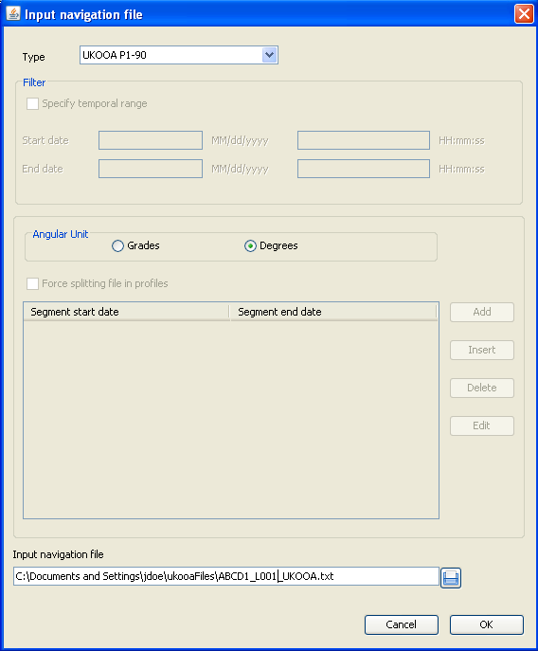
Figure 6 Input navigation file window, UKOOA format

Default computation
This function uses the default algorithm described in paragraph 3.1. It consists in computing several models per segment, at most ten. For each segment, a default model is selected. Two criteria are taken into account to choose the default model :
- The first model which contains the maximum number of points in a summary file.
- The first model whose error is less than 10⁻⁵.
After this computation, the segment list is updated. As each segment contains several models, the combo lists in the "model" column are enabled for each segment.
The performed computation doesn't take into account the maximum number of point for the whole survey, so by default the total number of points is most of the time greater than the acceptable sumary file limit, except when the central table contains only one segment.

Farthest point optimization
This function uses the optimized algorithm described ion paragraph 3.2, using the longest distance as a criterion to choose the segment which has to be optimized.
For each segment, only one model is computed, it is named "optimdist".After this computation, the segment list is updated. As each segment contains only one model, the combo lists in the "model" column are disabled for each segment.

Error optimization
This function uses the optimized algorithm described in paragraph 3.2, using the error as a criterion to choose the segment which has to be optimized.
For each segment, only one model is computed, it is named "optim error".After this computation, the segment list is updated. As each segment contains only one model, the combo lists in the "model" column are disabled for each segment.

Saving processed data
This function exports a summary file from the selected models on each segment of the central table. If no model is selected, the original segment is used. The application displays a warning if the number of total point is greater than the acceptable sumary file limit. Then we have the possibility to load a file paramater. If you don't choose to load any parameter file the window opens on the Ifremer ASCII format.
In the "Output navigation file" window we have to choose between five formats :
- Ifremer ASCII format
- ASCII columns format
- WKT format
- GML format
- Shape format
When all parameters are filled you must give a file name and the data are exported.
The geographical coordinates written in the summary file are those which were initially read in the navigation file, they didn't go through any transformation.

Ifremer ASCII Format
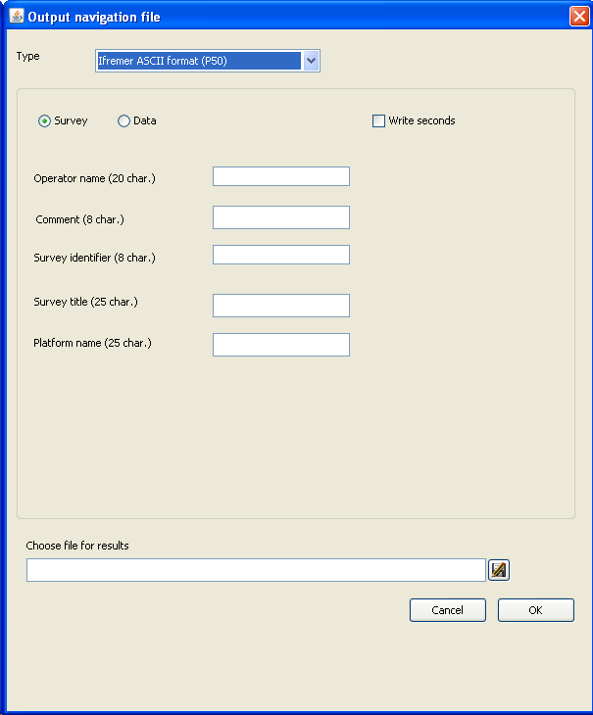
Figure 7 Output navigation file window, IfremerAscii format
Here, one can edit the necessary information to fill the summary file headers.

ASCII columns format
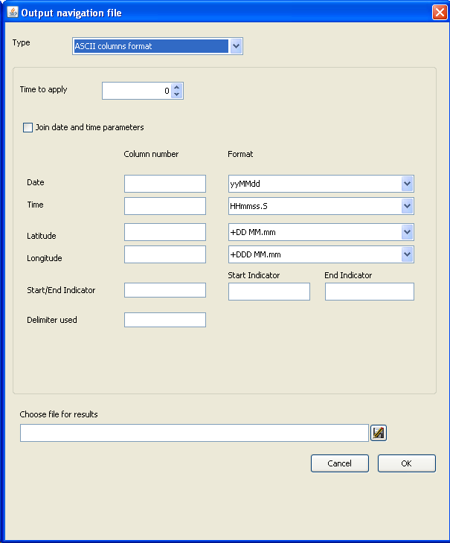
Figure 8Output navigation file window, Asciicolumns format
Here, one can specify his own output ASCII format. All fields are mandatory in this window

WKT format
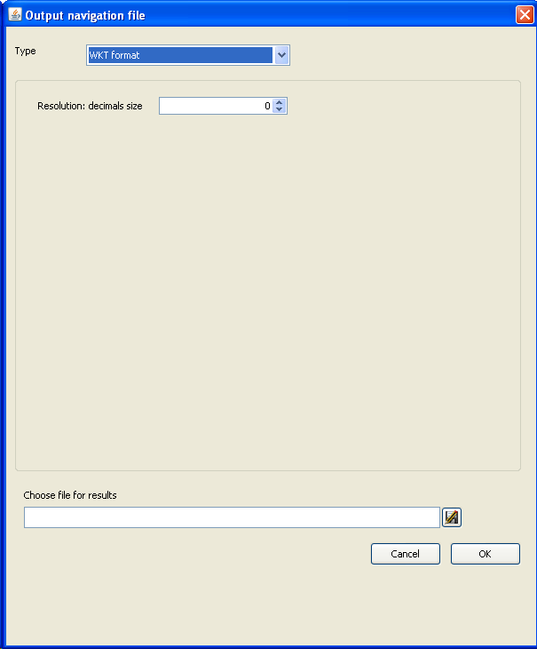
Figure 9Output navigation file window, WKT format

GML format
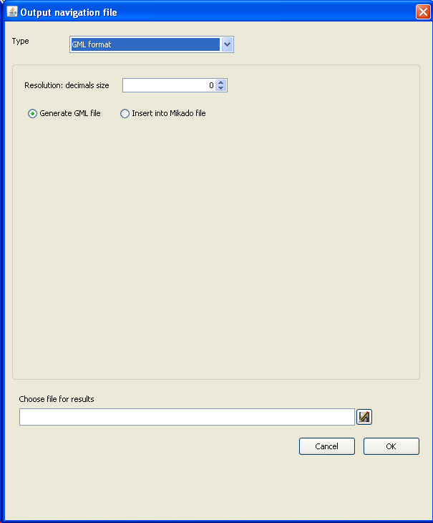
Figure 10Output navigation file window, GML format
There are two ways to generate GML information :
- GeoBndBox and multicurve information in geoEle tags are written in an XML file.
- GeoBndBox and multicurve information in geoEle tags are updated in a mikado file (CDI or CSR).
- EndsAndBends expects a mikado file ISO 19139. To update old CDIs or CSRs, please use Mikado version 3.3.3 or later.

Shape format
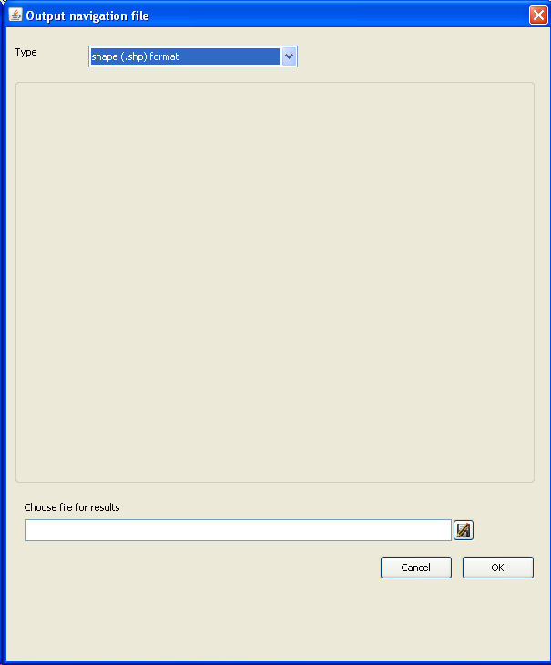
Figure 11Output navigation file window, shape format

Segment handling
Once a segment is selected in the central table, the buttons from the Segment process area are available.

Segment visualization
When selecting a line in the central table a "Segment visualization" window appears.
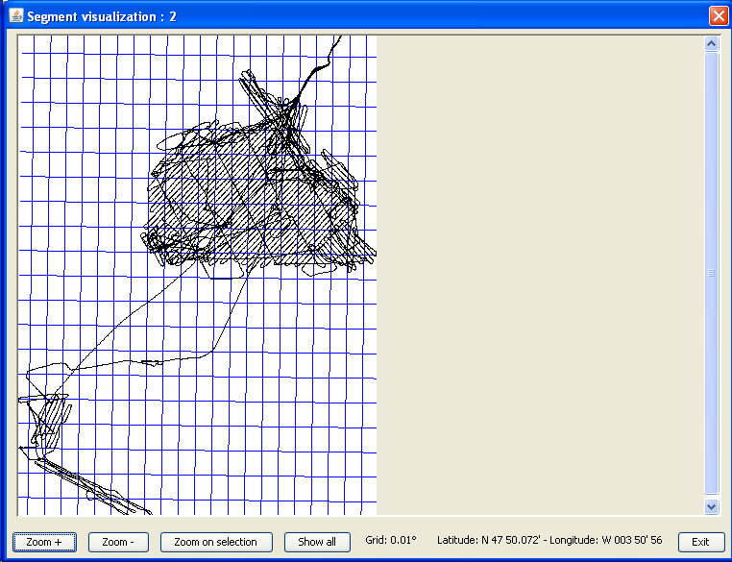
Figure 12 Segment visualization window
When using the "Show survey" button, another "Survey visualization" window appears underneath. In this window the survey appears in black and the selected segment in green.
Meridians are also represented in blue.
Meridians are also represented in blue.
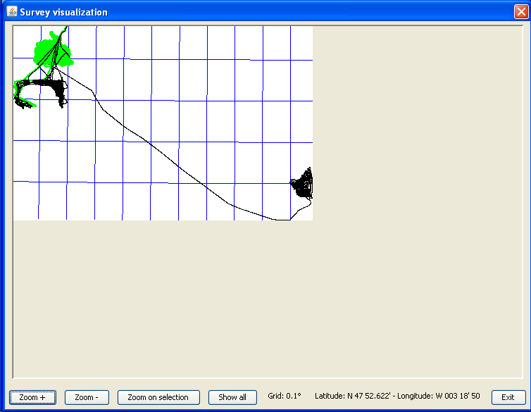
Figure 13Survey visualization window
After a computation, thanks to these windows, projected geographical coordinates from the initial navigation file are displayed in black while the coordinates from the models are displayed in red with crosses.

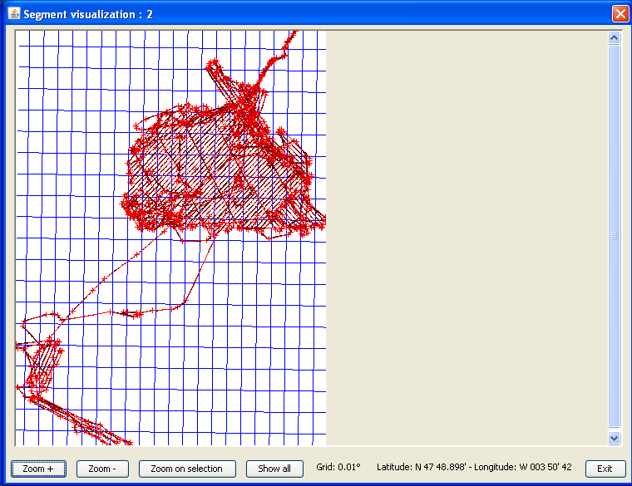
Figure 14Survey visualization after computation
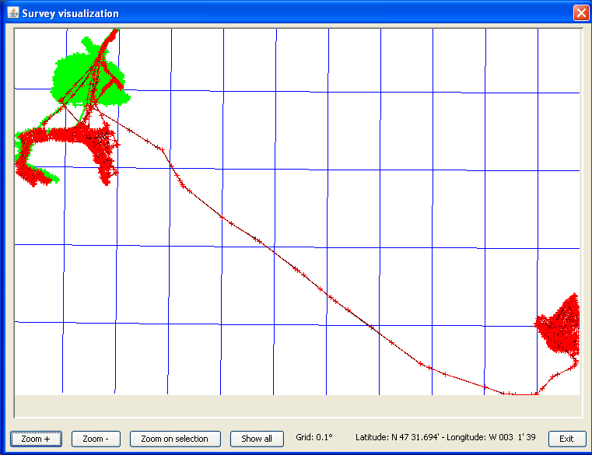
Figure 15 Survey visualization scale
A text displayed at the bottom of the window gives a geographical scale of the outline. This scale is the angular distance between two meridians.
When these windows open, the zoom is automaticaly chosen so that the segment or survey fits the window size. Buttons and scrollbars at the bottom of the window enable the user to display any area.
Buttons have the following properties :
Zoom + | increase the zoom so that the outline is scaled up
Zoom - | decrease the zoom so that the outline is scaled down
Zoom on selection | define an area to zoom on
Show all | get back to a proper scale so that the whole segment or survey fits the visualization window
Tableau 1 Survey visualization window buttons
When the « Zoom on selection » button is enabled, the mouse cursor is in a selection zone mode on the visualization window, that is to say one can define a rectangle moving the mouse while left-click and dragging. The other buttons are disabled.
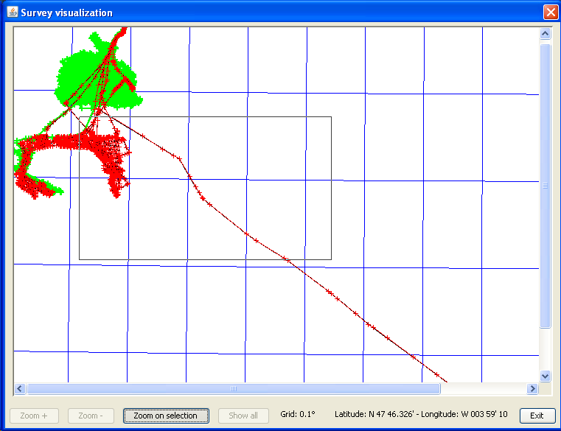
Figure16 Survey visualization zoom

Default computation
This function performs the computation described in paragraph3.1 on the selected segment.

Customized computation
This function performs the computation described in paragraph 3.3 on the selected segment. A dialog box is displayed to fill in the number of points desired at the optimization outcome. Only one model is computed, it is named "custom".
Once this computation performed, the segment list is updated. As each segment has only one model, the combo lists in the "model" column are disabled for each segment.

Options
Ends & Bends computations and output summary files are widely configurable.
The « Options » button opens the option window with three tabs, each one tuning a different aspect of the application.

Thresholds | It defines the different thresholds used when loading an input file : the time gap limit for interrupt segment detection and the maximum number of points allowed in a summary file.
Projection | One can choose the projection used and the kind of distance computed.
Very long distance | It defines the maximum angular distances according to very extended segments issue.
Tableau 2 options buttons

Thresholds
Here, one can tune the thresholds used during the input file loading and the computations.
Two thresholds are considered :
- The first one is the time gap limit above which we want to consider that the navigation has been interrupted. It is used when loading a navigation file in order to split the data into continuous segments. By default, this threshold type is "time" and is set to 10 minutes.
- The second threshold is the maximum number of positions a summary file can hold. It is used during the default or optimized computation and its default value is 999.
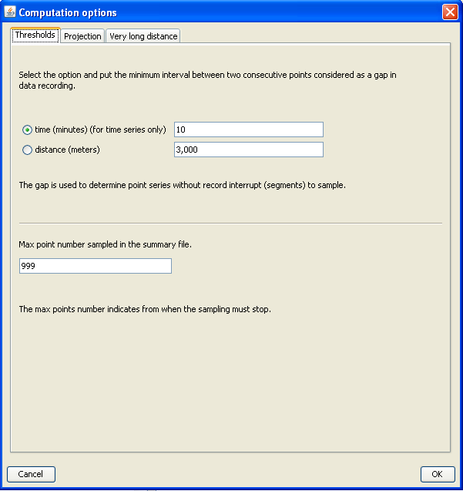
Figure 17 Computation options - Thresholds

Projection
Here, one can choose the projection being used when loading a navigation file.
For now, the only projection implemented is the Gauss-Krueger.
The kind of distance chosen during the computation can also be chosen. This distance is measured between a point and a line.
Two kinds of distances are available :
- The Vertical distance is computed along the y-axis between a point and the optimized line.
- The Orthogonal distance is computed between a point and a line on an orthogonal segment to this line.
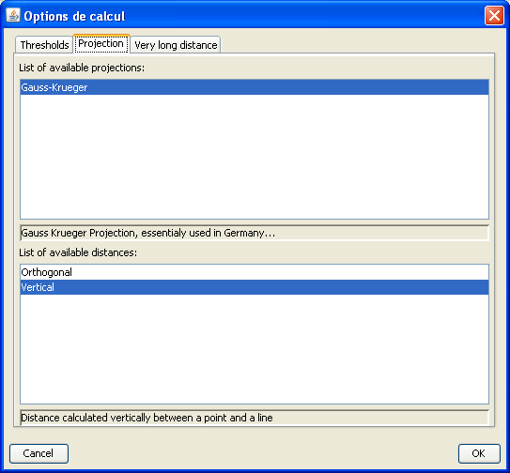
Figure 18 Computation options - Projection

Very long distance
Here, one can define specific parameters for Gauss-Krueger projection.
These parameters set the maximum longitudinal extension that can handle the projection.
In order to be more convenient, this feature lies in two parameters :
- The angular distance a unique segment can reach without being splitted when loading is set by default to 11°.
- The angular distance from which a segment exceeding the first threshold would have been splitted is set by default to 10°.
This method aims at avoiding the creation of very small segments. For example, with the default values, a segment whose maximum extension is 11.05° will be splitted into two segments of 10° and 1.05°.
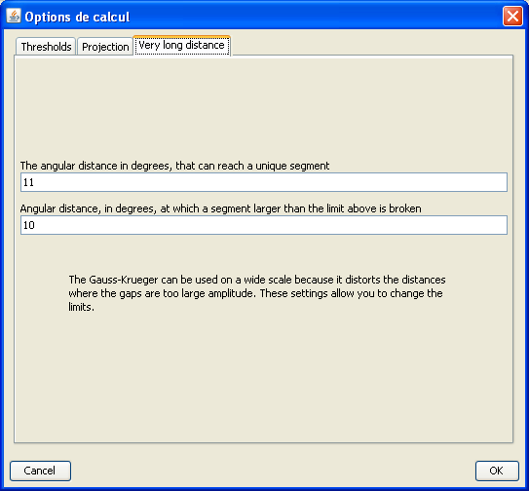
Figure 19Computation options - Very long distance

References
This is section mandatory for all deliverables
This is the Style “Geo-Seas Reference”. Just press enter to create the next one.

Figures and Tables

List of Figures
Figure 1 Main window 9
Figure 2 Models list 12
Figure 3 Options area 13
Figure 4 Input navigation file window, netCDF NVI format 14
Figure 5Input navigation file window, CSV format 15
Figure 6 Input navigation file window, UKOOA format 17
Figure 7 Output navigation file window, IfremerAscii format 19
Figure 8Output navigation file window, Asciicolumns format 20
Figure 9Output navigation file window, WKT format 21
Figure 10Output navigation file window, GML format 22
Figure 11Output navigation file window, shape format 23
Figure 12 Segment visualization window 24
Figure 13Survey visualization window 25
Figure 14Survey visualization after computation 26
Figure 15 Survey visualization scale 27
Figure16 Survey visualization zoom 28
Figure 17 Computation options - Thresholds 30
Figure 18 Computation options - Projection 31
Figure 19Computation options - Very long distance 32

List of Tables
Tableau 1 Survey visualization window buttons 27
Tableau 3 options buttons 29

Terminology
This annex is also mandatory
Term | Definition
CDI | The Common Data Index designates the catalogues of observation data sets of the Geo-Seas (www.geo-seas.eu/) and SeaDataNet (http://www.seadatanet.org/) infrastructures
CSV | Comma-Separated Values : file format to store tabular data (numbers and text) in plain-text form
GIS | Geographic Information System
GML | The Geography Markup Language (GML) is the XML grammar defined by the Open Geospatial Consortium (OGC) to express geographical features
GPS | Global Positioning System
NetCDF | Network Common Data Form : set of software libraries and self-describing, machine-independent data formats that support the creation, access, and sharing of array-oriented scientific data. The project homepage is hosted by the Unidata program at the University Corporation for Atmospheric Research(UCAR)http://www.unidata.ucar.edu/software/netcdf/
NetCDF NVI | A NetCDFIfremer navigation file format
Shape | Geospatial vector data format for geographic information systems (GIS) software
UKOOA format | A format for the exchange of positioning data originally defined by the UK Offshore Operators Association : http://www.ogp.org.uk/publications/geomatics-committee/p-formats-for-the-exchange-of-positioning-data/
WMS | Web Map Service : an OGC standard protocol for serving georeferenced map images over the Internet that are generated by a map server using data from a GIS database
WFS | Web Feature Service : an OGC interface allowing requests for geographical features across the web using platform-independent calls
WKT | Well-Known Text :a text mark-up languagefor representing vectorgeometryobjects on a map, spatial reference systemsof spatial objects and transformations between spatial reference systems

Log
A log file named endsAndBends.log is available in the Ends&Bends root installation directory.

