

Octopus manual

Octopus is a multi-formats splitter & converter tool.

Octopus can be used in graphical or batch mode.

Requirements
Octopus requires java 1.8.0_60 or greater.
Octopus is available for multiple platforms: Windows, windows 64, linux, linux 64.
Languages : French, English

Get started

Settings

Menu Edit/settings
- Choose your language
- Choose your EDMO code (used to convert MGD files)
- Choose your default input and output directories. The browse button will automatically open these directories.
- Coupling table : if you want to fill the local Octopus coupling table, check use coupling table and choose the coupling prefix (path prefix that will NOT be written in the coupling files path)

Clic on the update lists button to update external lists (EDMO codes and BODC Nerc Vocabularies)

Features
Available conversions/splits are
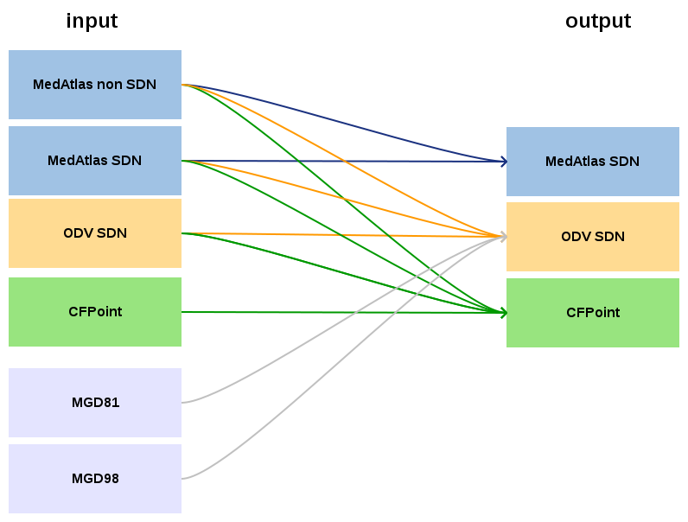

Input can be a file, or a directory containing files (all files using the same format, no sub-directory).

Automatic formats updates :
→ For all conversion/split cases, Octopus will automatically add SDN CDI references.
→ Form conversion/split from Medatlas (SDN or non SDN) to Medatlas SDN, SDN CSR and SHIP (NVS2CON) references will be added to output file(s).
→ Form conversion/split from Medatlas non SDN to Medatlas SDN, SDN mapping lines will be added to output file(s).

Process a file or a directory in graphical mode

Open input file(s)
Open a file:
Menu file/open file
OR write or paste the input path in the input file/directory then clic on submit or press ENTER

Open a directory:
Menu file/open directory
OR write or paste the input path in the input file/directory then clic on submit or press ENTER

Check input files

Clic on check input format

Choose input file(s) local CDI Ids to export
This feature is not available for MGD files.

Check the show CDIs checkbox to see local cdi Ids read from input file(s).

By default, all local CDI Ids are checked. You can select/deselect lines, to choose which ones you want to export.

Choose output type
This feature is not available for MGD files.
Octopus can keep each input file into multi-stations file, or split it into multiple mono-stations files.
Note : if the input is a directory, set output type to multi will generate a multi-station file for each input file (Octopus does not merge stations).

Choose output file or directory
Use the browse button, or write or paste the output path in the output file/directory.
If input is a file, and output type is keep, you have to set a filename.
Otherwise, set a directory name.

Note on output files names :
Except the case of one input file exported as a multi-stations file, Octopus will generate paths as below :

where : - directories are in red, files are in bold green.
- Output is the path set in the output file/directory Octopus field
- inputFileName is the name of one input file in the input directory
- cdi is the local CDI ID contained in a mono-station file

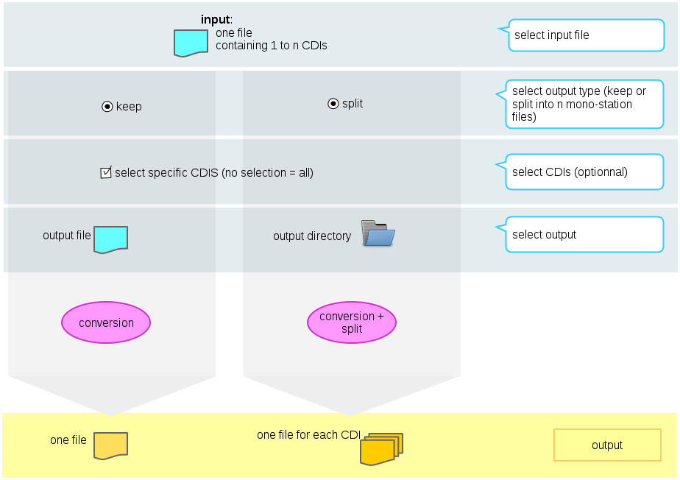Illustration 1: octopus process for input file

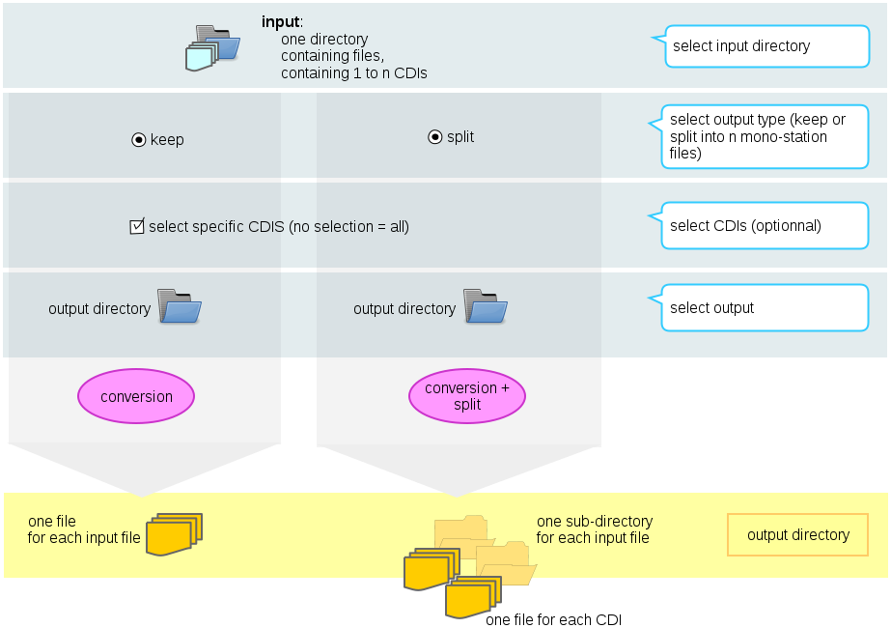Illustration 2: Octopus process for input directory

Process a file or a directory in batch mode
open a console and go in the Octopus installation directory (where the octopus.jar is)
launch command : java -jar octopus.jar <options>

WARNING : octopus shall not be launched in graphical mode.
If an error « ERROR XJ040 : Failed to start database » occurs in batch mode, check that octopus is not launched in graphical mode.

usage:

octopus [-c <arg>] [-f <arg>] [-i <arg>] [-l <arg>] [-o <arg>] [-t <arg>]

-c <arg> (optionnal) list of local_cdi_id, eg <FI35AAB, FI35AAC>, all
cdi are exported if this argument is ommited
-f <arg> (mandatory) output format: <medatlas>, <odv> or <cfpoint>
-i <arg> (mandatory) input path: </home/user/...>
-l <arg> (mandatory if input is MGD) local CDI Id value if input is a
file, mapping file is input is a directory
-o <arg> (mandatory) output path: </home/user/...>
-t <arg> (mandatory except if input is MGD) output type: <split> or
<keep>

examples :

export all stations in input medatlas files directory to mono-stations CFPoint files
unix/linux :
java -jar octopus.jar -i /home/input/profileDir -o /home/out/exportCFDirectory -f cfpoint -t split
windows :
java -jar octopus.jar -i «C:\Users\example\input\profileDir» -o « C:\Users\example\out\exportCFDirectory » -f cfpoint -t split

export CDI1 and CDI2 stations in input medatlas file to multi-stations ODV file
unix/linux :
java -jar octopus.jar -i /home/input/profile.med -o /home/out/exportODV1and2.txt -f odv -t keep -c CDI1,CDI2
windows :
java -jar octopus.jar -i «C:\Users\example\input\profile.med» -o «C:\Users\example\out\exportODV1and2.txt» -f odv -t keep -c CDI1,CDI2

export MGD file file to multi-stations ODV file using XXX as local CDI ID
unix/linux :
java -jar octopus.jar -i /home/input/mgd81.mgd77 -o /home/out/exportODV.txt -f odv -l XXX
windows :
java -jar octopus.jar -i « C:\Users\example\input\mgd81.mgd77» -o «C:\Users\example\out\exportODV.txt» -f odv -l XXX

