Octopus
User Manual

Deliverable number | Short title
 | OCTOPUS user Manual
Long title
OCTOPUS user Manual
Short description
Octopus is a multi-formats splitter & converter tool. It replaces the following software: med2medSDN, Change_vocab_V1toV2, MedSDN2CFPoint, OdvSDN2CFPoint, offering a unique and ergonomic tool.
It also allows :
- to split a multistation file into monostation ones
- to extract 1 to n stations from a multistation file and export them into another multistation file or several monostation ones.
- to check the compliancy of MedAtlas, ODV and ODV variant formats, netCDF-CFPoint and netCDF for HF-Radar
- To convert MGD files to ODV format
- To convert EGO glider files to netCDF-CFpoint format
- To convert ADCP (CASCADE) files to netCDF-CFPoint format
Author | Working group
S. Brégent, M. Fichaut, S. Crouzille
Dissemination | Copyright terms
Public

History
Version | Authors | Date | Comments
1.0 | S. Brégent, M. Fichaut | 07/01/2016 | Creation
1.1 | S. Brégent, M. Fichaut | 19/12/2016 | Add installation instructions.  Change export types names from “mono” to “split” and from “multi” to “keep”  5.2. Specifications for MGD: 81 and 98 are different formats. They cannot be converted from the same input directory.
1.2 | S. Brégent, M. Fichaut | 27/01/2017 | Add warning on MGD formats: MGD81 and MGD98 are distinct formats (§5.1).  Add warning on output path in case of directories: do not write the last separator (§6)
1.3 | S. Brégent, M. Fichaut | 21/07/2017 | - Add information on BODC vocabularies checks (§4.2)  - Output file type choice: modification of the label in the graphical interface (no modification for batch mode) (§5.3 and §5.4)  - Additionnal information about log files (§5.6)
1.4 | S. Brégent, M. Fichaut | 04/03/2019 | - Add procedure to launch octopus behind a proxy (§3.1,§ 3.2)  - Add a procedure to launch in batch mode, on a server without a graphical interface (§6)  - add option for check only in batch mode (§6)  - Modify Octopus requirements and installation  - Add a procedure to update external resources in batch mode
1.5 | S. Brégent, M. Fichaut | 05/06/2019 | Take into account ODV variants for biology, microlitter and flowcytometry for checks and conversion ODV to ODV.
1.5.3 | S. Brégent, M. Fichaut | 24/03/2020 | - For all conversions/split cases, update URLs for CDIs, CSRs and Nerc vocabularies (§4.2)
1.6.0 | S. Crouzille, M. Fichaut | 07/01/2021 | - Add a table of file formats that can be checked.  - Add “HF Radar NetCDF” as a format file that can be checked.
1.6.1 | S. Crouzille | 11/03/2021 | - Add HTTPS elements to the launch command through a proxy.
1.7.0 | S. Crouzille | 08/07/2021 | - Add EGO file handling.
1.7.1 | S. Crouzille | 25/11/2021 | - Update version.
1.8.0 | S. Crouzille | 04/05/2022 | - Update version.  - Add details about ODV variants (BODV, MODV, SODV).
1.8.1 | S. Crouzille | 07/11/2022 | - Update version.
1.10.0 | S. Crouzille | 05/10/2023 | - Add ADCP conversion.
1.12.0 | S. Crouzille | 27/02/2026 | - Update version.  - Update Java minimum version.
Table of contents
1. Introduction 5
2. Requirements 5
3. Installation 5
3.1. Launch on windows 6
3.2. Launch on Linux 6
4. Get started 7
4.1. Settings 7
4.1.1. Menu Edit/settings 7
4.1.2. Menu Edit/Coupling table 8
4.2. Features 9
4.2.1. File checks 9
4.2.2. File conversions/splits 9
5. Use of OCTOPUS in interactive mode 11
5.1. Open input file or directory 11
5.2. Check input file(s) 12
5.3. Split to mono station files 12
5.4. Select the output file or directory 12
5.5. Select the LOCAL CDI ID(s) for ODV file(s) 12
5.6. OCTOPUS log file 13
6. Use of OCTOPUS in batch mode 14

Introduction
Octopus is a multi-formats checker, converter and splitter tool. It replaces the following software: med2medSDN, Change_vocab_V1toV2, MedSDN2CFPoint, OdvSDN2CFPoint, offering a unique and ergonomic tool.
- OCTOPUS checks the compliance of a file to the SeaDataNet ODV, ODV variants, netCDF (CFPOINT), netCDF for HF-Radar and MedAtlas standard formats.
- OCTOPUS converts files in a given SeaDataNet format to another SeaDataNet format (e.g.: ODV to netCDF, netCDF to ODV, MedAtlas to NetCDF, MedAtlas to ODV).
- OCTOPUS has also additional functions such as:
  - Split a multi-station SeaDataNet file into mono-station SeaDataNet files
  - Extract station(s) from SeaDataNet files
  - Convert MGD v81 and v98 to SeaDataNet ODV files
  - Convert EGO glider files to SeaDataNet netCDF files
  - Convert ADCP (CASCADE) files to SeaDataNet netCDF files
Octopus can be used in interactive mode or in batch mode.
ODV variants are: Biology (BODV), Flow cytometry, Microlitter in water column (MODV), Microlitter in sediments (SODV).

Requirements
Octopus is written in Java.
Octopus is available in 2 versions:
- a "classic" version, without Java. It requires Java/OpenJDK 11 or greater already installed in the system, as well as JavaFX.
- a "standalone" version, with OpenJDK 11 + JavaFX bundled into it (located in the `octopus/jre` directory).
Octopus is available for multiple platforms: Windows, Linux.
32 bits platforms are not supported.
Languages: French, English

Installation
Download the Octopus software from SeaDataNet web site, under Standards & Software:
http://www.seadatanet.org/Standards-Software
Simply choose the version according to your system (Linux/Windows), and your Java configuration ("classic", "standalone").
Copy the zip file on your computer and unzip it.
The change log is available in octopus menu help> about

Launch on windows
To launch Octopus, double click on octopus.exe in the octopus directory.
If your internet connection has a proxy server, please use the following procedure:
- In the octopus installation directory (containing the octopus.jar file): create a file named octopus.bat
- in this file, write the following line:

[directory\]java –D http.proxyHost=xx.xx.xx.xx –D http.proxyPort=yy -jar octopus.jar

where
- xx.xx.xx.xx = your proxy IP address
- yy = your proxy port
- [directory\] is the optional `java.exe` location, depending on your Java installation.

In the "standalone" version, the directory is `.\jre\bin\`. If you already have Java installed, no directory is needed.

In case of a HTTPS proxy, you may use similar options:

[directory\]java –D https.proxyHost=xx.xx.xx.xx –D https.proxyPort=yy -jar octopus.jar

HTTP and HTTPS proxy parameters can be combined if needed:

[directory\]java –D http.proxyHost=xx.xx.xx.xx –D http.proxyPort=yy –D https.proxyHost=aa.aa.aa.aa –D https.proxyPort=bb -jar octopus.jar

- launch Octopus using this octopus.bat file (double click) instead of the octopus.exe file.

Launch on Linux
To launch Octopus, double click on octopus.sh in the octopus directory, or launch it from a terminal:
cd octopus
./octopus.sh
If your internet connection has a proxy server, please use the following procedure:
- In the octopus installation directory (containing the octopus.jar file): create a file named octopus_proxy.sh
- in this file, write the following line:

[directory/]java –D http.proxyHost=xx.xx.xx.xx –D http.proxyPort=yy -jar octopus.jar

where
- xx.xx.xx.xx = your proxy IP address
- yy = your proxy port
- [directory/] is the optional `java` binary location, depending on your Java installation.

In the "standalone" version, the directory is `./jre/bin/`. If you already have Java installed, no directory is needed.

In case of a HTTPS proxy, you may use similar options:

[directory/]java –D https.proxyHost=xx.xx.xx.xx –D https.proxyPort=yy -jar octopus.jar

HTTP and HTTPS proxy parameters can be combined if needed:

[directory/]java –D http.proxyHost=xx.xx.xx.xx –D http.proxyPort=yy –D https.proxyHost=aa.aa.aa.aa –D https.proxyPort=bb -jar octopus.jar

- launch Octopus using this octopus_proxy.sh file (double click)

Get started

Settings

Menu Edit/settings
This item is used to configure OCTOPUS for your own utilization.
You can:
- Choose your language.
- Choose your default input and output directories. The browse button will automatically open these directories.
- Choose your EDMO code (used to convert MGD files and non SDN MedAtlas file to SDN files).
- Ask Octopus to fill the local coupling table, by checking “Use coupling table” and choosing the coupling prefix (path prefix that will NOT be written in the coupling files path).
- Update external lists (EDMO codes and BODC NERC Vocabularies).
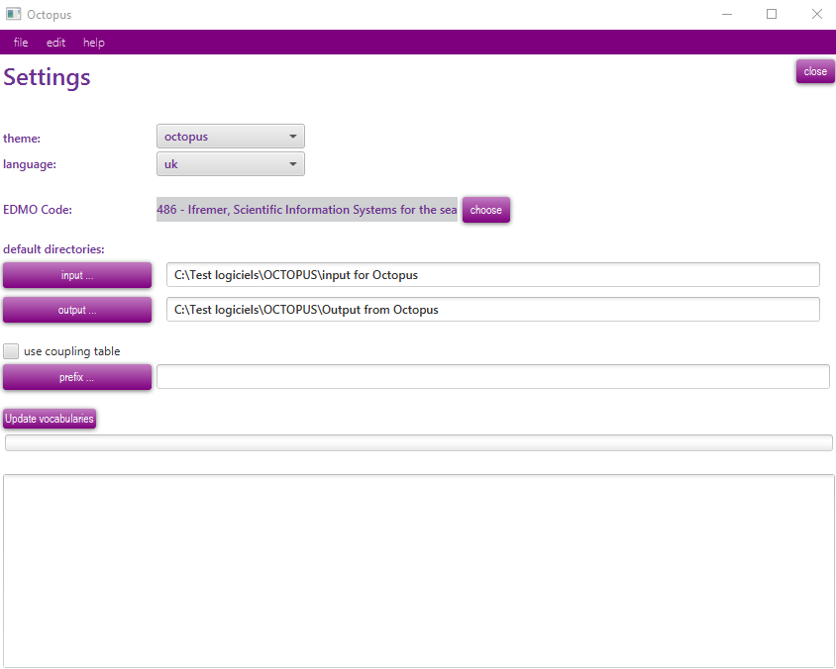
Figure 1 – OCTOPUS settings windows

Menu Edit/Coupling table
The “Coupling Table” menu of OCTOPUS allows basic management of the content of the coupling table used by the SeaDataNet download manager to retrieve the LOCAL_CDI_IDs requested by a user downloading.

Export
This export function generates a coupling file that will be used by SeaDataNet Download Manager for retrieving stations in the files.
The coupling file used by SeaDataNet download manager is unique and called “coupling.txt”. This file must not contain duplicates (the coupling file ID is LOCAl_CDI_ID + format) It’s up to OCTOPUS user to create only one file called “coupling.txt” for SeaDataNet purpose by using the coupling table facilities.
The format of this coupling file is the following:
LOCAL_CDI_ID;Modus;Format;File_name
The export function will replace the previous coupling file if the name of the export file is the same.

Delete all
The delete all button is used to empty the coupling table. All records will be deleted. The table should be first exported if the user wants to keep the information in a flat file.

Features

File checks
Available file checks are listed in the table below.
Table 1 - Possible format checks using OCTOPUS (ODV variants stands for biology, microlitter - in water column or sediments - and flow cytometry data)
Format | Check
MedAtlas non SDN | ✗
MedAtlas SDN | ✔
ODV SDN | ✔
ODV variants | ✔
netCDF – SDN CFPoint | ✔
HF-Radar (SDN netCDF) | ✔
MGDv81 | ✗
MGDv98 | ✗
EGO | ✗
ADCP (CASCADE) | ✗

File conversions/splits
Available file conversions/splits are listed in the table below
Table 2 - Possible format conversions using OCTOPUS (ODV variants stands for biology, microlitter - in water column or sediments - and flow cytometry data)
output→  input ↓ | MedSDN | ODV | ODV variants | netCDF -CFPoint
Med non SDN | ✔ | ✔ | ✗ | ✔
Med SDN | ✔ | ✔ | ✗ | ✔
ODV SDN | ✗ | ✔ | ✗ | ✔
ODV variants | ✗ | ✗ | ✔ | ✗
netCDF-CFPoint | ✗ | ✔ | ✗ | ✔
MGDv81 | ✗ | ✔ | ✗ | ✗
MGDv98 | ✗ | ✔ | ✗ | ✗
EGO | ✗ | ✗ | ✗ | ✔
ADCP (CASCADE) | ✗ | ✗ | ✗ | ✗

Input can be a file, or a directory containing several files (all files using the same format, no sub-directory).
Automatic format updates:
- For all conversion/split cases, Octopus will automatically add SDN CDI references.
- For conversion/split from MedAtlas (SDN or non SDN) to MedAtlas SDN, existing SDN CSR and SHIP (NVS2CON) references will be added to output file(s).
- For conversion/split from MedAtlas non SDN to MedAtlas SDN, SDN mapping lines will be added to output file(s).
- For all conversion/split cases, Octopus will automatically check the BODC vocabularies terms. Octopus will automatically replace deprecated term, and display an error if term does not exists or is deprecated and has no “ReplacedBy” attribute.
- For all conversions/split cases, update URLs for CDIs, CSRs and NERC vocabularies

Use of OCTOPUS in interactive mode

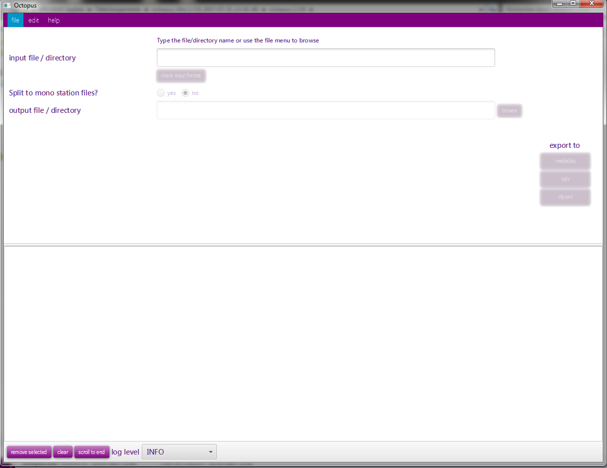
Figure 2 – Main screen of OCTOPUS

Open input file or directory
This step allows to select the file(s) to be converted/split.
OCTOPUS is able to process one file or one directory containing files at the same format.
WARNING: MGD81 and MGD98 are not the same format. They must be gathered in separated directories.
There are two possible ways to open a file:
- Menu file/open file
- Write or paste the input path in the input file/directory then TAB or ENTER
There are two possible ways to open a directory:
- Menu file/open directory
- Write or paste the input path in the input file/directory then TAB or ENTER

Check input file(s)
Once the file of directory has been chosen, it is possible to check the format of the file(s) by clicking on the “Check the input format” button. In the case of a directory, all files are supposed to be at the same format (it is not possible to check a directory containing MedAtlas and ODV files, or netCDF-CFPoint and ODV files, for example).

Split to mono station files
This feature is not available for MGD files.
If the user clicks on Yes, the multi station input file will be split to n mono station files.
By default No is selected.

Select the output file or directory
Use the browse button, or write or paste the output path in the output file/directory.
If input is a file, and output type is multi, you have to input a filename.
Otherwise, set a directory name.
Note on output files names:
Except the case of one input file exported as a multi-stations file, Octopus will generate paths as described below.
 |  | Split to mono station files
 |  | Yes (interactive mode) =  Split (batch mode) | No (interactive mode) = Keep (batch mode)
Input type | File | output/LOCAl_CDI_ID.ext | output
Input type | Directory | output/inputFileName/ LOCAl_CDI_ID.ext | output/inputFileName.ext

where : - directories are in red, files are in green.
- Output is the path set in the output file/directory field
- inputFileName is the name of one input file in the input directory
- .ext is the extension of the filename: .txt for ODV, .nc for netCDF-CFPOINT and .<free text> for MedAtlas

Select the LOCAL CDI ID(s) for ODV file(s)
This field is available only for MGD input files or directories. MGD files do not have LOCAL CDI IDs. You have to specify it.
In case of an input file, write the LOCAL CDI ID in the field.
In case of an input directory, you will have to write a mapping file. Use the Browse button to select the mapping file path, or write or paste the output path in the field.
Write a mapping file:
The mapping file is a semi-colon separated file, with two columns: file name and LOCAL CDI ID
Example:
20002001ATE.mgd77;FI29_2002AT
20003001ATE.mgd77;FI29_2003AT

OCTOPUS log file
While checking and/or converting OCTOPUS logs information, warnings and errors in the lower part of the main window and in the log file octopus.log located under [octopus_install_folder]/logs.
In the main octopus log window: information are written in black, warnings are written in orange and Errors are written in red.
If the check/conversion is OK, a green message is also written in the window.
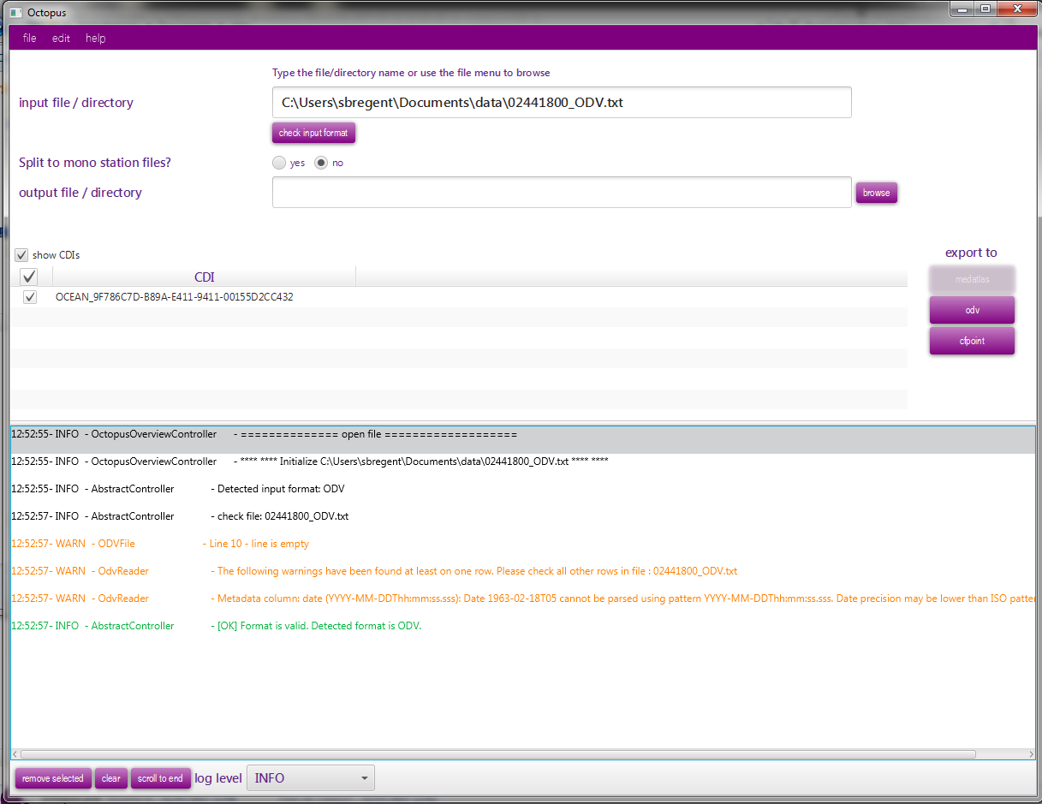
Figure 3 – Log information in OCTOPUS main screen
The max size of the log file is limited to 20 Mb. If the size exceed 20Mb, Octopus will create a zip file octopus-[YYYY-MM-DD]-[number].log.zip with this 20 Mb of information and open a new current octopus.log file.

Use of OCTOPUS in batch mode
Open a console and move to the Octopus installation directory (where the octopus.jar is)
Launch command: java -jar octopus.jar <options>
If you need to launch octopus on a server without a graphical interface (no graphical packages installed), use the command below:
java -cp octopus.jar fr.ifremer.octopus.controller.BatchController <options>
Usage:
Check a file or a directory
[directory\] java -jar octopus.jar -i <arg> –check

Convert a file or a directory
[directory\] java -jar octopus.jar [-c <arg>] -f <arg> -i <arg> [-l <arg>] -o <arg> [-t <arg>]

Update external resources
[directory\] java -jar octopus.jar –update
where [directory\] is the optional java binary location, depending on your Java installation:
In the "standalone" version, the directory is `.\jre\bin\`. If you already have Java installed, no directory is needed.
In [octopus_install_folder]/logs, Octopus in batch mode generates also a log file using JSON format, which can be easily read by a software.

Argument | O/M | Comment
-check | Optional | check a file or a directory (no conversion)
-c <arg> | Optional | list of LOCAL_CDI_IDs, eg <FI35AAB, FI35AAC>, all CDIs are exported if this argument is omitted
-f <arg> | Mandatory | output format: <medatlas>, <odv> or <cfpoint>
-i <arg> | Mandatory | input path: </home/user/...>
-l <arg> | Mandatory if input is MGD | LOCAl_CDI_ID value if input is a file, mapping file if input is a directory (see §5.5)
-o <arg> | Mandatory | output path (file or directory): </home/user/...>
-t <arg> | Mandatory except if input is MGD | output type: <split> or <keep>
-update | optional | Update external resources (BODC vocabularies, CSR list, EDMO codes)

WARNING:
If the output path is a directory, DO NOT WRITE a slash or backslash at the end of the path:
–o “/home/out/exportCFDirectory” is correct
–o “/home/out/exportCFDirectory/” is incorrect
Examples:
- Export all stations from input MedAtlas files directory to mono-stations CFPoint files
java -jar octopus.jar –i “/home/input/profileDir”–o “/home/out/exportCFDirectory”-f cfpoint –t split
- Export CDI1 and CDI2 stations from input MedAtlas file to multi-stations ODV file
java -jar octopus.jar -i “/home/input/profile.med”–o “/home/out/exportODV1and2.txt”-f odv –t keep -c CDI1,CDI2
- Export MGD file to multi-stations ODV file using XXX as local CDI ID
java -jar octopus.jar –i “/home/input/mgd81.mgd77”-o “/home/out/exportODV1and2.txt”-f odv -l XXX

While checking and/or converting OCTOPUS logs information in the log file octopus.log located under [octopus_install_folder]/logs.
The max size of the log file is limited to 20 Mb. If the size exceed 20Mb, Octopus will create a zip file octopus-[YYYY-MM-DD]-[number].log.zip file with this 20 Mb of information and open a new octopus.

