DAMAR MARGI WIGUNO
SOFTWARE DEVELOPER
Laravel · PHP · REST API · Full-Stack Development · AI-Assisted Development
Software developer experienced in building and maintaining production systems across automotive, healthcare, logistics, ERP, e-learning, crowdfunding, and asset management. Hands-on across backend and frontend development, API development, database design, system integration, performance optimization, production maintenance, and AI-assisted software development workflows.

Professional Profile
I work across backend and frontend development, with strong experience in Laravel and PHP and hands-on involvement throughout the software lifecycle: requirement analysis, database design, API development, integration, deployment, optimization, maintenance, and code review. My recent automotive-platform experience also provided professional exposure to ReactJS and Golang. I use AI-assisted development tools such as Codex and Claude Code to support implementation, debugging, code exploration, refactoring, and delivery.

Core Technical Skills
Backend | PHP · Laravel · CodeIgniter · REST API
Databases | MySQL · PostgreSQL · Oracle · SQL Server · Database Design
Frontend | JavaScript · jQuery · Vue.js · Bootstrap · HTML
Engineering | API Integration · Legacy Integration · Performance Optimization · Production Maintenance · Code Review · AI-Assisted Development (Codex · Claude Code)

Featured Projects
MOTOVAX & AgenMobix 2026
AI-Assisted Development · Automotive Platform
- Collaboratively developed MOTOVAX, an automotive sales platform that brings vehicle inventory, leads, sales workflows, omnichannel interactions, and operational data into a connected platform.
- Worked collaboratively with the development team using AI-assisted software development workflows, leveraging coding agents such as Codex and Claude Code for implementation, iteration, debugging, code exploration, refactoring, and feature delivery.
- Contributed to vehicle inventory and operational features used to manage unit data, status, pricing, photos, branch/location information, and sales-related workflows.
- Developed AgenMobix, a related tenant-facing vehicle catalog that exposes available vehicle stock to sales agents so they can browse units and present relevant options to prospective customers.
Websites: motovax.ai · agenmobix.id
MOTOVAX — Unit Management
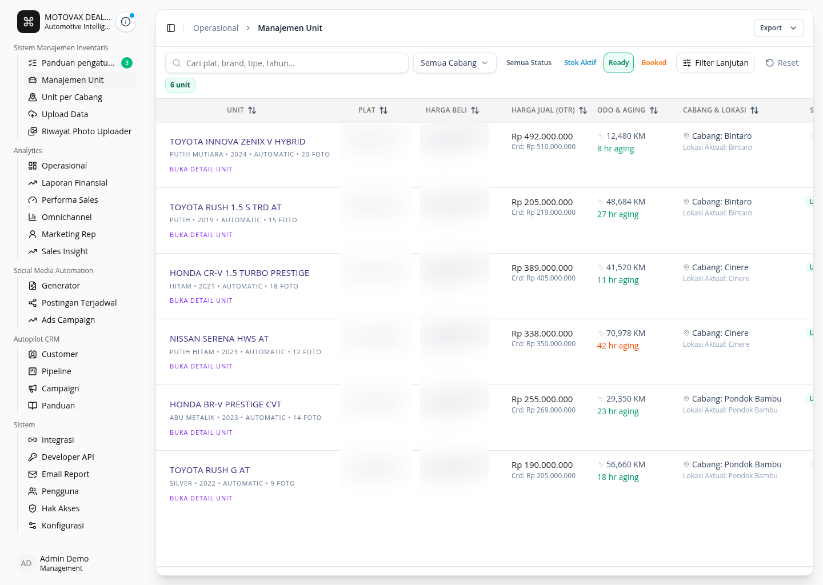
AgenMobix — Mobile Catalog & Unit Detail
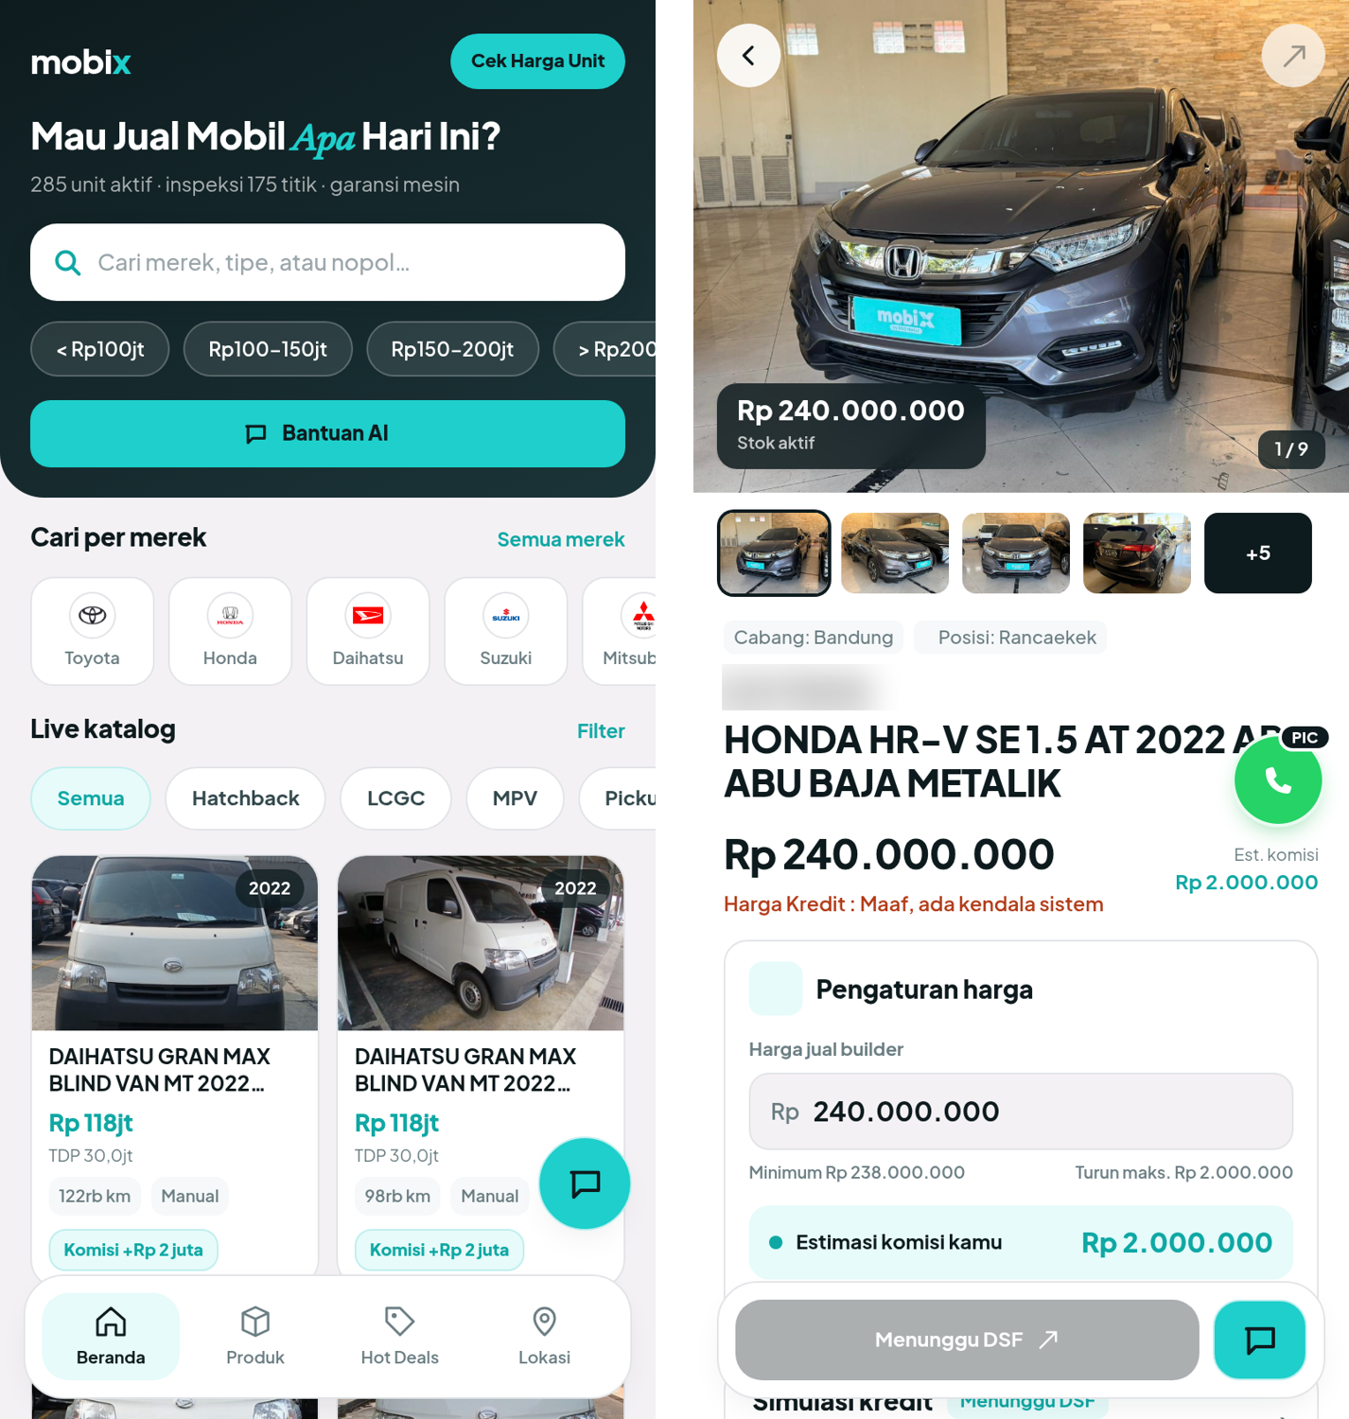

E-Medical Records 2024–2025
Laravel · Bootstrap · jQuery · Database Design
- Analyzed hospital medical documents and workflows and translated them into system requirements.
- Designed database structures and migrations for electronic medical-record data and data integrity.
- Developed Laravel backend logic and integrated the system with an existing legacy hospital application.
- Built administrative interfaces and contributed to performance optimization and code reviews.
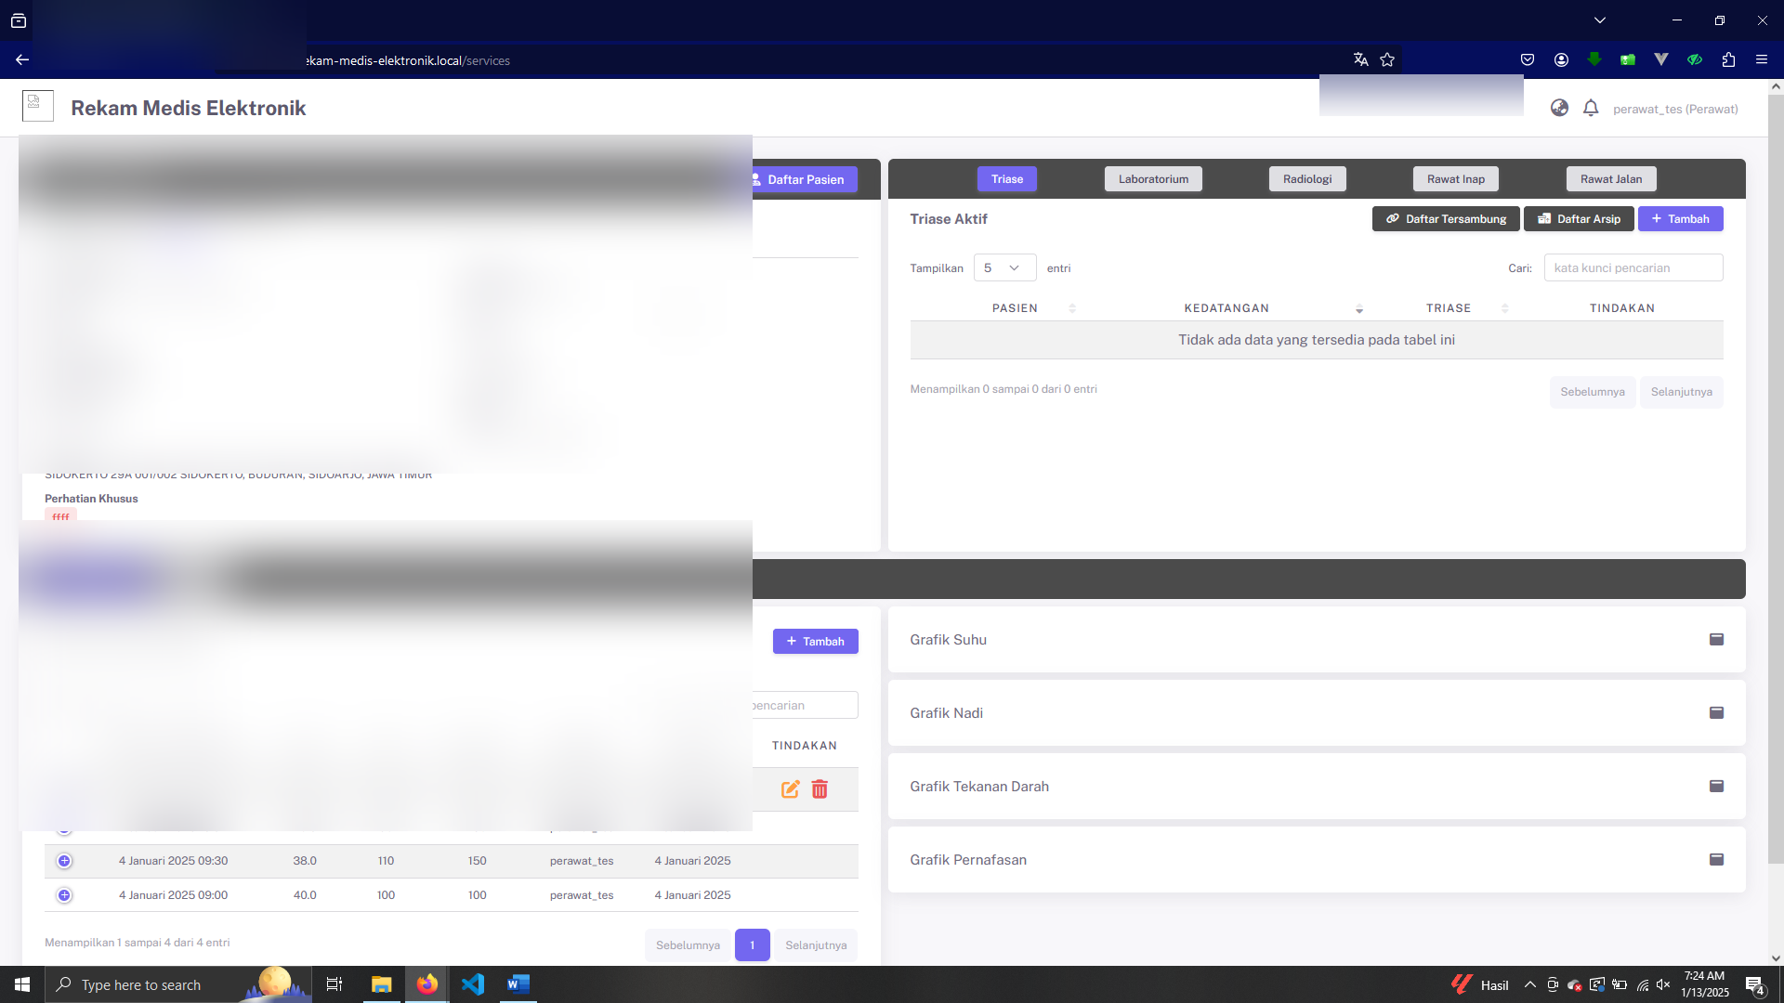

ERP Systems — Kamus ERP, Uncharted & Hokky 2026
Software Developer | Laravel · MySQL · REST API · Purchasing · Inventory · POS · Operational Workflows
- Developed and maintained multiple ERP systems tailored to different business processes, covering purchasing, inventory, point-of-sale, and specialized operational workflows.
- Kamus ERP — Developed and maintained Sales Request and Purchase Order workflows, integrated purchasing with inventory and procurement processes, and improved transaction flow and data consistency across ERP modules.
- Uncharted — Ongoing. Delivered the purchasing flow from Purchase Order through Purchase Receipt, as well as Beli Putus and Point of Sale (POS) functionality. Development continues as additional ERP modules are introduced.
- Hokky — Developed specialized operational modules for fruit sorting and meat sorting, implementing workflows to record and manage sorting processes based on operational requirements.
Screenshot: Kamus ERP — representative ERP interface
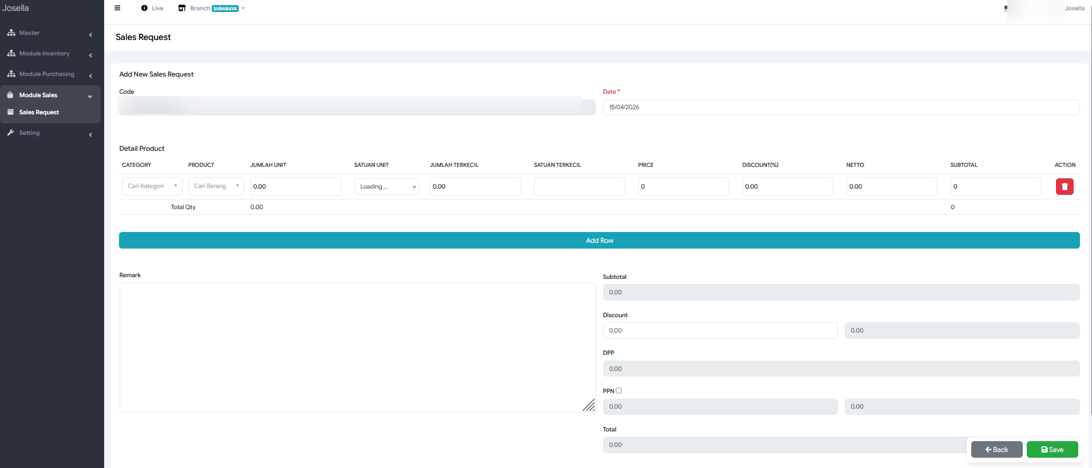
Briton E-Learning Platform 2026
Full-Stack Developer | Laravel · LMS · Production Maintenance
- Extended an existing production learning platform across Course, IELTS, and Live Class features.
- Handled backend and frontend development while improving application stability and user experience.
- Reduced bugs in learning flows and maintained and extended the learning dashboard.
Website: https://learn.onbriton.com
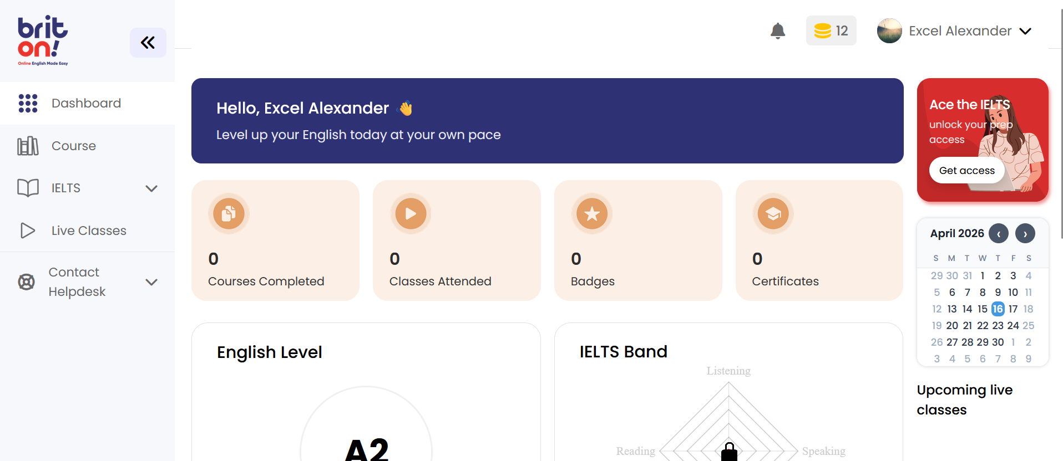

HijabSheily Internal Management System 2024–2026
Laravel · Inventory · Order Workflow · Telegram Integration
- Maintained an internal system covering employees, product inventory and variations, customers, shipping, and orders.
- Supported order-processing and quality-control workflows together with operational reporting.
- Integrated Telegram notifications for real-time reporting and continuously enhanced the system as requirements evolved.
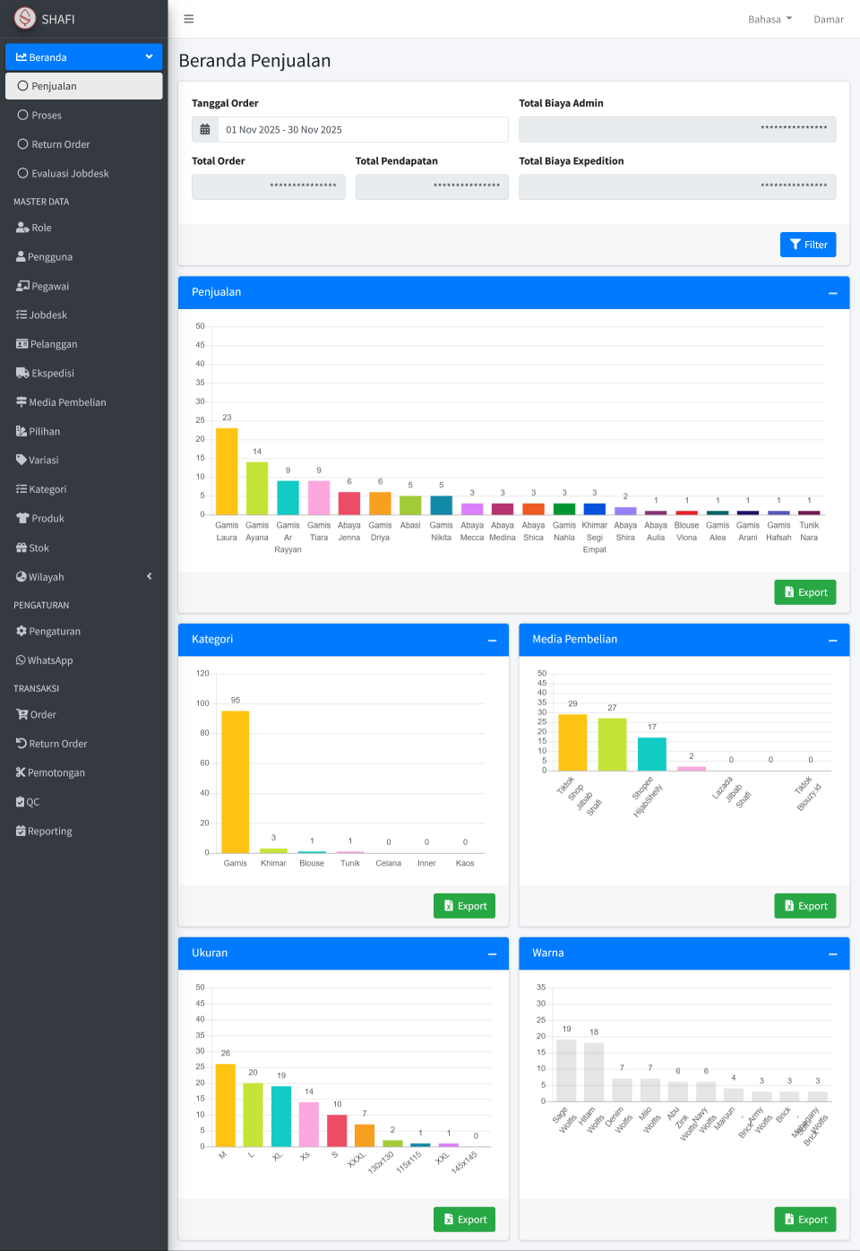

Vision — LODI Client Platform 2022–2024
Laravel · CodeIgniter 3 · Vue.js · PostgreSQL
- Developed a client-facing platform for warehouse inventory, sales, and marketplace-related operations.
- Integrated the web application with backend APIs and marketplace services.
- Maintained Leanbox API v1 built with CodeIgniter 3 and contributed to Leanbox API v2 built with Laravel.
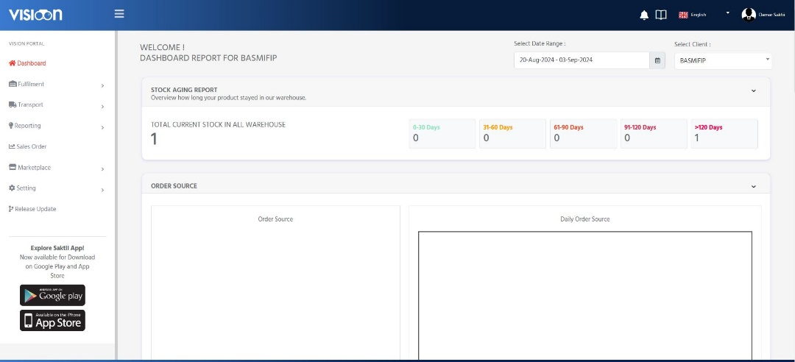
Asset Management — PDAM Surya Sembada 2018–2022
Web / Backend Developer | Laravel · Oracle · REST API
- Built and maintained a web application supporting maintenance teams, operational control, and planning functions.
- Developed modules for asset data, monitoring, work orders, and investment-priority workflows.
- Extended database structures and developed REST APIs for integration with the Android application.
- Worked with operational teams and Android developers to follow up requirements and production issues.
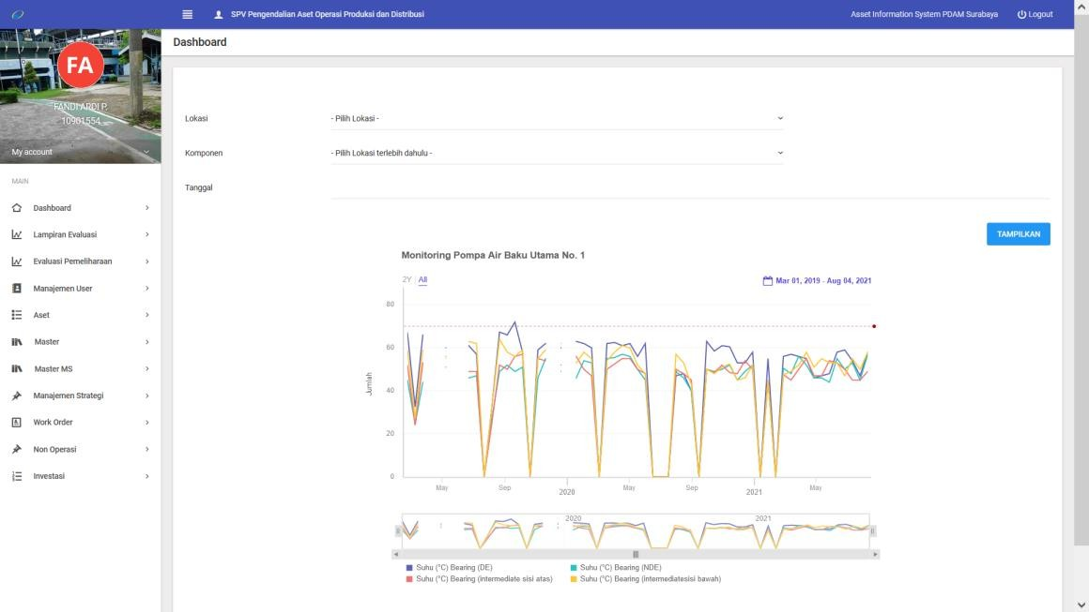

Additional Project Experience
SIMRS eHOS · 2024–2025
Hospital information system maintenance, API development, admin-panel enhancements, performance optimization, and integration across hospital service modules.
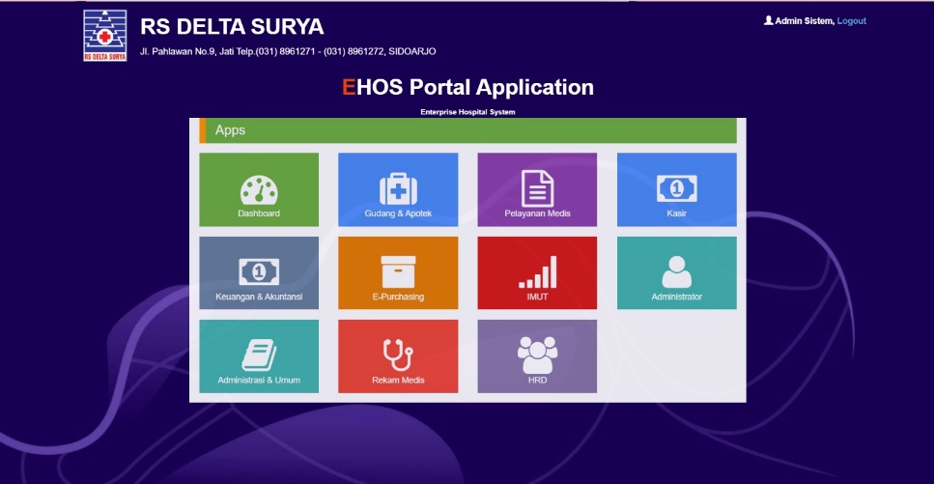
Fulusme.id · 2024–2025
API development for CMS, web, and mobile applications on a sharia-based crowdfunding platform, including database design and development/production deployments.
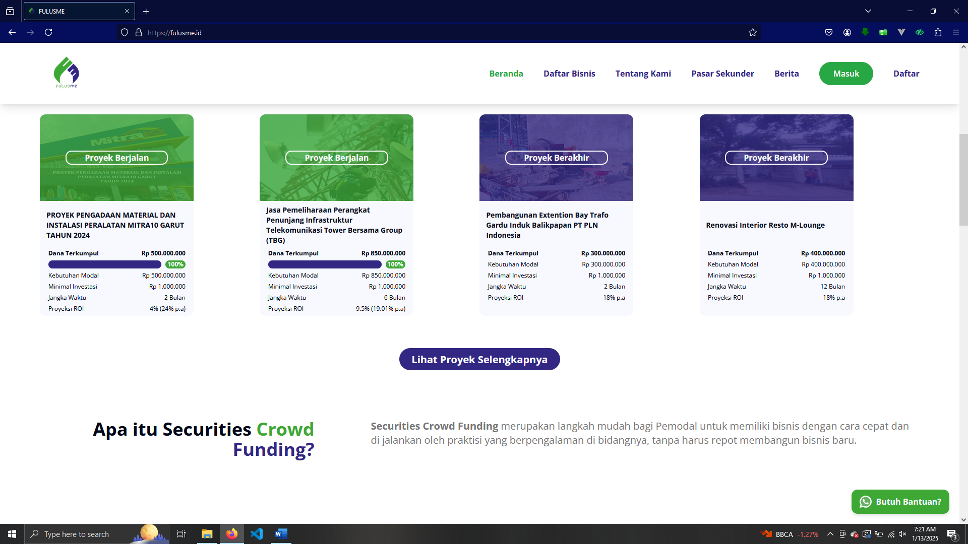

Inboks CMS · 2024
Internal warehouse CMS for managing users, storage space, customers, and shipping monitoring through backend APIs.
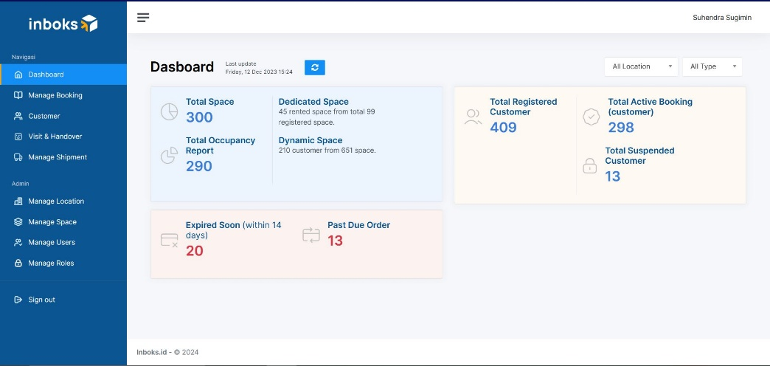
LODI Operational Dashboard · 2022–2024
Operational web features and APIs for warehouse, transporter, and shipping monitoring; maintenance of Leanbox API v1 and contribution to API v2.
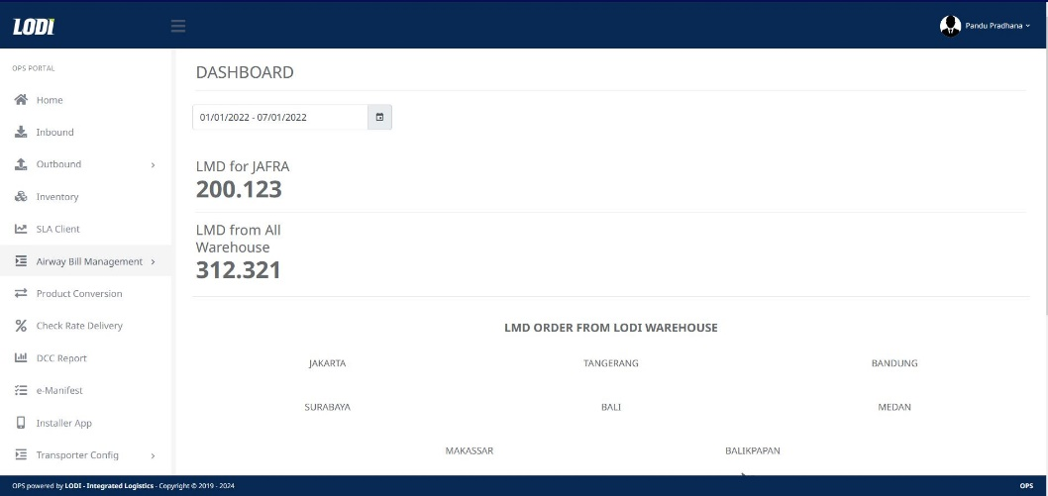
LODI Billing System · 2022–2024
Web and API development for company income monitoring and courier-payment processes using Laravel, Vue.js, Bootstrap, and PostgreSQL.
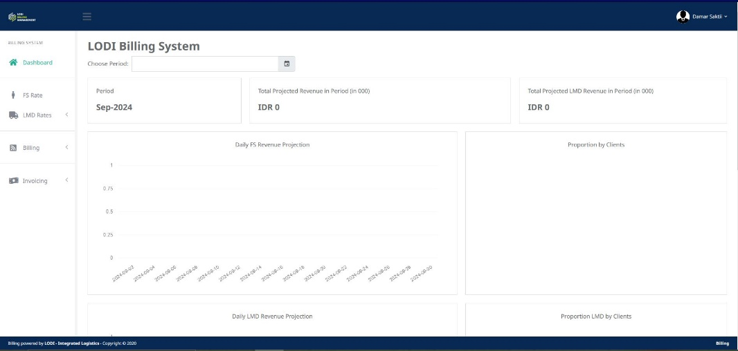
Transport Management System · 2022
Transportation and logistics management application built with Laravel, Bootstrap, jQuery, and Oracle. Website: tms.wika-beton.co.id
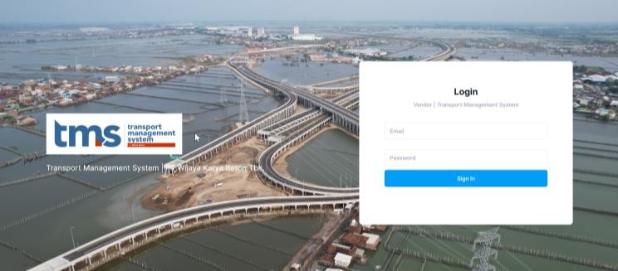
English Proficiency Test · 2022–2024
Online TOEFL-style practice platform with admin, supervisor, and student roles covering listening, structure and written expression, and reading.
