Trainspotting

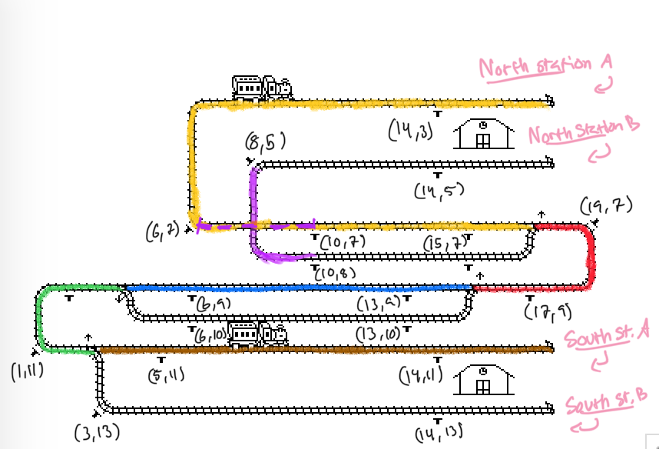

We started by marking out one main route through the network from North Station A to South Station B. We divided this main route into segments between the switches. The idea is that if a train wants to enter a new segment it either has to wait to let the other train pass or switch tracks.

Each segment of the main route is represented by a semaphore. This is to make sure that a train can not enter an already claimed segment.

There are probably many ways of placing the sensors (and probably a more efficient way than ours). However, we decided to place one sensor in front of each segment and one after each segment, one at each turning point at the stations and one at each corner of the crossing.

It takes some time for the trains to stop and so we wanted to have a safe margin. The maximum speed of the trains depends on how close the sensors are to the switches. We do not want them too far apart to keep the flow. We have tested up to speed 15. A speed of 20 works in most cases (but it is definitely on the edge) , but it seems to depend on other factors such as simulation speed and what not.

The cross section is a little different. Here we do not need to switch tracks and so one semaphore is enough. A train will wait to acquire the semaphore before it passes.

Each segment ends in either a turning point or a switch. However, each train will only release its claim of a segment after passing the current and entering the next. This is to avoid the other train getting the permit too soon.

A train only acquires a segment before entering, we had to handle the initial claim of the starting positions. Since both trains will pass the turning point in the beginning (at each station A), we decided to use a one-time-set boolean to acquire the first yellow and brown segment.

One thing that we know could be improved is that a train will switch tracks even though it travels behind another train. To optimize this problem we would have to implement functionality for the trains to detect the distance to others. Otherwise they could end up crashing back to front.