Atoms
  - Key Revision Facts: GCSE Science

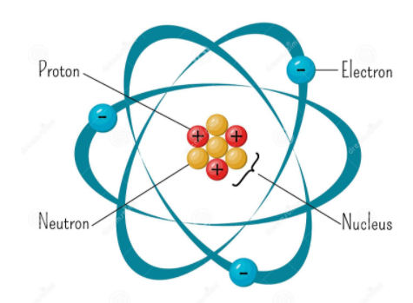
All matter is made from Atoms. The critical atom related words are:

Atom
An atom is a fundamental piece of matter. (Matter is anything that can be touched physically.)

Element
An element is a substance that cannot be broken down into any other substance. Every element is made up of one type of atom.

Nucleus
The nucleus (plural nuclei) is the central part of the atom; it contains the protons and neutrons.

Neutron
The neutron is a subatomic particle found in the nucleus, which has a neutral (not positive or negative) charge.

Proton
The Proton is a subatomic particle found in the nucleus, which has a positive electric charge of +1e.

Electron
An electron is a negatively charged subatomic particle. It can be either free (not attached to any atom) or bound to an atom's nucleus.

Mass Number
The mass number of an atom is its total number of protons and neutrons. Mass = Number of Protons + Number of Neutrons

Atomic Number
The atomic number of a chemical element is the number of protons in the nucleus of an element's atom.

Isotopes
Isotopes are variants of a particular chemical element that differ in Neutron number. (Proton number is the same)

Noble Gases
The noble gases, also called inert gas, make up a class of chemical elements with similar properties. They are all odorless, colorless, with very low chemical reactivity. Noble Gases include helium, neon, argon, krypton, xenon.

Mass and Electric Charge
The two critical properties of Protons, Neutrons, and Electrons are Mass and Electric charge.

Particle | Mass | Charge
Proton | 1 | +1
Neutron | 1 | 0
Electron | Almost zero | -1

Electron Shells
Electrons in atoms exist in spherical shells of various distances from the nucleus, representing energy levels. The larger the spherical shell, the higher the energy contained in the electron. Each shell has a maximum number of electrons it can hold. Electrons will fill the shells nearest the nucleus first. The first shell can hold two electrons. The second shell can have a max of eight electrons. Electron arrangement is written as 2,8,8

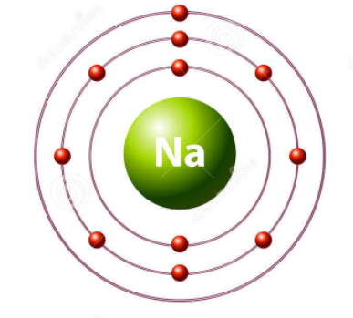
Noble gasses are inert because their outer electron shell is full. They do not need to lose or gain any electrons.

Download
More Key Fact Revision sheets can be downloaded from
www.andrew-seaford.co.uk/revision

Version information
Date | Arthur | Comment
17-Jan-2021 | Andrew Seaford | Initial release.

