AI-Driven Cyber Threat Detection and Intrusion Detection System (AI-CTIDS)
An Explainable Machine Learning Framework for Real-Time Security Analytics

Munish Ghai  Master of Science in Applied Artificial Intelligence  Shiley Marcos School of Engineering / University of San Diego  mghai@sandiego.edu | Sarang Sawant  Master of Science in Applied Artificial Intelligence  Shiley Marcos School of Engineering / University of San Diego  sarangsawant@sandiego.edu | Darshan Kumar Naidu  Master of Science in Applied Artificial Intelligence  Shiley Marcos School of Engineering / University of San Diego  dnaidu@sandiego.edu

KEYWORDS

Artificial Intelligence (AI), Cyber Threat Detection, Intrusion Detection System (IDS), Machine Learning, Deep Learning, Explainable Artificial Intelligence (XAI), Anomaly Detection, Network Security, Autoencoder, Long Short-Term Memory (LSTM), Network Traffic Analysis, Concept Drift, Model Explainability, Threat Intelligence, Security Operations Center (SOC).

Assignment 1.1 Introduction
The rapid adoption of digital transformation initiatives, cloud computing, Internet of Things (IoT) devices, and distributed enterprise networks has fundamentally changed the cybersecurity landscape (NIST, 2024; IBM Security, 2024). Organizations now generate and process vast amounts of network traffic across increasingly complex infrastructures, creating a significantly larger attack surface for cyber adversaries. Sophisticated attacks such as Distributed Denial-of-Service (DDoS), brute-force attacks, botnet activity, infiltration attempts, and web-based exploits continue to evolve in both frequency and complexity, making them more difficult to detect using conventional security technologies. As cyber threats become increasingly dynamic, organizations face growing challenges in protecting critical information assets while maintaining uninterrupted business operations.
Traditional Intrusion Detection Systems (IDS) primarily rely on predefined signatures and manually crafted detection rules to identify malicious activity. While these approaches remain effective for detecting known attack patterns, they often struggle to identify previously unseen threats, zero-day exploits, and rapidly evolving attack techniques (Denning, 1987; Liao et al., 2013). Furthermore, signature-based systems frequently generate high false-positive rates, requiring security analysts to manually investigate large volumes of alerts and contributing to increased operational costs, alert fatigue, and delayed incident response. These limitations highlight the need for intelligent, adaptive, and explainable cybersecurity solutions capable of learning complex behavioral patterns from network traffic rather than relying solely on static detection rules.
Artificial Intelligence (AI), Machine Learning (ML), and Deep Learning (DL) have emerged as transformative technologies for enhancing cyber threat detection by automatically learning relationships within high-dimensional network traffic data (Buczak & Guven, 2016). Unlike traditional rule-based systems, AI-driven intrusion detection models can identify subtle anomalies, recognize previously unseen attack behaviors, and continuously improve detection performance through data-driven learning. Recent advances in Explainable Artificial Intelligence (XAI) further address one of the primary challenges associated with AI adoption in cybersecurity by providing interpretable predictions that improve analyst confidence (Guidotti et al., 2018; Molnar, 2022), support incident investigation, and facilitate informed security decision-making.
This capstone project, AI-Driven Cyber Threat Detection and Intrusion Detection System, proposes the development of an intelligent and explainable machine learning framework for detecting malicious network activity and supporting real-time security analytics. Rather than focusing exclusively on maximizing classification accuracy, the project adopts an end-to-end machine learning perspective that encompasses the complete AI lifecycle, including data acquisition, preprocessing, exploratory data analysis, feature engineering, model development, hyperparameter optimization, explainability, performance evaluation, deployment considerations, and production readiness. By combining supervised machine learning, deep learning, and anomaly detection techniques within a unified framework, the proposed system aims to deliver a practical and scalable solution suitable for modern cybersecurity environments.
The overall architecture of the proposed AI-Driven Cyber Threat Detection and Intrusion Detection System is illustrated in Figure 1.

Figure 1. High-Level Architecture of the Proposed AI-Driven Cyber Threat Detection and Intrusion Detection System
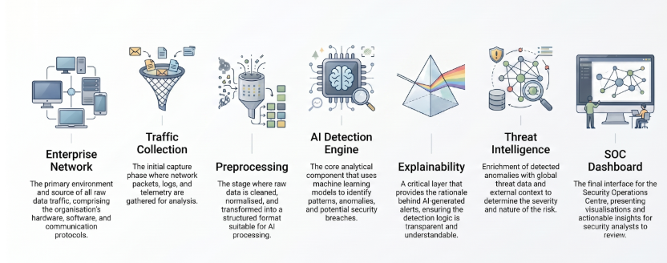
Figure 1 illustrates the high-level architecture of the proposed AI-Driven Cyber Threat Detection and Intrusion Detection System (AI-CTIDS). Network telemetry collected from enterprise security infrastructure is processed through a structured machine learning pipeline consisting of data preprocessing, intelligent threat detection, explainability, and threat intelligence enrichment. The resulting security insights are presented through a Security Operations Center (SOC) dashboard, enabling analysts to rapidly investigate, prioritize, and respond to potential cyber threats.
The primary users of the proposed system include Security Operations Center (SOC) analysts, cybersecurity engineers, enterprise security administrators, incident response teams, and Managed Security Service Providers (MSSPs). These stakeholders require accurate, timely, and interpretable threat detection capabilities to reduce investigation time, prioritize high-risk security events, and improve operational efficiency. By integrating explainable AI techniques into the detection process, the proposed system seeks to support human decision-making rather than replace it, enabling analysts to better understand model predictions and respond more effectively to potential security incidents.

Dataset Selection Rationale
The CICIDS2017 dataset (Sharafaldin et al., 2018) was selected because it is one of the most widely adopted benchmark datasets for intrusion detection research. The dataset contains realistic network traffic generated under both normal operating conditions and multiple categories of contemporary cyberattacks, including DDoS, brute-force attacks, botnet activity, infiltration, denial-of-service attacks, and web-based attacks. Its comprehensive collection of flow-based network features, realistic traffic patterns, and well-labeled attack scenarios make it an appropriate benchmark for evaluating machine learning-based intrusion detection systems. While historical benchmark data will be used for model development and validation, the proposed system is designed to simulate a production environment in which network telemetry would be continuously collected from enterprise firewalls, routers, intrusion detection systems, cloud security platforms, Security Information and Event Management (SIEM) systems, and network flow technologies such as NetFlow or IPFIX.
The primary objective of this project is to design, develop, and evaluate an AI-driven intrusion detection system capable of accurately identifying malicious network traffic while providing transparent and interpretable predictions suitable for operational cybersecurity environments. Specifically, the project aims to compare multiple supervised machine learning, deep learning, and anomaly detection approaches; evaluate their effectiveness using comprehensive performance metrics; and investigate the contribution of explainable AI toward improving trust and usability within Security Operations Centers. Success will be evaluated not only through predictive performance measures such as precision, recall, F1-score, Receiver Operating Characteristic Area Under the Curve (ROC-AUC), and false-positive reduction, but also through the system's ability to produce meaningful explanations and demonstrate architectural readiness for practical deployment.

Success Criteria
Goal | Success Metric
Detect attacks | Precision, Recall and F1-score >95%
Reduce false positives | Lower FPR than baseline
Improve interpretability | SHAP explanations generated
Support SOC analysts | Feature importance visualization
Real-time readiness | Demonstrate an end-to-end deployment architecture suitable for near real-time threat detection
Compare algorithms | Performance comparison using ROC-AUC and F1
The scope of this project focuses on the development of an intelligent AI-assisted intrusion detection framework for enterprise network environments. The project includes data preprocessing, feature engineering, comparative model evaluation, explainable AI, and high-level deployment architecture to demonstrate how modern machine learning techniques can enhance cybersecurity operations. The implementation is intended to simulate a production-ready AI solution rather than a fully operational enterprise security platform; therefore, components such as live packet capture, direct integration with commercial firewalls or SIEM platforms, and continuous production deployment are considered future extensions beyond the scope of this capstone.
In Scope
- Data preprocessing
- Feature engineering
- Multiple ML models
- Explainable AI
- Comparative evaluation
- Production-ready architecture
Out of Scope
- No live network traffic
- No SIEM integration
- No real-time deployment
- Limited to benchmark dataset
- Commercial Security Information and Event Management (SIEM) deployment
- Continuous online model retraining

Expected Deliverables
Deliverable | Description
Data preprocessing pipeline | Cleaned and engineered dataset
Machine Learning Models | RF, XGBoost, LightGBM, etc.
Deep Learning Models | LSTM / Autoencoder
Explainability Module | SHAP & LIME
Evaluation Report | Performance comparison
Architecture | End-to-end deployment workflow
Final Presentation | Capstone presentation
Research Report | Final capstone report documenting methodology, findings and conclusions
The central hypothesis of this research is that an explainable hybrid machine learning framework combining supervised learning, deep learning, and anomaly detection techniques can achieve more effective cyber threat detection than conventional signature-based approaches while simultaneously improving model transparency and supporting faster, more informed security decision-making. By integrating predictive intelligence with explainability and production-oriented system design, this project demonstrates how artificial intelligence can strengthen modern intrusion detection capabilities and provide a practical foundation for next-generation AI-enabled cybersecurity solutions.

Expected Impact
The proposed AI-driven intrusion detection framework aims to improve cybersecurity operations by increasing attack detection accuracy, reducing false positives, providing interpretable predictions for security analysts, and demonstrating a scalable architecture suitable for enterprise deployment. Ultimately, the project seeks to enhance analyst productivity, accelerate incident response, and contribute to the broader adoption of trustworthy AI within modern Security Operations Centers (SOCs).

Research Contributions
This project is expected to make the following contributions to AI-enabled cybersecurity research and practice:
- Developing a hybrid machine learning framework that integrates supervised learning, deep learning, and anomaly detection techniques to improve the accuracy and robustness of network intrusion detection.
- Comparing the performance of multiple supervised, ensemble, and deep learning models using the CICIDS2017 benchmark dataset to identify the most effective approach for detecting malicious network activity.
- Integrating Explainable Artificial Intelligence (XAI) techniques, including SHAP and LIME, to improve model transparency, enhance analyst trust, and support informed decision-making within Security Operations Centers (SOCs).
- Evaluating the production readiness of the proposed framework through an end-to-end machine learning pipeline that includes data preprocessing, feature engineering, model optimization, performance evaluation, and deployment planning.
- Demonstrating a scalable, production-oriented system architecture that illustrates how the proposed AI-driven intrusion detection framework can be adapted for enterprise environments to enable real-time threat detection and intelligent security analytics.

Project Risks and Mitigation
Risk | Mitigation
Class imbalance | Stratified sampling, class weighting, SMOTE if appropriate
Overfitting | Cross-validation and hyperparameter tuning
High dimensionality | Feature selection and correlation analysis
Concept drift | Discuss monitoring strategy for future deployment
Limited generalization | Validate on unseen test data
Model interpretability | SHAP and LIME explanations
Dataset bias | Evaluate performance across multiple attack categories
Conclusion
This proposal establishes a comprehensive foundation for developing an explainable AI-driven cyber threat detection and intrusion detection framework capable of addressing modern cybersecurity challenges. Through the integration of machine learning, deep learning, anomaly detection, and explainable AI, the proposed system aims to deliver accurate, transparent, and scalable threat detection suitable for enterprise environments. The subsequent phases of this capstone will focus on data exploration, model development, experimental evaluation, and deployment considerations to validate the proposed objectives and research hypothesis.

Assignment 2.1 – Project Planning, Scheduling and Project Management

Project Planning and Project Management Framework
The primary objective of Assignment 2.1 was to establish a comprehensive project management framework that provides complete visibility into the planning, execution, monitoring, and control of the AI-Driven Cyber Threat Detection and Intrusion Detection System (AI-CTIDS) project. While Assignment 1.1 focused on defining the business problem, research objectives, project scope, and proposed AI solution, Assignment 2.1 translates those objectives into a structured execution plan that guides the project from initiation through final delivery.
A Project Management Office (PMO) workbook was developed as the central project governance artifact. Rather than functioning solely as a task tracker, the workbook provides a single source of truth for monitoring project progress, managing resources, tracking milestones, identifying risks, and communicating project status to stakeholders. The workbook was intentionally designed to align with the end-to-end machine learning lifecycle implemented in the Jupyter Notebook, ensuring that project management activities directly support technical implementation rather than operating as a separate administrative process.
The project follows an Agile-inspired execution model over a seven-week implementation period, allowing incremental delivery of project components while providing regular opportunities for review, validation, and continuous improvement.

PMO Workbook Overview
The PMO workbook serves as the central project management repository and integrates project planning, scheduling, progress monitoring, milestone tracking, risk management, resource allocation, and executive reporting into a single document. The workbook has been designed to be simple to maintain while providing sufficient detail for effective project governance.
The workbook consists of several interconnected worksheets, each supporting a specific project management function.

Executive Dashboard
The Executive Dashboard provides a real-time, high-level view of the overall health of the project. It enables project stakeholders to quickly assess project status without reviewing detailed schedules or task lists.
The dashboard includes:
- Overall Project Progress (% Complete)
- Project Health Indicator (Red-Amber-Green Status)
- Current Project Week
- Next Planned Milestone
- Project Duration
- Number of Completed Tasks
- Remaining Tasks
- Total Project Tasks
- Open Risks
- Open Issues
- Team Status
- Upcoming Deliverables
- Milestone Timeline
- Progress by Project Phase
The dashboard is intended to function as an executive reporting page suitable for presentations, steering committee meetings, and weekly status reviews.

Project Charter
The Project Charter summarizes the foundational elements of the project, including:
- Business Problem
- Project Objectives
- Project Scope
- Out-of-Scope Items
- Success Criteria
- Project Assumptions
- Constraints
- Stakeholders
- Expected Deliverables
This worksheet provides the strategic context for the project and ensures that all team members maintain a common understanding of project goals and expected outcomes.

Project Schedule
The Project Schedule translates the technical implementation plan into manageable project activities. Instead of tracking every individual notebook operation, related technical tasks are grouped into logical work packages corresponding to major phases of the AI lifecycle.
Each scheduled activity includes:
- Work Breakdown Structure (WBS)
- Activity Name
- Assigned Owner
- Start Date
- Finish Date
- Duration
- Status
- Percentage Complete
- Dependencies
- Deliverables
Grouping notebook activities into higher-level work packages simplifies project tracking while preserving visibility into overall progress.

Gantt Chart
The Gantt Chart provides a visual representation of the complete project schedule over the seven-week implementation period. It illustrates task sequencing, durations, dependencies, milestones, and overlaps between concurrent activities.
The Gantt Chart includes:
- Seven-week project timeline
- Color-coded project phases
- Major milestones (M1–M7)
- Task durations
- Start and finish dates
- Progress indicators
- Current reporting week
- Critical project activities
The chart enables stakeholders to understand the overall execution timeline at a glance and supports schedule monitoring throughout the project.

Notebook Progress Tracker
Unlike traditional project management documents, the Notebook Progress Tracker directly maps project activities to the implementation steps completed within the Jupyter Notebook. This creates clear traceability between project planning and technical execution.
The tracker monitors progress across major notebook phases, including:
- Problem Definition
- Dataset Acquisition
- Data Validation
- Exploratory Data Analysis
- Data Cleaning
- Feature Engineering
- Feature Selection
- Model Development
- Hyperparameter Optimization
- Model Evaluation
- Explainable AI
- Deployment Simulation
- Monitoring
- Final Validation
This alignment demonstrates that project management activities accurately reflect the development lifecycle of the AI solution.

Milestone and Deliverables Tracker
Project milestones represent significant completion points that indicate successful progression through the project lifecycle. Each milestone is associated with specific deliverables and acceptance criteria.
Major milestones include:
- M1 – Project Initiation and Planning
- M2 – Data Understanding and Preparation
- M3 – Model Development and Optimization
- M4 – Explainability and Model Evaluation
- M5 – Deployment and Monitoring
- M6 – Documentation and Presentation Preparation
- M7 – Final Submission and Project Closure
The tracker records milestone status, planned completion dates, actual completion dates, responsible team members, and associated deliverables.

Team Management and Resource Allocation
The workbook includes a Team Management worksheet that documents resource assignments and workload distribution across the three project members.
Responsibilities are allocated according to individual expertise:
- Munish Ghai – Data Engineering, Monitoring, Documentation, Project Coordination
- Sarang Sawant – Production Platform, APIs, Kafka Integration, CI/CD
- Darshan Kumar Naidu – Machine Learning Models, Evaluation, Explainability, Testing
The resource allocation section supports workload balancing, accountability, and monitoring of task completion.

RAID Log
Effective project governance requires proactive identification and management of project uncertainties. The RAID Log captures:
- Risks – Potential events that could impact project success
- Assumptions – Conditions accepted as true for planning purposes
- Issues – Current problems requiring resolution
- Dependencies – External activities or deliverables that influence project progress
Each entry includes a description, owner, impact level, mitigation strategy, and current status, enabling systematic monitoring throughout the project lifecycle.

Weekly Status Reports
Weekly Status Reports provide a structured summary of project progress and support regular communication among team members and stakeholders. Each report documents:
- Planned activities
- Completed work
- Outstanding tasks
- Challenges encountered
- Risk updates
- Planned activities for the following week
- Lessons learned
These reports facilitate continuous monitoring and timely corrective action when necessary.

Key Performance Indicators (KPIs)
To objectively monitor project performance, several Key Performance Indicators (KPIs) are incorporated into the Executive Dashboard. These KPIs provide quantitative measures of project health and progress.
The dashboard tracks:
- Overall Project Completion Percentage
- Number of Completed Tasks
- Remaining Tasks
- Milestone Achievement
- Project Schedule Performance
- Team Utilization
- Open Risks
- Open Issues
- Notebook Completion Status
- Deliverable Completion Status
- Weekly Progress
- Documentation Completion
These KPIs provide management with a concise yet comprehensive overview of project performance and enable informed decision-making throughout the execution phase.

Benefits of the PMO Workbook
The PMO workbook provides several important benefits:
- Centralizes all project management information in a single repository.
- Aligns project planning with the AI implementation lifecycle.
- Improves visibility into project progress and milestone achievement.
- Supports effective resource planning and workload management.
- Enables proactive risk identification and mitigation.
- Facilitates communication through executive dashboards and weekly reports.
- Simplifies project tracking while maintaining sufficient detail for governance.
- Produces professional documentation suitable for academic assessment and future portfolio use.
Overall, the PMO workbook transforms the AI-CTIDS project from a collection of technical tasks into a well-governed, measurable, and professionally managed Capstone project, demonstrating the application of project management best practices alongside the implementation of an end-to-end AI-enabled cybersecurity solution.

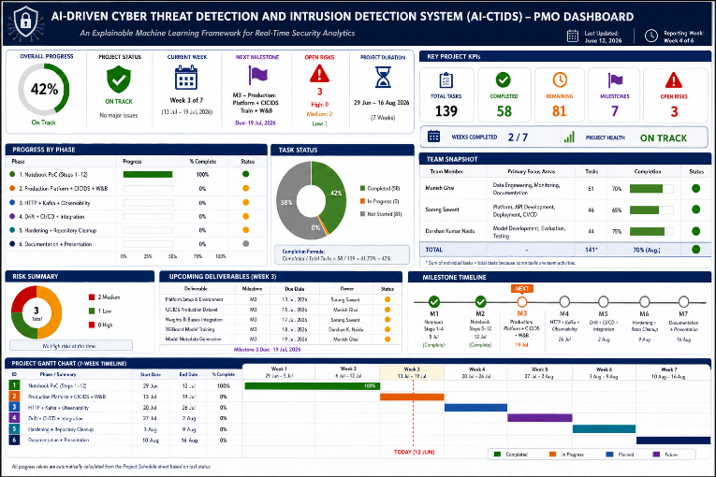

Assignment 3.1 – Data Summary

Dataset Variables
The proposed AI-Driven Cyber Threat Detection and Intrusion Detection System (AI-CTIDS) uses the CICIDS2017 benchmark dataset, which contains network flow records representing both legitimate network communication and multiple categories of cyberattacks. Each observation corresponds to a single network connection (flow), while the target variable identifies whether the traffic is benign or malicious. For this project, the target classes were simplified to three categories: BENIGN, DDoS, and PortScan, enabling the development of a multiclass intrusion detection model while maintaining sufficient representation of each attack category.
Rather than representing individual packets, the predictor variables describe the overall behavior of each network flow. These variables can be grouped into several meaningful categories:
Communication characteristics, including the network ports used and the duration of each communication session.
Traffic volume measurements, describing the number of packets and the total amount of data transmitted in both the forward and backward directions.
Packet size statistics, including minimum, maximum, average, and variation in packet lengths.
Timing characteristics, describing the intervals between packets, overall flow timing, and communication latency.
Transmission rate measurements, including packet transmission rates and data throughput.
Protocol and TCP flag information, representing connection establishment, acknowledgements, resets, and other protocol-level behaviors.
Flow behavior metrics, describing active communication periods, idle periods, packet fragmentation, window sizes, and header information.
Collectively, these variables capture both the volume and behavioral characteristics of network communications. Because cyberattacks often exhibit distinctive traffic patterns, such as unusually high packet rates, abnormal session durations, repetitive connection attempts, or atypical packet distributions, these features provide meaningful information for distinguishing malicious traffic from normal network activity.
Dataset Quality Issues and Preprocessing
Although the CICIDS2017 dataset is widely used in intrusion detection research, exploratory data analysis identified several data quality issues that required preprocessing before model development. These preprocessing activities were implemented systematically within the notebook to ensure a reliable and reproducible machine learning pipeline.
The initial assessment identified a small number of missing values and infinite numerical values generated during feature extraction, primarily resulting from division-by-zero operations when calculating network traffic rates. These invalid observations were converted to missing values and subsequently imputed using median values, thereby preserving the dataset while minimizing the influence of extreme observations.
Several predictor variables contained identical values across every observation. Because these constant features provide no discriminatory information, ten constant variables were removed from the dataset to reduce dimensionality without affecting predictive performance.
The analysis also identified duplicate predictor variables generated during CICFlowMeter feature extraction. Six variables were found to be exact duplicates of existing measurements (correlation coefficient = 1.00) and were removed after empirical verification. Eliminating these redundant predictors reduced computational complexity while preserving the complete information content of the dataset.
Duplicate feature analysis further confirmed that repeated header-length variables contained identical information, allowing redundant columns to be safely removed. The notebook also evaluated negative numerical values. Most negative values occurred in TCP window size features where a value of −1 represents unavailable or undefined protocol information rather than erroneous measurements. A very small number of additional negative values were attributed to feature extraction artifacts. Since these values are recognized characteristics of the original dataset and occurred infrequently, they were retained without modification.
Finally, the categorical target labels were encoded into numerical classes, the dataset was partitioned into stratified training (70%), validation (15%), and testing (15%) subsets, and predictor variables were standardized using StandardScaler fitted exclusively on the training data. This approach prevented information leakage while ensuring consistent feature scaling across all datasets.
In a fully operational machine learning pipeline, these preprocessing tasks would be fully automated. Incoming network telemetry would first undergo schema validation, missing-value detection, invalid-value handling, duplicate feature validation, feature scaling using previously learned preprocessing artifacts, and continuous data quality monitoring. Automated monitoring would additionally detect concept drift, feature drift, and unexpected data anomalies to maintain long-term model performance.
Relationship Between the Variables and the Project Goal
The objective of this project is to accurately distinguish normal network traffic from malicious cyberattacks while providing interpretable predictions suitable for Security Operations Centres (SOCs). The selected predictor variables are directly aligned with this objective because they describe measurable characteristics of network communication that often change during cyberattacks.
For example, Distributed Denial-of-Service (DDoS) attacks typically generate exceptionally large numbers of packets over very short periods, resulting in unusually high packet rates, increased flow volumes, and abnormal timing behavior. Similarly, PortScan attacks often consist of numerous short-lived connections targeting multiple destination ports, creating distinctive patterns in connection duration, packet counts, and protocol behavior. In contrast, benign traffic generally exhibits more balanced communication patterns and stable timing characteristics.
Exploratory analysis demonstrated that several variables exhibited noticeably different distributions across the three traffic classes. Traffic volume, packet statistics, timing measurements, transmission rates, and TCP connection characteristics all appeared likely to contribute meaningful predictive information. Conversely, constant features and duplicated variables showed no discriminatory capability and were removed during preprocessing.
These observations suggest that the remaining variables provide complementary information capable of distinguishing different forms of network behavior, thereby supporting the project's objective of developing accurate and explainable intrusion detection models.
Relationships Among Predictor Variables
Network traffic features are naturally interrelated because many statistical measurements are derived from the same communication flow. Correlation analysis confirmed that several variables exhibited extremely high positive correlations, particularly those representing identical network measurements calculated under different names by the CICFlowMeter feature extraction process.
Six predictor variables were identified as perfect duplicates (correlation coefficient equal to 1.00) of existing features and were removed from the final dataset. These included duplicate measurements describing packet counts, byte counts, and average packet sizes in both communication directions. Removing these redundant predictors reduced multicollinearity and simplified the feature space without sacrificing predictive information.
Although other variables exhibited moderate to high correlations, these relationships generally reflected meaningful characteristics of network behavior rather than redundant information. For example, packet counts naturally correlate with total transmitted bytes, and packet timing measurements often correlate with overall flow duration. These relationships are expected in network traffic data and may provide complementary information for machine learning algorithms.
Understanding these correlations informed the model development strategy. Removing exact duplicate variables reduced unnecessary redundancy and improved computational efficiency, while retaining informative correlated features allowed tree-based ensemble methods such as Random Forest, XGBoost, and LightGBM to exploit complex interactions among predictor variables. Standardization further ensured that algorithms sensitive to feature scale, including Logistic Regression, Support Vector Machines, Neural Networks, and K-Nearest Neighbors, could learn effectively from the processed data.
Overall, the final feature set represents a balanced collection of independent yet complementary network traffic characteristics that are well suited for accurate and explainable multiclass cyber threat detection.
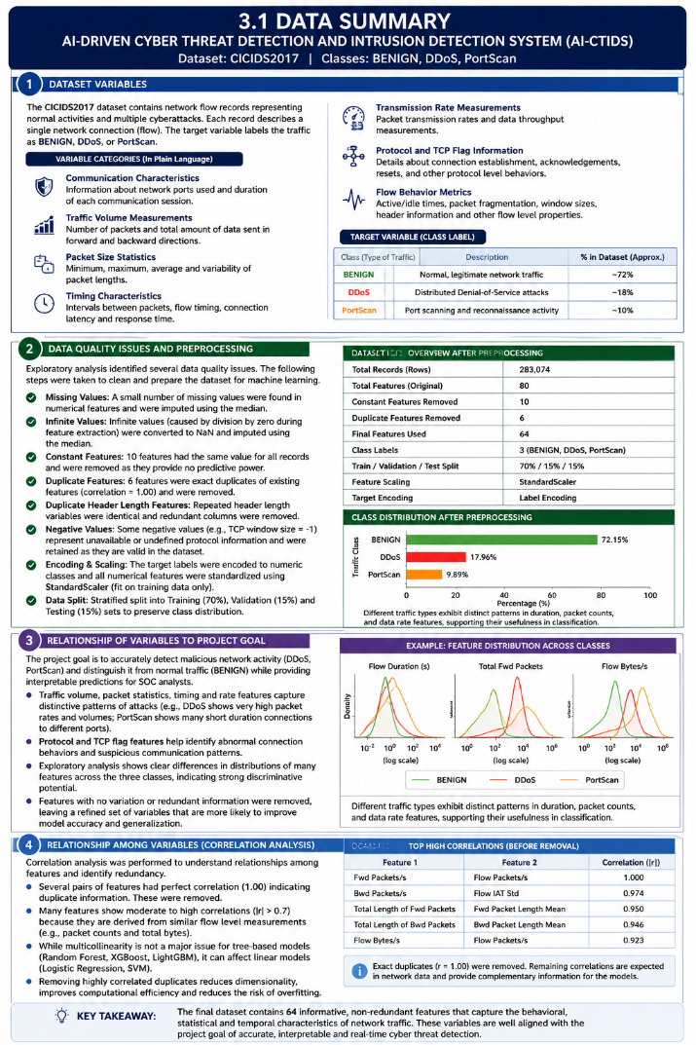

Reference List
European Union Agency for Cybersecurity. (2024). ENISA threat landscape 2024. https://www.enisa.europa.eu/publications/enisa-threat-landscape-2024
National Institute of Standards and Technology. (2023). Artificial intelligence risk management framework (AI RMF 1.0). U.S. Department of Commerce. https://www.nist.gov/itl/ai-risk-management-framework
The MITRE Corporation. (2024). MITRE ATT&CK® framework. https://attack.mitre.org/
Buczak, A. L., & Guven, E. (2016). A survey of data mining and machine learning methods for cyber security intrusion detection. IEEE Communications Surveys & Tutorials, 18(2), 1153–1176. https://doi.org/10.1109/COMST.2015.2494502
CISA. (2024). Cybersecurity best practices. Cybersecurity and Infrastructure Security Agency. https://www.cisa.gov/topics/cybersecurity-best-practices
Denning, D. E. (1987). An intrusion-detection model. IEEE Transactions on Software Engineering, SE-13(2), 222–232. https://doi.org/10.1109/TSE.1987.232894
Guidotti, R., Monreale, A., Ruggieri, S., Turini, F., Giannotti, F., & Pedreschi, D. (2018). A survey of methods for explaining black box models. ACM Computing Surveys, 51(5), Article 93. https://doi.org/10.1145/3236009
IBM Security. (2024). Cost of a data breach report 2024. IBM. https://www.ibm.com/reports/data-breach
Liao, H.-J., Lin, C.-H. R., Lin, Y.-C., & Tung, K.-Y. (2013). Intrusion detection system: A comprehensive review. Journal of Network and Computer Applications, 36(1), 16–24. https://doi.org/10.1016/j.jnca.2012.09.004
Molnar, C. (2022). Interpretable machine learning (2nd ed.). Lulu Press. https://christophm.github.io/interpretable-ml-book/
National Institute of Standards and Technology. (2024). Cybersecurity framework (CSF) 2.0. U.S. Department of Commerce. https://www.nist.gov/cyberframework
Sharafaldin, I., Lashkari, A. H., & Ghorbani, A. A. (2018). Toward generating a new intrusion detection dataset and intrusion traffic characterization. In Proceedings of the 4th International Conference on Information Systems Security and Privacy (ICISSP 2018) (pp. 108–116). SCITEPRESS. https://doi.org/10.5220/0006639801080116

