Domoticz, influxDB and Garfana
( MQTT)
for nice graphs







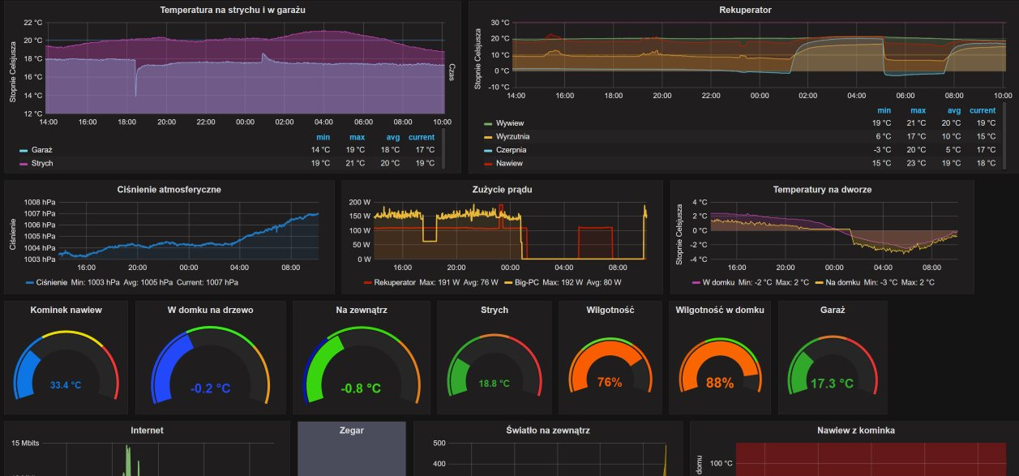

Table of Contents
Description 3
Request: 3
Assumptions: 3
Principle: 3
Variant 1 – Write data direct into influxDB 3
Variant 2 – Write data from Domoticz to influxDB through MQTT 4
Prepare influxDB 4
Send data from domoticz to influxDB 5
Variant 1 - Set Domoticz write data direct into influxDB 5
Variant 2 - Write data from Domoticz to influxDB through MQTT 8
Prepare MQTT broker MOSQUITO 8
Configure DOMOTICZ to public device changes into MQTT 11
Send data from MQTT do influxDB (by python script) 13
Use GRAFANA to draw graphs 13
Více informací: 18
Write by: 18

Description
This document describe how-to create nice graphs from domoticz by program Grafana and auxiliary programs (influxDB, [MQTT + python script]).

Why I do this:
Because Domoticz can draw only basic graphs and older data summarize for save memory. Other-way Grafana can draw nice graphs and influxDB can store data for longer time.

Request:
- Domoticz automation system
- [ MQTT server with websocket (best is mossquito) + python with mqtt and influxDB support )
- InfluxDB
- Grafana
- Web browser

Assumptions:
- running domoticz

Principle:
In this article are described two variants how to send data from domoticz to influxDB.

Short description used services or programs:
Domoticz – home automation system
( www.domoticz.com )
MQTT – messages server (forwarder) for IOT (internet of things) (only for variant 2)
(https://mosquitto.org)
Python – program language, for run script who sending information from MQTT to InfluxDB (only for variant 2)
InfluxDB – database server, used for store information from domoticz (https://docs.influxdata.com/influxdb/v1.5/)
Grafana – is web program for visualize data (in this case from influxDB). Draw nice graphs.
(https://garafana.com)

Variant 1 – Write data direct into influxDB

HTTP API
Port: 8086
HTTP
Port: 3000
Domoticz
Automation system
Client web page
Store data
Visualize data
This easer variant.

Variant 2 – Write data from Domoticz to influxDB through MQTT

MQTT
messages
HTTP
Port: 3000
MQTT
brouker
Domoticz
Automation system
Client web page
Store data
Visualize data
Forward data
This variant more difficult but is cleaner when you use communication between Domoticz and MQTT early for another purpose.

In both variants enable view data behind NAT, if you use public influxDB and Grafana server.

Prepare influxDB

Downlload and install
Best guide is on https://portal.influxdata.com/downloads#influxdb.
For ubuntu and debian type on command line:

wget https://dl.influxdata.com/influxdb/releases/influxdb_1.5.2_amd64.deb
sudo dpkg -i influxdb_1.5.2_amd64.deb

Configure:
If you wish do some change etc. change default ports, than you can do in /etc/influxdb/influxdb.conf.
Default port if 8086 for communication and 8085 for admin web page.

Start deamon:
sudo service influxdb start

Create new database:
Connect to InfluxDB shell using the commandline
influx
Visit https://enterprise.influxdata.com to register for updates, InfluxDB server management, and monitoring.
Connected to http://localhost:8086 version 0.10.0
InfluxDB shell 0.10.0
>

Create a database.
For this quick start we’ll call the database “demo“. Run this command inside the InfluxDB shell.
> CREATE DATABASE demo
>

Only for test:
You can show list databases.
> SHOW DATABASES
name: databases
---------------
name
_internal
demo

>
Select database
> USE demo
Using database demo
write data by influxdb shell
INSERT cpu,host=serverA value=0.64
or data into influxDB you can also write by standard http request e.g. bash script
curl -i -XPOST 'http://localhost:8086/write?db=demo' --data-binary 'cpu,host=serverA value=0.84'
select data from influxdb shell
> SELECT * FROM cpu
name: cpu
---------
time host value
1527176107506652262 serverA 0.64
1527176252035641431 serverA 2.01
OK database is ready.

Send data from domoticz to influxDB

Variant 1 - Set Domoticz write data direct into influxDB
It is very easy. Open menu Hradvare->More Otions->Data pusch->InfluxDB and create list who devices or variables will push into influxDB.
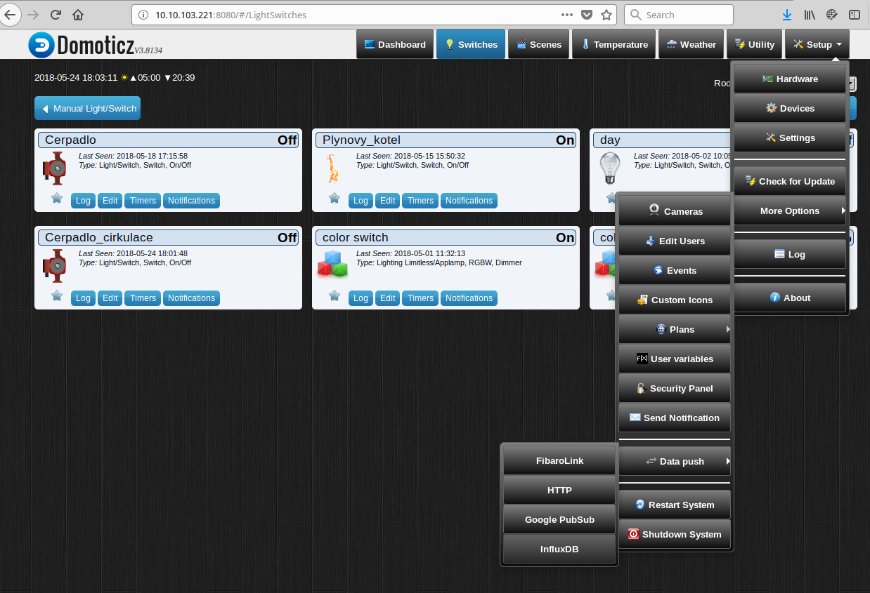

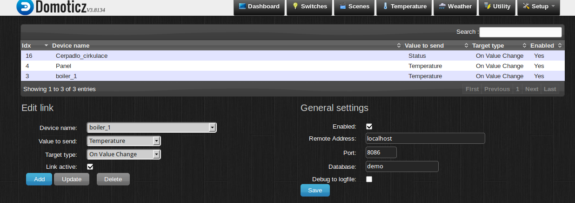
InfluxDB
Connection
setting
List devices
or variables
who push data
to influxDB
Add new device
or variable
to pushing list

Another possibility howto send is use menu Hradvare->More Otions->Data pusch->Http and define http request to push into influxDB by influxDB http api.
This is more difficult, but useful for older versions of domoticz who haven’t support for influxDB.
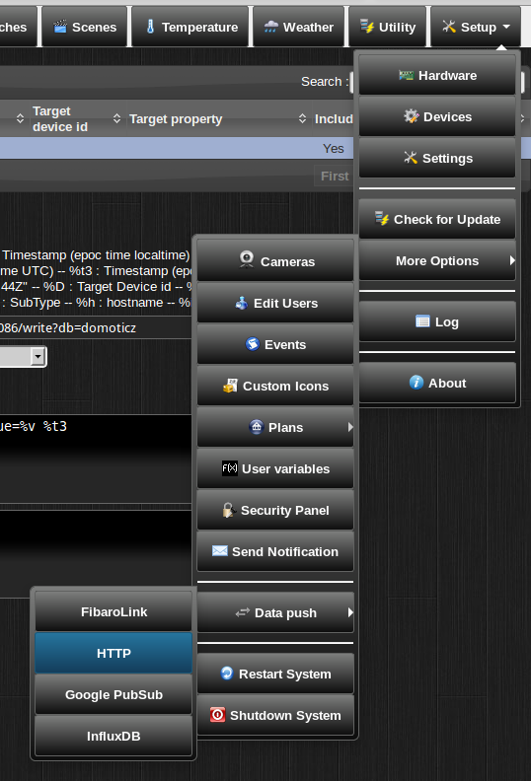

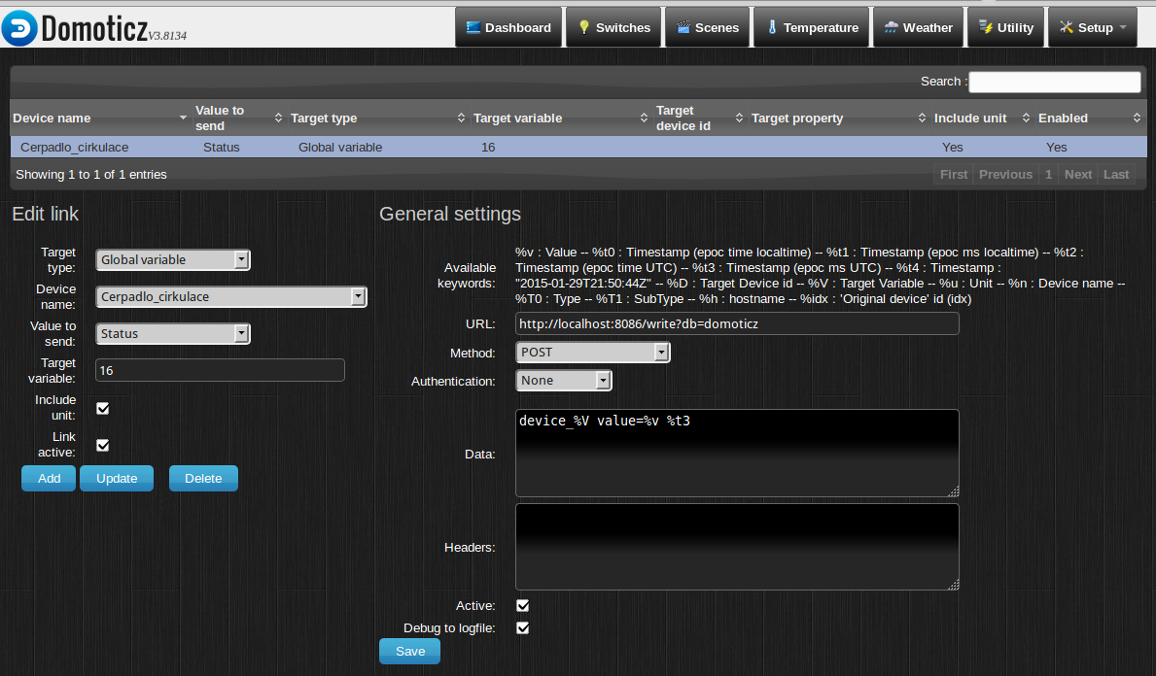
Addres influxDB server
and name of DB
by influxDB http API
Data will be send
by InfluxDB API
Select name
of device
ID from
Domoticz
device list
List adds devices
will be send yours
change status

Variant 2 - Write data from Domoticz to influxDB through MQTT

Prepare MQTT broker MOSQUITO

Description:
MQTT is a machine-to-machine messaging protocol, designed to provide lightweight publish/subscribe communication to "Internet of Things" devices. It is commonly used for geo-tracking fleets of vehicles, home automation, environmental sensor networks, and utility-scale data collection.
Mosquitto is a popular MQTT server (or broker, in MQTT parlance) that has great community support and is easy to install and configure.

Install mosquitto:
On ubuntu and debian type on command line:

sudo apt-get install mosquitto mosquitto-clients
By default, Ubuntu will start the Mosquitto service after install. Let's test the default configuration. We'll use one of the Mosquitto clients we just installed to subscribe to a topic on our broker.

Topics are labels that you publish messages to and subscribe to. They are arranged as a hierarchy, so you could have sensors/outside/temp and sensors/outside/humidity, for example. How you arrange topics is up to you and your needs. Throughout this tutorial we will use a simple test topic to test our configuration changes.

Log in to your server a second time, so you have two terminals side-by-side. In the first terminal, use mosquitto_sub to subscribe to the test topic:

mosquitto_sub -h localhost -t test

-h is used to specify the hostname of the MQTT server, and -t is the topic name. You'll see no output after hitting ENTER because mosquitto_sub is waiting for messages to arrive. Switch back to your other terminal and publish a message:

mosquitto_pub -h localhost -t test -m "hello world"
The options for mosquitto_pub are the same as mosquitto_sub, though this time we use the additional -m option to specify our message. Hit ENTER, and you should see hello world pop up in the other terminal. You've sent your first MQTT message!

Configuring MQTT Passwords:
Let's configure Mosquitto to use passwords. Mosquitto includes a utility to generate a special password file called mosquitto_passwd. This command will prompt you to enter a password for the specified username, and place the results in /etc/mosquitto/passwd.

sudo mosquitto_passwd -c /etc/mosquitto/passwd sammy
Now we'll open up a new configuration file for Mosquitto and tell it to use this password file to require logins for all connections. Should you open an empty file /etc/mosquitto/conf.d/default.conf
and paste in the following:

allow_anonymous false
password_file /etc/mosquitto/passwd
allow_anonymous false will disable all non-authenticated connections, and the password_file line tells Mosquitto where to look for user and password information. Save and exit the file.

Now we need to restart Mosquitto and test our changes.

sudo systemctl restart mosquitto

Try to publish a message without a password:

mosquitto_pub -h localhost -t "test" -m "hello world"

The message should be rejected:

Output
Connection Refused: not authorised.
Error: The connection was refused.

Before we try again with the password, switch to your second terminal window again, and subscribe to the 'test' topic, using the username and password this time:

mosquitto_sub -h localhost -t test -u "sammy" -P "password"

It should connect and sit, waiting for messages. You can leave this terminal open and connected for the rest of the tutorial, as we'll periodically send it test messages.

Now publish a message with your other terminal, again using the username and password:

mosquitto_pub -h localhost -t "test" -m "hello world" -u "sammy" -P "password"

The message should go through as in Step 1. We've successfully added password protection to Mosquitto. Unfortunately, we're sending passwords unencrypted over the internet. Fix that next by adding SSL encryption to Mosquitto, but is out of this manual.

Configuring MQTT Over Websockets (Optional)

In order to speak MQTT using JavaScript from within web browsers, the protocol was adapted to work over standard websockets. This is not nessesery for use domoticz, mqtt and grafana, but may be very useful in future for create interactive web pages with domoticz. If you don't need this functionality, you may skip this step.

We need to add one next more listener block to our Mosqiutto config file in /etc/mosquitto/conf.d/default.conf .

. . .
listener 8083
protocol websockets
This is mostly the same as the previous block, except for the port number and the protocol websockets line. There is no official standardized port for MQTT over websockets, but 8083 is the most common.

Save and exit config the file, then restart Mosquitto.

sudo systemctl restart mosquitto

For simply test is best use browser-based MQTT client as Open mqtt-admin .
You'll see the following:
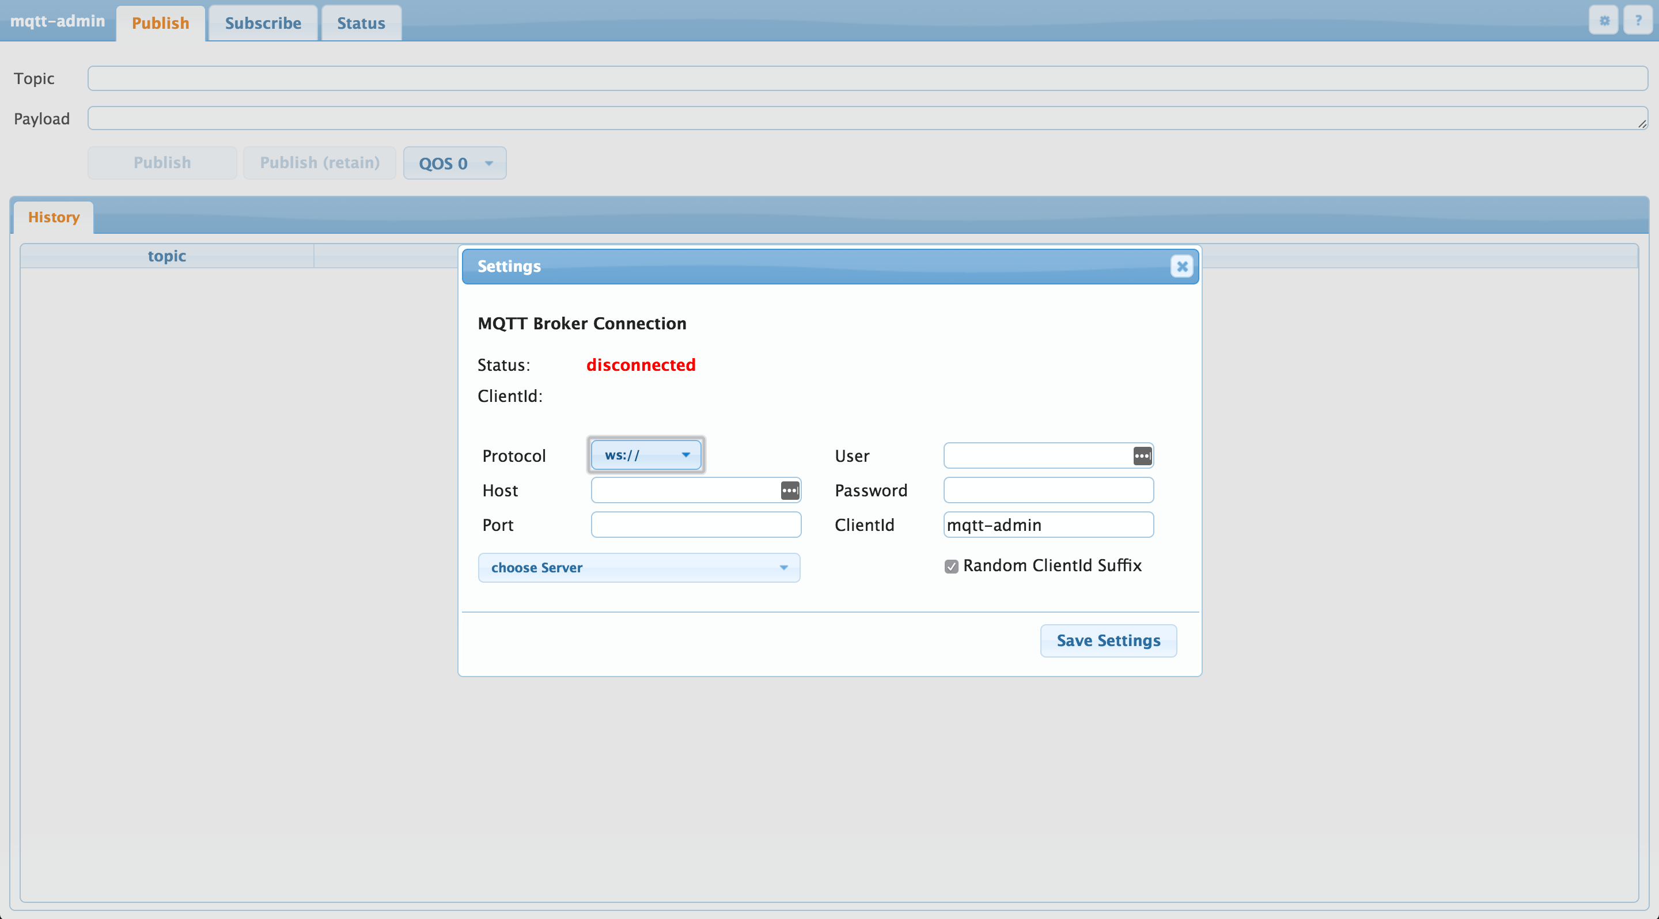
Fill connection informations to your MQTT broker save settings and you can go test.

Configure DOMOTICZ to public device changes into MQTT

Description:
Domoticz contain direct support for MQTT who send and receivre messages from/to MQTT broker.
Send mqtt meseges is standard way howto forward data to another aplication. Every messages who domoticz send and accept receive is in JSON format e.g.:
{
"Battery" : 255,
"RSSI" : 12,
"description" : "",
"dtype" : "Light/Switch",
"id" : "00014060",
"idx" : 16,
"name" : "Pump_of_circulate",
"nvalue" : 1,
"stype" : "Switch",
"svalue1" : "0",
"switchType" : "On/Off",
"unit" : 1
}
more about used JSON format is on https://www.domoticz.com/wiki/MQTT

Configure:
In menu Setting->Hardware find and set type MQTT Client Gateway with LAN interface
fill conection information to MQTT brouker, select publish Topic out, name Hardware and click add.
1.
2.
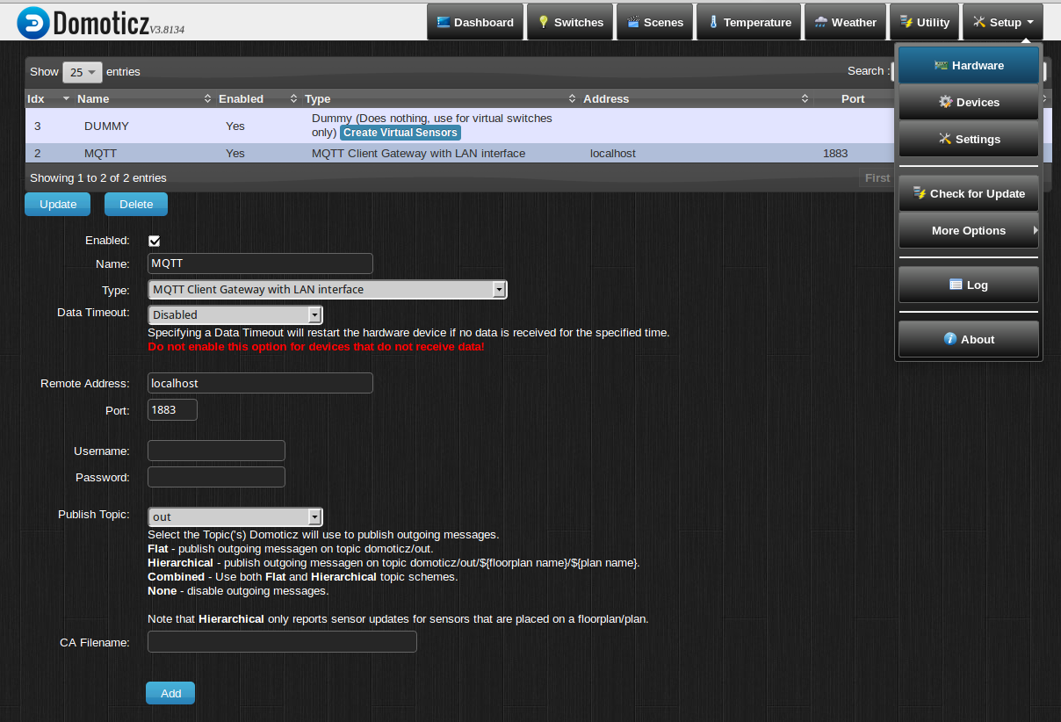
3. Select MQTT client with
LAN interface
4. fill connect
informations
5.
6. If use security connection set certification
7. add
In (point 5) Publish Topic is next slection:
- out – every outdoing message have domoticz/out mqqt topic (recomnend)
- / - outdoing messages have topic domoticz/out/{$forplan name}/{$plan name} (me not run)
- out + / - combination both of select
- none – domotict not send outdoing mqtt messages
In all case domoticz recivre incoming messages from domoticz/in mqtt topic

Deafault MQTT topis for domoticz is:
- domoticz/out – for outding messages (domoticz send message when change any device)
- domoticz/in – for incoming messages ( incoming message can influence devices on domoticz)

Send data from MQTT do influxDB (by python script)
Commonly for this purpose is used program telegram from www.influxdata.com. Bat this program have problem to convert some data from domoticz mqtt messages. Therefore we write own python script who read messages from MQTT change format and send into influxDB.
If you need change connection informations, than open and edit this script. This script must be run all of time. If you need run automatical after start, put this execute into /etc/rc.local .
Donwload this script on ….. .

Use GRAFANA to draw graphs

Description:
Grafana is open source web based program for draw nice graphs from various data source.
In this document is described only basic control how-to create you first graph.

Install:
On ubuntu or debian (only 64-bit):
wget https://s3-us-west-2.amazonaws.com/grafana-releases/release/grafana_5.1.3_amd64.deb
sudo dpkg -i grafana_5.1.3_amd64.deb
Oficial grafana not support for 32-bit and arm platform. For raspberry PI and other amr platform use instalation from: https://github.com/fg2it/grafana-on-raspberry

Start Grafana:
/etc/init.d/grafana start
Stanadard tcp port for Grafana is 3000. Open your web browser into addres http://your_garfana_server:3000

defaut login: admin
defult password: admin

Example howto create first graph
1. login
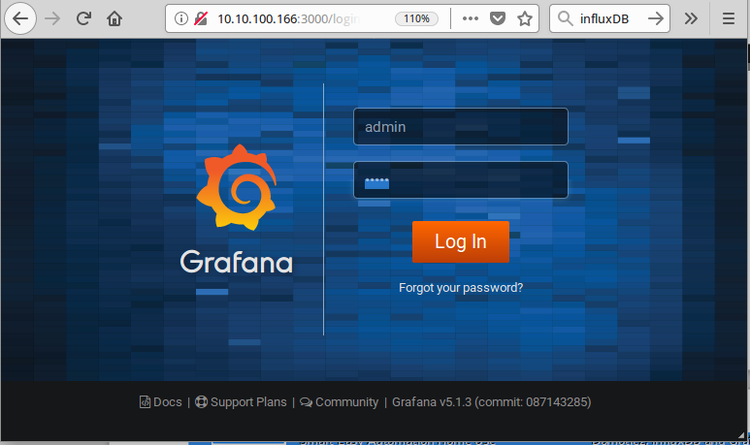

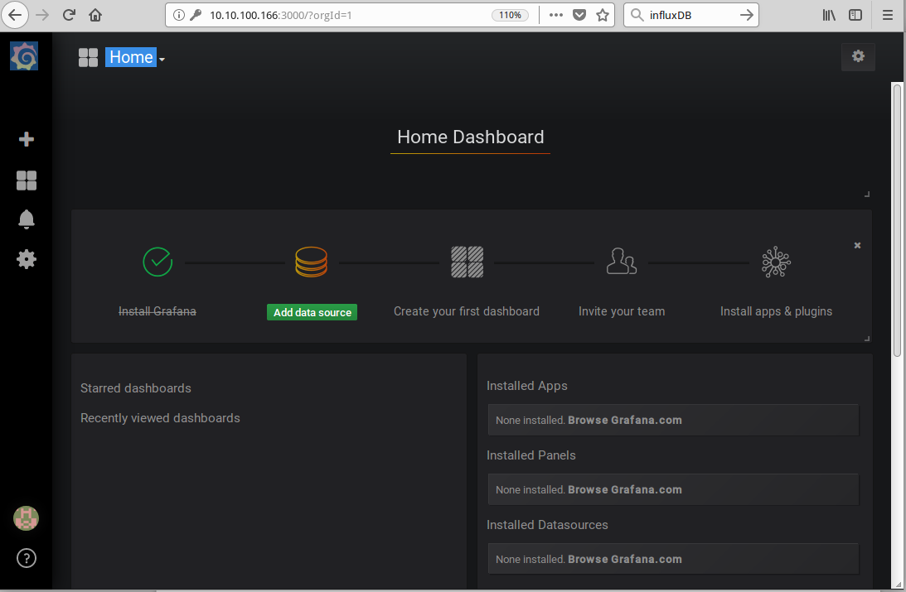
2. Add data source

3. select influxDB and fill connection informations
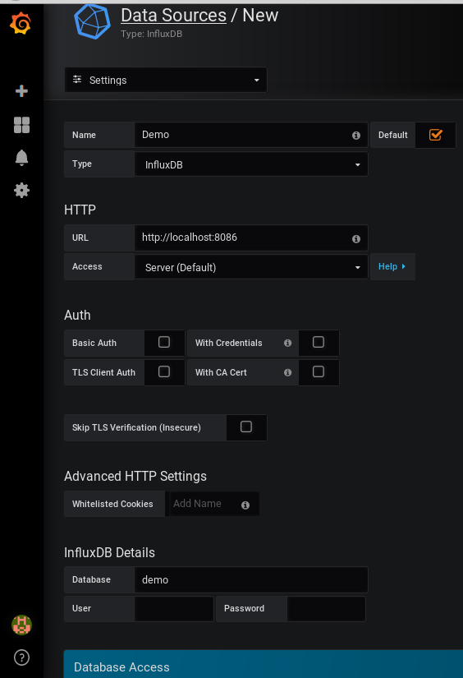

4. After sucessfully save and test go back to main menu
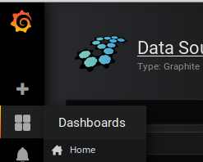

5. Select new dashboard
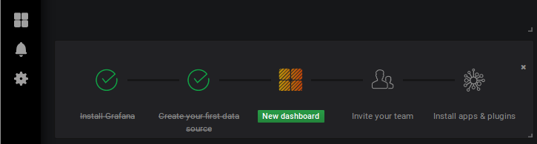
6. Into new dashboard select add graph
1. Click on
title
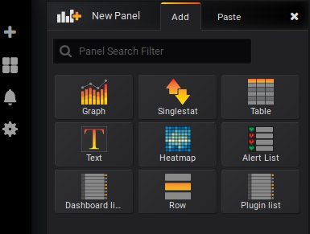
7. In new graph click into title and select edit
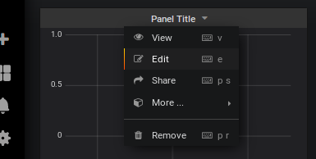
2.
1.

8. Edit selection query to data from influxDB source, siply to click on items

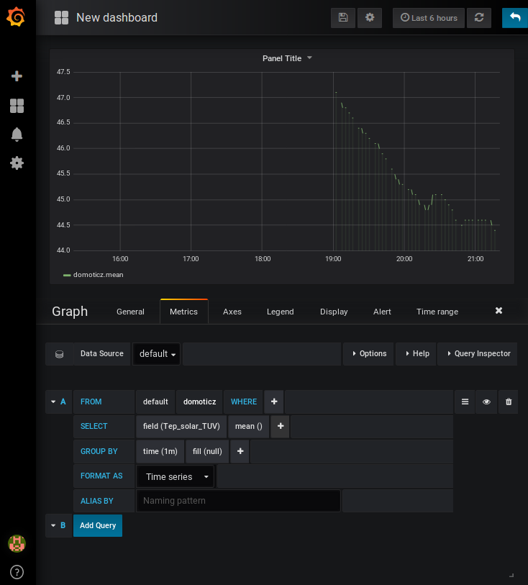
Click and
Select serie
Click and
Select field
Click and Select
time interval
Select metrics

9. Fill title of graph
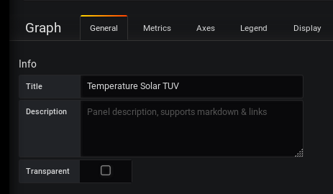
Fill title
Select general
10. Otinaly change display otions and many other graph properties
11. Save graph setting
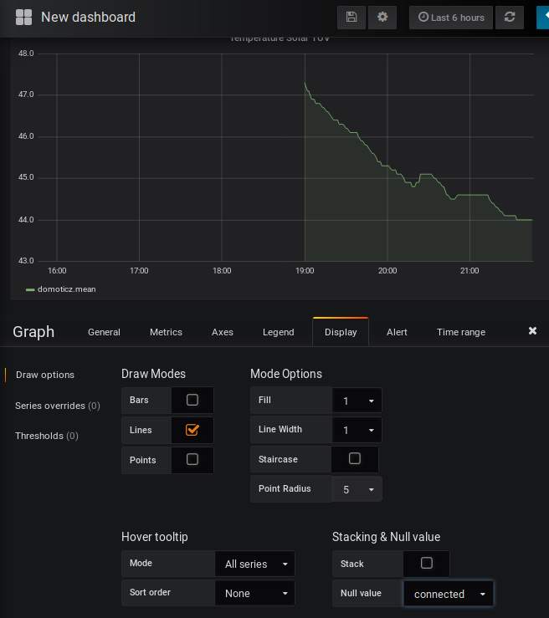
Display options
Connect
points
Now you have you created our first graph. You can add other graphs, tables,.. define users, team, more dashboard.
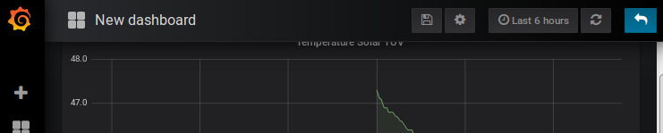
Save
More documentions: http://docs.grafana.org/

More information and sources:
- mosquitto (MQTT server): https://mosquitto.org/
- domoticz: https://domoticz.com/
- web seahu: http://www.seahu.cz

- Grafana and InfluxDBquickstart on Ubuntu
http://www.andremiller.net/content/grafana-and-influxdb-quickstart-on-ubuntu

-How to Install InfluxDB on Ubuntu 14.04
https://hostpresto.com/community/tutorials/how-to-install-influxdb-on-ubuntu-14-04/

Write by:
Ing. Ondřej Lyčka 5-2018
Document version: 1.01 (drawt)

