

 Basic setting
with home control module
SEAHU SH017
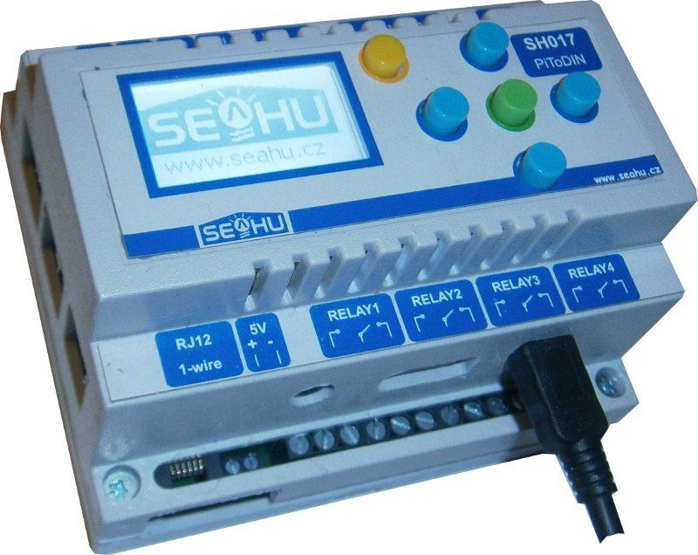
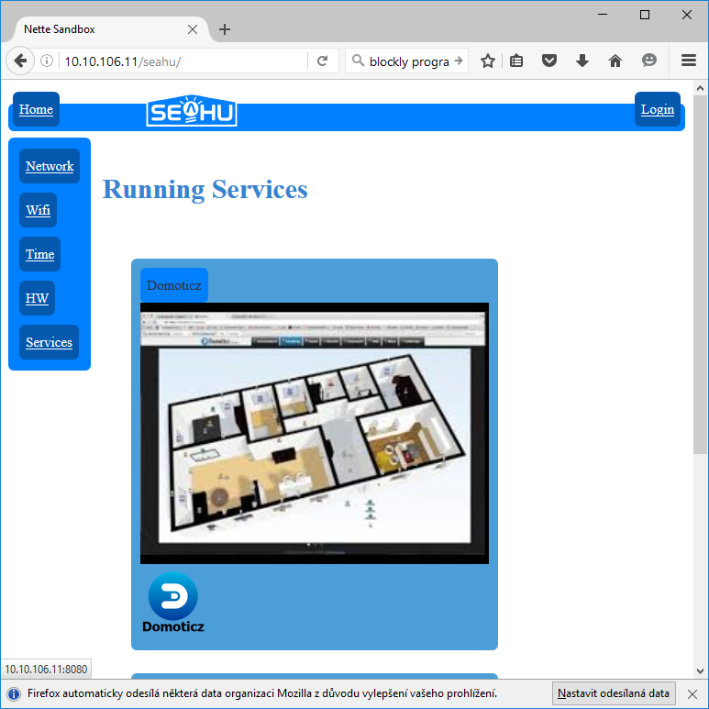
- Access into service DOMOTICZ
Open web page with IP address your module (IP address your module you can find from LCD menu). In home page is list running services. If this list contain service domoticz, click on his illustration image for redirect domoticz web page. If service domoticz is not in list services, than log in and in menu service start service domoticz.
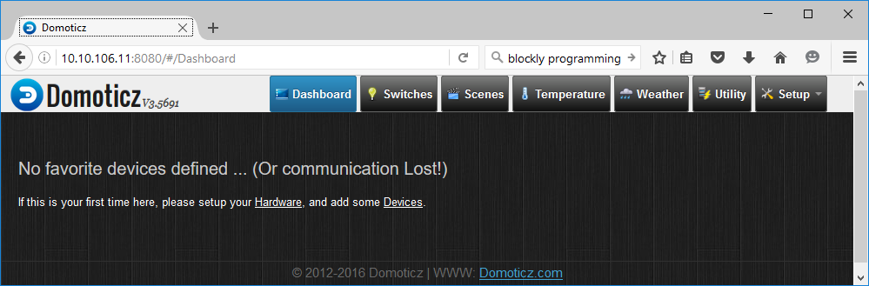
- Menu description
Dashboard – Domoticz home page, view favourite items actually empty.
Switches – list of switchs
Scenes – list groups (of switch) and scenes (preparation setting switches – some ON and some OFF)
Temperature – list available temperatures
Weather – list available meteo point
Utility – list thermostats
Setup – follow below
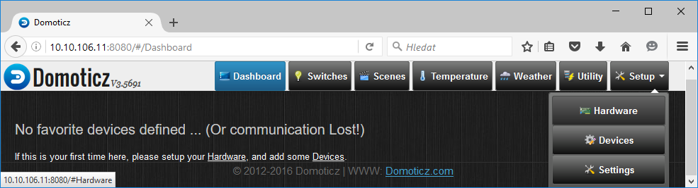
- Hardware setting (menu SETUP→Hardware)
Hear add support various hardware:
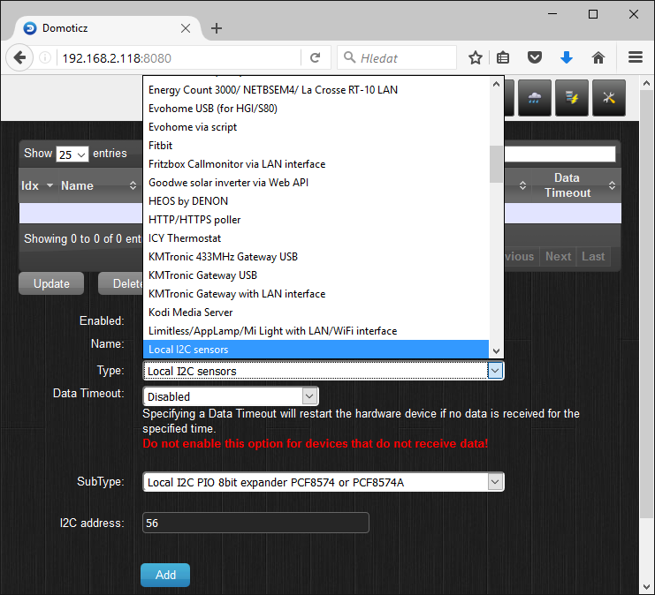
Can be real device e.t. smart TV, or bus with can have connect many sensor, or virtual device who real does not exist. Some type of hardware can be use more times. For orientation is useful have own name for every added hardware.
Domoticz don't have direct support for Seahu SH017, but support chip used in this module. Used chips is PCF8574. First of chips is use in base board (with I2C address 56) and second on LCD board (with I2C address 60). You can add those chips by select type “ Local I2C sensors”, next select subType “Local I2C PIO 8bit expander PCF8574 or PCF8574A” and insert I2C address. After add those hardware in menu “SETUP→ Devices” will be created 16x switch. Will be suitable rename those switches by his purpose (see hardware specification). For easy start you can download prepared start backup setting from address: http://IP_your_modul/help/domoticz/domoticz.db and restore this backup. Restore you can fin on menu “SETING→Setting→panel: Backup/Restore→button: Restore Database”. Click on “browse” and list download file “domoticz.db” and Upload. After this your setting may look this:
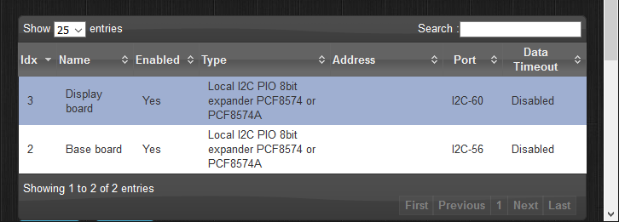Seznam hardwaru po nahraní počátečního stavu
If you use 1-wire sensors, then add „1-Wire (system)“. If you use any other sensors try find your Type. (Domoticz support many types wire or wireless sensors, meteostatiosn, remote controls, ...)
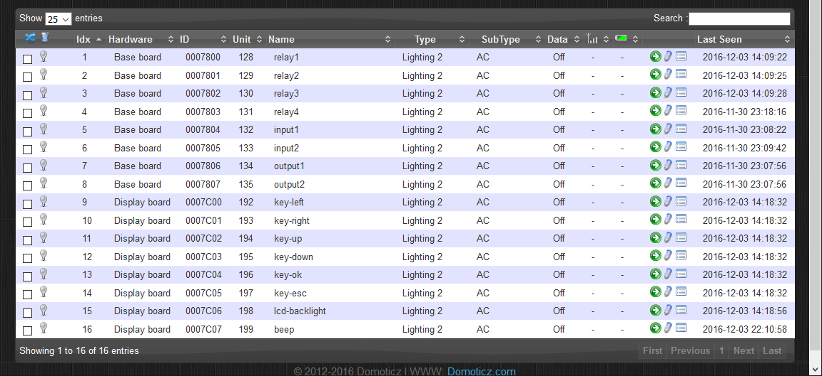Seznam zařízení (devices) s jejích popisky po načtení počátečního stavu
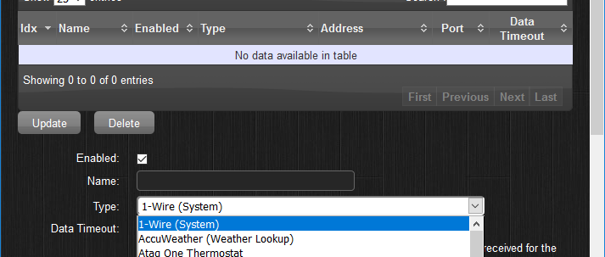
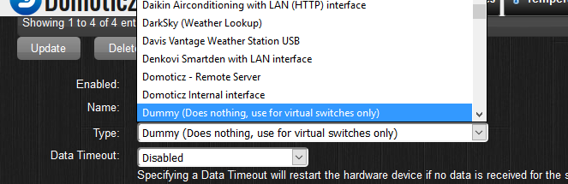
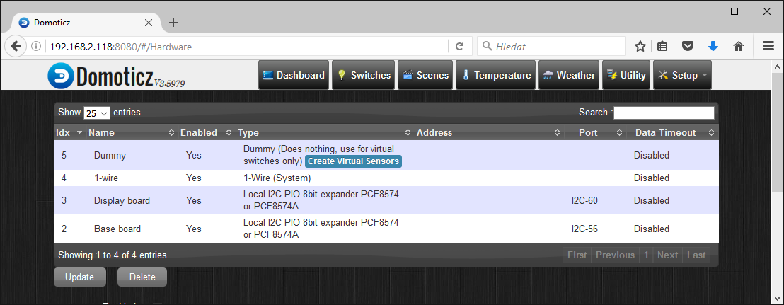
Very useful is add “Dummy (Does nothing, use for virtual switches only)”. This hardware seem as no unusable, but is useful in evaluated events or testing purpose.
In my case I add 2x”Local I2C PIO 8bit expander PCF8574 or PCF8574A “, “1-Wire (System)“ a “Dummy (Does nothing, use for virtual switches only)“ and rename “Display board“,“Base board“,“1-wire“,“dummy“. List my Hardware table:

- Rename and select device for use (menu SETUP→Devices)
Next step is select and human rename devices who we are plan use (etc. switch-heating-pump, temp-leaving-room,..).Some hardware contains many switches, . We will not necessarily use all.
After click on green arrow you may rename and add device for next use. This signalize blue arrow (blue arrow enabled device take off from use).
Added device can be visible in our categories in main menu (switch, temperature,…)
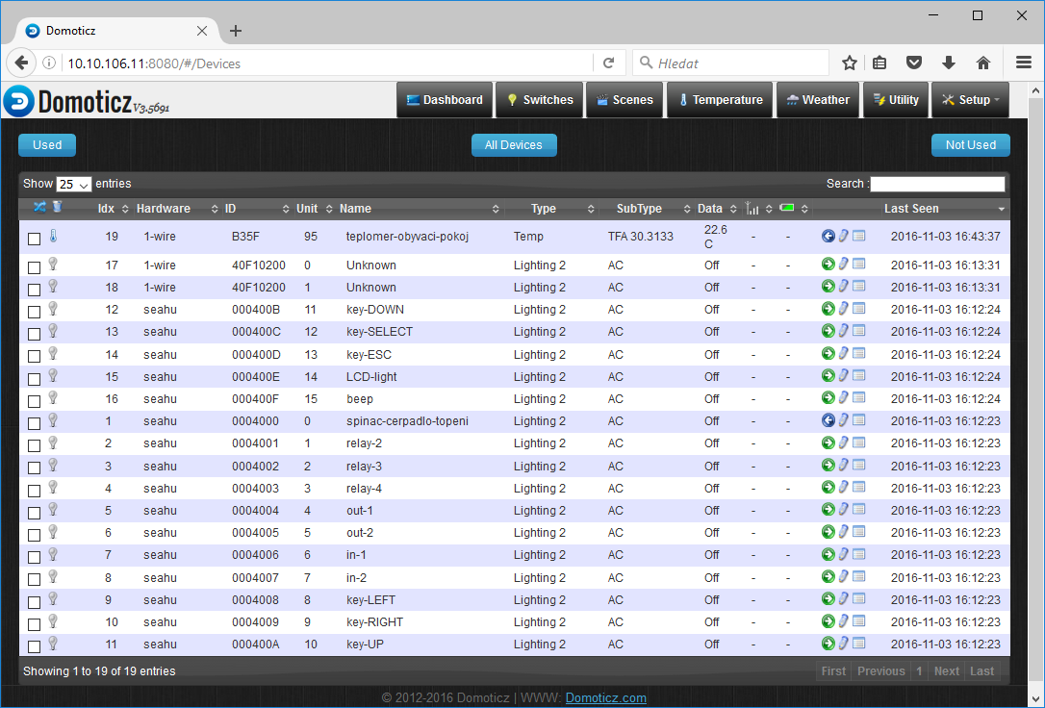
Example:
Clik rename and add device for use
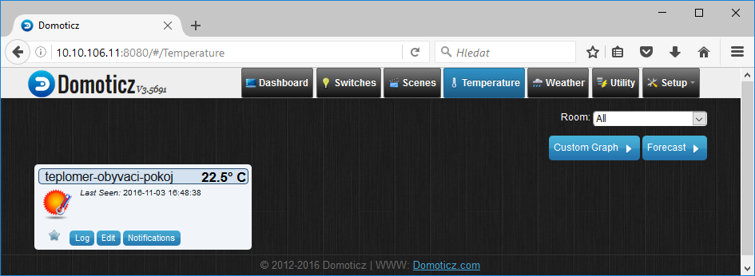
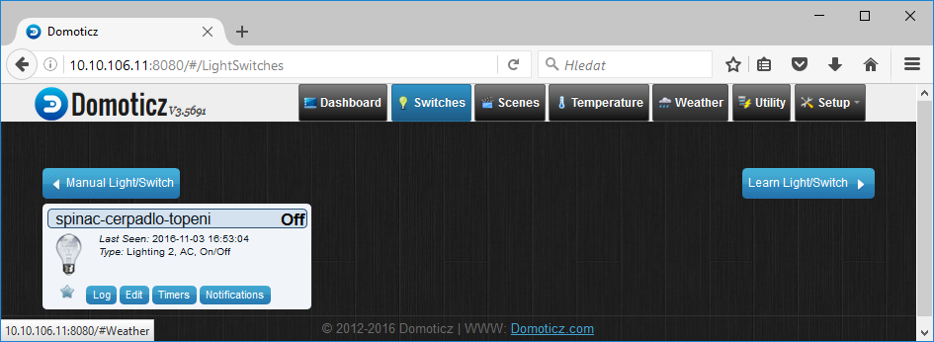
- Favourite (menu Dashboard)
Individual components in yours categories can you marked as favourite. Easy click on start icon. Favourites will be displayed on Dashboard
favorite
Dashboard may be look:
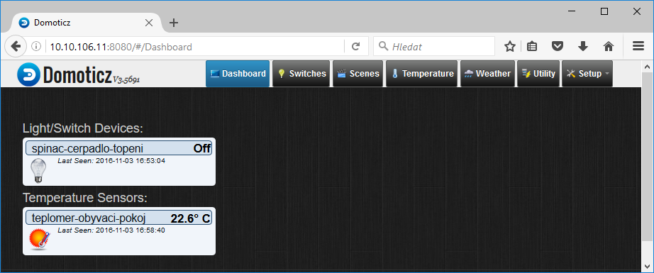
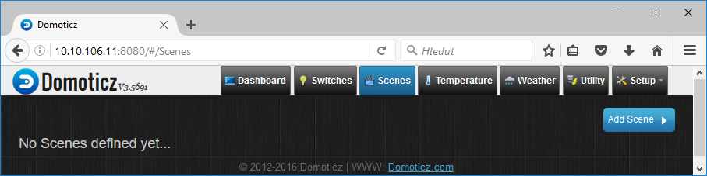
- Scenes and groups (menu Scenes)
Witch more switch you can create group. Group you can control by one button all ON or OFF. Otherwise scene is combination some switch can be set ON and some can be set OFF. One button can re-switches more switches.
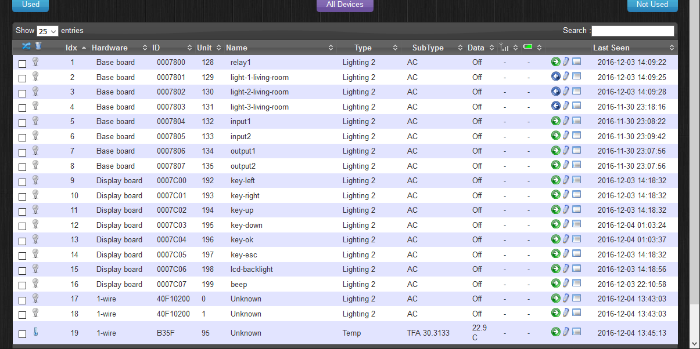
EXAMPLE SET GROUP:
Rename switches in menu Setup→Devices relay-2 to relay-4 as light-1-living-room to light-1-living-room
And create group “Light-living-room” who contain switches from living room:

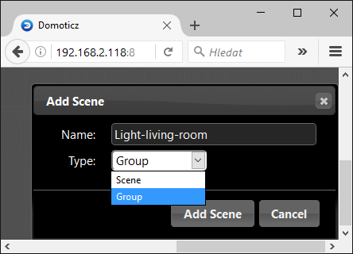
In menu “Scenes” click on button “Add scene” on dialog window rename e.t. to “Light-livinf-room”, select type “Group” and confirm “Add Scene”
This is created group. Next click button “Edit” for edit members:
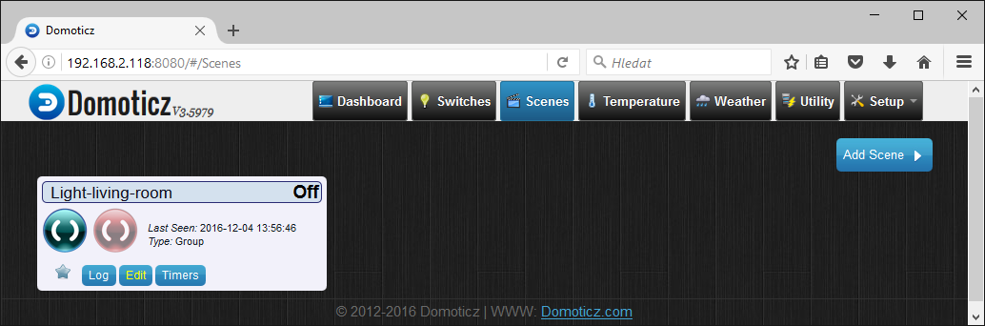
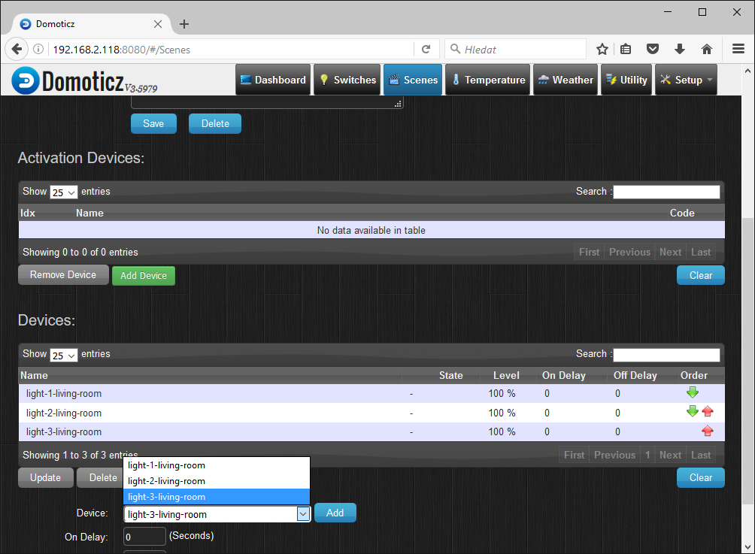
In editing group add all switch from living room by click drop-down menu “Device:” and select switch and confirm “Add”.
Now you can control all light from one place:
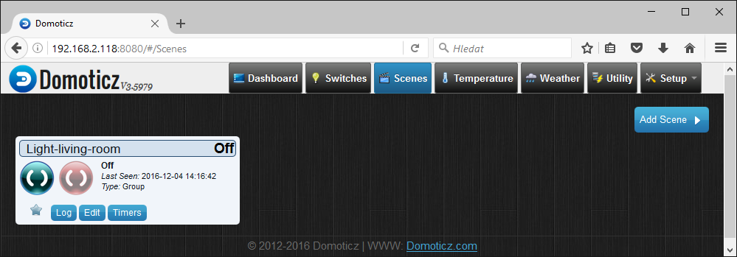
ON
OFF

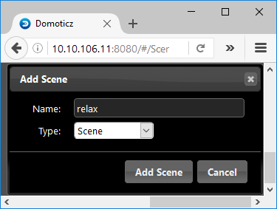
Example add scene:
I create scene with name “relax”. In this scene I ON only one light “light-3-living-room” other off.
In menu “Scenes“ click button „Add Scene“ write name and select type scene:

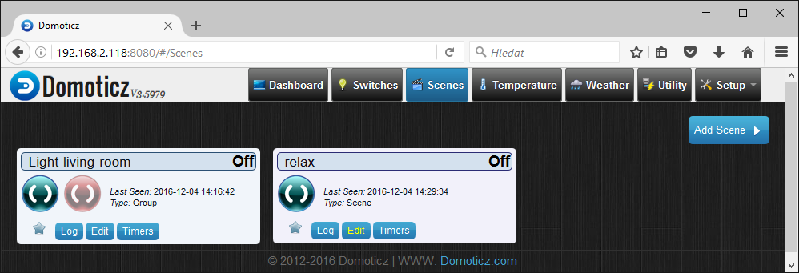
On crated scene click on button “Edit”:
into scene add switches with your pre-selection (on/off). This I do by click drop-down menu “Device:” select switch, next in box “command:” select on/off and confirm by button “Add”.
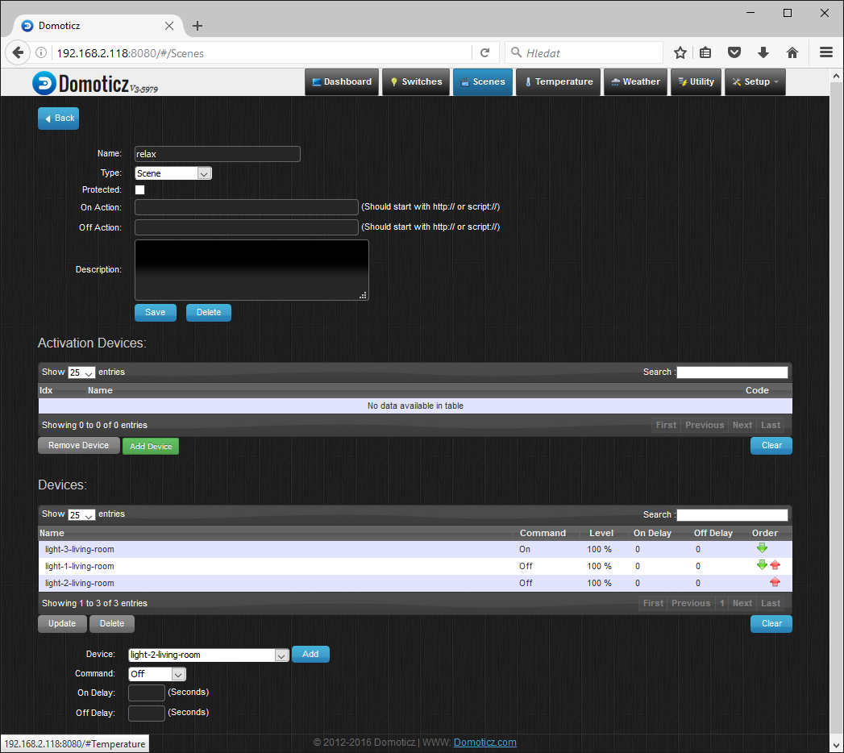
With Button „Back“ (left up ) can go back to list groups and scenes. Once click can be scene activated.
- Setting E-mail (Menu Setup→Seting→Email)
In this manual is not use, but in future can be useful. System can send messages, for those reason must be set besides e-mail also access information for email server.
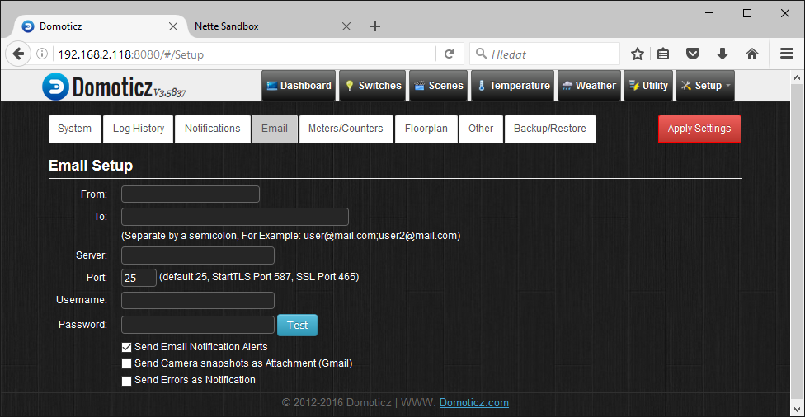
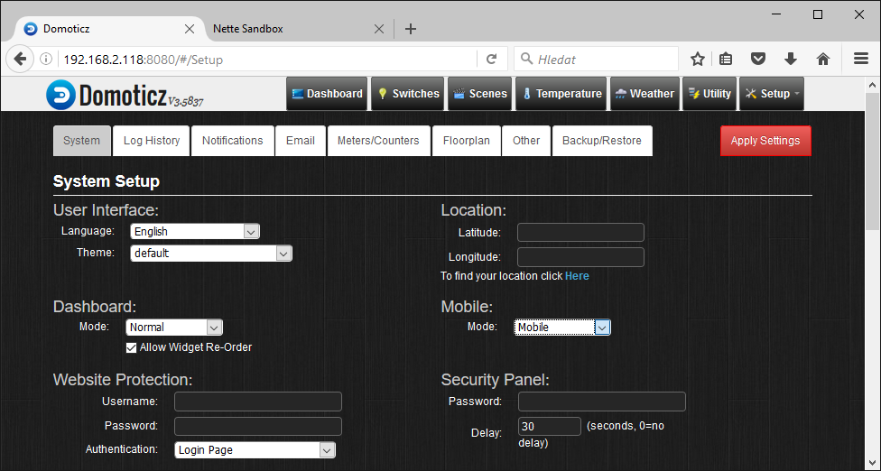
- Setting Location (Menu Setup→Seting→System→kolonka Location)
Again in this manual not used, but in future can be useful. Mainly for timing by sunset or sunrise who is depend on date and location. Location can be set by GPS coordinates or find by name of city.

- Division
If you have lot of devices is useful to somehow divide. In home automation is best divide on rooms and floors. This is a way who domoticz provide.
First we define rooms and assign sensors to them. Next step is define floor. For every floor may be set image and assign rooms, define area of rooms in image and locations sensors, switches,.. to image.

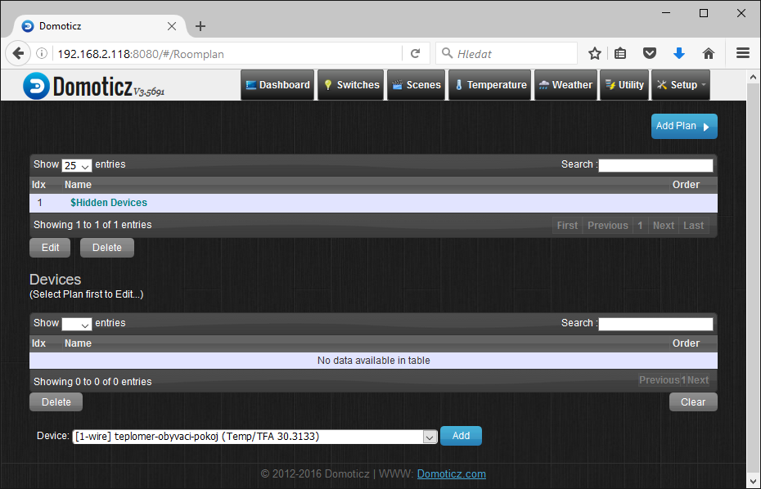
  - Definition of rooms
Setup→More Options→Plans→Roomplan

Click on “Add Plan“ and write name and confirm by button “Add“.
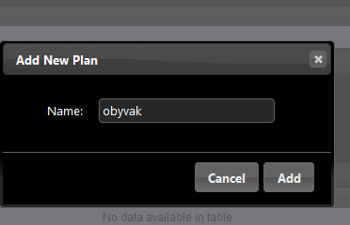

Now select created room and step by step assign devices (switches, sensors, scenes, groups,..) for this room. Do this for all your rooms.
May be looks:
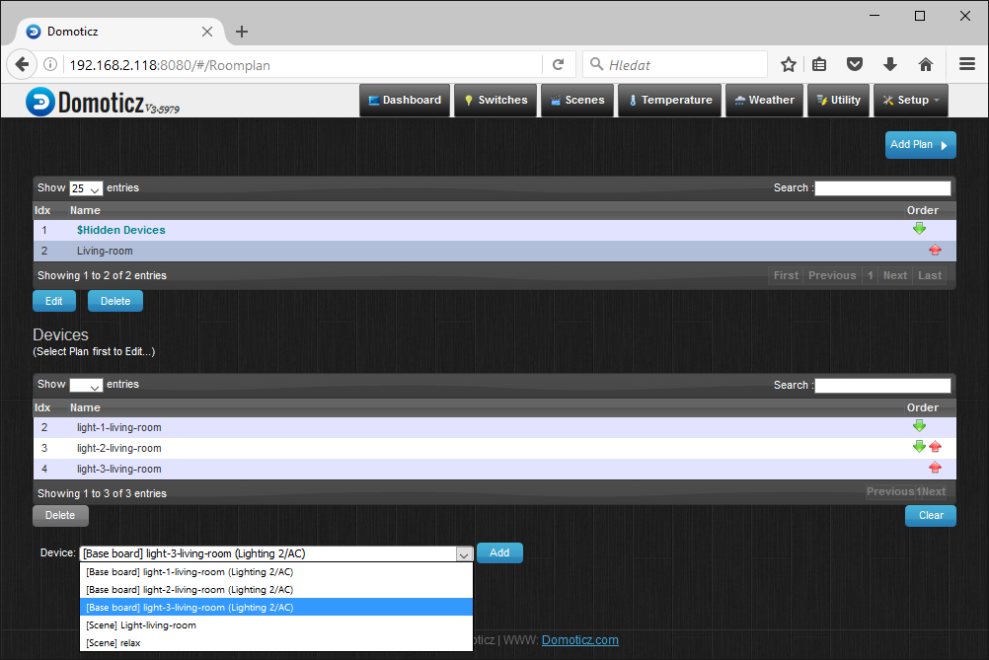
Select room
Select device
Confirm
  - Definition of floors
Menu Setup→More Options→Plans→Floorplan
Here in up half screen you can add images for floors. Click on button “Add” name floor and select image for floor. You can select only pre loaded images. If you use own image, then you must first load this image. For load images must use external program on Windows my be use e.t. winscp, on Linux e.t. command scp. Below is example how to load own images from Windows.
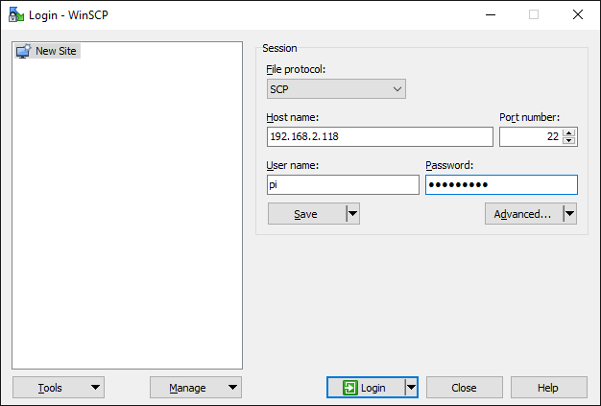
Example howto load own images with winscp.
Program winscp find on your module at address: http://Ip_your_Module/help/utility/winscp576.exe or https://winscp.net/eng/download.php . After run winscp program is necessary select File protocol: scp , and write IP address your module, User name: pi , password is (if you still do not change): raspberry.

After login is open file manager. Left side is your disk and right side is raspberryPI disk. On raspberryPi browse to directory:
/home/pi/domoticz/www/images/floorplans and copy this own images.
Domoticz support images type: .jpg, png, bmp
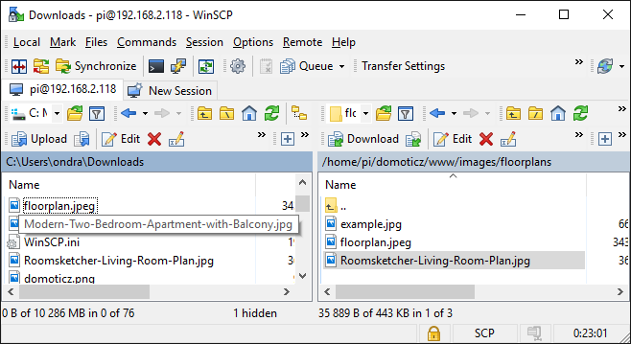
Create floor
Image you have copy. Les go back on web domoticz and select menu „Setup/More Options/Plans/Floorplan“
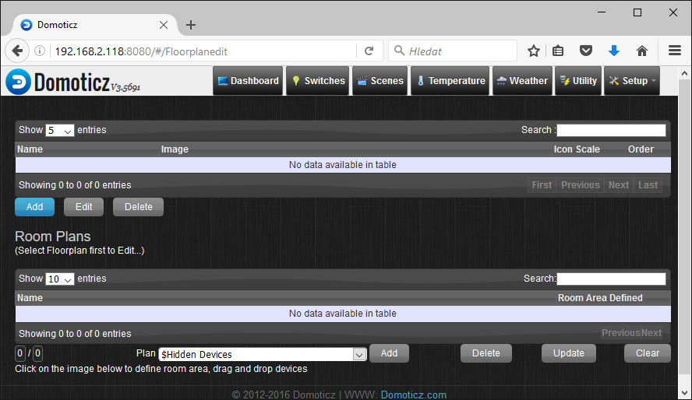
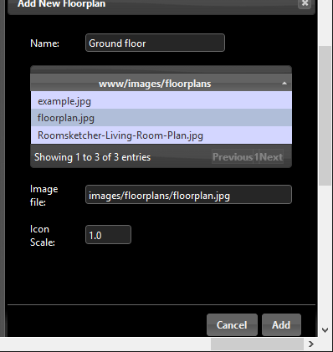
By button “Add” in up half of screen add floor with selected own image and your name of floor e.t. “Ground floor”. This way can you create other floors.
Click on row created floor with selected image. After few seconds in down half of screen will be display floor image.
Add room into floor
In drop-down menu “Plan:” select room (who you previously defined) and confirm by button “Add”. Now room is part of selected floor.

Click on rows with room in rooms table for define area this room on image (easy click on corners room in image) and locate devices from room to right place on image. Finish by button “Update”. This way you can define all rooms with his devices on all floors.

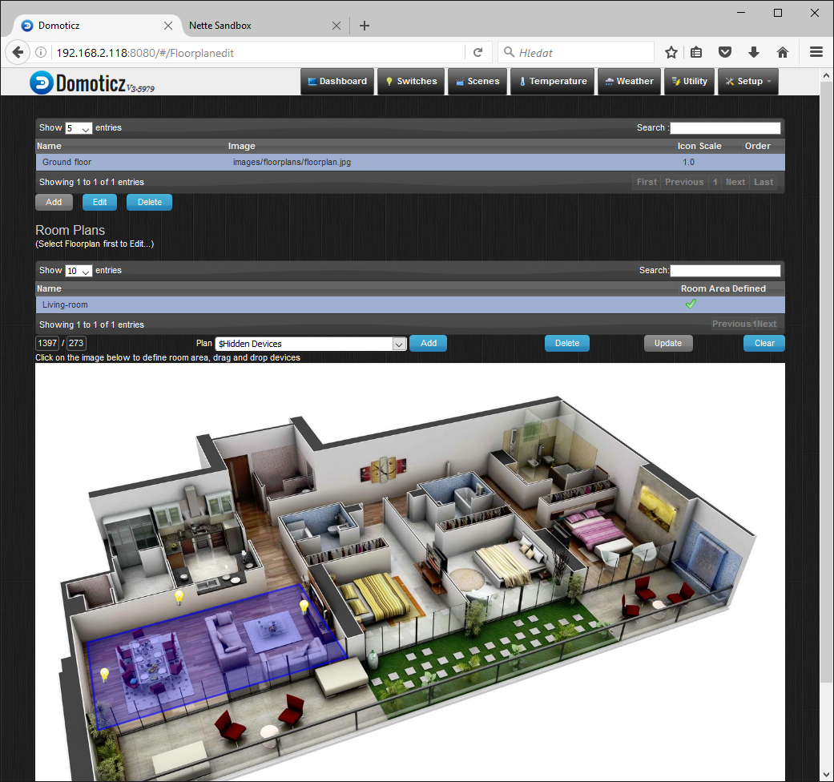
List of floors with his images, click rows to select floor
List of rooms in selected floor
Add nex room into selected loor
Define area of selected room
Locete devices selected room
Add button Floorplan into main menu
Add button can you set in menu “Setup/Setting“. In box “Active Menus:“ you can check options “Floorlan“. For quick view floors you can force floors into dashboard see. Next image.
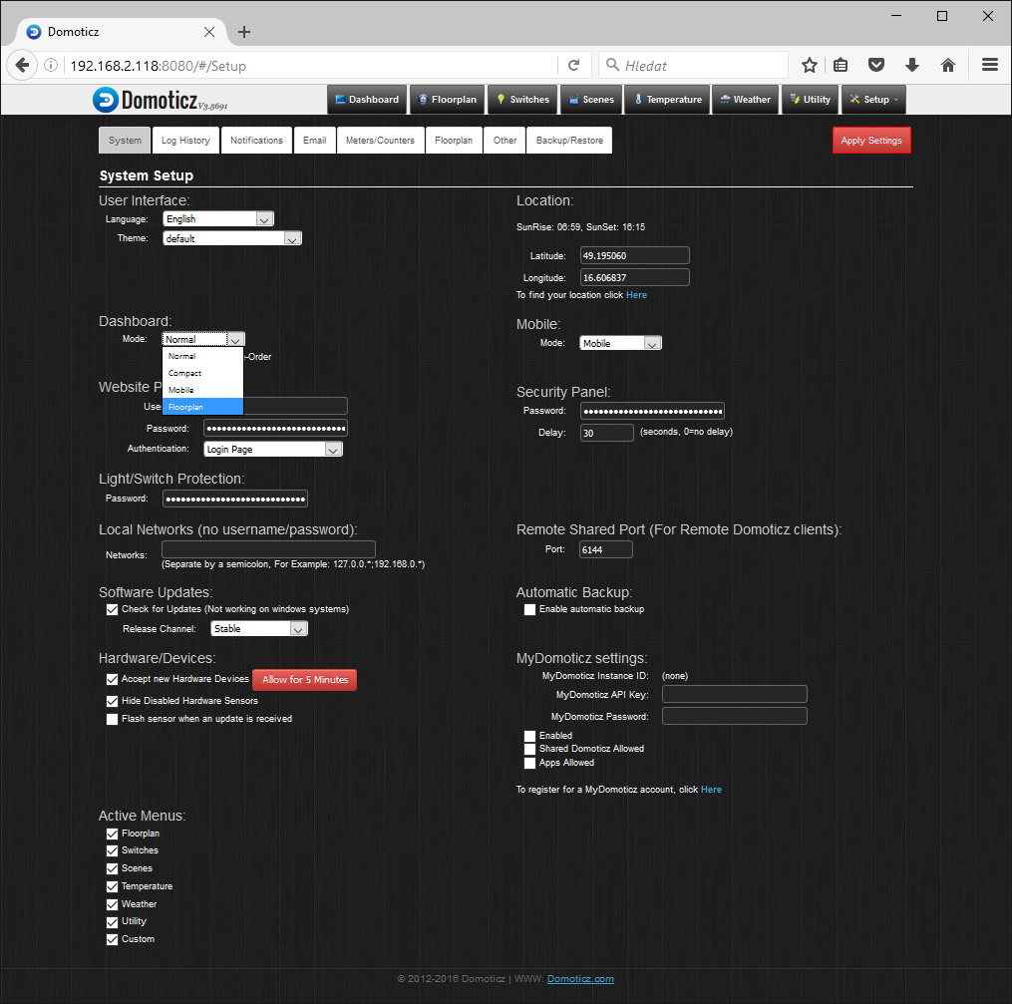
Floorplan button in main menu
Add button Floorplan indo main menu
Change Dashboard for wiev floorplans

- More info
- on web project : http://www.domoticz.com/
- on wikipedia: https://www.domoticz.com/wiki/Domoticz_Wiki_Manual
- on youtube.com: https://www.youtube.com/results?search_query=domoticz
- options: http://www.seahu.cz

- Writer
Ing. Ondřej Lyčka v December 2016
version document: 1.1

