

 Example service events
with home control module
SEAHU SH017
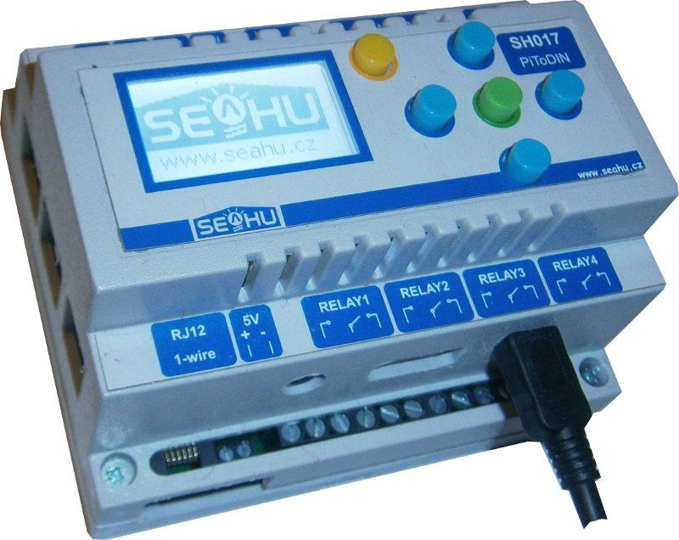

Preface:
Previous manuals show how to start run and basic setting Domotiz automation system (e.t. set HW, rename aviable devices, create groups and scenes, definition rooms and floors). Now concentrate for service events. Events start every change (change status switches, buttons, temperatures, timers..). This event service by simply script. In domoticz events script my be write on more programming languages, but this manual describe only graphic programming language “Block”. Is very easy to use, and user can't need any programming experience. Programming is perform clip varicoloured puzzles width various significance one to other. It is not suitable for complicated programming, but for simple home automation is sufficient.

Where find programming events :
Menu Setup→More Options→Events
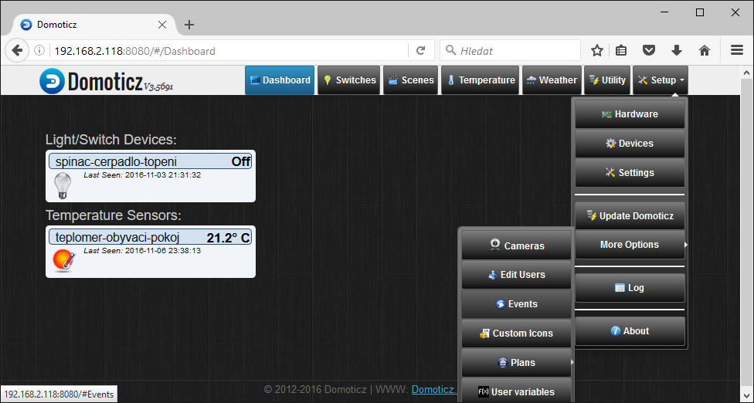
Open next window:
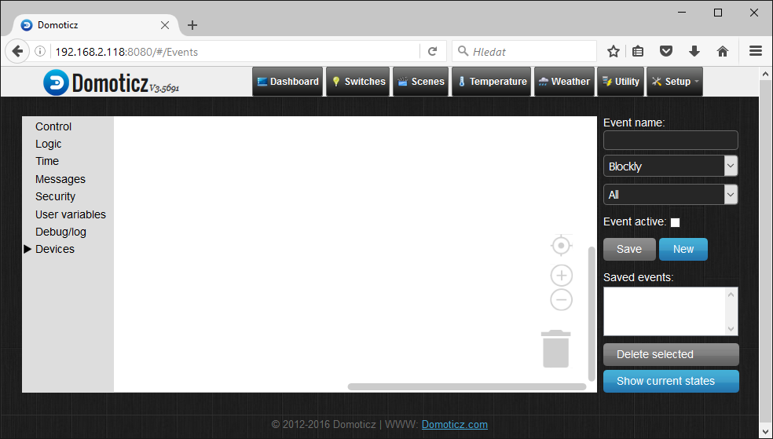
Menu with
commands
Name of
script for
save
Select
programing
language
Activatin
script
List
saved
scripts

Command menu fast describe:
- control – function for control rum program, here only if simply or composite (cycle in this versions not supported may be in next version)
- Logic- logical functions
  - compare two value =,>,<,>=,<=, not equal
  - logical grouping with and, or
    - and – for true result must be both tests true
    - or – for true result must be one of two test true
  - values for comparison off/on/group on/group off/… or set
  - level – percent values fro compare or set
  - number – numeric value for compare or set
  - set – function for set (switch,..), select who and next set value
  - set after- function set with delay in seconds
  - set for – function set for inserted time in minutes
- Time – time functions
- Messages – function for send messages
- Security – security function
- User variables – user variables, numbers or strings
- Debug/log – possibility write to log
- Devices – use devices (switch, thermometers,...)

Example blink led.
Description
Firs you need switch. In this example I use setting from previous manual (Domoticz basic setting). List of my switch look this:
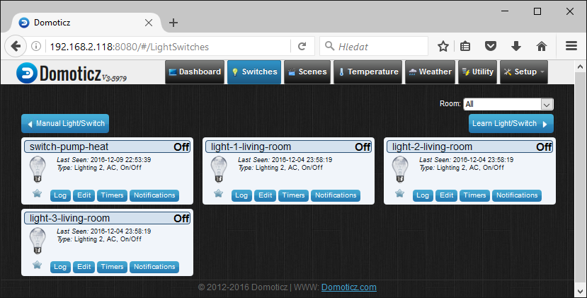
For blink I use switch “light-1-living-room”. Next I create two scripts for two simple events. Into one insert condition who trace status of switch, when be set ON, then set switch to OFF with small delay. Second condition trace switch status and when change to OFF then set switch to ON witch small delay.

Condition
Go to Menu Setup→More Options→Events, click on control function and select simple condition who move to white place:
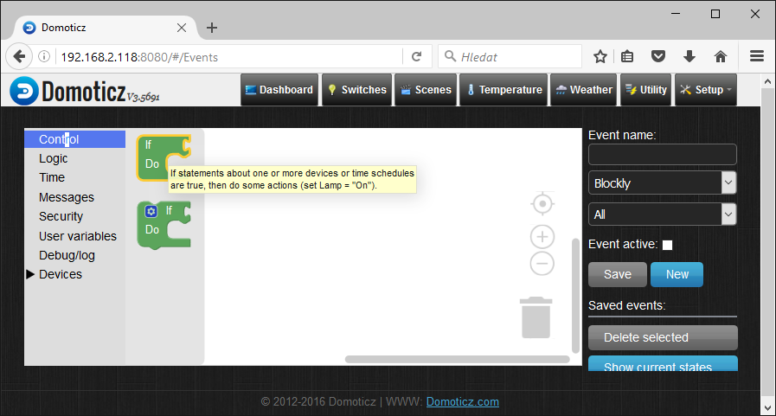
Next from logical function pull out compare function
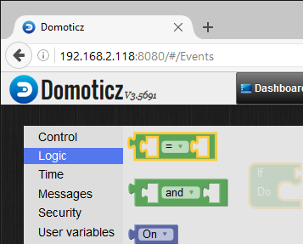
into one side insert switch (from menu switches) who re-click to “light-1-living-room” and other side insert (from menu Logic) field with value ON.
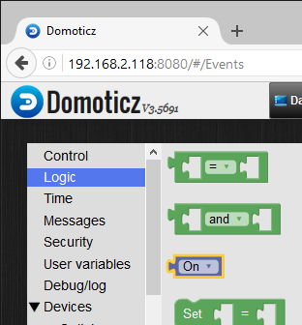
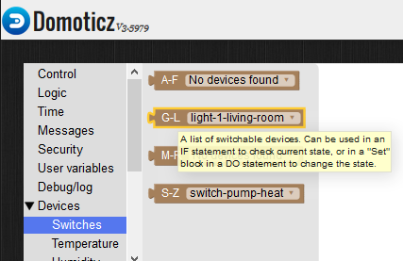
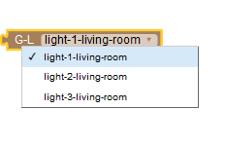
And all clips put together according to next image:
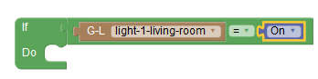
Yet set, switch OFF with delay if condition done. From menu “Logic” pull out function set After seconds“, in left side copy exist „light-1-living-room“ and right side copy filed „ON“ and re-click into „OFF“ (copy is doing by click on exist puzzle right mouse button and select „duplicate“). Into delay insert value 5 seconds, but value must be insert into separate puzzle for number value (from menu Logic – filed with value zero):
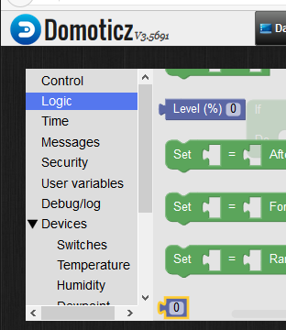
Final condition look as:
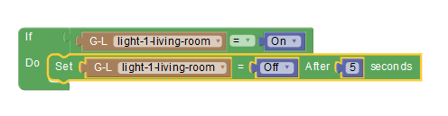
Activation and save script
For activation check filed „Event activate“, into field „Event name:” write name of event and press button “Save”. Saved script will be show in List saved script and double click on name of script you can open this script fro edit.
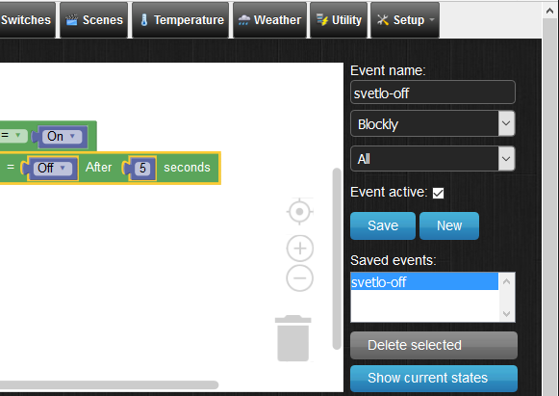
Now you can tray test.
Go to menu “Switches” and switch on “light-1-living-room”, after 5 seconds automatically off.
For blink we need yet add reverse condition, i.e. if switch light-1-living-room then switch off with 5s delay.
Fasted way is double-click on saved event, do some change (only exchange values on and off) activate and save as another Event name. It should be as follows:

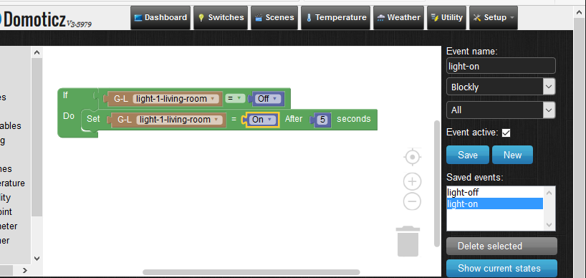

Theoretical this now blink, but nothing doing. Is necessary first impulse, because events is serve at change time and during save script no change come. In menu “Switches” switch on “light-1-living-room”, after this is blink run. (Attention interval refresh web page may come late, that blink on web page may not be show).
PS: do not ask for domoticz reaction in ms, but in sec. Its make for home autmation when speed is not very important. If you faster reaction then use another system i.e. REX controls or write own program.
The same but all in one script.
If you use composite condition, then you may write all in one script. Composite condition you can find in “Controls” functions (condition with small cogwheel). If you click on cogwheel, then you can condition chaining.
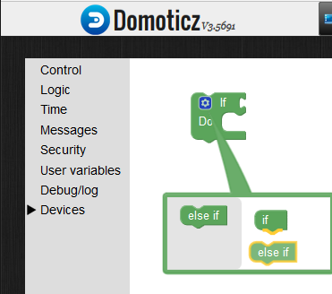
click
Drag mouse

Final condition may look:
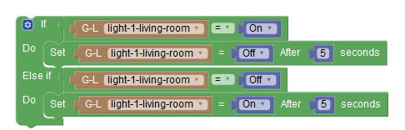
literally if is satisfy then do, if not then test another and if this is satisfy then do another else.

Weekly thermostat
Create virtual thermostat
You can use supported hardware thermostat, then domotic only set required temperature and regulation run independently. Or you can create virtual thermostat a some way use exiting thermometer and switch. This is own case.
First you need support for dummy (virtual devices). Go to menu “Setup→Hardware” and check whether in table exist „Dummy (Does nothing, use for virtual switches only)“, if not then select it drop down and add it.
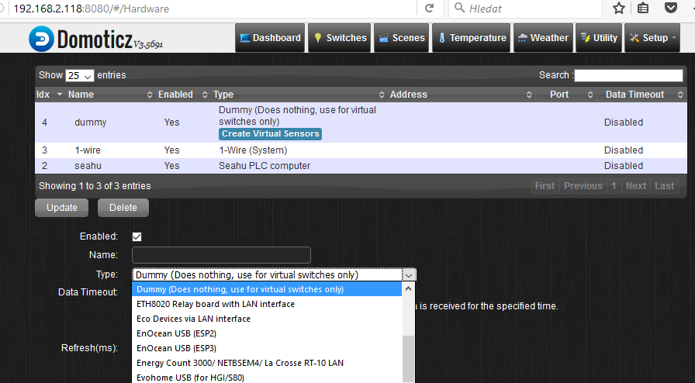
Tlačítko pro vytvoření virtuálního
senzoru

Next click on link „Create Virtual Sensors“ (see. image up). In next form write name of thermostat and select Sensor Type “Thermostat Setpoint“ and confirm OK.
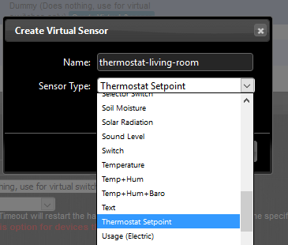
This was created virtual thermostat or more exactly set point of thermostat. This device can you find in list devices, or main menu “Utility” who look as:
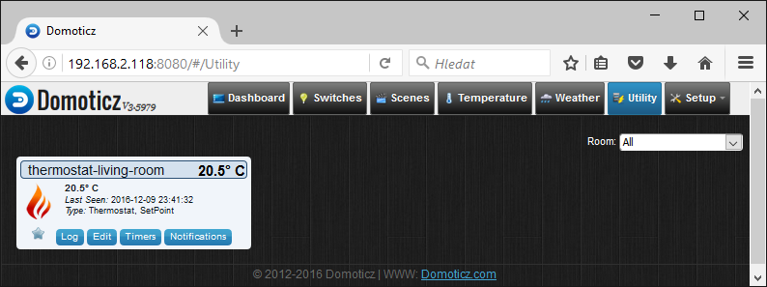
Everybody will be except under button edit of thermostat possibility link thermostat witch temperature and switch, but only you can edit this is request value of thermostat. Connection with thermometer and switch you must do by event script.
Attention “Block” program language in this version have not mathematical operation, therefore is not possible use dispersion e.t. +- 2Cº, in this case is possible use programming language “Luna”, bat this is not describe in this manual.
Script server thermostat
Script is simple. When temperature down over set value in thermostat, then set ON switch, otherwise set OFF switch. In example switch is “switch-pump-heat” and thermometer is “thermometer-living-room”, who was set in previous manual “Domotic basic setting”. Script make clicking in menu “Setup→More Options→Events”. Done script look as:
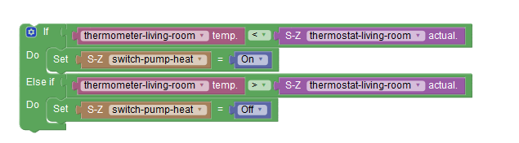
Don't forget script activate, name and save. Now is done thermostat function and next we go to set timer.

Week timers
In menu “Utility” click on button “Timers” on your thermostat. Next show form where you can insert hour (type: On Time) and day application your inserted value of thermostat. Same timers you can insert for switches, groups and scenes. This way you can plan temperature for all week. Interested values is sunset, sunrise who can use for control on garden or sun-blind. Done timers may be look as:
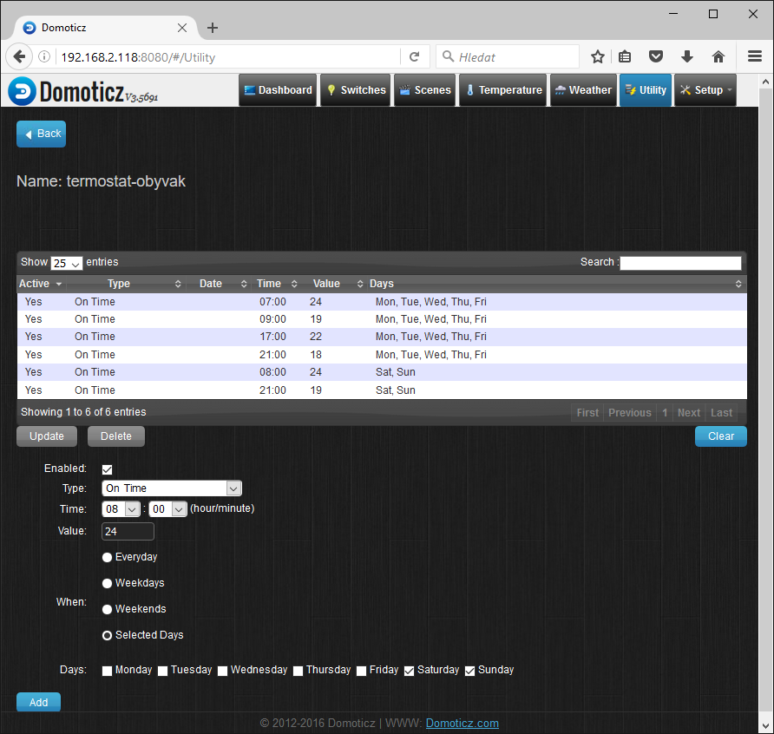

Control integrated display
Example print to integrated display
Access to display is trough external script, who call by events. It is suitable for simple message e.t.: ”Attention alarm”. Show number values is in fact out of options scripting language “Block”. In those cases you must use scripting language “Lua”, but is not topic this manual. You can also combinate both scripting language. E.t. more complex events server with “Lua” and simple events by “Block”.
Script for control display you can find in /opt/seahu/client_graph_lcd.py . For testing is useful run this in linux terminal.
Script work with next parameters:
-h (help) suitable only from terminal – print help
„c” (clear) clear all display
„g“ (get) suitable only from terminal – print text content of display
„p,01,01,text“ print text on inserted position – firs number is column (00-16) second is row (00-03) both number must be two digits. Beginning is from left up corner of display.
„i,01,01,text“ same as up, but text is printed with inverted color text and background
„m,imagefile“ draw image on display from imagefile. File must be exist into directory: /opt/seahu/lcd_images and image must be black and white with resolution 128x64px

Options call any script you find in menu with commands “Messages” as puzzle “Start Script: with parameter(s)”:
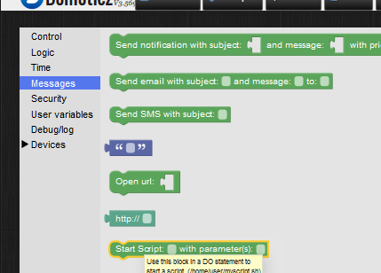
Good fill puzzle can look as:
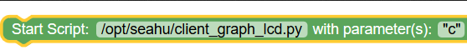
clear display
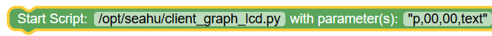
print text on input location
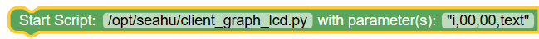
print inversion text on input location
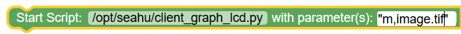
draw image with filename: image.tif

Next example print alarm when over temperature
Next is example simple script, who print on display text “ALARM temperature out of range” and 30s beep. For example purpose we use 1-wire thermometer for monitoring temperature. In menu “Setup/Devices” we named this temperature as “thermometr-living-room” and registering his for next use.
Basic of script is condition monitoring temperature. If temperature is over than inserted value (20), then clean display, next print alarm message, next on beep with delay off. If temperature is down below inserted value, than clear display and off beep. Scrip activate, name and save. Script may look as:

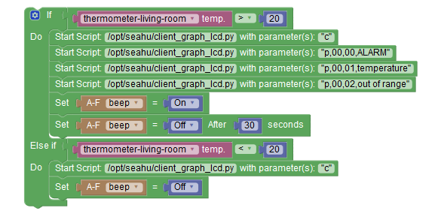

More information
- on web of project: http://www.domoticz.com/
- on wikipedia: https://www.domoticz.com/wiki/Domoticz_Wiki_Manual
- on youtube.com: https://www.youtube.com/results?search_query=domoticz
- optionally: http://www.seahu.cz

Writer
Ing. Ondřej Lyčka December2016
versin of documnet: 1.1

