

 Quick start
with home automation module
SEAHU SH017
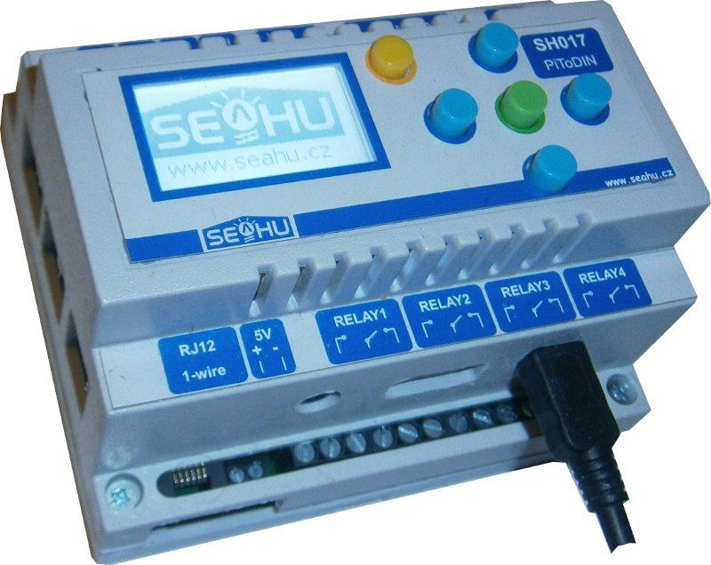
- Short description
System REX Controls is commercial automation system, fully use must bay licence on http://rexcontrols.com . Otherwise this system running in demo. Demo run only two hours, for next rum must be restart. Rex controls is complex system whose mastering takes some time. This manual help you only start working with this system, but for full control is need study documentation from producer system.
The system consists of several parts:
  - runtime kernel of system – i.e. program, who run in Seahu SH017 module and execute automation
  - Presentation layer, which is responsible for displaying Web user interface or interfaces for mobile phones, also running in the module Seahu SH017.
  - Programming environment, there you can prepare program, which will be load into runtime kernel. This programming environment is separate application running only at Microsoft Windows.
- Access to service REX CONTROLS
Open web page on IP your module (IP you can find on LCD menu on your module). In module home pages is list of running services. If you don't see service REX controls, than you log-in by button “Login” and in menu “services” start service Rex controls.
Click on illustration image of service you will be redirect to presentation layer this system, but now is not set. If you have only demo you must every two hours stop and start this service.
For next work you need install programming environment in your PC (only for MS Windows)
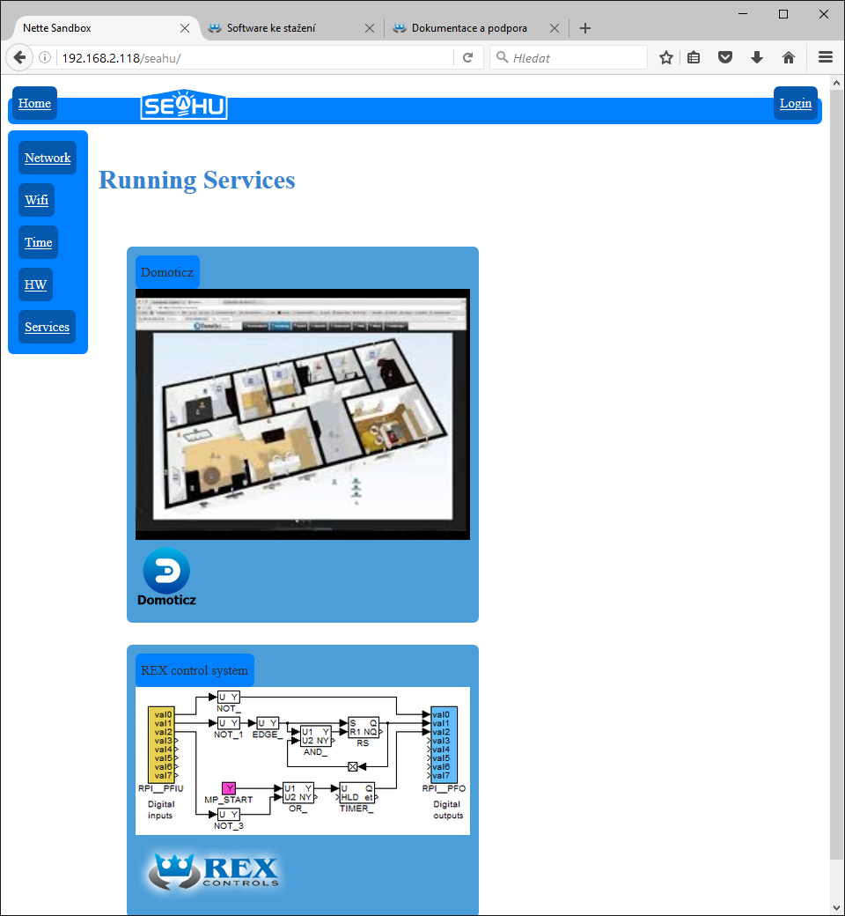
Serice (or runtime kernel and presentation layer) running

- Install program environment
Install files you find on your module on address http://Ip_address_your_module/help/rex_controls/producer/REX-2.50.1.7567-x86.exe or web http://rexcontrols.com .
Installation is standard, see next images:
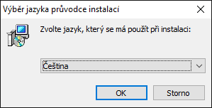
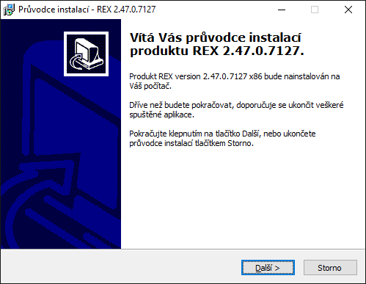
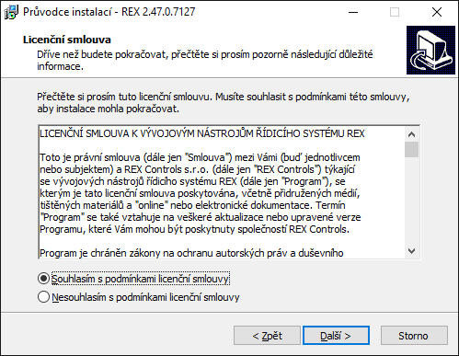
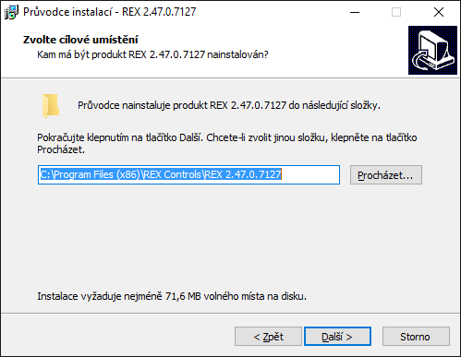
- Start programing environment
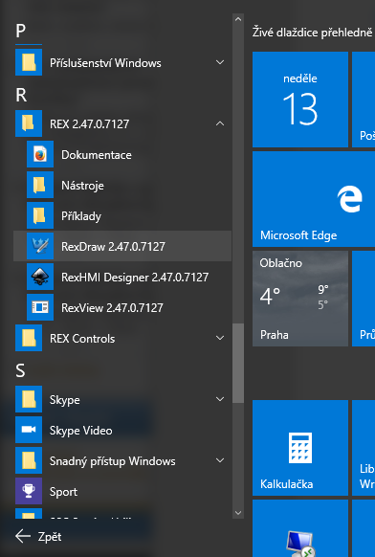
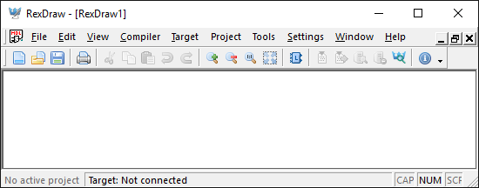
Programming environment may be start from windows start menu ( program RexDraw) e.t. image or double-click in file, who was in this environment created.
Best for beginner is open functional example. And if you have Seahu SH017 I recommend example direct for this. See. next.
- Example for mudele Seahu SH017
Examples you can download from: http://IP_address_your_module/help/rex_controls/seahu_support.zip or find on web http://www.seahu.cz . Download archive and unzip. Unzip folder contain documentation to module ,folder witch examples and prepared task for enabled easy control hardware this module.
- Open example – Examples/Blink (blink of one relay on module)
For start I recommended open downloaded example from folder “Examples/Blink”. Here double click on file “exec.mdll“. Would be open programming environment, with easy example, who blink one of relay from module.
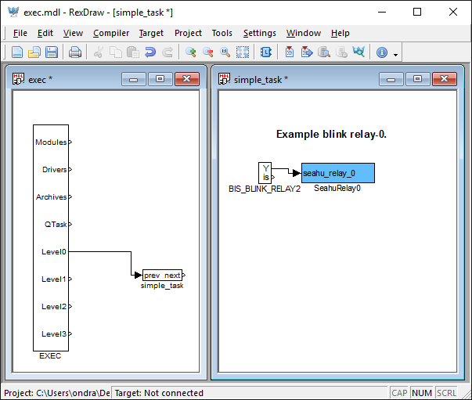
Every functional code in this system contain min. two window (files). One is exe, who contain “exec” block, on witch is connected to tasks blocks who link to separate files. After open file with “exec” block, then be automaticaly open linked files. This is a reason way you have open two windows “exec” and “simple_task”.
- Description of simple task
Block “exec” cyclic (here 10x by second) run simple_task. In simple_task is inserted block who alternate after 2 sec. generate output on, off who is forward into input of block control relay.
- Compile and send into module
Done scheme must be compile for runtime kernel before send to module. Compile you can run from menu “Compiler→compile” or key F5. Result is window with report. If report don't contain error all is all-right.
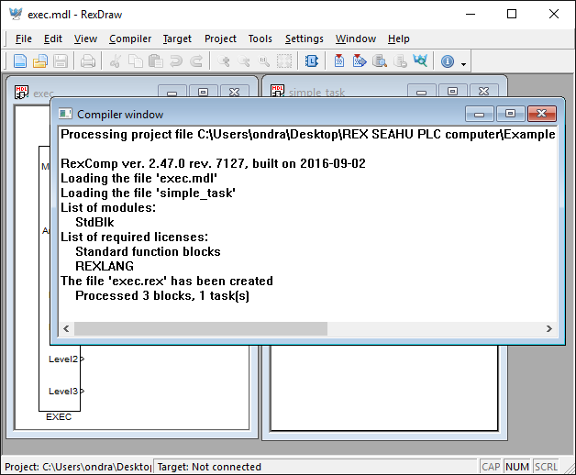
If all is OK , then you can send to module. Menu „Compiler→Compile and Download“ or key F6. After repeatedly compile is view window witch information abut connect to module. In label Target: write IP your module. Default User: admin and default Password: admin .
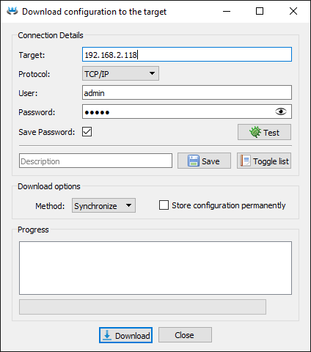
After upload into module, code is immediately run. If can't connect to module may be pass two hours of demo mode or licence problem. Also for demo version you need license key. If license key missing then you will invite insert license key with option send demo license key to your e-mail.
Simple example is done.

Next download examples calculate with connected temperature sensor through 1-wire bus and show create easy thermostat. For master configuration 1-wire bus you need study separate manual http://IP_address_your_module/help/rex_controls/producer/pdf_eng/OwsDrv_ENG.pdf .
- Short description with functions blocks
Programming is doing by connect functions block witch arrows. Arrows forward output from one block to input another block.
  - Parameters of function block
Every block can have some inputs and some outputs. Except input and output can affect result of function block his parameters. List of parameters you have double click on block. List of parameters nothing say about his meaning therefore is here button “Help”, who you redirect to detail help about function block. It's not fully intuitive, but after study several block is oddly enough good use.
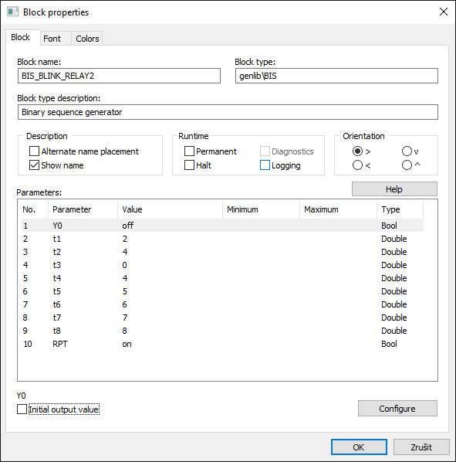
help
List of parameters
  - Insert function blocks
Function block you can insert by press button or ctrl+L, after this is open window with selection. In this window you can find block you want.
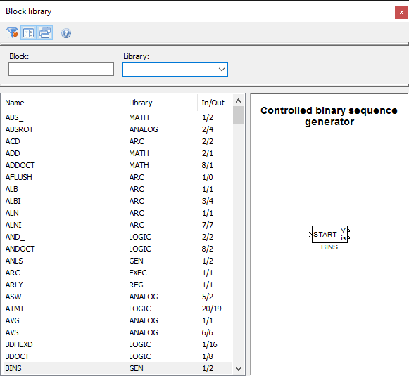
  - Copy function blocks between files
Better then, search function block is copy him. You can open another project and simply copy (drag and drop) one block from one project to another project or copy all parts of project.
For this purpose is prepared folder “prepared task”, where is blocks representating elements of module Seahu SH017.
Change e.t. relay in our example to another relay is very easy. Open file from download folder with examples “prepared task/seahu_task.mdl“ and move blue block “seahu_raley_1” into your project.
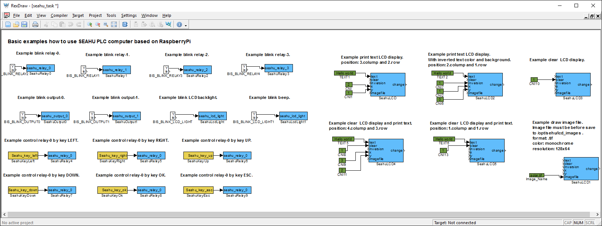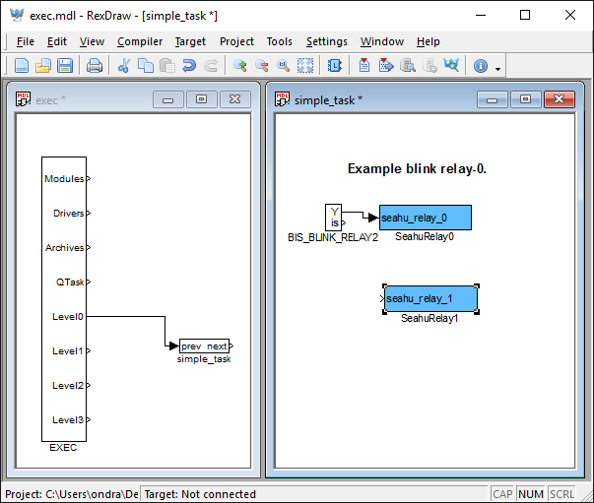
Move block fron one project to another project
Next old relay block delete and reconnect arrow to new block. This is change done.
  - Connection function block together
Function block can be easy connect dragging arrow from one block to another block. If connection is right then connection line change colour to green for a little while. Bat connection is not aviable done. If position connection no look pretty for you, then you can move connection line. if you need branch connection, then press ctrl and click on existing connection line and dragging new connection line. Any time you can connection line delete by click on connection line and press key delete.

- Block exec
Function block exec, gave in Rex controls special importance. This block responsible for run next tasks. Exec block run linked task. Task is consist from function blocks. After task done his code, than end. After some time exec block run this task cyclic again. Exec block have more run level, every this level may be set own frequency of start. Task who need faster reaction (e.t. control motor speed) may be link to another level, than task less time consuming (e.t. monitor temperature). On equal level can be linked more task.
File with exec block may be flag as main. Done this in menu “File→Set as main”. Is not write rule, that file name containing exec block should have in name word exec.
Block exec also doing interface for additions modules and hardware driver, e.t. 1-wire, mod bus, additions card for raspberryPI mini PC,..
- Support for hardware of modul Seahu SH017
Support for this hardware is not solved by module or driver for exec block, but helps special functions block (REXLANG), who enable run program like programming language C. For this reason you don't add any module or driver to exec block for this hardware. But you must copy into folder with your project next files (copy from folder “Prepared task” in download archive witch examples, see. point 5 on this manual who download examples).
- seahu_plc_computer_input.c
- seahu_plc_computer_lcd.c
- seahu_plc_computer_output.c
Also in this folder you can find file “seahu_task.mdl”, where is predefined functions blocks for control hardware of this module (input, output, relay, display, buttons). For use in you project you can simply move selected blocks into you project.

- More informations
- on web producer: https://www.rexcontrols.cz
- on your module: http://IP_address _your_module/help/rex_controls
- options: http://www.seahu.cz

- Writer
Ing. Ondřej Lyčka, December 2016
version of document: 1.1

