SEAHU SH017 (PiToDin)
Hardware specification

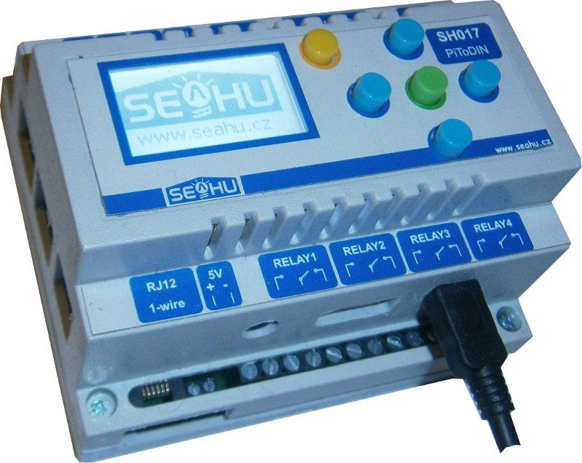
PiToDIN (RaspbeeryPI to DIN)

DESCRIPTION
PLC computer based on raspberryPI on DIN case. Included monochrome display witch 5 buttons, rassperryPi B+ or v2 or v3 and base board witch 4x relay, RS235, RS485, 2x optical isolated output, 2x optical isolated input, buzzer, real time witch battery and 5V one wire interface. DIN case 6 module width.

HARDWARE SPECIFICATION:
4x Relays - 15A/ 125V~
15A/ 24V=
10A/ 250V~
U 5 V
R 69 Ω
P 0,36 W
controlled by I2C 8bit PIO PCF8574 with I2C address 0x20
I2C One-wire master – DS 2482-100 more on http://datasheets.maximintegrated.com/en/ds/DS2482-100.pdf
with ESD protection and 5V output with polyfuse 0,5A. I2C address 0x18.
RS232 – only TX,RX
RS485 – share witch RS232, included jumper for terminator resistor.
Buzzer – connected to raspberryPi pin 12 (GPIO18)
Display – 1.4 inch Graphic 128x64 LCD Module Serial SPI ST7565 Black on White
5x Buttons – connected to I2C 8bit PIO PCF8574 with I2C address 0x24 Bit 6 is used as backlight display.
Real-time – connected to I2C RTC PCF8563 with I2C address 0x51 and battery backup.
2x optical isolated input – configure-able by jumpers on base board as isolated work in activate range 3,3-12V, or usage internal voltage with activate by short. (use chip PC847). Control by some chip as relays with bit 4,5.
2x optical isolated output – open collector max. 6V 50mA e.g. chip PC847 isolation voltage 5KV. Control by some chip as relays with bit 6,7.
Power – 5V 2A by micro usb on raspberryPI or DC2,5mm connector.

Other specification by used raspberryPI computer https://www.raspberrypi.org .

MAIN BOARD:
1
2
3
4
5
6
7
8
12
13
14
15
17
16
9

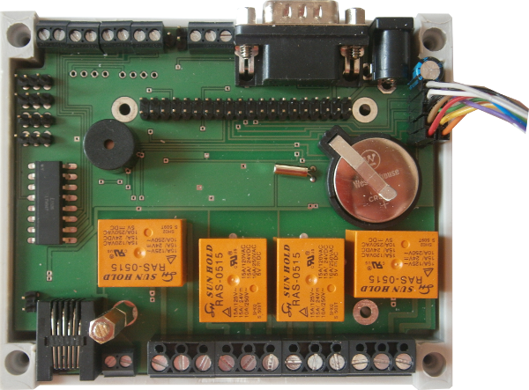

11
10

DESCRIPTION:

- C 2,5mm connector 5V 2A.
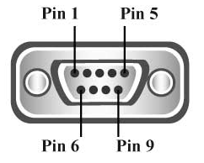
- Serial connector (RS232).
Pin 2 – RX
Pin 3 – TX
Pin 5 – GND
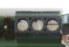
- RS485
1 – terminator resistor 120Ω jumper
2 – B pin
3 – A pin
4 – GND
4
3
2
1

- Antenna pin for options 433MHz module

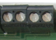
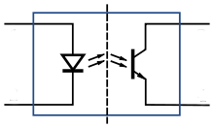
- 2x optical isolated output with open collector
(use chip PC847)
output1 – pin 1, 2
output2 – pin 3, 4
pin 1,3 – collector (max. +6V 50mA)
pin 2,4 – emitter (0V)
control by I2C 8bit register (chip PCF8574 or PCF8574A) with I2C address 0x20 or 0x38
4
1
2
3
1, 3
2, 4
Bit 0 | Bit 1 | Bit 2 | Bit 3 | Bit 4 | Bit 5 | Bit 6 | Bit 7
raley1 | raley2 | raley3 | raley4 | input1 | input2 | output1 | output2

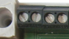
- 2x optical isolation input
is configure-able by jumper explain bellow.
Input1 – pin 3, 4
Input2 – pin 1, 2
pin 2, 4 – has negation logic 3,3-12V mens logic 0
pin 1, 3 – by jumpers configuration 0V or 5V.
control by some chip as output.
2, 4
+5V
1, 3
1
2
3
4
INPUT2
INPUT1

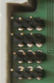
- Jumpers configure optical isolation input
Jumpers
INPUT1
Jumpers
INPUT2
Pin 2, 4
+5V
Pin 1, 3
3,3-12V
0V
Pin 2, 4
+5V
Pin 1, 3
Activate by expernal power.
Activate by short .
(no need external power, but not galvanic isolation)
- buzzer
connected cross transistor to connected to raspberryPi pin 12 (GPIO18)

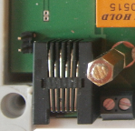
- Jumper for short pin 1 and pin 5 in RJ12 one wire connector
standard one wire connector use RJ12 connector with pin1 to 5V power slave devices. This mean then you can’t use telephone cable with RJ11 connector with no parasite power device. Some devices e.g from http://www.hw-group.com use power on pin 5. In these case simply short jumper. But careful some devices or systems may use on pin 5 RJ12 12V for power more consumes devices.
Jumper
Shor 1 and 5 pin on RJ12
1W
RJ12
- RJ12 standard one wire connector
control by I2C one wire master DS2482-100 with I2C address 0x18 and ESD protection.
5V logical one wire data and 5V output is protected by 0,5 A poly-fuse.
1
2
3
4
5
6
Looking into Female RJ12
Connector
PIN CONFIGURATION RJ12 CONNECTOR
PIN | SIGNAL  NAME | DESCRIPTION
1 | V_{DD} | 5 V DC
2 | GND | Ground
3 | OW | 1-Wire Data  (only 5V level logic)
4 | GND | Ground
5 | N.C.  [V_{DD}] | If jumper ON  then 5V DC  else No Connection
6 | N.C. | No Connection

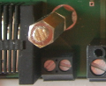
- Output 5V connector with poly-fuse 0,5A
poly-fuse shared with 5V output in RJ12 connector.
5V
GND
- 4x Relays
relays is control by I2C 8bit register (chip PCF8574 or PCF8574A) with I2C address 0x20 or 0x38
bit mapping:

Bit 0 | Bit 1 | Bit 2 | Bit 3 | Bit 4 | Bit 5 | Bit 6 | Bit 7
relay1 | relay2 | relay3 | relay4 | input1 | input2 | output1 | output2
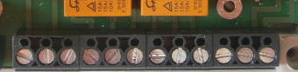
relay characteristic:
15A/125V~
15A/24V=
10A/250V~
connection:
OFF
ON
OFF
ON
OFF
ON
OFF
ON
relay1
relay2
relay3
relay4
- Battery for real time clock
type: CR2032 3V
Real time chip is PCF8563 on I2C bus with I2C address 0x51

- Display and keyboard connector
keyboard use I2C 5V bus controlled by I2C 8bit register (chip PCF8574 or PCF8574A) with I2C address 0x24 or 0x3C
bit mapping
1
3
5
7
9
2
4
6
8
10
pin1 – A0, PI pin18
(GPIO24)
pin3 - RST, PI pin22
(GPIO25)
pin5 – CS, PI pin24
(GPIO08)
pin7 - MOSI, PI pin 19
(GPIO10)
pin9 – SCLK, PI pin 23
(GPIO11)
pin2 – 3,3V
pin4 – 5V

pin6 – SLC, PI pin 5
(GPIO03)
pin8 – SDA,Pi pin 3
(GPIO02)
pin10 - GND
Bit 0 | Bit 1 | Bit 2 | Bit 3 | Bit 4 | Bit 5 | Bit 6 | Bit 7
LEFT | RIGHT | UP | DOWN | OK | ESC | backlight display | Not use

Display 1.4 inch Graphic 128x64 LCD Module Serial SPI ST7565 Black on White
controlled by SPI 3,3V bus compatible with ST7565 LCD driver.
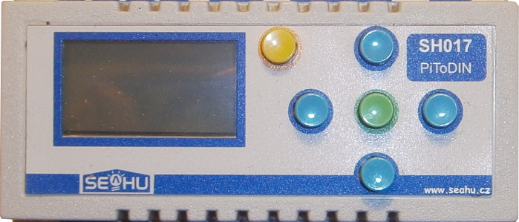
Example at http://m8051.blogspot.cz/2015/04/raspberry-pi-gpiospi-to-use-st7565-lcd.html
- RaspberryPI 40pin connector.
- Options module SYN115 / F115 433 MHz ASK Wireless Transmitter
can by on:
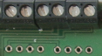
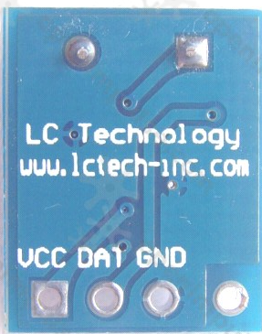
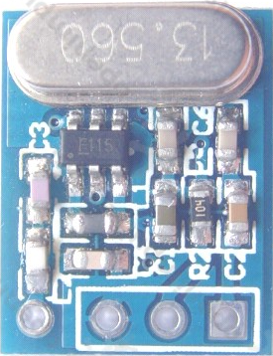
https://www.openimpulse.com/blog/products-page/product-category/syn115-f115-433-mhz-ask-wireless-transmitter-module/
http://www.ebay.com/itm/433MHz-Transmitter-Receiver-Module-SYN115-SYN480R-ASK-Wireless-Module-/351350062982
3,3V
GND
ANT
RaspbeeryPI pin38 (GPIO20)
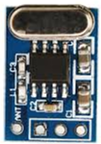
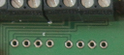

- Options module 433MHz SYN480R ASK Wireless Receiver
3,3V
GND
ANT
RaspbeeryPI pin40 (GPIO21)

POWER SUPPLY:
Power 5V from 1-wire bus on pin 1 RJ12 connector or pin 5 if jumper on PBC is linked.
Max 2,3W.

DIMENSIONS:
46mm
68mm
90mm
94mm
33mm
49mm
65mm

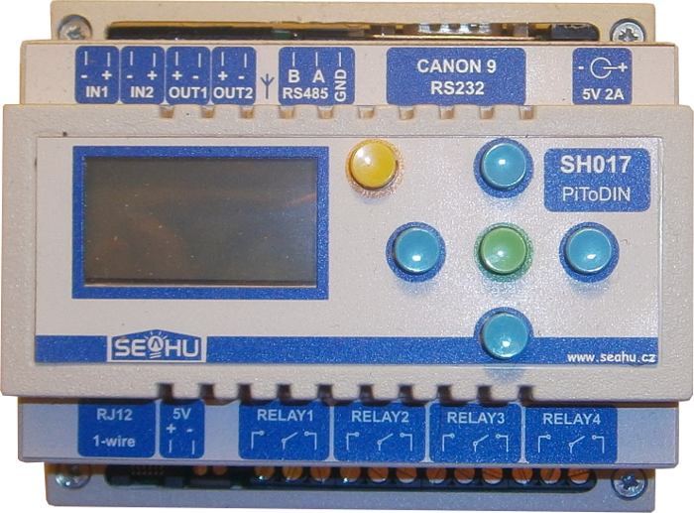

6x modul (107 mm)

VIEWS:
3.5jack audio and TV out

front:
MicroUSB
otions power input
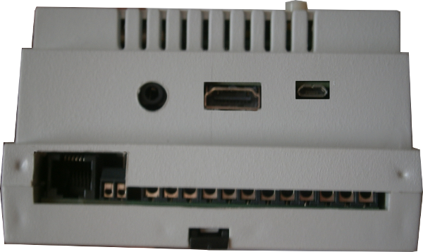

One Wire
4xrelay

5V output
Protected 0,5 A fuse

RS485 terminator
jumper
433MHz atene
back:
RS485
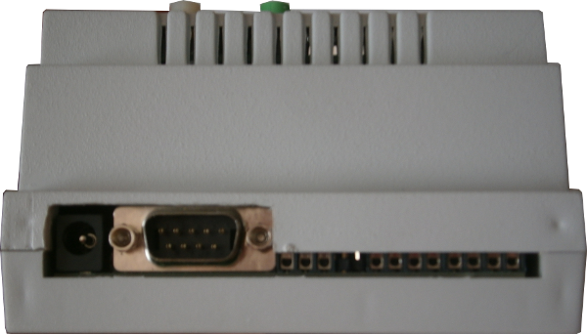
RS232
2x Optical
Isolated
output

POWER IN 5V
2,5A
2x Optical
Isolated
input

left:
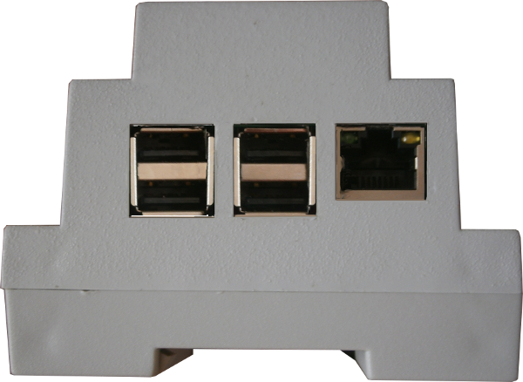
4x USB 2.0
ETHERNET 100Mbs

inside:
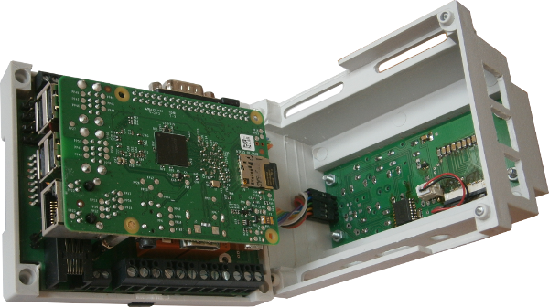
RaspberryPI mini computer

More informations:
- web raspberrypi project: https://www.raspberrypi.org/
- web seahu: http://www.seahu.cz

Writer:
Ing. Ondřej Lyčka november 2016
Document version: 1.01

