SEAHU SH017
QUICK START MANUAL

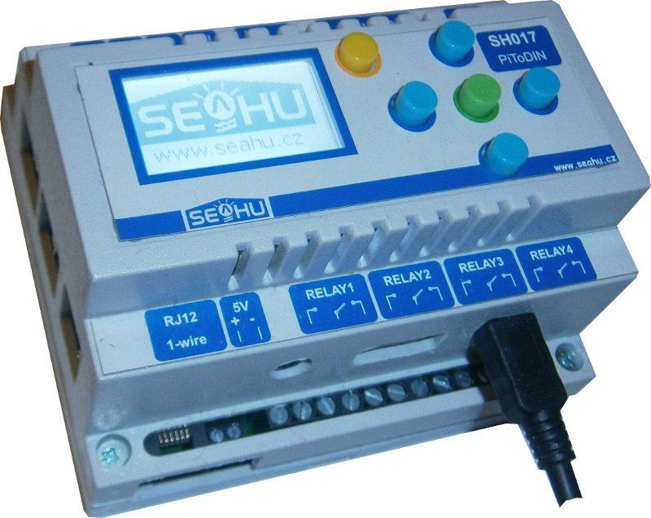

Seahu 017 PiToDIN (RaspbeeryPI To DIN)

Description:
PLC computer based on raspberryPI on DIN case, deployment for easy create home automation. Included monochrome display witch 5 buttons, rassperryPi B+ v3 and base board witch 4x relay, RS232, RS485, 2x optical isolated output, 2x optical isolated input, buzzer, real time witch battery and 5V one wire interface. DIN case 6 module width. Software run on popular operating system for raspberry PI – raspbian (clon of Debian - Linux distribution), therefore you may use any program for those distribution not only pre installed software. This module have two pre installed automation system Domoticz and Rex controls. Domoticz is user friendly automation system mainly for home use. Rex controls system is more complex system for generic automation (home and industry).

Plug power and get IP address
First step is get IP address and other setting doing via web. You can connect device via Ethernet cable or Wi-Fi. Next manual assume that, your network have dhcp server, other way you must configure IP manually (not in this manual).

Plug power
Plug power connector to module. Recommended is use adapter 5V min. 2A with C 2,5mm connector (alternative microusb connector plugged directly into raspberry PI mini PC). And plug Ethernet cable. Start system is finished after beep and draw seahu logo on display.
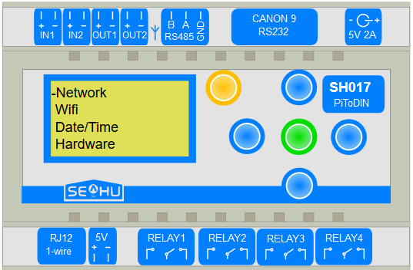
Napajecí konektor C2,5mm
Alternativní
napajecí konektor
Micro USB
Napajecí konektor C2,5mm
Ethernet konektor (počítačová síť)

Get IP from Ethernet cable connection to network

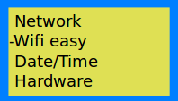Vyberte Wi-Fi easy
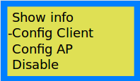Select Config Client
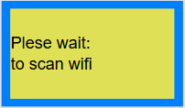Wait
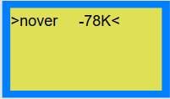Select your Wi-Fi
number is strength signal
K – means KEY password
F – means free
Wait for end network restart
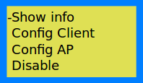Select Show info
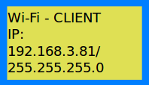Read IP
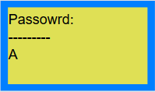Set password
DOWN,UP select character
LEFT,RIGHT select position
OK set password
ESC cancel setting
Wait for network restart
- Plug power connector and Ethernet cable to module and wait to finish start system.
- Press any key for view menu on LCD display and search IP address by example below.
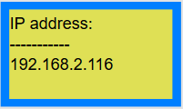
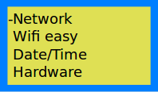Click OK
Click OK
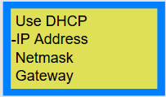Click DOWN, then OK

Get IP address from connect to existing Wi-Fi network
- Plug power connector and Ethernet cable to module and wait to finish start system.
- Set Wi-Fi connection
Press any key for view menu on LCD and follow next step:

Create Wi-Fi access point and get local IP address
- Plug power connector and Ethernet cable to module and wait to finish start system.
- Set Wi-Fi access point
Press any key for view menu on LCD and follow next step:

Select Wi-Fi easy
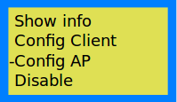Select Config AP
Enter own Wi-Fi name
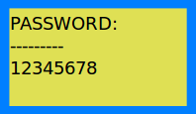Enter own passwd
min. 8 chars
Wait for end network restart
Select Show info
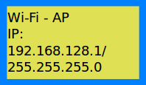Read IP
Wait for network restart

Setting via web
Start web browser and into address line type IP address your SH017. Via web you can easy edit network (Wi-Fi) setting, set time and time zone, look actually status of device (eventually change), reset, change password and select type of automation system. Some task need by log-in. Default Log-in password is: raspberry . Is strongly recommended this password change. In case of lost password, the module can be reset to original state, by pressing the ESC key during start-up device.

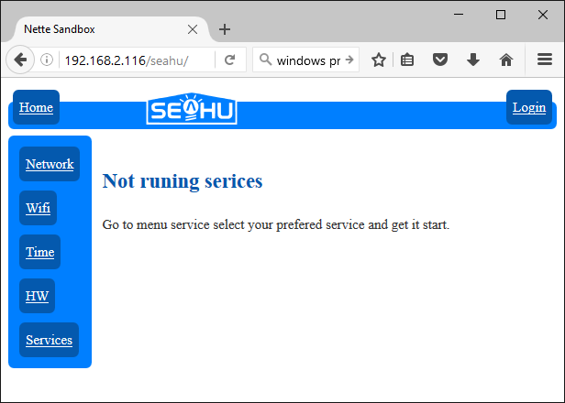
Home page:
Default not running services.

Network setting:
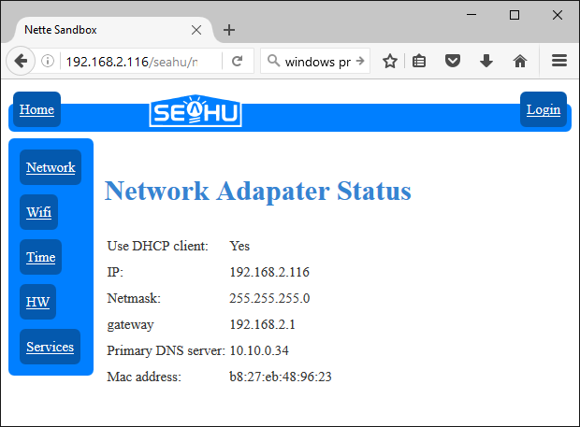View status
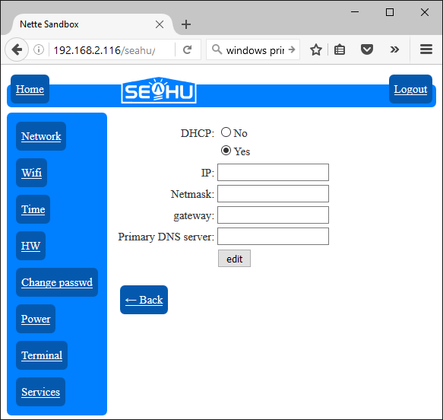Set network configure

Wi-Fi setting:
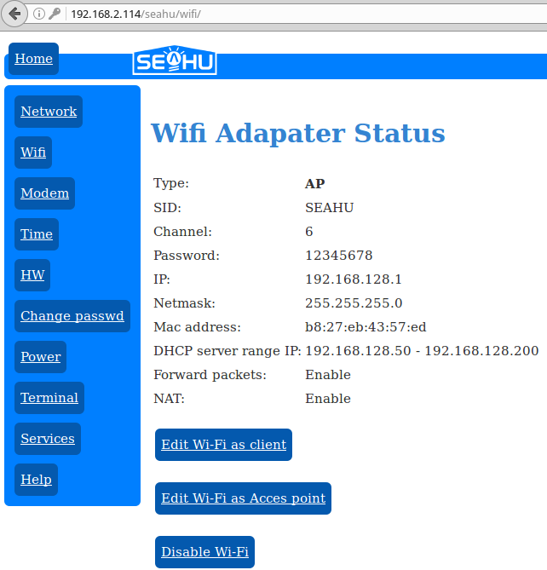View Wi-Fi status
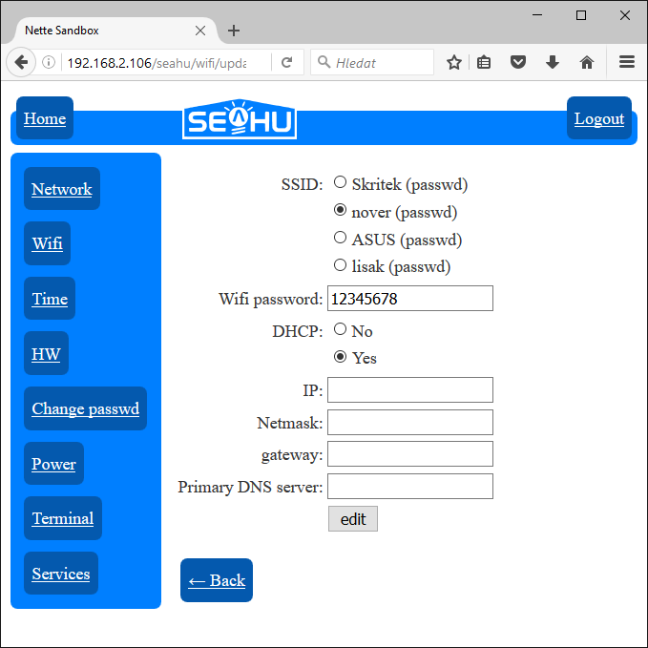Set Wi-Fi configure.
(view this page may take some time because scan available Wi-Fi network)
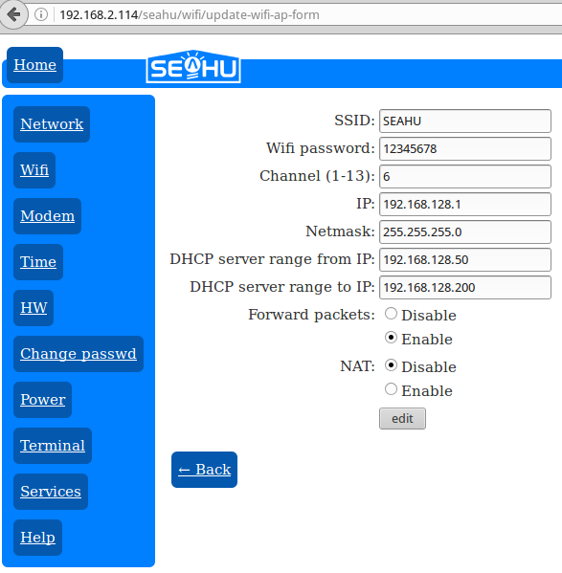Setting for Wi-Fi access point.

Time setting:
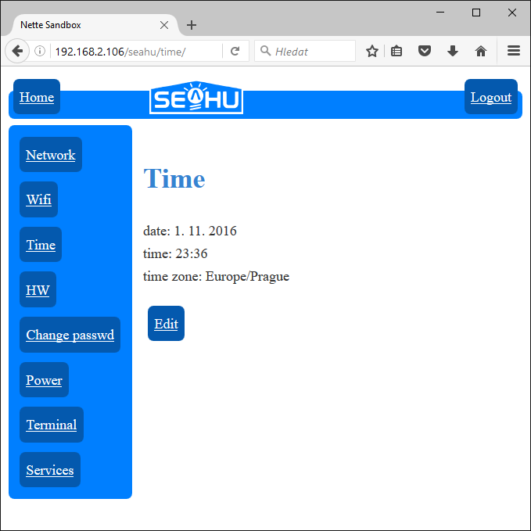View time status
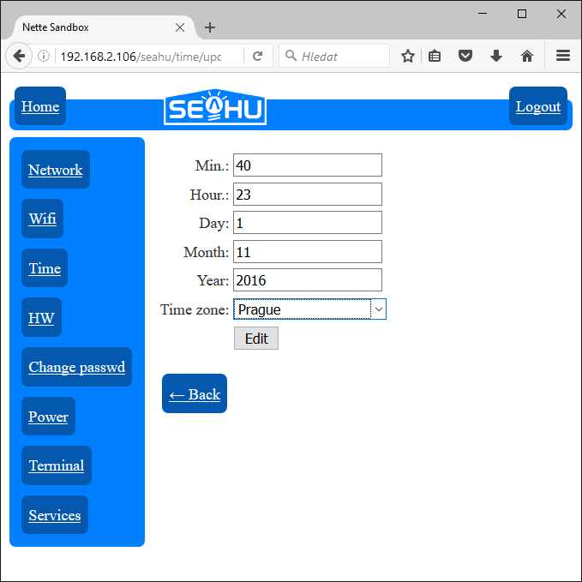Set time. If available internet time get from internet, do not need setting. Important is only select time zone.

View and control hardware status:
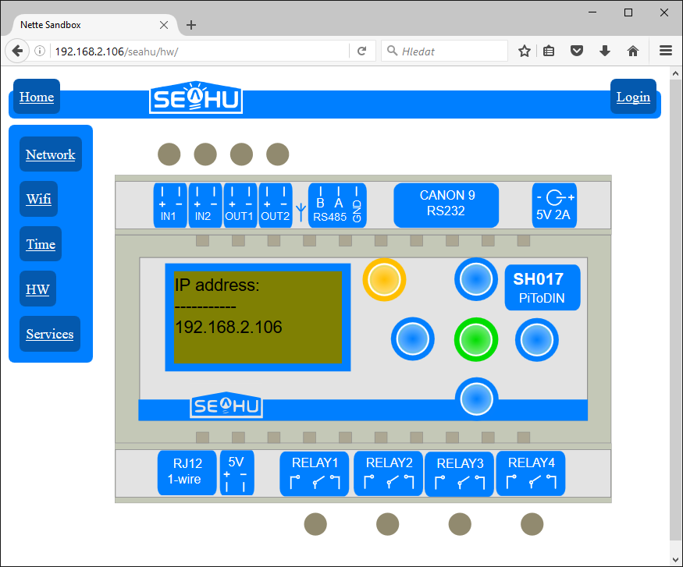View actual status. Display only text and ignore inversion text.
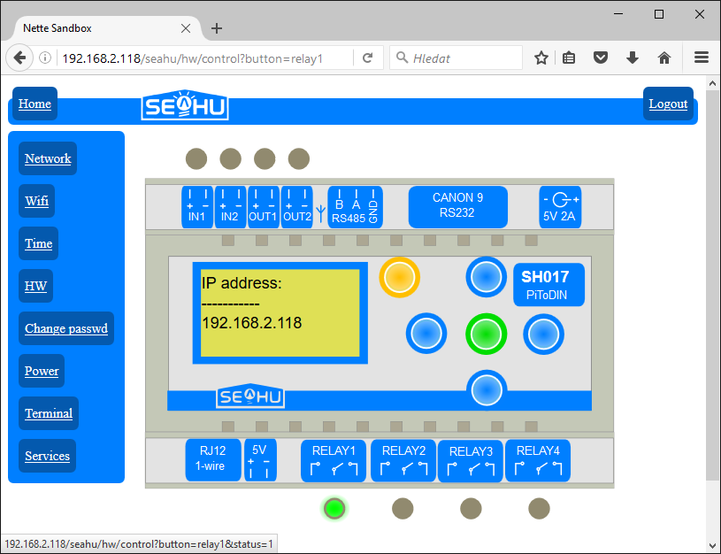Control relay or output and press buttons.
Be careful, if run another service that control this relay or output manually intervention may confuse this service.

PS: Content of display view only text without resolution inversion text and background.

TERMINAL
Button TERMINAL is available only for log-in users. Terminal use ssl connection with self sign certification who is not for modern web browsers trustworthy. If you want use this terminal, you must add security exception into your web browser. Terminal my be also run as separate web on address: https://your_IP:4200 . Login is: pi default password: raspberry or yours changed password.
Another way connect to terminal is use program ssh in Linux or program putty on Windows.
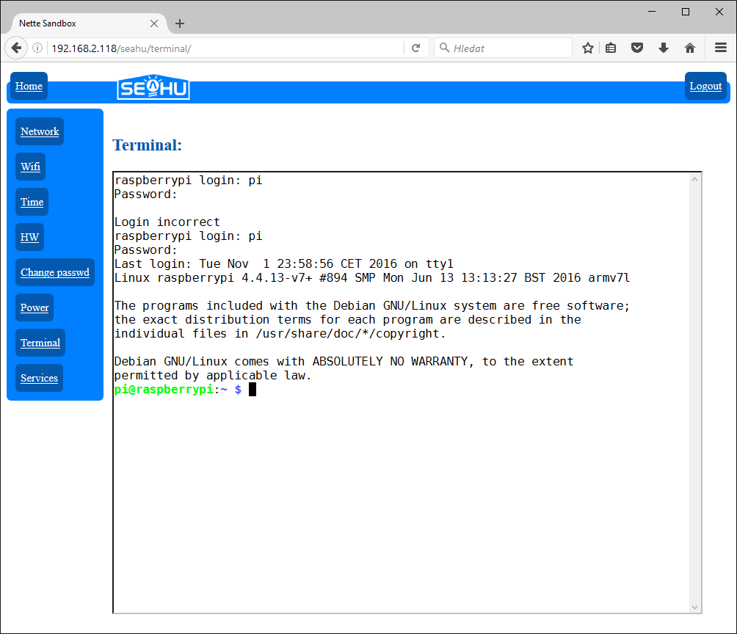Example terminal
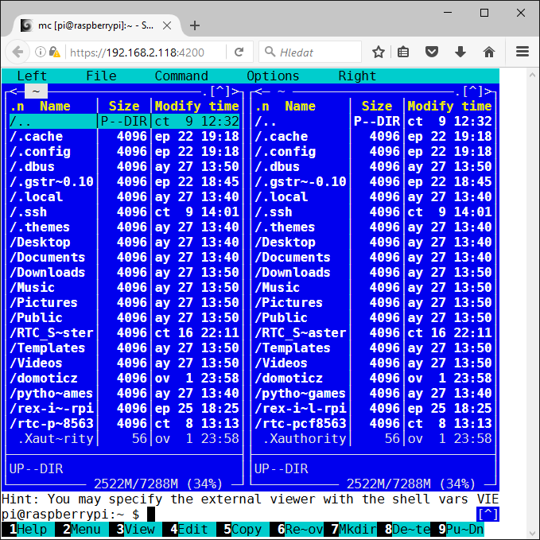Terminal as separate web page

Service setting
On this page you can select automation service who you can use. Actually is supported two automation services and some addition services. If you log-in than can stop or start service. Click to illustration image of service for redirect to web page this service. You can also install any other automation system, bat it is not easy.
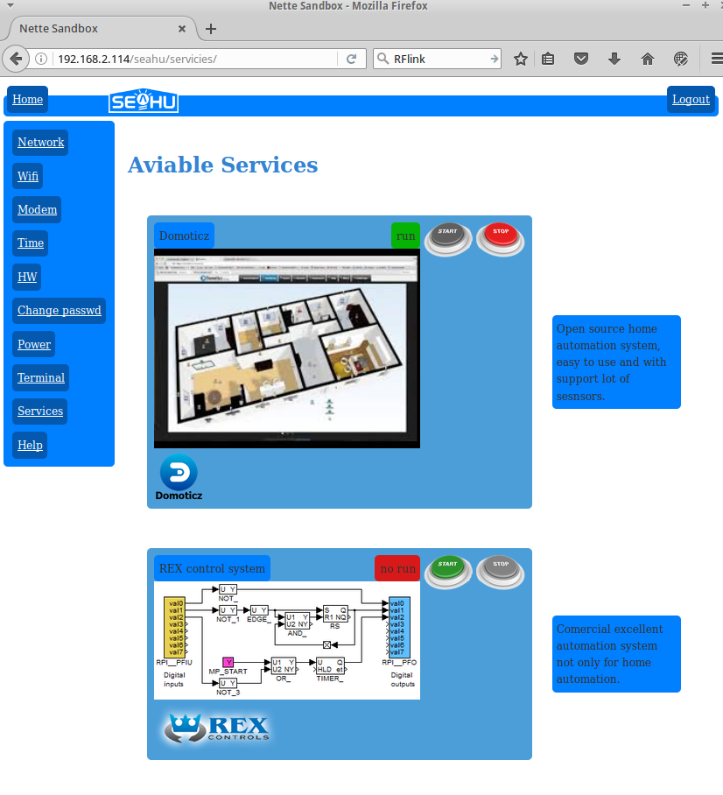
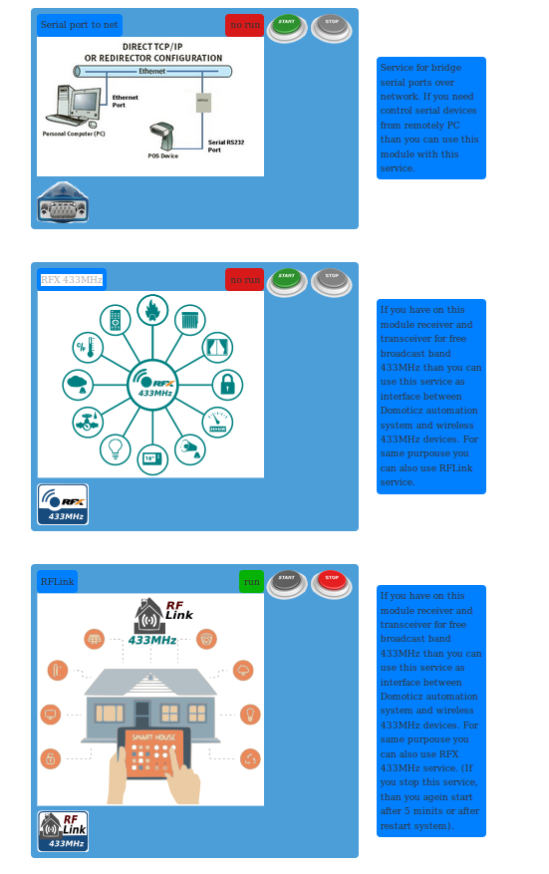

Domoticz
Easy open source system. Ideal for home automation. This system has easy configuration, who can handle everyone (bat strongly recommended read min. quick manual).
REX controls
Complex automation system, suitable for bigger or industry automation. It is not open-source, for fully use must bay licence on http://rexcontrols.com . Otherwise this system running in demo. Demo run only two hours, for next rum must be restart.
Serial port to net
Addition services for create bridge serial port over network into remote PC. For bridge can be used internal serial port or additional USB serial ports.
RFX 433MHz
Addition services for enable control selected wireless devices on free band 433MHz. Specialy for use with system Domoticz.
RFLink
Service like as RFX 433 MHz. Create interface between 433MHz devices and automation system. This is mainly for used with system Domoticz. Selection between RFX 433MHz and RFLink is on user, but is not recommender use both at one time.

More information:
Next manual select by your preferred automation system.
Eventually go:
- web raspberrypi project: https://www.raspberrypi.org/
- web domoticz project: http://www.domoticz.com/
- web Rex controls: https://www.rexcontrols.com/
- or: http://www.seahu.cz

Writer:
Ing. Ondřej Lyčka in july 2017
version document: 1.02

