

1-WIRE RGBW led driver
SH025a

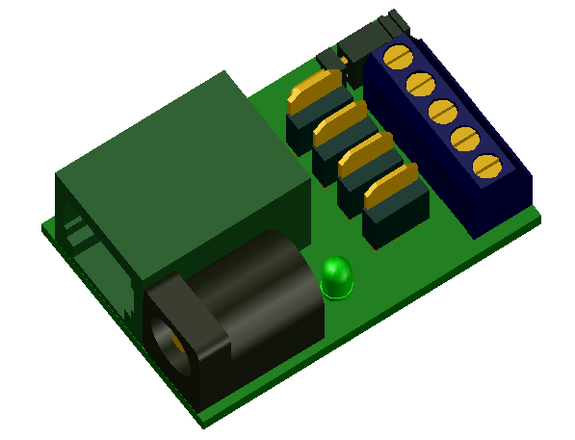

1-WIRE RGBW LED DRIVER

DESCRIPTION
This device enable drive RGB OR RGBW led strip by 1-Wire bus. Device use for RGB hardware PWM modulation with 8bit resolution for one colour component and software 8-bit PWM modulation for white colour.

FEATURES
- 1-Wire ESD protection
- enable power by 1-Wire RJ12 connector or external power by 2.1mm connector up to 24V.
- Value up to 1A per one color, max 3A for all colours
- led indication (share witch white led output)
- enable 24 bit RGB colour resolution and 8 bit resolution for white colour
- enable repeat fluent or flash change colour
- enable save energy by turns off the engine after inactivity
- enable software or hardware force halt motor
- enable change motor rotate direction
- enable choice one of 3 types of step tables (one phase, two phase and two or one phase)
- enable save motor configure
- software support for arduino, linux kernel and OWFS project

CONNECTION
3
`
1

+ 0-24V
Blue

Red
-
+
0-24V
Green
White

5
4
2

1 – conector RJ12 for 1-wire bus
2 – optionaly 2,1mm power connector 0-24V
3 – jumper
On – join 1 and 5 pins of RJ12 connector
enable 5V power driver from pin 5
!!! no join if on pin 5 of RJ12 connector
has more than 5V !!!
4 – clamp for connect to motor
+ 0-24V
Blue
Red
Green
White
5 – indication led (shared with White colour)

PIN CONFIGURATION RJ12 CONECTOR
PIN  1  2  3  4  5  6  Looking into Female RJ12  Connector | SIGNAL  NAME | DESCRIPTION
1 | V_{DD} | 5 V DC
2 | GND | Ground
3 | OW | 1-Wire Data  (only 5V level logic)
4 | GND | Ground
5 | N.C.  [V_{DD}] | If jumper ON  then 5V DC !!! no more !!!  else option led power +0 - 24V
6 | N.C. | No Connection

POWER SUPPLY:
For logic electronic:
Form 1-wire bus by default pin 1 of RJ12 connector. Some one-wire devices use 4-wire cable with power pin 5 instead pin 1 on RJ12 connector. In this case may use jumper who join this pines.

For led strip:
From 1-wire bus by pin 2 and 4 for GND and pin 5 for 0-24V (max 0,8A). Do not use jumper if pin 5 of RJ12 connector has more than 5V (may be destroy this device and other devices on 1-wire bus).
Or from 2,1mm power connector max 24V 3A.

1-WIRE:
Use only 5V logic level.

Family Code: 0xCD
based on arduino 1-Wire slave devices as mulstisensors/actors project more at https://github.com/seahu/seahu_CD/tree/master/Documentation
The devide for setting and control moving use 9 sections. The sections description is bellow.

Device description :SEAHU SH025a 1-Wire to RGBW
Number of section: 5
Sections:
Section 0: RGBW
RGBW value of colour value=Blue+256*Green+65536*Red+16777216*white
value type: unsigned number integer 32bit
some examples:
255 – blue
65 280 – Green
16 711 680 – Red
4 278 190 080 – White
Section 1: Change duration time
Duration time in [ms] to change last colour to new colour.
value type: number integer 32bit
0- immediately change colour
time value < 0 time to flash change
time value > 0 time to fluent change
Section 2: Repeat
The number of repeated changes from actual to new values and back again with a duration as defined in Section 1.
value type: number integer 32bit
value 0 – no repeated
value -1 = repeat to infinity
value 1 to 2147483647 – number of repeat
Section 7: led identification
identify of 1-Wire device (identification led share same pin as white led output)
value type: bool value (only 0 or 1) as unsigned number integer 32bit
1=on
0=off
Section 8: save
save actual values (for read always =0)
value type: bool value (only 0 or 1) as unsigned number integer 32bit
1= start save
0= do nothing

SOFTWARE SUPPORT:
The device is supported in next software platforms.
Arduino as custom library:
https://github.com/seahu/seahu_CD/tree/master/arduino/OneWireMaster0xCD

Linux kernel as kernel module
https://github.com/seahu/seahu_CD/tree/master/linux-kernel-module

OWFS (one wire file system) as own clone:
https://github.com/seahu/owfs

More information
- web page seahu http://www.seahu.cz

Writer:
Ing. Ondřej Lyčka in December 2021

version document: 1.01

