

1-WIRE UNIPOLAR
STEPER MOTOR DRIVER
SH025b

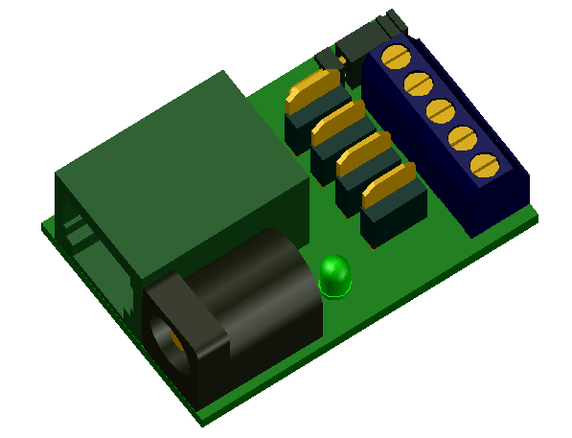
1-WIRE UNIPOLAR STEPPER MOTOR DRIVER

DESCRIPTION
This device enable drive unipolar stepper motor (five wired) by 1-Wire bus. Is excellent for use with 28BYJ-48 stepper motor, but can be used width any unipolar stepper motor up to 24V 1A per phase.

FEATURES
- 1-Wire ESD protection
- enable power by 1-Wire RJ12 connector or external power by 2.1mm connector up to 24V.
- Value up to 1A per one phase, max 3A for all phases
- led indication (share witch one phase)
- enable set speed
- control by relative or absolute coordination
- enable save energy by turns off the engine after inactivity
- enable software or hardware force halt motor
- enable change motor rotate direction
- enable choice one of 3 types of step tables (one phase, two phase and two or one phase)
- enable save motor configure
- software support for arduino, linux kernel and OWFS project

CONNECTION
3
Stepter motor
28BYJ-48
`
1

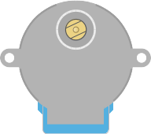

+ 0-24V
A1
B0
A0
-
+
0-24V
B1

5
4
M
A0
A1
B0
B1
+ 0-24V
2

1 – conector RJ12 for 1-wire bus
2 – optionaly 2,1mm power connector 0-24V
3 – jumper
On – join 1 and 5 pins of RJ12 connector
enable 5V power driver from pin 5
!!! no join if on pin 5 of RJ12 connector
has more than 5V !!!
4 – clamp for connect to motor
for 28BYJ-48 stepper motor:
+ 0-24V – red wire
A1 – orange wire
B0 – yellow wire
A0 – pink wire
B1 – blue wire
5 – indication led (shared with pahse B1)

PIN CONFIGURATION RJ12 CONECTOR
PIN  1  2  3  4  5  6  Looking into Female RJ12  Connector | SIGNAL  NAME | DESCRIPTION
1 | V_{DD} | 5 V DC
2 | GND | Ground
3 | OW | 1-Wire Data  (only 5V level logic)
4 | GND | Ground
5 | N.C.  [V_{DD}] | If jumper ON  then 5V DC !!! no more !!!  else No Connection
6 | N.C. | No Connection

POWER SUPPLY:
For electronic:
Form 1-wire bus by default pin 1 of RJ12 connector. Some one-wire devices use 4-wire cable with power pin 5 instead pin 1 on RJ12 connector. In this case may use jumper who join this pines.

For motor:
From 1-wire bus by pin 2 and 4 for GND and pin 5 for 0-24V (max 0,8A). Do not use jumper if pin 5 of RJ12 connector has more than 5V (may be destroy this device and other devices on 1-wire bus).
Or from 2,1mm power connector max 24V 3A.

1-WIRE:
Use only 5V logic level.

Family Code: 0xCD
based on arduino 1-Wire slave devices as mulstisensors/actors project more at https://github.com/seahu/seahu_CD/tree/master/Documentation
The devide for setting and control moving use 9 sections. The sections description is bellow.

Device description :SEAHU SH025b 1-Wire unipolar stepter motor driver
Number of section: 9
Sections:
Section 0: MoveRelative
moving to relative distance in steps
value type: number integer 32bit
-2147483646 steps => never ending move to left
+2147483646 steps => never ending move to right

Section 1: MoveAbsolute
moving to absolute distance in steps
value type: number integer 32bit
Section 2: Speed
moving speed in steps/sec
value type: unsigned number integer 32bit
Section 3 : AbsoluteCoordinate
actual absolute coordinate in steps
value type: number integer 32bit
Section 4: TimeToDisableMotor
delay in us to turns off the engine after inactivity
value type: unsigned number integer 32bit
Section 5: ConfigFlags
configure bits falgs
value type: unsigned number integer 32bit
1.bit (+1) - 0= normal motor direction, 1= inverse motor direction
2.-4.bit - select step table used for stepter motor:
(+0) = one phase at a time, simples less torque less electric consume
(+2) = two phases at a time, more torque but more electric consume
(+4) = two or one phase, two times more precise (smaller step)
Step table:
 | one phase at a time  (less torque save energy) |  |  |  | two phases at a time  (more energy bigger torque) |  |  |  | two or one phase  (more precise)
Config flag  value | +0 |  |  |  | +2 |  |  |  | +4
Phase | A0 | B0 | A1 | B1 | A0 | B0 | A1 | B1 | A0 | B0 | A1 | B1
Step 1 | 0 | 0 | 0 | 1 | 0 | 0 | 1 | 1 | 0 | 0 | 0 | 1
Step 2 | 0 | 0 | 1 | 0 | 0 | 1 | 1 | 0 | 0 | 0 | 1 | 1
Step 3 | 0 | 1 | 0 | 0 | 1 | 1 | 0 | 0 | 0 | 0 | 1 | 0
Step 4 | 1 | 0 | 0 | 0 | 1 | 0 | 0 | 1 | 0 | 1 | 1 | 0
Step 5 |  |  |  |  |  |  |  |  | 0 | 1 | 0 | 0
Step 6 |  |  |  |  |  |  |  |  | 1 | 1 | 0 | 0
Step 7 |  |  |  |  |  |  |  |  | 1 | 0 | 0 | 0
Step 8 |  |  |  |  |  |  |  |  | 1 | 0 | 0 | 1
Steps to one revolution  28BYJ-48  before/after  gearbox | 32/2048 |  |  |  | 32/2048 |  |  |  | 64/4096

Section 6: ForceHalt
enable halt or continue moving
0=continue moving
1=immediately halt moving
value type: bool value (only 0 or 1) as unsigned number integer 32bit
Section 7: led identification
identify of 1-Wire device (indentification led share same pin as motor pin B1, therefore during moving may flash)
value type: bool value (only 0 or 1) as unsigned number integer 32bit
1=on
0=off
Section 8: save
save actual values (for read always =0)
value type: bool value (only 0 or 1) as unsigned number integer 32bit
1= start save
0= do nothing
SOFTWARE SUPPORT:
The device is supported in next software platforms.
Arduino as custom library:
https://github.com/seahu/seahu_CD/tree/master/arduino/OneWireMaster0xCD

Linux kernel as kernel module
https://github.com/seahu/seahu_CD/tree/master/linux-kernel-module

OWFS (one wire file system) as own clone:
https://github.com/seahu/owfs

More information
- web page seahu http://www.seahu.cz

Writer:
Ing. Ondřej Lyčka in September 2017

version document: 1.01

