

SH026a
1-WIRE universal analogue/digital
interface

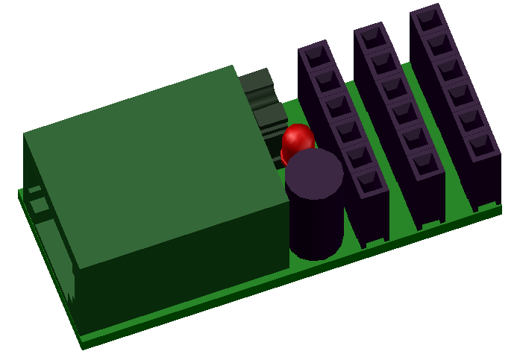

1-WIRE UNIVERSAL ANALOGUE/DIGITAL INTERFACE

DESCRIPTION
This is universal 1-wire device with one digital PIO and one analogue input. This PIO can be use many differently way. For example with movie sensor, door or window open sensor, pulse counter and analogue ping can measure temperature, humidity, pressure, light,…. This is usefully with join with many arduino sensors. This device save actual values on power off events.

FEATURES
- 1-Wire ESD protection
- one digital input/output pin
- one analogue input pin
- led indication
- counter on digital input pin
- enable alarm for digital or analogue values to save traffic on 1-Wire bus
- ready to direct connect popular arduino sensors
- save actual values to EEPROM after loost power
- software support for arduino, linux kernel and OWFS project

CONNECTION
1
2
3
`
GND
PIO
+5V
A-IN
+5V
GND
+5V
PIO
A-IN
PIO
GND
+5V
A-IN
PIO
A-IN
`
`
`
4

1 – conector RJ12 for 1-wire bus
2 – jumper
On – join 1 and 5 pins of RJ12 connector
enable 5V power driver from pin 5
3 – indication led
4 – cavity mouldings

PIN CONFIGURATION RJ12 CONECTOR
PIN  1  2  3  4  5  6  Looking into Female RJ12  Connector | SIGNAL  NAME | DESCRIPTION
1 | V_{DD} | 5 V DC
2 | GND | Ground
3 | OW | 1-Wire Data  (only 5V level logic)
4 | GND | Ground
5 | N.C.  [V_{DD}] | If jumper ON  then 5V DC !!! no more !!!  else No Connection
6 | N.C. | No Connection

POWER SUPPLY:
Form 1-wire bus by default pin 1 of RJ12 connector. Some one-wire devices use 4-wire cable with power pin 5 instead pin 1 on RJ12 connector. In this case may use jumper who join this pines.

1-WIRE:
Use only 5V logic level.

Family Code: 0xCD
based on arduino 1-Wire slave devices as mulstisensors/actors project more at https://github.com/seahu/seahu_CD/tree/master/Documentation
The device use 8 sections. The sections description is bellow.

Device description :SEAHU SH026a 1-Wire 1xPIO + 1xAIN
Number of section: 8
Sections:
Section 0: PIO-IN digital pin
digital pin input value (for enable digital pin as input must be set to 1 actual value in section 1)
value type: unsigned number integer 32bit
Section 1: PIO-OUT digital pin
digital pin output value (=1 enable use digital pin as input)
value type: number integer 32bit
Section 2: Counter digital pin
read value of counter on digital pin
value type: unsigned number integer 32bit
Section 3 : ADC analog pin
Analogue value of A-IN pin (0-5V).
value type: integer 32bit (0 to 1023)
ADC use 10-bit. Referral voltage is Vref=5V from 1-Wire power. Analog value is:
ADC = (Vin * 1024)/(Vref)
Section 4: Setter correction signed value for ADC
correction for analogue value
value type: number integer 32bit
Section 5: led identification
identify of 1-Wire device
value type: bool value (only 0 or 1) as unsigned number integer 32bit
1=on
0=off
Section 6: save
save actual values (for read always =0)
value type: bool value (only 0 or 1) as unsigned number integer 32bit
1= start save
0= do nothing
Section 7: Counter counter_poweroff
If the device is switched off, increase this counter.
value type: unsigned number integer 32bit
Value is stored into EEPROM who has lifetime about 100 000 writies.
therefore do not switch on/off the device unnecessarily.

SOFTWARE SUPPORT:
The device is supported in next software platforms.
Arduino as custom library:
https://github.com/seahu/seahu_CD/tree/master/arduino/OneWireMaster0xCD

Linux kernel as kernel module
https://github.com/seahu/seahu_CD/tree/master/linux-kernel-module

OWFS (one wire file system) as own clone:
https://github.com/seahu/owfs

More information
- web page seahu http://www.seahu.cz

Writer:
Ing. Ondřej Lyčka in September 2017

version document: 1.01

