

SH026b
1-WIRE interface for temperature and humidity sensor DHT22 (AM2302)

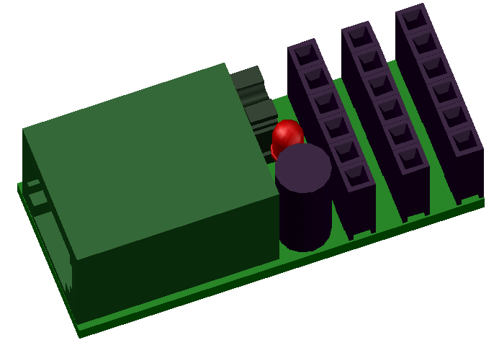

1-WIRE INTERFACE FOR TEMPERATURE AND HUMIDITY SENSOR DHT22

DESCRIPTION
This is 1-wire interface for DHT22 (AM2302) temperature and humidity sensor. The use universal board Seahu SH026 with firmware specialized for DTH22 sensor.

FEATURES
- 1-Wire ESD protection
- led indication
- enable set correction values fro temperature and humidity
- enable alarm for digital or analogue values to save traffic on 1-Wire bus
- save actual values to EEPROM after loost power
- software support for arduino, linux kernel and OWFS project

DHT22 (AM2302) sensor:
- temperature: -40 to +80 C +/- 0.5 C
- humidity: 0% to 100 % +/- 5%
- sampling: 0.5Hz (one every 2 seconds)

CONNECTION
2
3
`
GND
PIO
+5V
A-IN
+5V
GND
+5V
PIO
A-IN
PIO
GND
+5V
A-IN
PIO
A-IN
`
`
`
4
VCC
DATA
NC
GND
1
Temperature and humidity sensor
DHT22
(AM2302)

1 – conector RJ12 for 1-wire bus
2 – jumper
On – join 1 and 5 pins of RJ12 connector
enable 5V power driver from pin 5
3 – indication led
4 – cavity mouldings

PIN CONFIGURATION RJ12 CONECTOR
PIN  1  2  3  4  5  6  Looking into Female RJ12  Connector | SIGNAL  NAME | DESCRIPTION
1 | V_{DD} | 5 V DC
2 | GND | Ground
3 | OW | 1-Wire Data  (only 5V level logic)
4 | GND | Ground
5 | N.C.  [V_{DD}] | If jumper ON  then 5V DC !!! no more !!!  else No Connection
6 | N.C. | No Connection

POWER SUPPLY:
Form 1-wire bus by default pin 1 of RJ12 connector. Some one-wire devices use 4-wire cable with power pin 5 instead pin 1 on RJ12 connector. In this case may use jumper who join this pines.

1-WIRE:
Use only 5V logic level.

Family Code: 0xCD
based on arduino 1-Wire slave devices as mulstisensors/actors project more at https://github.com/seahu/seahu_CD/tree/master/Documentation
The device use 8 sections. The sections description is bellow.

Device description :SEAHU SH026b 1-Wire to DHT22 sensor
Number of section: 6
Sections:
Section 0: Temperature [x0.1 C]
value of temperature x0.1 C
value type: number integer 32bit
Section 1: PIO-OUT digital pin
digital pin output value (=1 enable use digital pin as input)
value type: number integer 32bit
Section 2: Temperature [x0.1 C] temperature corection
correction of temperature x0.1C
value type: number integer 32bit
Section 3 : Humidity [%]
value type: integer 32bit
Section 4: Humidity [%] Humidity corection
correction of humidity %
value type: number integer 32bit
Section 5: led identification
identify of 1-Wire device
value type: bool value (only 0 or 1) as unsigned number integer 32bit
1=on
0=off
Section 6: save
save actual values (for read always =0)
value type: bool value (only 0 or 1) as unsigned number integer 32bit
1= start save
0= do nothing

SOFTWARE SUPPORT:
The device is supported in next software platforms.
Arduino as custom library:
https://github.com/seahu/seahu_CD/tree/master/arduino/OneWireMaster0xCD

Linux kernel as kernel module
https://github.com/seahu/seahu_CD/tree/master/linux-kernel-module

OWFS (one wire file system) as own clone:
https://github.com/seahu/owfs

More information
- web page seahu http://www.seahu.cz

Writer:
Ing. Ondřej Lyčka in September 2017

version document: 1.01

