

SH026d
1-WIRE interface for 2x servo
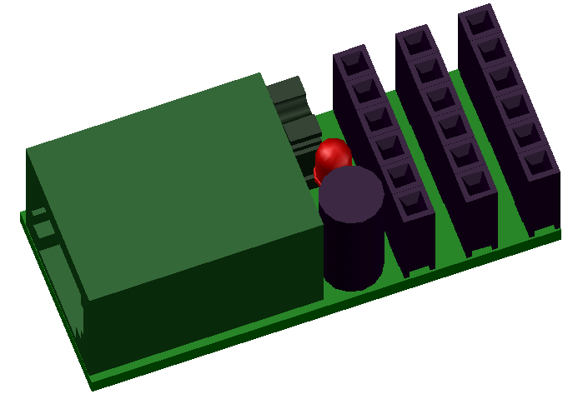

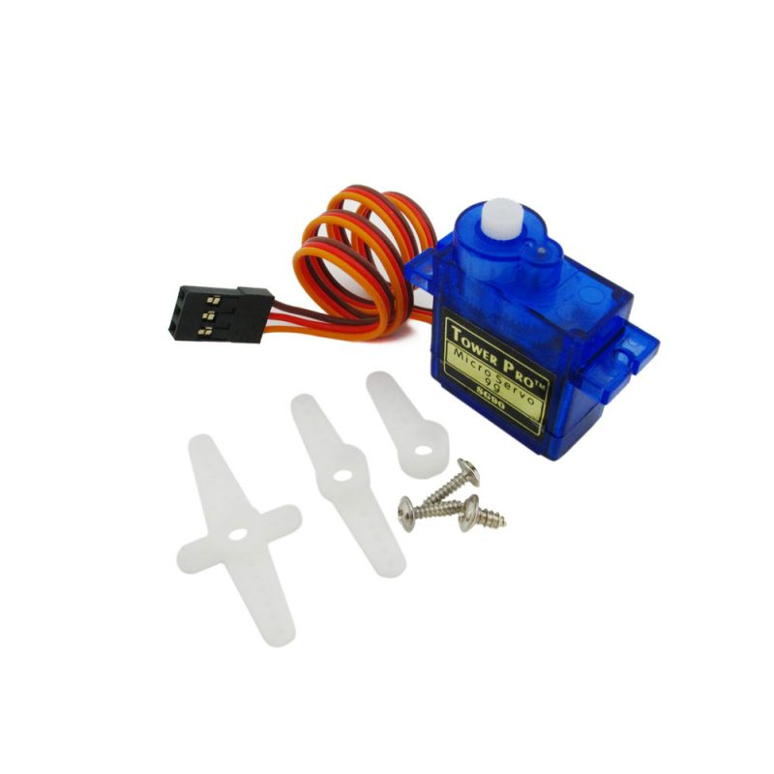
1-WIRE INTERFACE FOR ULTRASONIC DISTANCE SENSOR
DESCRIPTION
This is 1-wire interface for HC-SR04, HC-SR045, HY-SR05 or JSN-SR04T ultrasonic distance sensor (meter). Enable measure depend on sensor from 2cm to 5,2m.
The use universal board Seahu SH026 with firmware specialized for DTH22 sensor.

FEATURES
- 1-Wire ESD protection
- led indication
- enable drive up two servos
- enable save actual and setting values to EEPROM
- software support for arduino, linux kernel and OWFS project

CONNECTION
2
3
GND
S0
+5V
S1
+5V
GND
+5V
S0
S1
PIO
GND
+5V
S1
S0
S1
`
`
`
S1
1
`
5
+5V
GND
S0
+5V
GND
0 to +12V
From pin 5 of RJ12 connector
SERVO 0
SERVO 1

1 – conector RJ12 for 1-wire bus
2 – jumper
On – join 1 and 5 pins of RJ12 connector
enable 5V power driver from pin 5
3 – indication led
4 – cavity mouldings
5 – optionaly 0 to +12 V from pin 5 of RJ12 connector (!!! if volatge there is more than 5V do not use jumper!!!)

PIN CONFIGURATION RJ12 CONNECTOR
PIN  1  2  3  4  5  6  Looking into Female RJ12  Connector | SIGNAL  NAME | DESCRIPTION
1 | V_{DD} | 5 V DC
2 | GND | Ground
3 | OW | 1-Wire Data  (only 5V level logic)
4 | GND | Ground
5 | 0-12V  [V_{DD}] | If jumper ON  then 5V DC !!! no more !!!  else No Connection
6 | N.C. | No Connection

POWER SUPPLY:
Is from 1-wire bus by default pin 1 of RJ12 connector.
Some one-wire devices use 4-wire cable with power pin 5 instead pin 1 on RJ12 connector. In this case you may use jumper who join those pines.
But standard 1-wire connection use this pin for bigger power supply e.g. +12V. This pin is lead into jumper connector and my be used as optional power supply for servos. In this case you do not use join jumper, otherwise you risk damage this and other devices on 1-wire bus.

1-WIRE:
Use only 5V logic level.

Family Code: 0xCD
based on arduino 1-Wire slave devices as mulstisensors/actors project more at https://github.com/seahu/seahu_CD/tree/master/Documentation
The device use 8 sections. The sections description is bellow.

Device description :SEAHU SH026c 1-Wire to 2xservo
Number of section: 8
Sections:
Section 0: Angle [deg]{0-180} angle of servo1
servo 1 angle in degree
value type: number integer 32bit
Section 1: Speed [deg/s]{0-65535} 0=max speed servo1
servo 1rotatory speed in degree/sec
value type: number integer 32bit
Section 0: Switch {0,1} 0=normal mode 1=power save mode
servo 1 switch for power save mode
(this mean power off motor on end of rotatory moving)
value type: bool value (only 0 or 1) as unsigned number integer 32bit

Section 3: Angle [deg]{0-180} angle of servo1
servo 2 angle in degree
value type: number integer 32bit
Section 4: Speed [deg/s]{0-65535} 0=max speed servo1
servo 2rotatory speed in degree/sec
value type: number integer 32bit
Section 5: Switch {0,1} 0=normal mode 1=power save mode
servo 2 switch for power save mode
(this mean power off motor on end of rotatory moving)
value type: bool value (only 0 or 1) as unsigned number integer 32bit

Section 6: led identification
identify of 1-Wire device
value type: bool value (only 0 or 1) as unsigned number integer 32bit
1=on
0=off
Section 7: save
save actual values (for read always =0)
value type: bool value (only 0 or 1) as unsigned number integer 32bit
1= start save
0= do nothing

SOFTWARE SUPPORT:
The device is supported in next software platforms.
Arduino as custom library:
https://github.com/seahu/seahu_CD/tree/master/arduino/OneWireMaster0xCD

Linux kernel as kernel module
https://github.com/seahu/seahu_CD/tree/master/linux-kernel-module

OWFS (one wire file system) as own clone:
https://github.com/seahu/owfs

More information
- web page seahu http://www.seahu.cz

Writer:
Ing. Ondřej Lyčka in January 2022

version document: 1.01

